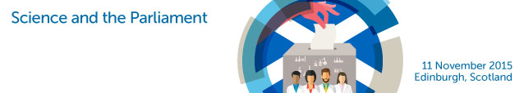
Programme

11.30: Registration, exhibition and light refreshments

12.30: Introduction by Chair
Professor Alan Alexander, General Secretary, The Royal Society of Edinburgh

12.35: Opening Speech
Professor Dominic Tildesley, President, Royal Society of Chemistry

12.50: Address by
Professor Neva Haites, Vice President, The Royal Society of Edinburgh

13.05: Address by
Dr Alasdair Allan MSP, Minister for Learning, Science & Scotland’s Languages

13.20: Research & Higher Education
Professor Andrew Morris, Chief Scientific Officer (Health), Scotland
Professor Garry Taylor, Deputy Principal, University of St. Andrews
Professor Julie Fitzpatrick, Moredun Research Institute Scientific Director &Group CEO

14.10: Chair:
Kenneth MacDonald, BBC Scotland

Addresses by:
Kezia Dugdale MSP, leader, Scottish Labour Party
Liz Smith MSP, Scottish Conservative Party

14.40: TEA BREAK

15.10: Addresses by:
Willie Rennie MSP, leader, Scottish Liberal Democrats
Patrick Harvie MSP, leader, Scottish Green Party

1540: Chair:
Professor Stuart Munro

Science and Society
Jon Edwards, Royal Society of Chemistry
Professor Steve Yearley, University of Edinburgh
Dr Stephen Breslin, Glasgow Science Centre

16.30: Innovation & the Economy
Professor Bob Tooze, Managing Director, Sasol Technology (UK)
Professor Tim Bedford, Deputy Principal, University of Strathclyde
Dr Siobhán Jordan, Interface

17.10: Awarding of prizes
Royal Society of Chemistry, Royal Society of Biology, Institute of Physics, RSSA

1730: Closing Remarks
Professor Lesley Yellowlees, Vice Principal, University of Edinburgh

17.45: Drinks Reception/Buffet and Exhibition (closes 2000)

