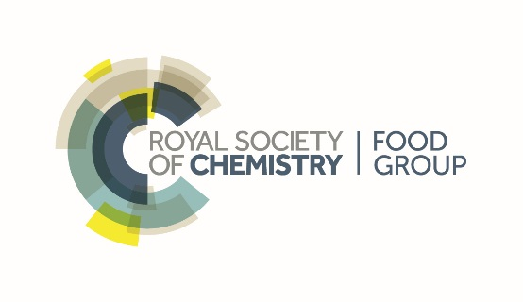

At The University of Reading, The Meadows Suite, RG6 6UR

Time: 9.30am – 5.00pm

In light of recent regulatory changes, this one-day symposium will bring you an update from regulatory, industry and academic experts. It will also include an opportunity to ask your questions to a panel of experts in the field.

Confirmed speakers include:

Regulatory: Mark Willis (FSA)

Industry: Andrew Curtis (ESA)

Dr Natalie Thatcher (Mondelez, UK)

Professor Nigel Halford (Rothamstead Research)

Academia: Professor Don Mottram (University of Reading)

Analysis: Nathan Hawkins (Anatune)

Recent developments in the analysis of of acrylamide, acrylamide formation, mitigation and related topics will be covered by a **poster session** and **flash presentations**. Please submit abstracts (~200 words) by 20th October 2017 to Jane Parker at [j.k.parker@reading.ac.uk](mailto:j.k.parker@reading.ac.uk).

Acrylamide - Regulatory and Industry Update Thursday 16th November 2017

[REGISTRATION link](https://www.eventbrite.co.uk/e/acrylamide-regulatory-and-industry-update-tickets-37915543411)

RSC Members £85

Non-Members £99

Students/retired £30