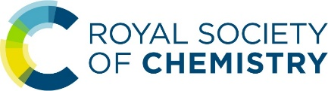
Analytical Division Regions Forum
12 October 2021 ADR/1121:01

Schools’ Analyst Competition

Purpose:

To inform Analytical Division Regions on the outcomes of the 2021 Schools’ Analyst Competition and plans for the 2022 Schools’ Analyst Competition. The in-school format for the 2022 competition was approved by AD Council on 12th October 2021.

Recommendation:

Analytical Division Regions are asked to discuss this paper.

Background:

As the effects of the Covid-19 pandemic were realised in early 2020, AD Council took the decision to cancel the Schools’ Analyst Competition (SAC) final and convert to an online format while the national lockdown was required. With physical restrictions set to remain for the remainder of 2020 and possibly into 2021, myself and Prof. John Dean (then National Coordinator of the SAC) proposed an alternative competition to AD Council in October 2020. This proposal included plans to prepare 200 boxes of consumables and samples to send to schools in the UK and Ireland to allow them to host a practical competition locally, in their own time, and subject to their own restrictions. The proposal was accepted and the competition carried out. This document is a summary of the 2021 competition and a proposal for 2022.

Applications

Although 200 boxes were funded for this competition, it was not known how many schools would want to participate given the significant disruption to teaching timetables. In consultation with the chairs of AD regions, it was decided that instead of awarding the boxes to the first 200 schools to apply entries would be selected randomly, and also allocated proportionally based on population of each of the nine AD regions. Based upon information provided to me by Leanne Marle on the number of secondary schools in the regions of the UK, along with statistics from the British Educational Suppliers Association and the Irish Government, and the assumption that the number of secondary schools would correlate to the number of colleges, I allocated boxes to the regions as shown in fig. 1.

Advertising for the event was posted in November 2020 through RSC Events, by email from RSC Networks as an e-alert, and also through the regular regional heat organisers via their network of teacher contacts. Teachers initially had until the 26th February 2021 to register their interest however this deadline was pushed back to 26th March given the disruption in schools at the time. In total 249 unique applications were made for the 200 boxes, with an additional five duplicate registrations (by different teachers at the same school) and six ineligible registrations from overseas. Four regions (IRE, MID, NE and NI) had fewer applications than their initial allocation and so that excess capacity was shared proportionally among the other regions (see fig. 2 for the full breakdown).

The Competition

Competition booklets were sent to schools by email along with teachers’ and technicians’ notes (see appendix 3-5). Northumbria University was engaged for the development work, purchase of consumables, assembly of kits, and postage to schools, and boxes were delivered to most by mid-April. The original timeline asked schools to complete their competitions by Friday 28th May with the winners informed early the following week. Due to the continued disruption schools were facing with ‘bubbles’ having to self-isolate, I sent teachers a questionnaire to ask if they needed extra time. Many were fine to complete within the proposed timeframe, but some said it was simply not possible. As a result of this, it was decided to split the competition in two: the regional competition would close on 28th May as planned, but schools unable to complete by then could still enter results up until 29th October. Both individual school and regional winners (see fig. 3) were informed of their success on 1st June. Late entries did come in, and overall, we had entries from 2,817 students in 939 teams, representing 151 of the 200 registered schools.

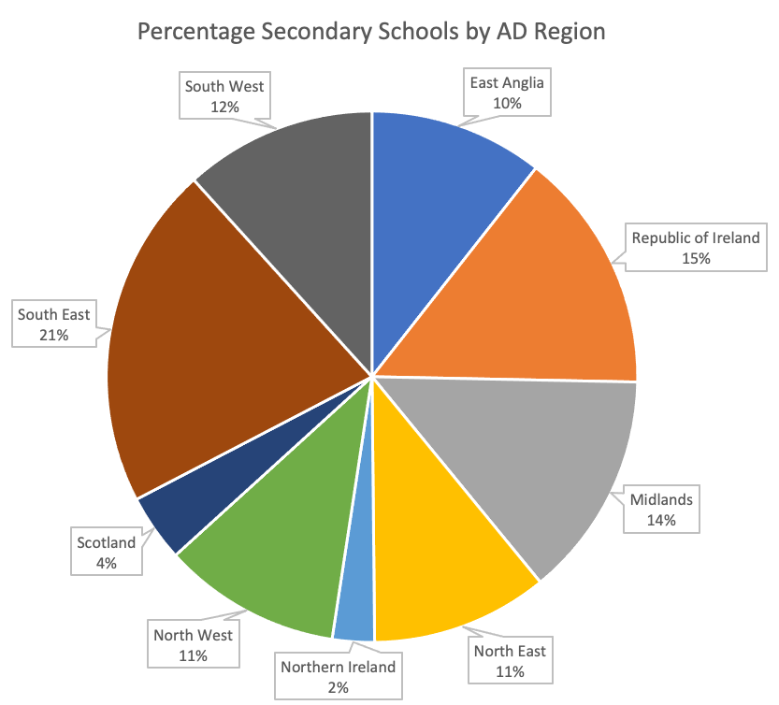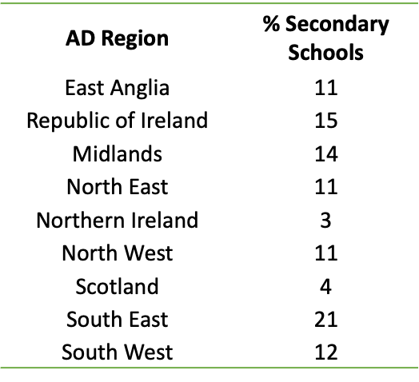
Fig. 1. Percentage of secondary schools in each AD region.

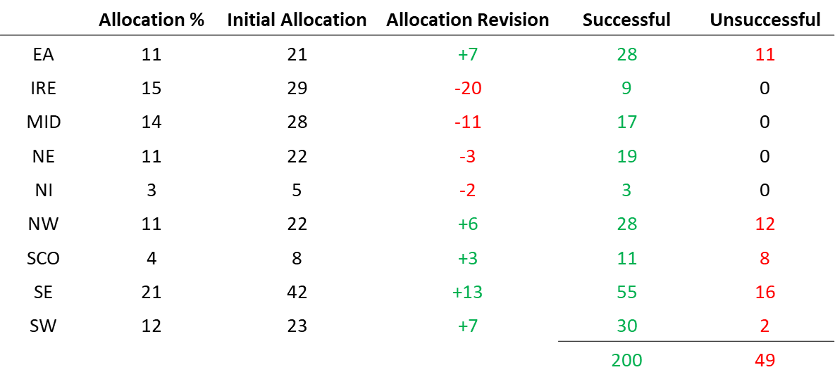
Fig. 2. Boxes allocated to each region.

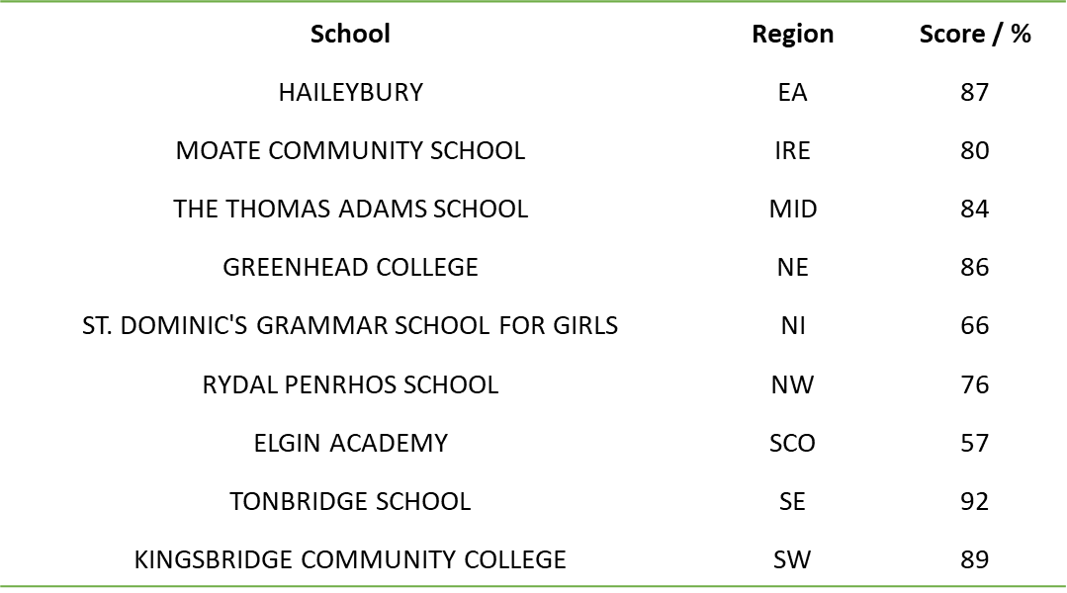
Fig. 3. Regional winners of SAC 2021.

Bursaries

Schools were asked to provide certain materials which it was prohibitively expensive to ship, but not particularly expensive to obtain (including nitric acid, hydrochloric acid, and barium chloride). For those that could not allocate school budgets to the competition we offered a £50 consumables bursary. Of the 50 bursaries approved in the budget only 14 were applied for. Two schools also asked for contribution for staff time but were told this was not available.

Feedback

Feedback from teachers has been entirely positive:

“Thanks so much for that. Great prizes! The students are delighted. Nice for them to get some recognition in a year where everything was cancelled. The whole class enjoyed the competition and it was definitely a more interesting way to cover the mandatory practicals!”

“The technicians and I were delighted with all the resources sent out and the clear instructions. It was a lot of fun!”

“I would like to say that this method of doing the competition would be fantastic for schools like us as a replacement longer term for the young analyst, as it means that more of our students can participate.”

“We finished our practical and the L6th honestly enjoyed it so much. I had forgotten what it feels like to see students do practicals for enjoyment. It was awesome.“

Future Competitions

Several teachers commented how they appreciated the opportunity to have more of their students involved in the competition, rather than just the single team they’re allowed to enter into the traditional SAC. There were two instances where academy trusts had entered teams from across their portfolio to use up all ten boxes and even one teacher stating that they would organise their own competition using our booklets in the event they were unsuccessful (they did receive a kit!). This competition format has been successful, has opened the competition to schools that have not interacted with us before, and I believe there are many schools interested in it carrying on in future.

SAC Heat Coordinators and the ‘Original Format’ Competition

Prior to the introduction of the schools-based competition I was a local heat organiser for the Newcastle area. As I personally have concerns about whether I could host a heat in my university’s labs this coming academic year, I sent out a single question to all 40 registered heat organisers: “If the Schools' Analyst Competition heats were to return for 2022, could you commit to hosting an in-person heat in your usual timeframe?” Of the 19 respondents, 11 selected “Yes, definitely” however the remaining 8 said “Perhaps, in a few months”.

In addition to the question, respondents were asked if they wish to provide any other comments for us to consider. A brief summary would be to say that some who wish to resume the heats are very keen to do so but there are also those who are cautious to commit too strongly to an outcome for this year given the continued uncertainty.

Given the effort that goes into organising the heats, the considerable expense that goes into organising the national final, combined with the continued uncertainty about how we will be affected by the pandemic this winter, a recommendation was made to AD Council that for 2022 we retain the in-school competition and postpone the national competition for one additional year. While I’m sure this will disappoint some, I believe we still have an opportunity for an extensive competition with real impact on student enjoyment of chemistry.

SAC 2022 Proposal

Due to the popularity of the 2021 in-school competition, over the summer I developed a new competition for 2022 around the topic of phytomining. The plan for this competition was to deliver electronic equipment to schools for them to create their own DIY colorimeters (see fig. 5) and to then analyse samples of plants used in phytomining to determine their metal content among other tasks.
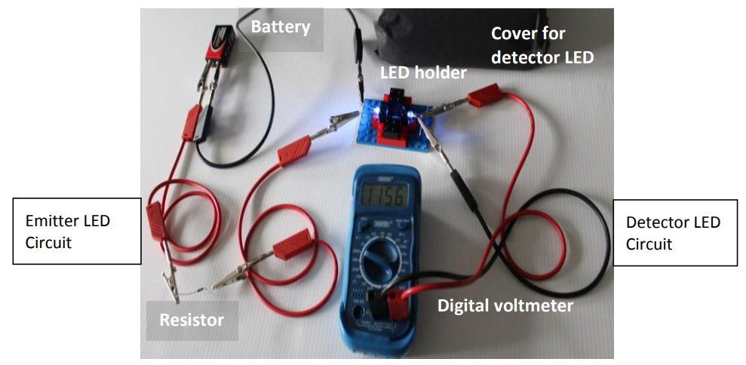
Fig. 5. A DIY colorimeter made from a digital multimeter, LEDs, and Lego! Image from CLEAPSS.

Sadly, this idea has been significantly affected by global supply chain issues and I can no longer obtain all the components on time. Checking on lead times shows advanced notice of 4-6 months required for most items in the volume we need – which is certainly a shame, as it would have been a lot of fun! Instead, this coming year we will be asking the students to become food analysts tasked with finding the perfect formula for fish and chips! The advert is now live on RSC Events and registrations have already started to come in.

Positive changes: Team Numbers

In 2021 I asked schools to register to receive a box of equipment suitable for ten teams – a decision which was made to simplify the packaging of the kits. This did mean that a small minority of schools received fewer kits that they would have liked, however for those that received an excess, some of this extra kit was used to support the learning of other students (including talented year 11 students in a few cases). This year we will keep the default ’10 teams per kit’ packaging as this excess kit does find a home. Sadly, due to the complexity of different postage rates for larger boxes I would not offer more than ten kits to larger schools.

Positive changes: School Numbers

Armed with the experience of the 2021 competition and the positive feedback received, we are expanding the number of schools that can participate from 200 to 300. Distribution will be by the 2021 model, with numbers of boxes sent to each region decided by population, and excess capacity shared out among the over-subscribed regions.

Positive changes: Prizes

In 2021 the initial proposal included prizes for each school in addition to a regional competition, however a revision to the RSC budget necessitated removing the school prize and retaining just the regional prizes. School winners each received a certificate to acknowledge their local success, with regional winners each receiving £50 of Amazon vouchers and a £500 prize for the school. This revised budget will remain for 2022 as the schools were thrilled to simply participate, and the local winner prizes were not missed. Regional winners will still be acknowledged with a larger prize.

Bursaries

Despite offering £50 bursaries to the 200 schools registered in the 2021 competition, only 14 schools registered to receive one. In this competition schools will again need to provide items that they may not have costed for, so we will retain a budget for up to 50 bursaries.

Dates for SAC 2022

Schools will be able to register interest until Sunday 27th March, with kits delivered by Monday 25th April for a post-Easter competition. Results will be sent to schools by 31st May.

Dr Graeme Turnbull
Northumbria University
10th November 2021

From personal experience, state schools typically take longer to obtain approval for changes to timetables and teacher cover. This decision was made to improve equality of access to the competition.

