Supplementary data
Magnetic force-based multiplexed immunoassay using superparamagnetic nanoparticles in microfluidic channel

Kyu Sung Kim and Je-Kyun Park*
Department of BioSystems, Korea Advanced Institute of Science and Technology (KAIST),
373-1 Guseong-dong, Yuseong-gu, Daejeon 305-701, Korea
E-mail address: jekyun@kaist.ac.kr

The magnetic fields outside a rectangular magnet were determined by following eqs¹:

$B_{x}(x,y,z)=\frac{μ_{0}M_{s}}{4π}\sum_{k=1}^{2}{\sum_{m=1}^{2}{(−1)^{k+m}\text{ln}[\frac{(y−y_{1})+[(x−x_{m})^{2}+(y−y_{1})^{2}+(z−z_{k})^{2}]^{1/2}}{(y−y_{2})+[(x−x_{m})^{2}+(y−y_{2})^{2}+(z−z_{k})^{2}]^{1/2}}]}}$ (1) $B_{y}(x,y,z)=\frac{μ_{0}M_{s}}{4π}\sum_{k=1}^{2}{\sum_{m=1}^{2}{(−1)^{k+m}\text{ln}[\frac{(x−x_{1})+[(x−x_{1})^{2}+(y−y_{m})^{2}+(z−z_{k})^{2}]^{1/2}}{(x−x_{2})+[(x−x_{2})^{2}+(y−y_{m})^{2}+(z−z_{k})^{2}]^{1/2}}]}}$ (2)

where B_{x} and B_{y} is magnetic field in the direction of x-axis and y-axis, respectively, μ₀ is the vacuum permeability, M_{s} is a magnetization of the magnet and (x₁, x₂), (y₁, y₂) and (z₁, z₂) denote the positions of the edges of the magnet with respect to the x-, y-, z-axes. The magnet is magnetization along z-axis. The magnetic fields and magnetic field gradients were evaluated using above eq 1 and eq 2 using MATLAB (The MathWorks, MA). We set x₁ = -50, x₂ = 0, y₁ = 0, y₂ = 25, z₁ = 0, z₂ = 10 mm and M_{s} = 9.0 × 10⁶ A m⁻¹ (Fig. 1a). As shown in Fig. 1b and 1c, we evaluate B_{x} and B_{y} across a surface from (1, 0) to (7, 25) at z = 1 mm. The magnetic fields were over 0.2 T. These values were enough to saturate magnetization of iron oxide magnetic nanoparticles.²⁻⁴ Therefore, the velocities of microbeads conjugated with magnetic nanoparticles are proportional to the magnetic field gradient, ∇B. The magnetic field gradients, dB_{x}/dx at y = 10 mm and dB_{y}/dy at x = 2 mm, were calculated. As shown in Fig. 1d and 1e, the magnetic field gradient along y-axis, dB_{y}/dy, is much less than the magnetic field gradient along x-axis, dB_{x}/dx. Therefore, the effect of the magnetic field gradient along y-axis, dB_{y}/dy, could be nearly ignored.
References

1 E. P. Furlani, Permanent Magnet & Electromechanical Devices: Materials, Analysis, and Applications, Academic Press, San Diego, 2001.
2 M. D. Mukadam, S. M. Yusuf, P. Sharma and S. K. Kulshreshtha, J. Magn. Magn. Mater., 2004, 272-276, 1401-1403.
3 Z. Z. Xu, C. C. Wang, W. L. Yang, Y. H. Deng and S. K. Fu, J. Magn. Magn. Mater., 2004, 277, 136-143.
4 D. K. Kim, Y. Zhang, W. Voit, K. V. Rao and M. Muhammed, J. Magn. Magn. Mater., 2001, 225, 30-36.

(a)
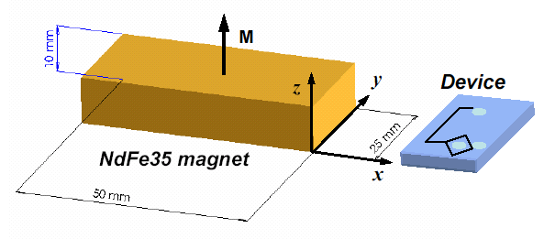
(b) (c)
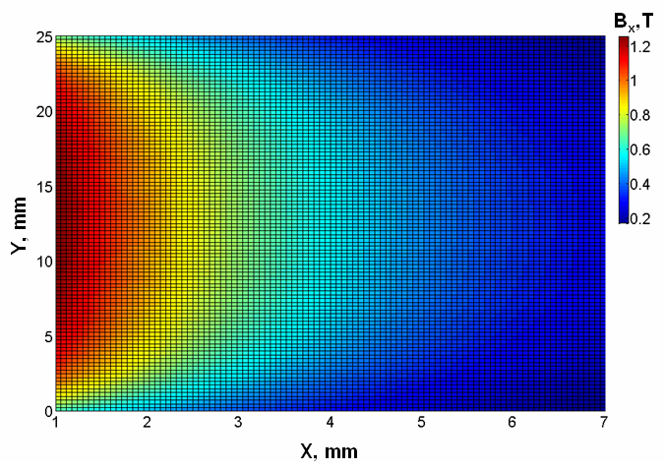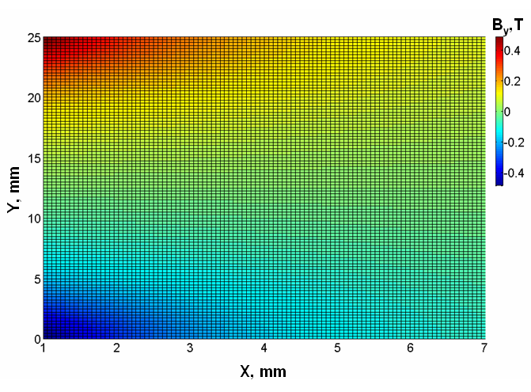
(d) (e)
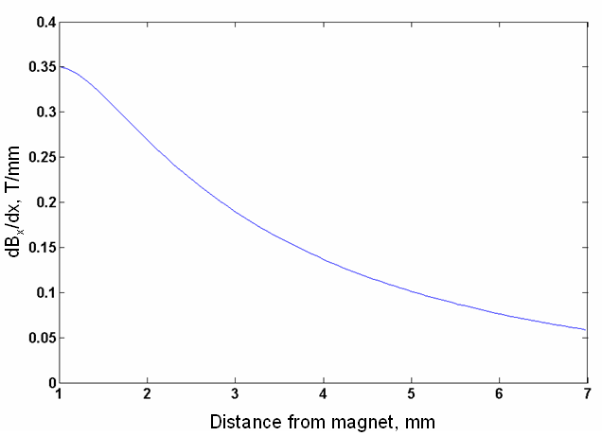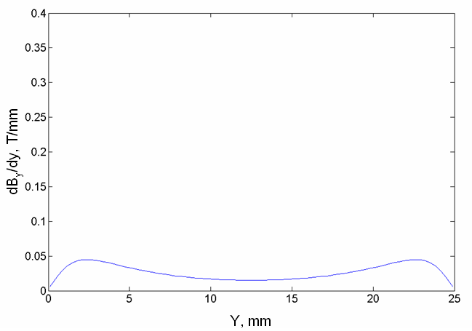
Fig. 1 (a) Scheme of a NdFe35 permanent magnet and the location of a microfluidic device from the permanent magnet. (b) The evaluated magnetic field along x-axis by NdFe35 permanent magnet across a surface from (1, 0) to (7, 25) at z = 1 mm. The channel of microfluidic device was aligned from y = 7.5 mm to y = 12.5 mm at x = 1, 2, 3, 4, 5, 6, 7 mm and z = 1 mm. (c) The evaluated magnetic field along y-axis by NdFe35 permanent magnet across a surface from (1, 0) to (7, 25) at z = 1 mm. The channel of microfluidic device was aligned from y = 7.5 mm to y = 12.5 mm at x = 1, 2, 3, 4, 5, 6, 7 mm and z = 1 mm. (d) Calculated values of the magnetic field gradient in the x-direction, dB_{x}/dx, at y = 10 mm and z = 1 mm. (e) Calculated values of the magnetic field gradient in the y-direction, dB_{y}/dy, at x = 2 mm and z = 1 mm.

