This Journal is © The Royal Society of Chemistry 2003

Supplementary Information for Article B212509A-The Analyst

The present supplement shows the relative content of the 14 aminoacids that have been quantitatively determined according to the procedure described in section 2.2 of the paper.

The data are separately shown by category and also they are shown together with the old samples.

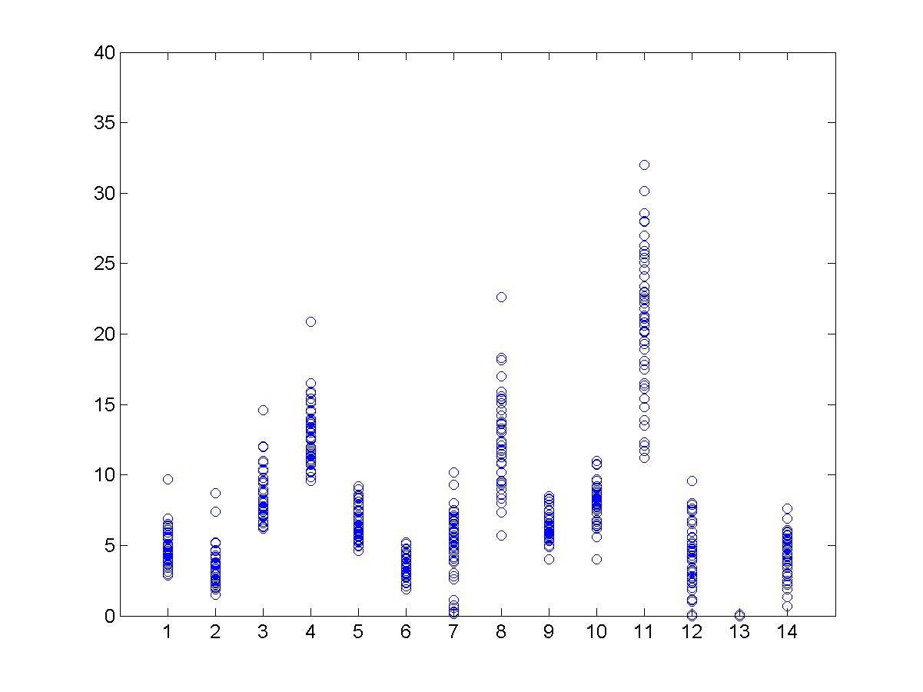
Figure S1. Relative percentage content of 14 amino acids. Training samples of the category 1 (casein).

Codification abscissa axis:
1, alanine. 2 glycine. 3 valine. 4 leucine. 5 isoleucine. 6 serine. 7 tyrosine,
8 phenylalanine. 9 aspartic acid. 10 glutamic acid. 11 lysine. 12 methionine.
13 proline. 14 hydroxyproline

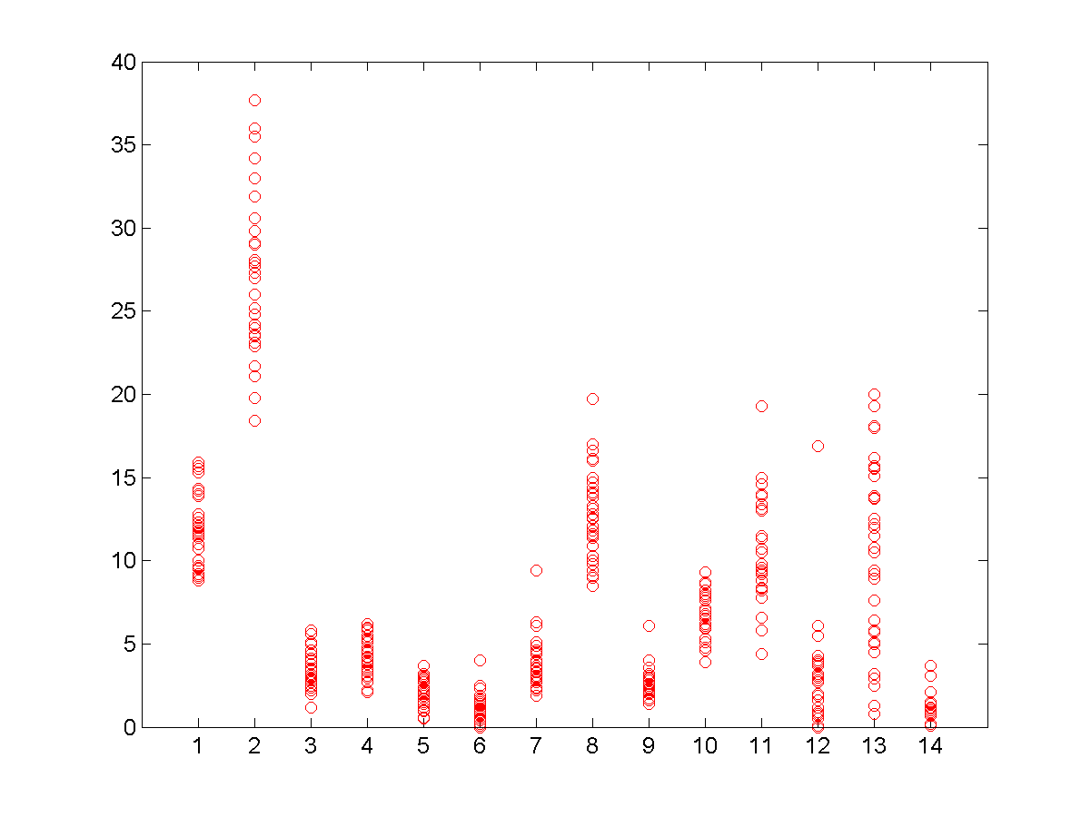
Figure S2. Relative percentage content of 14 amino acids. Training samples of the category 2 (animal glue).

Codification abscissa axis:
1 alanine. 2 glycine. 3 valine. 4 leucine. 5 isoleucine. 6 serine. 7 tyrosine.
8 phenylalanine. 9 aspartic acid. 10 glutamic acid. 11 lysine. 12 methionine.
13 proline. 14 hydroxyproline

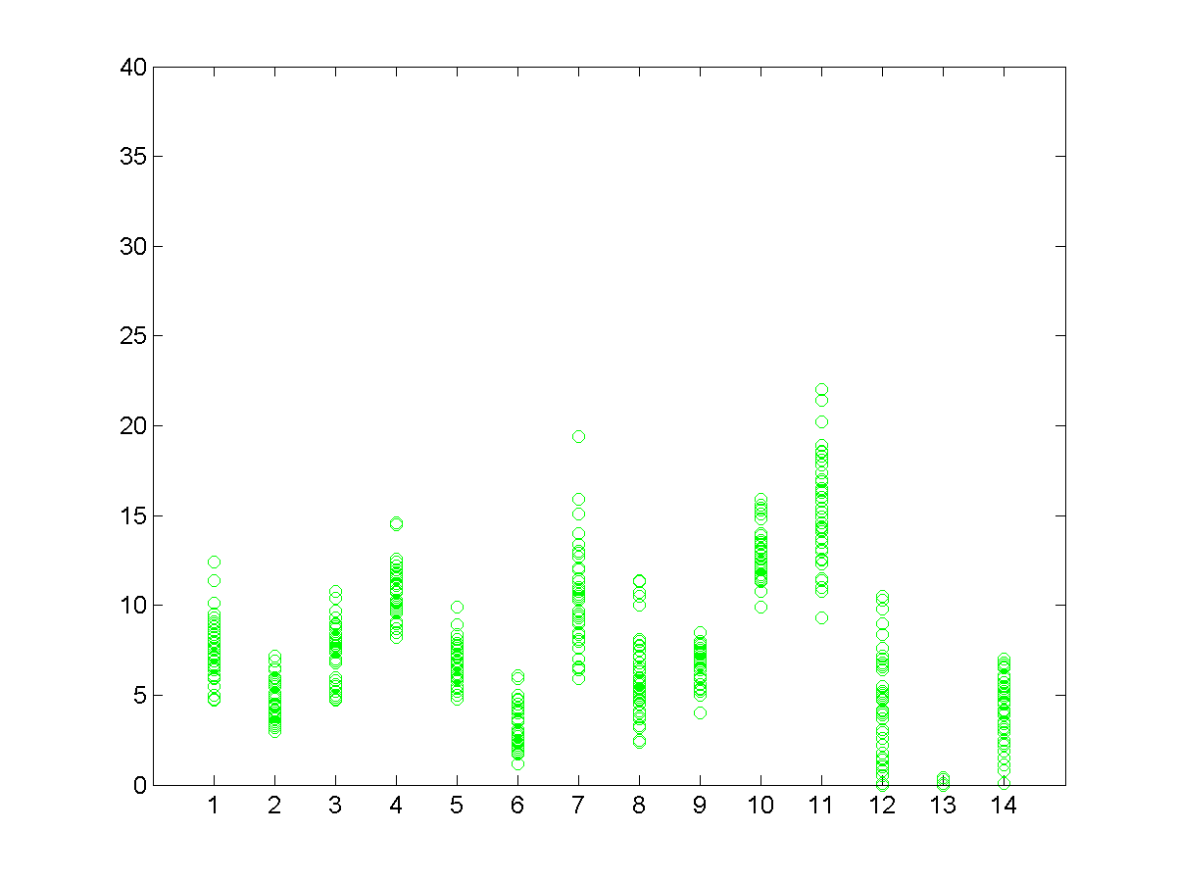
Figure S3. Relative percentage content of 14 amino acids. Training samples of the category 3(egg).

Codification abscissa axis:
1, alanine. 2 glycine. 3 valine. 4 leucine. 5 isoleucine. 6 serine. 7 tyrosine,
8 phenylalanine. 9 aspartic acid. 10 glutamic acid. 11 lysine. 12 methionine.
13 proline. 14 hydroxyproline

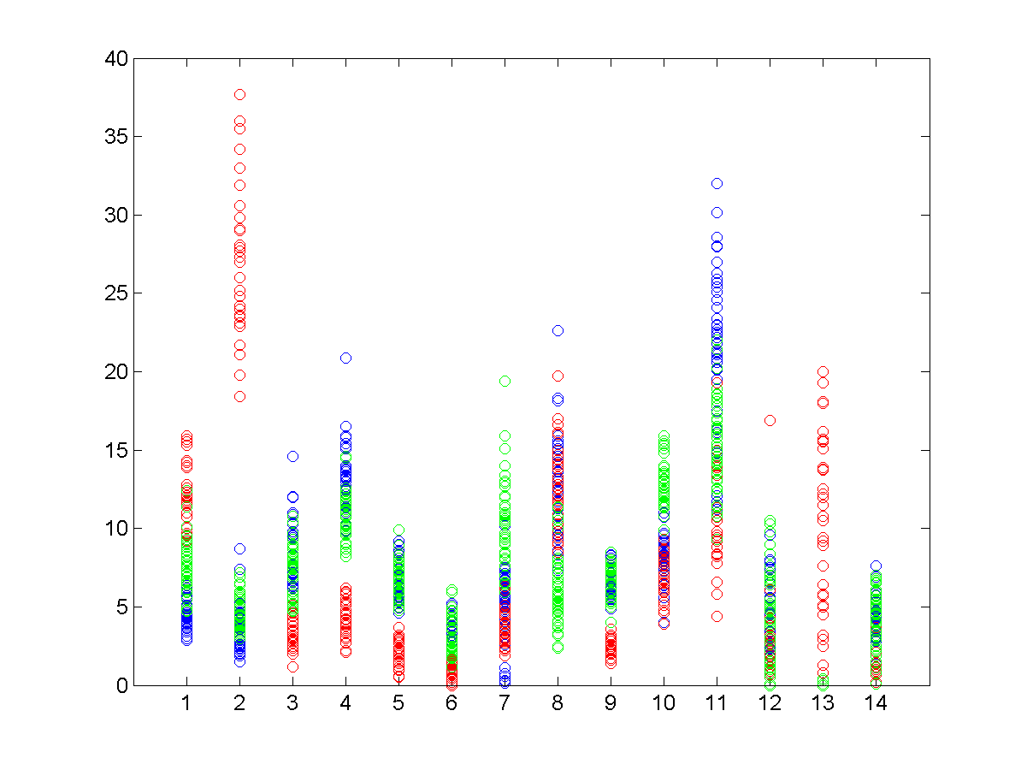
Figure S4. Relative percentage content of 14 amino acids. Training samples of the three categories. The colour of the figures 1, 2 and 3 is the same (blue, red and green for caseine, animal glue and egg respectively).

Codification abscissa axis:
1, alanine. 2 glycine. 3 valine. 4 leucine. 5 isoleucine. 6 serine. 7 tyrosine
8 phenylalanine. 9 aspartic acid. 10 glutamic acid. 11 lysine. 12 methionine.
13 proline. 14 hydroxyproline

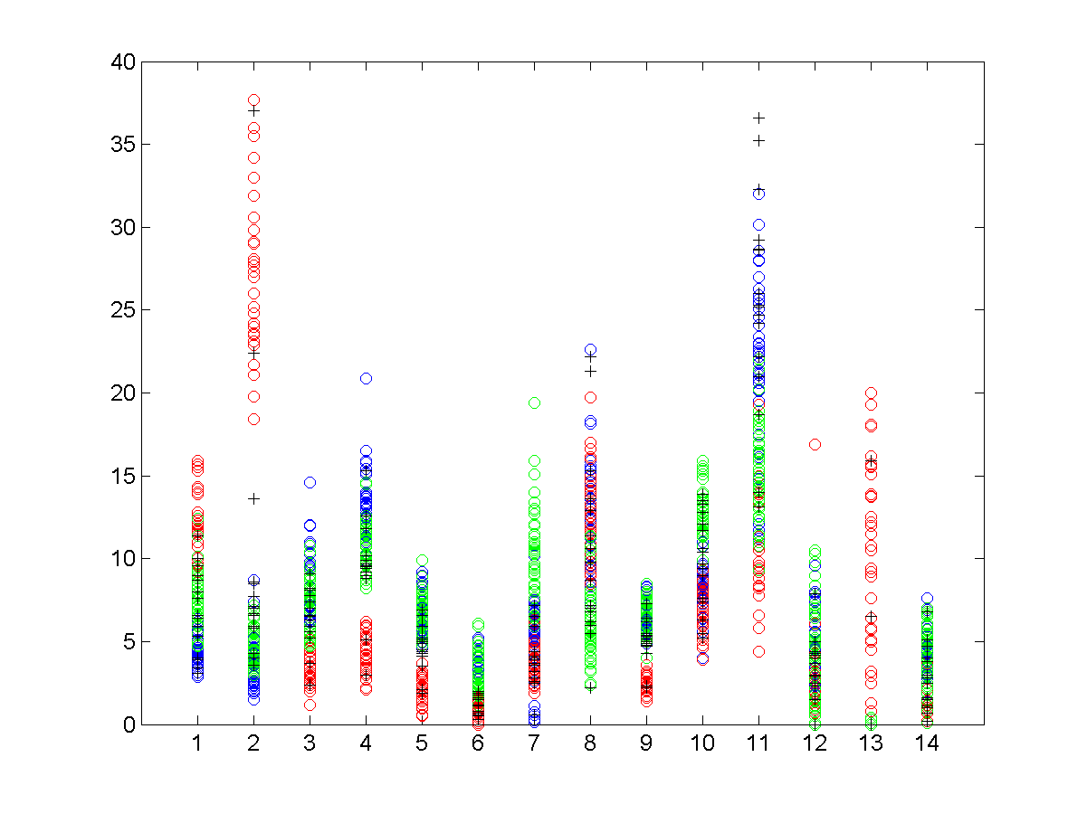

Figure S5. Relative percentage content of 14 amino acids. Training samples (coloured circles) and old samples (black cruises).

Codification abscissae axis:
1 alanine. 2 glycine. 3 valine. 4 leucine. 5 isoleucine. 6 serine. 7 tyrosine.
8 phenylalanine. 9 aspartic acid. 10 glutamic acid. 11 lysine. 12 methionine.
13 proline. 14 hydroxyproline

