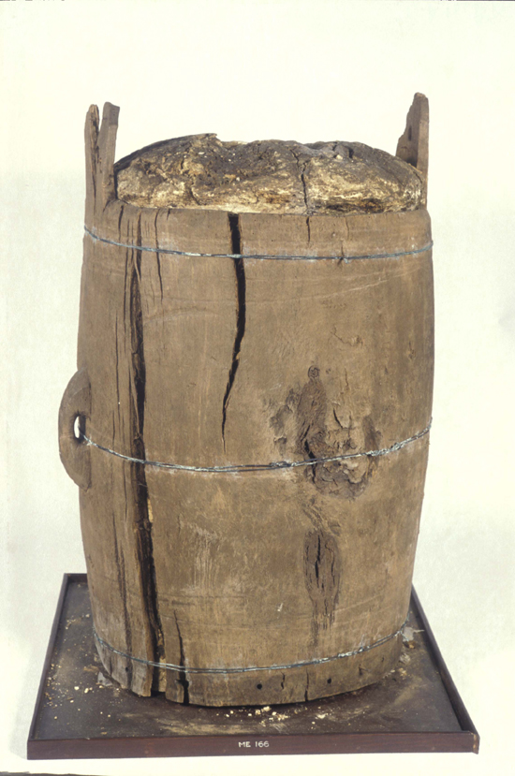

Image of bog butter barrel, ca. 1.4 m high, found at Glen Gell, Morven (object number ME166). Image copyright of Trustees of the National Museums of Scotland.

