Supplementary Data

A colourimetric calix[4]pyrrole–4-nitrophenolate based anion sensor

Philip A. Gale,*^{ab} Lance J. Twyman,*^{c} Cristin I. Handlin^{c} and Jonathan L. Sessler^{d}

ª Department of Chemistry, University of Southampton, Southampton, UK SO17 1BJ
^{b} Department of Chemistry, University of Oxford, Inorganic Chemistry Laboratory, South Parks Road, Oxford, UK OX1 3QR
^{c} The Polymer Centre, School of Physics and Chemistry, University of Lancaster, Lancaster, UK LA1 4YA
^{d}Department of Chemistry and Biochemistry, The University of Texas at Austin, Austin, Texas 78712-1167, USA
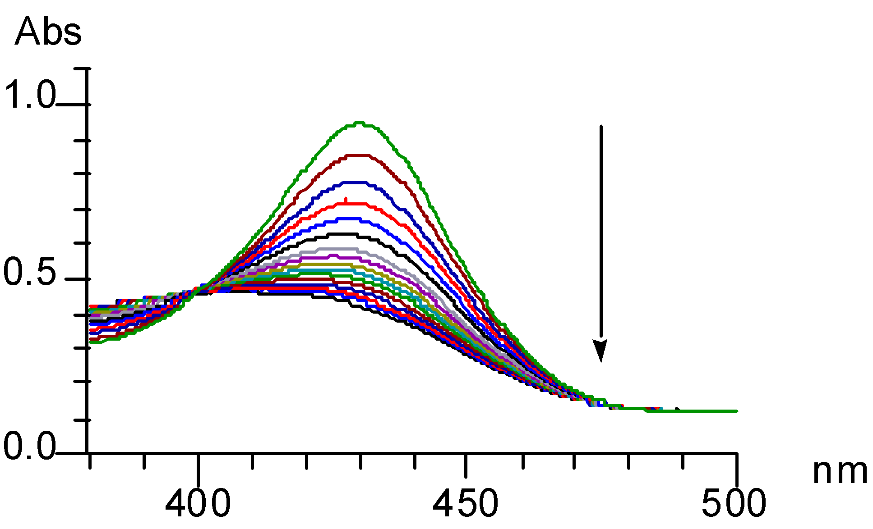

Supplementary Figure 1 Decreasing absorbance of the 4-nitrophenolate anion 2 (3.6 × 10⁻⁵ mol dm⁻³) upon addition of calixpyrrole 1 (5 × 10⁻² mol dm⁻³) in dichloromethane at 25 ˚C.
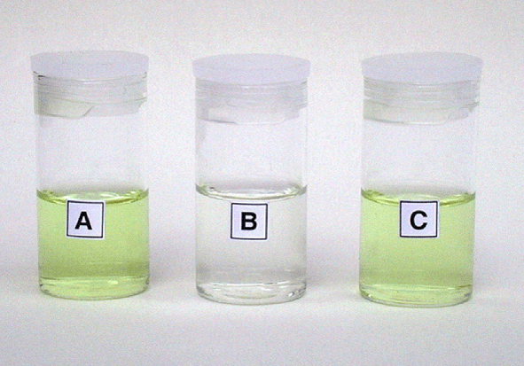

Supplementary Figure 2 Solutions (CH₃CN–CH₂Cl₂ 24:1 v/v) of (A) tetrabutylammonium 4-nitrophenolate 2 (1.3 × 10⁻⁵ mol dm⁻³), (B) meso-octamethylcalix[4]pyrrole 1 (2.3 × 10⁻⁴ mol dm⁻³) and tetrabutylammonium 4-nitrophenolate 2 (1.3 × 10⁻⁵ mol dm⁻³), and (C) meso-octamethylcalix[4]pyrrole 1 (2.3 × 10⁻⁴ mol dm⁻³), tetrabutylammonium 4-nitrophenolate 2 (1.3 × 10⁻⁵ mol dm⁻³) and tetrabutylammonium fluoride (7.7 × 10⁻⁴ mol dm⁻³).
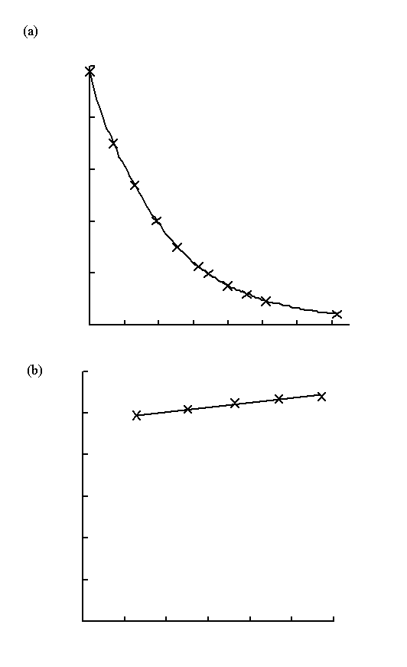
Supplementary Figure 3 UV/vis titration curves (a) 4-nitrophenolate + calixpyrrole
And (b) 4-nitrophenolate + pyrrole in dichloromethane (4-nitrophenolate concentration = 3.6 × 10⁻⁵ M)
Supplementary Figure 4 Experimental (crosses) and calculated (curve) NMR titration data for meso-octamethylcalix[4]pyrrole and tetrabutylammonium nitrophenolate in dichloromethane-d₂ at 25 °C.

