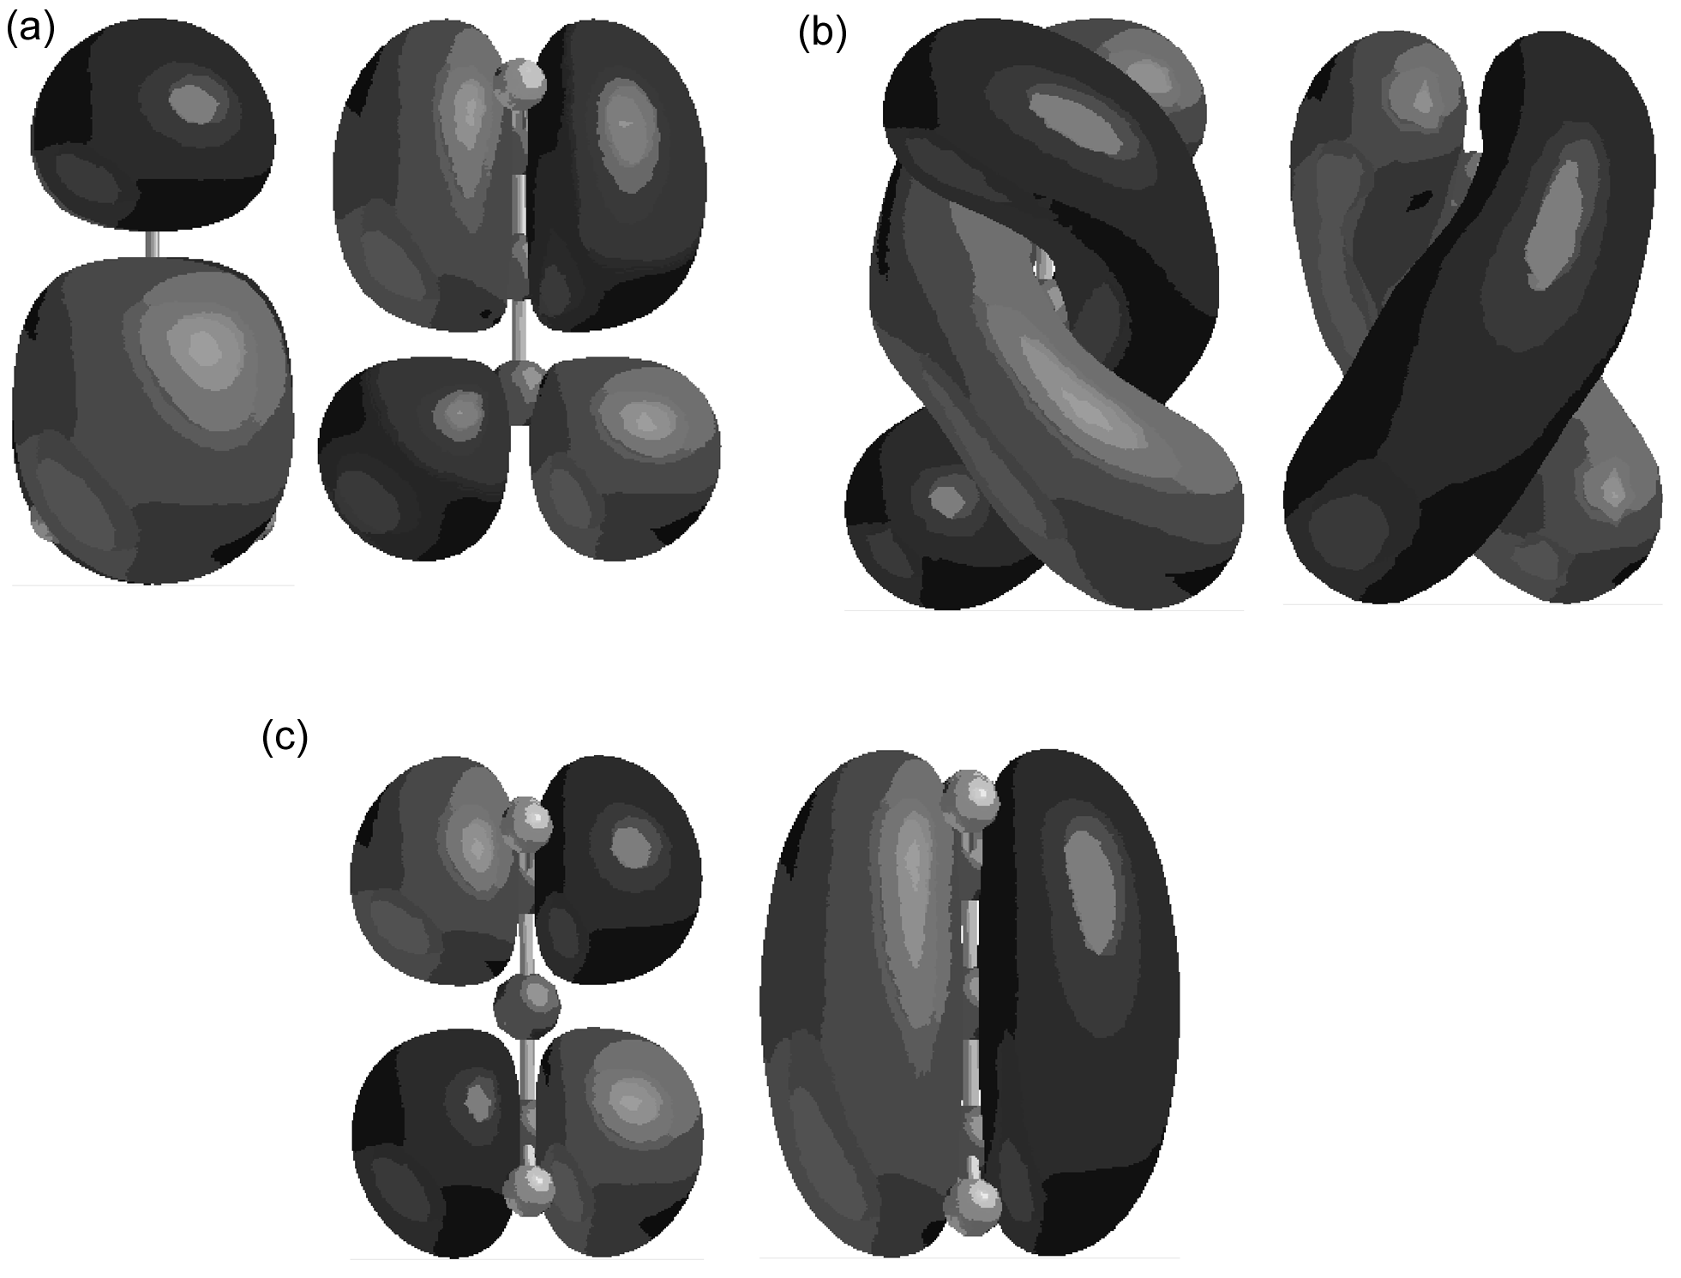

Fig. 1 AM1 allene orbitals (HOMO and HOMO - 1) as a function of the 1,3 dihedral angle being (a) 90º (degenerate, -10.1 eV), (b) 45º (-9.0, -11.2 eV), (c) 0º (-7.5, -12.5 eV).

