Chemical Communications

A New Approach for the Formation of the Alloy Nanoparticles: Laser Synthesis of Gold-Silver Alloy from Gold-Silver Colloidal Mixtures

(Electronic Supplementary Information)

Yu-Hung Chen and Chen-Sheng Yeh*

Department of Chemistry, National Cheng Kung University
Tainan, Taiwan 701, R.O.C

*Author to whom correspondence should be addressed. E-mail address: csyeh@mail.ncku.edu.tw Fax:+886-6-2740552

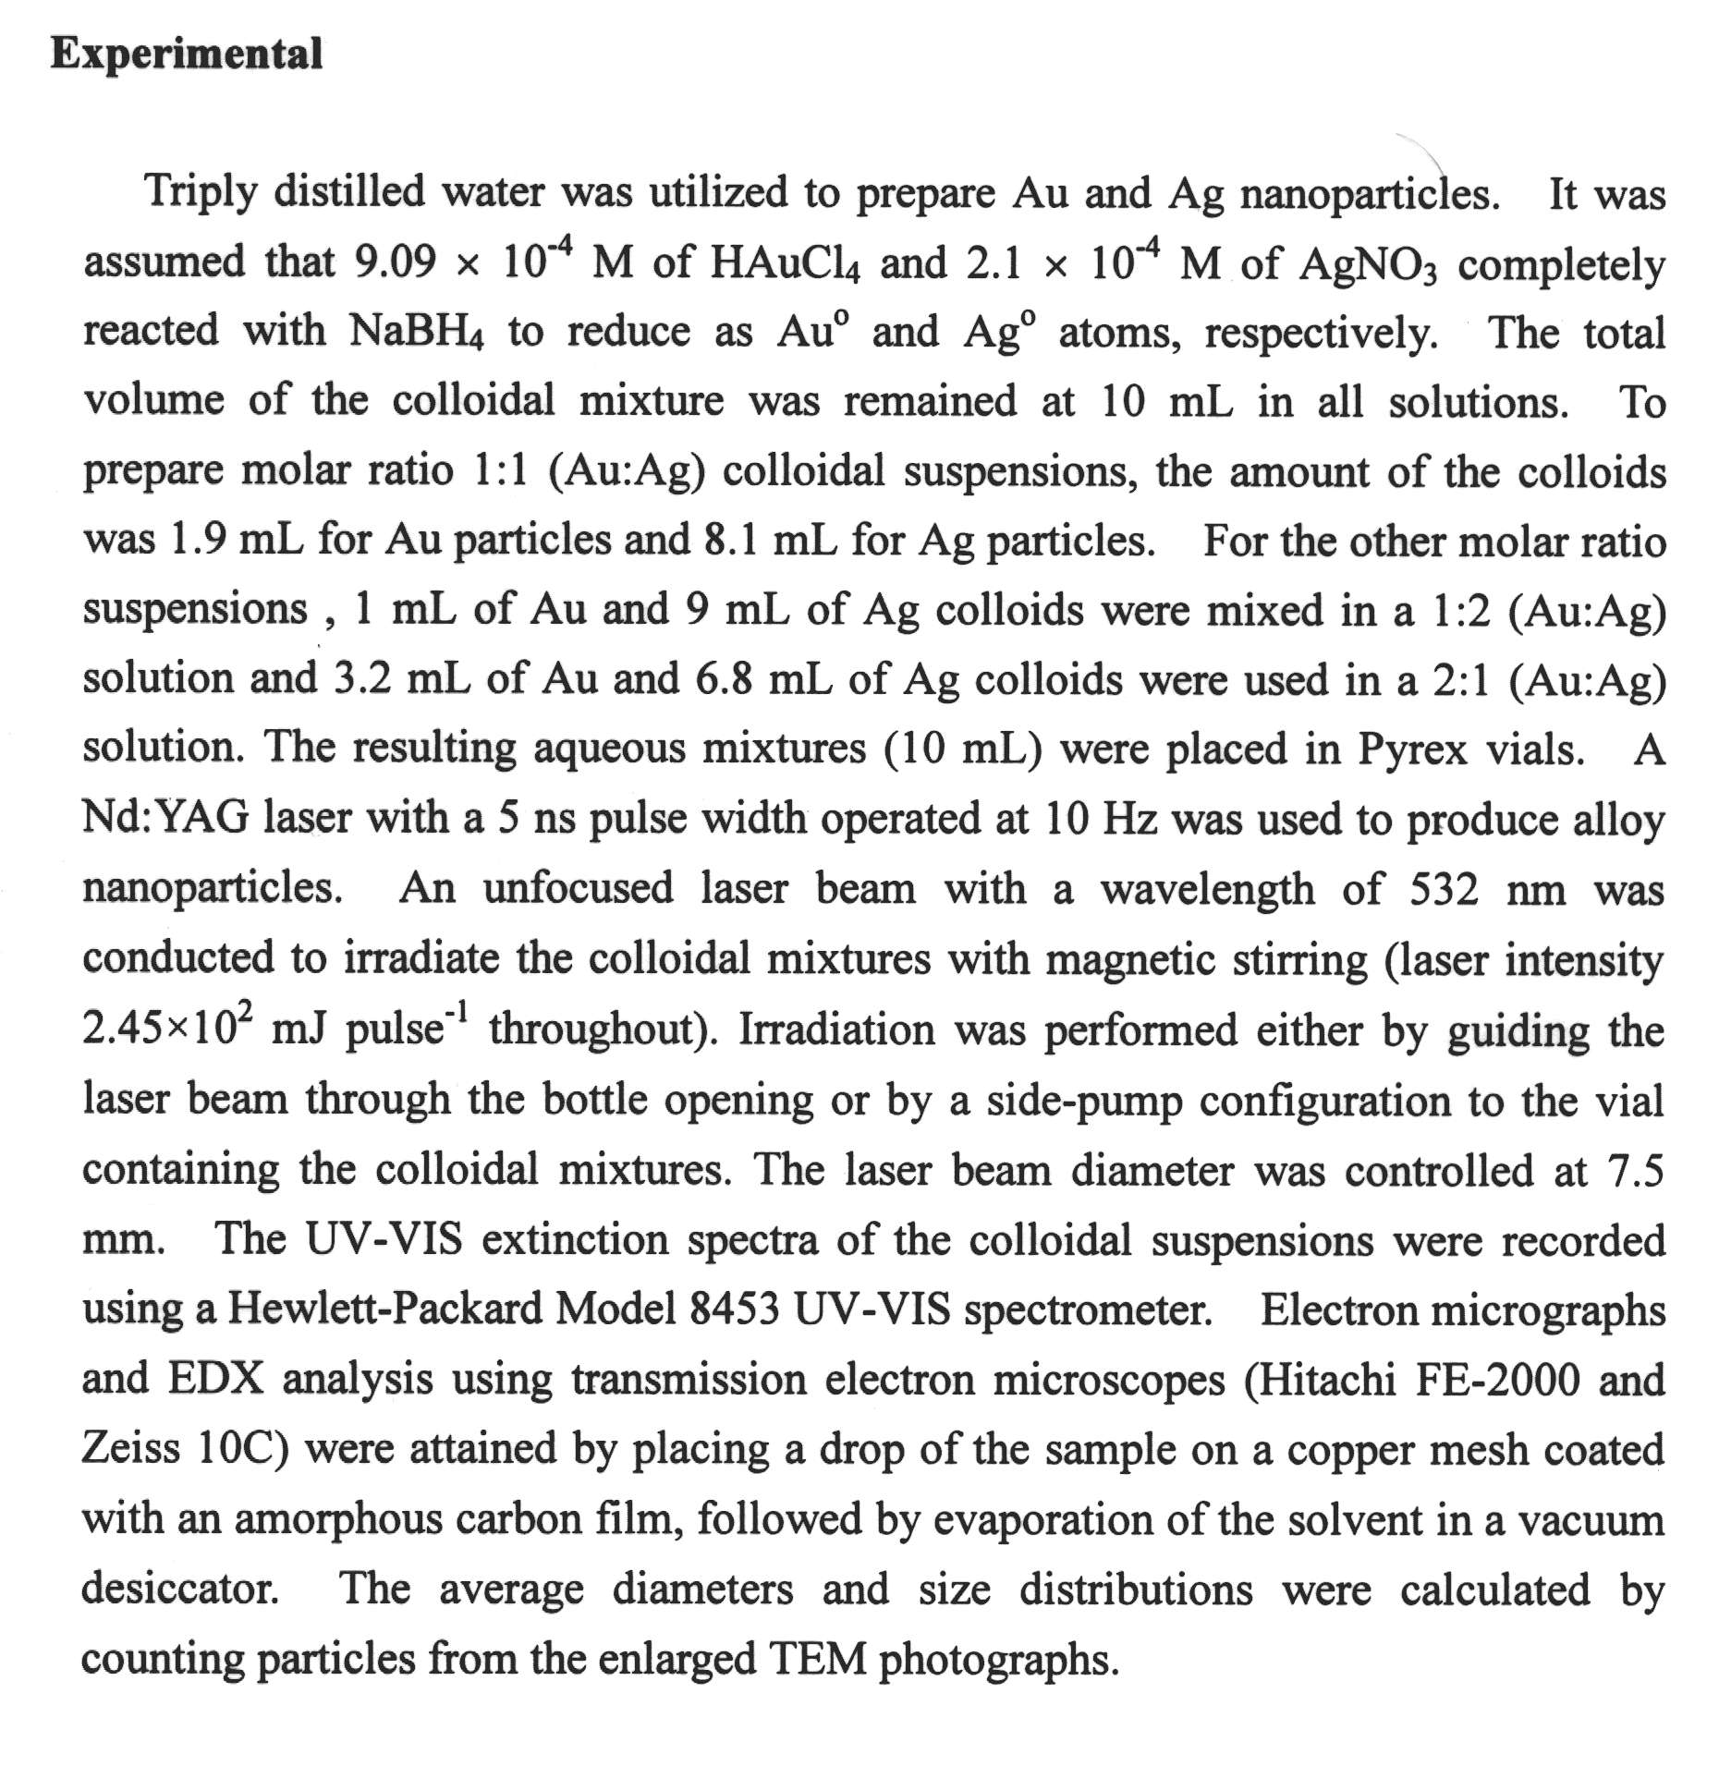

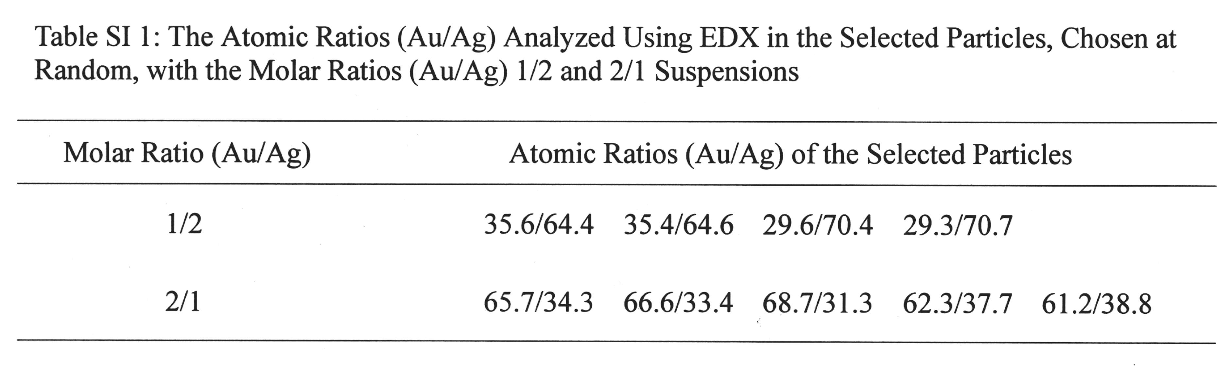

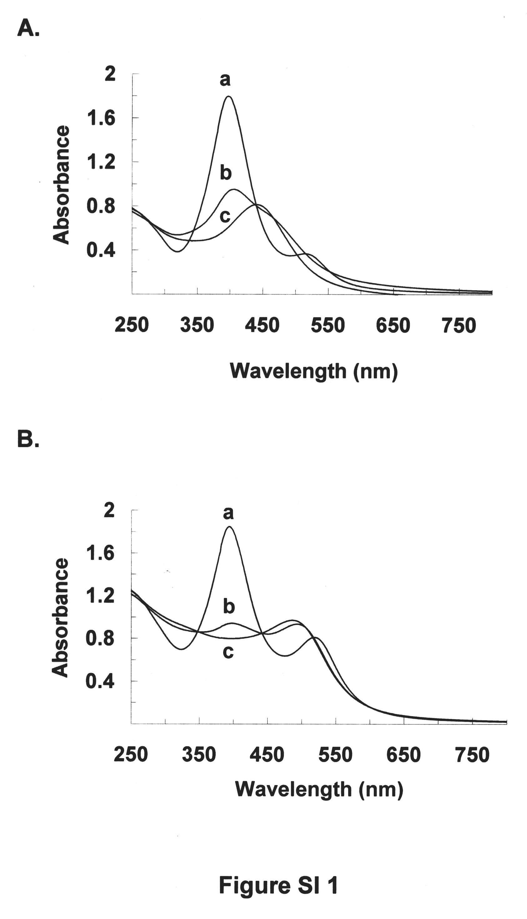

Figure SI 1: The Changes of the UV-vis absorption spectra as a function of the laser irradiation time with (A) 0 min (a), 5 min (b), and 25 min (c) in a molar ratio (Au/Ag) 1/2 suspension and (B) 0 min (a), 9 min (b), and 20 min (c) in a molar ratio (Au/Ag) 2/1 suspension. A 532 nm wavelength with laser intensity of 2.45 × 10² mJ/pulse was used to generate alloy nanoparticles.
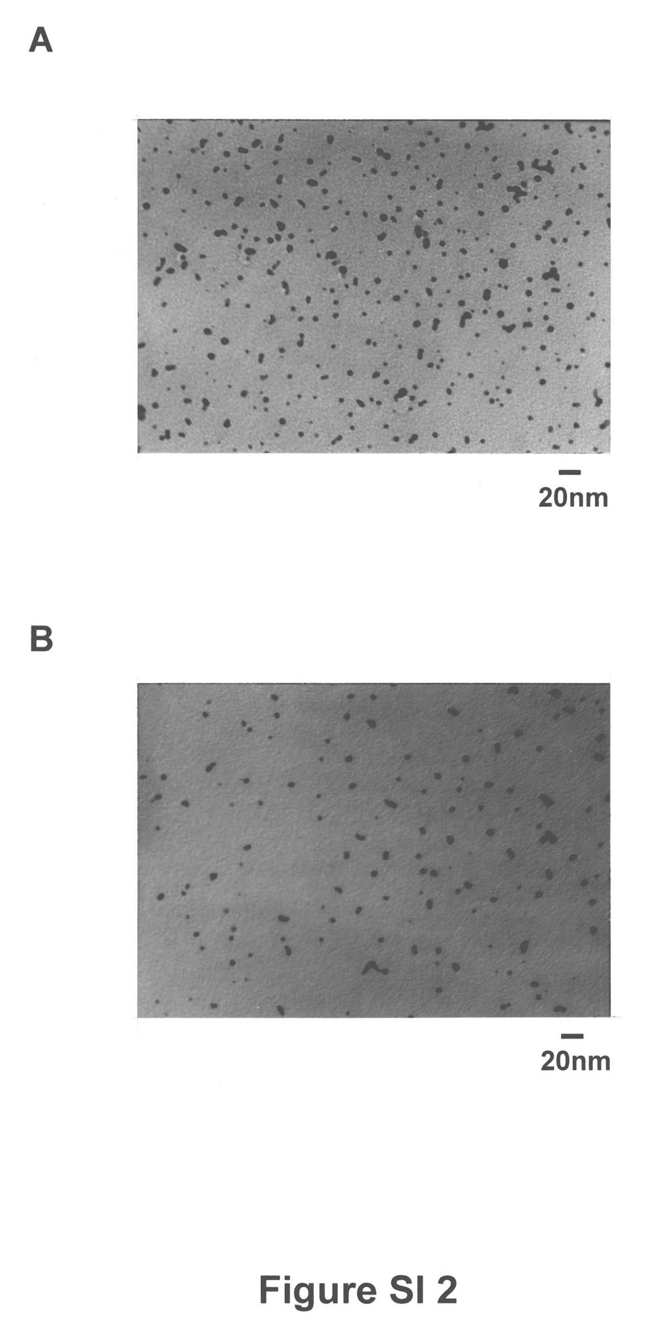
Figure SI 2: TEM images corresponding to the gold-silver alloy nanoparticles of (A) a molar ratio (Au/Ag) 1/2 suspension after exposure to the laser light for 30 min, and (B) a molar ratio (Au/Ag) 2/1 suspension after exposure to the laser light for 20 min.

