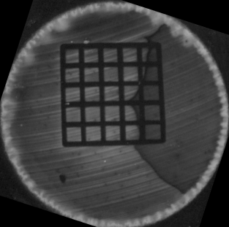
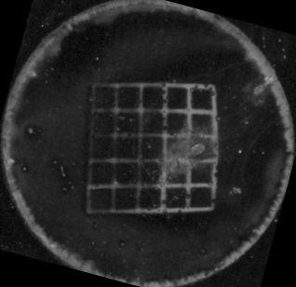
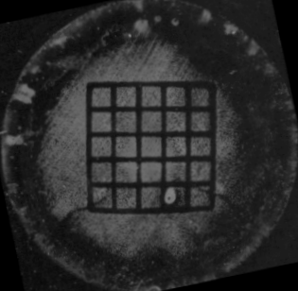
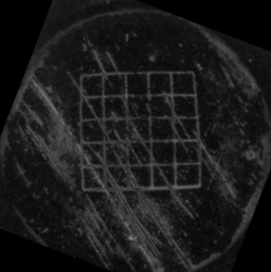
(a)
(b)
(c)
(d)
CeO₂
Cr₂O₃
n-type Si
p-type Si

Figure S1. Optical micrographs of the patterned CeO₂ [(a) and (b)] and Cr₂O₃ [(c) and (d)] films on n- and p-type Si. The diameter of the circular area is 1.0 cm. The light areas correspond to the metal oxide deposits while the dark areas underivatized Si surfaces.

