Supporting information:
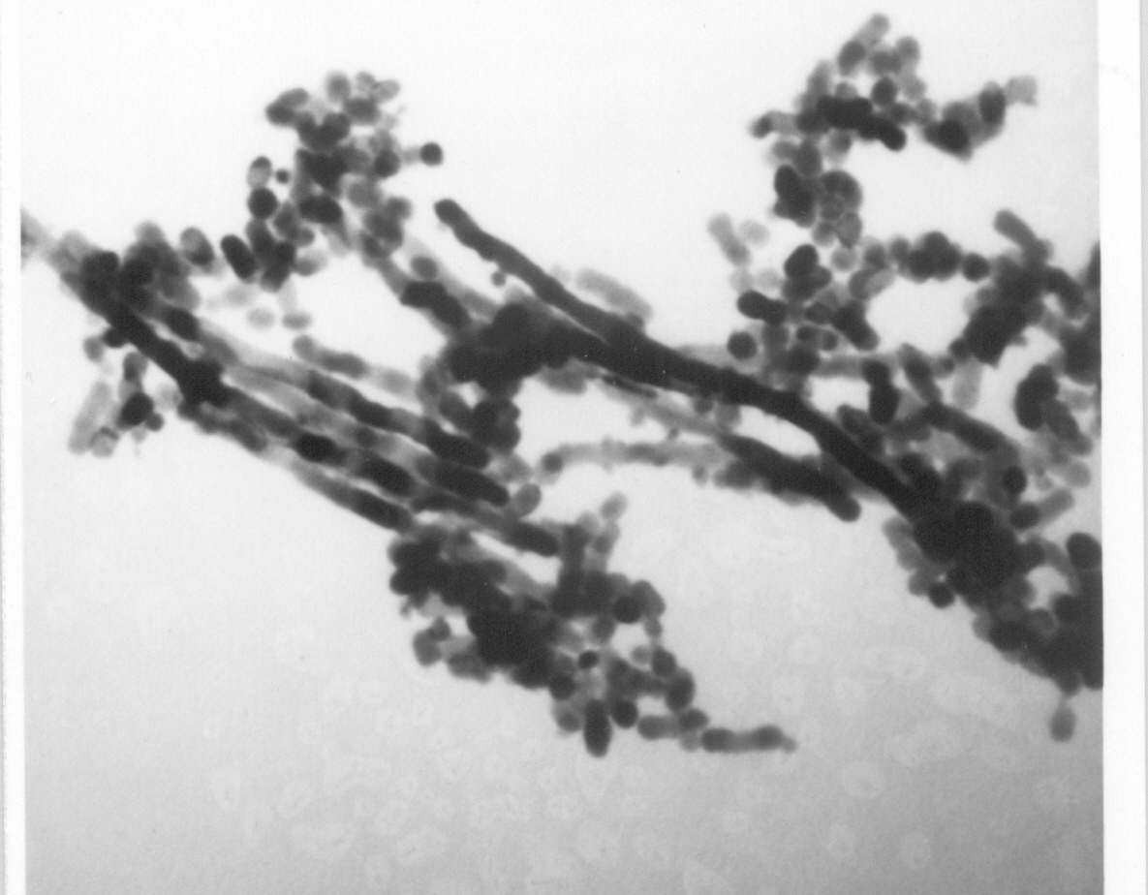
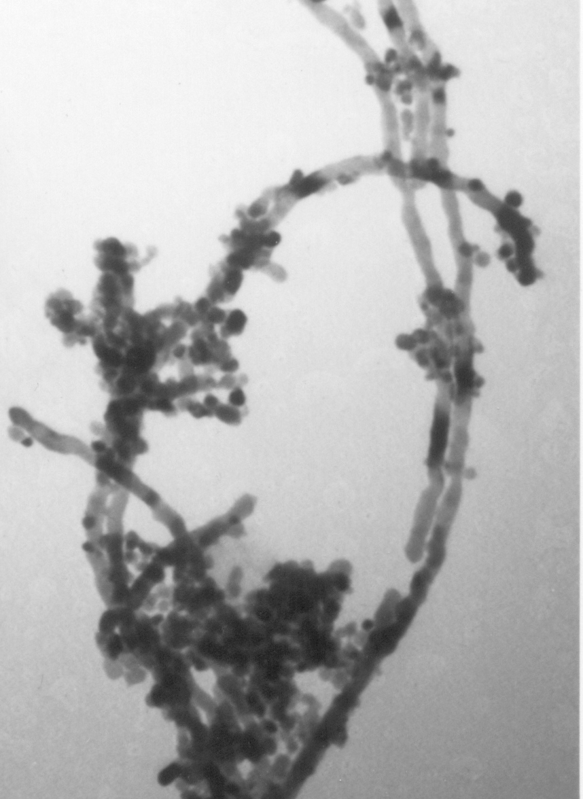

30 nm

30 nm

Fig. 1 Transmission electron micrographs for Pt-nanowires produced from micropore free SBA-15 framework

