Supplementary Material (ESI) for Chemical Communications
This journal is © The Royal Society of Chemistry 2002

Baylis-Hillman-Product:
Baylis-Hillman Product Reaction of Benzaldehyde and Methylacrylate [PhCH(OH)C(=CH2)COOMe]

Starting Materials:

Benzaldehyde PhCHO

Methylacrylate CH2=CH-COOMe

3-Hydroxyquinuclidine

Ionic Liquid (BMIM Cl)

Butylmethylimidazolium Chloride BMIM Cl CDCl3

Butylmethylimidazolium Chloride BMIM Cl CDCl3

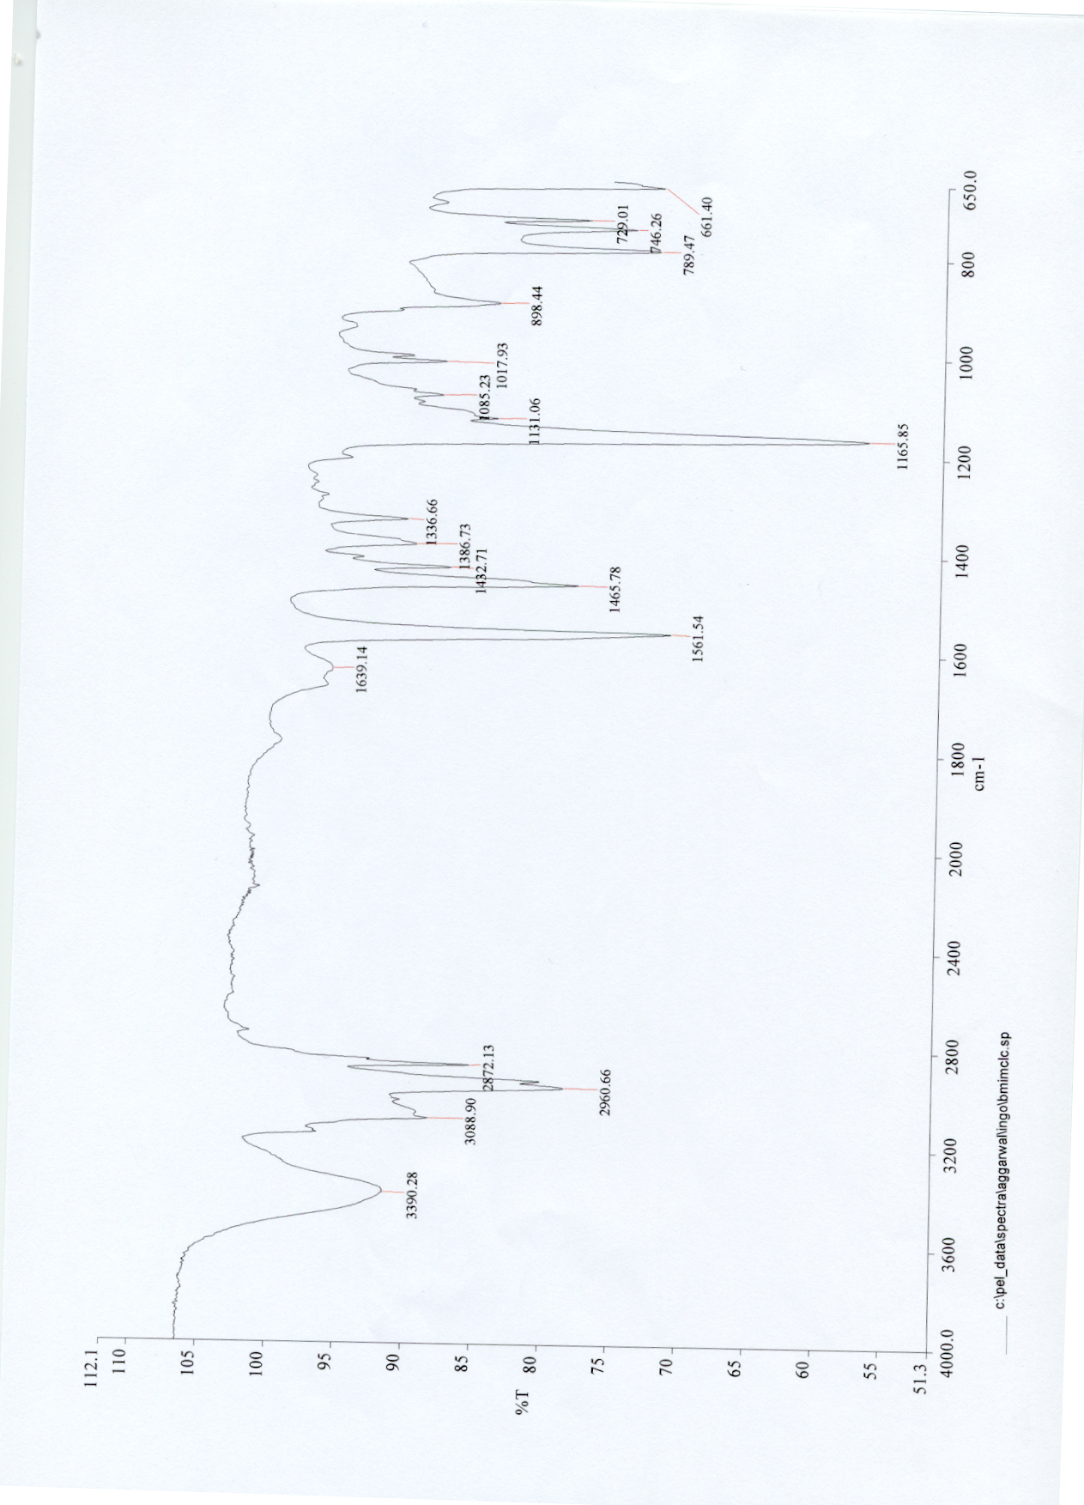
Butylmethylimidazolium Chloride BMIM Cl (contains water/compound very hygroscopic)

Converted Ionic Liquid [BMIM-CH(OH)Ph]Cl

Converted Ionic Liquid [BMIM-CH(OH)Ph]Cl CDCl3

Converted Ionic Liquid [BMIM-CH(OH)Ph]Cl d6-dmso

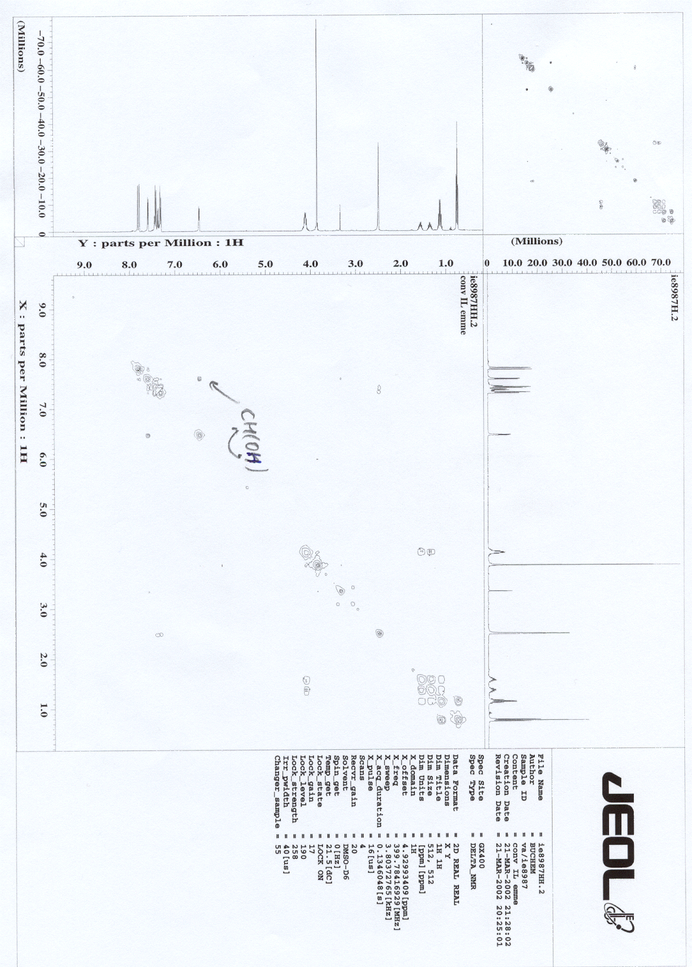

Converted Ionic Liquid [BMIM-CH(OH)Ph]Cl 13C and DEPT CDCl3

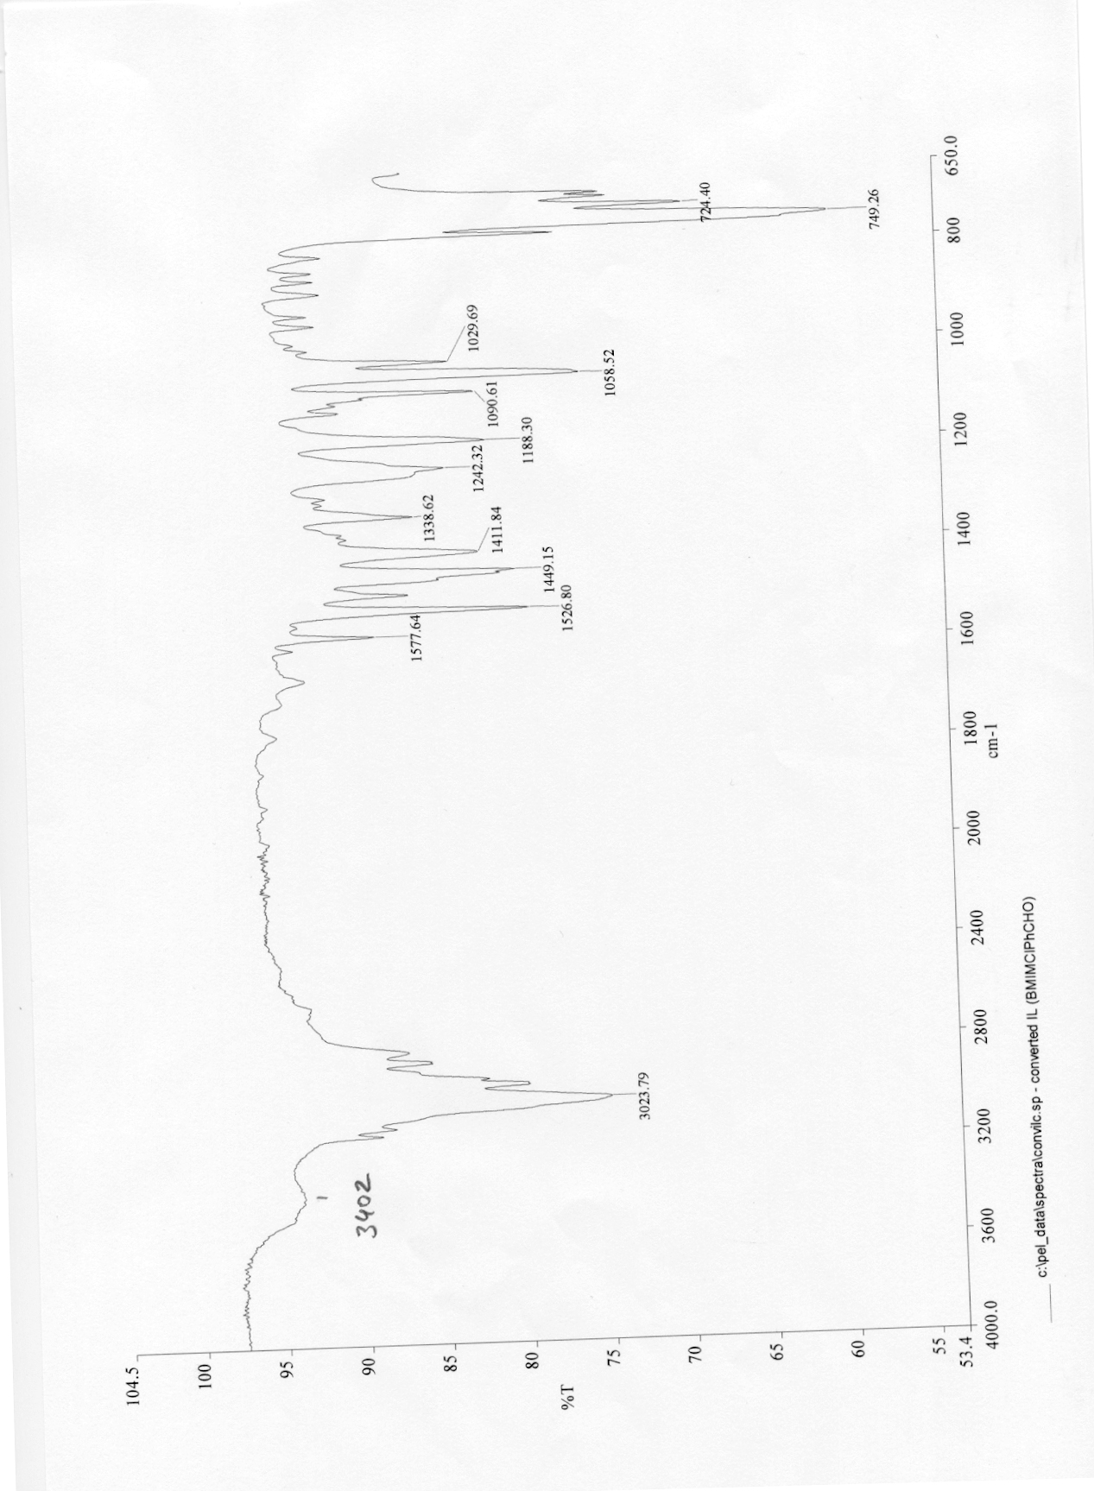
Converted Ionic Liquid [BMIM-CH(OH)Ph]Cl

Spectra Corresponding to Table 1

Tab1/Entry1: BHR of Benzaldehyde with Methyl Acrylate Catalysed by 3-HQD (0.2 eq) after 6 h at rt
- signal@7.9 = benzaldehyde, 2 H; // signal@6.35 = BH-Prod, 1 H // signal@2.7 = 0.2 eq. HQD, 4 H
conversion: [0.1185/ (1.789/2 + 0.1185)] = 0.117 ≈ 12% ; yield: 0.1185 ≈ 12%

Table 1/Entry 2: BMIMCl (0.5 eq), MA (1.2 eq.), BA (1 eq.), 3-HQD (0.1 eq).
signal@7.9ppm = benzaldehyde, 2 H; / @6.35ppm = BH-Prod, 1 H // @2.7ppm = 0.1 eq. HQD, 4 H.
conversion: [0.2469 / (0.2196 / 2 + 0.2469)] = 0.692 ≈ 69% ; yield: 0.2469 ≈ 25%.
Please notice: Triplet corresponding to BMIMCl @0.9ppm and from [BMIM-CH(OH)Ph]Cl @0.8ppm

Table 1/Entry 3: BMIMCl (0.5 eq), MA (1.2 eq.), BA (1 eq.), 3-HQD (0.2 eq).
signal@7.9 = benzaldehyde, 2 H; // signal@6.35 = BH-Prod, 1 H // signal@2.7 = 0.2 eq. HQD, 4 H.
conversion: [0.3591/ (0.1262 / 2 + 0.3591)] = 0.851 ≈ 85% ; yield: 0.3591 ≈ 36%.
Please notice: Triplet corresponding to BMIMCl @0.9ppm and from [BMIM-CH(OH)Ph]Cl @0.8ppm

Table 1/Entry 4: BMIMCl (0.5 eq), MA (1.2 eq.), BA (1 eq.), 3-HQD (0.5 eq).
signal@7.9 = benzaldehyde, 2 H; // signal@6.35 = BH-Prod, 1 H // signal@2.7 = 0.5 eq. HQD, 4 H.
conversion: [0.3672 / (0.1219 / 2 + 0.3672)] = 0.858 ≈ 86% ; yield: 0.3672 ≈ 37%.
Please notice: Triplet corresponding to BMIMCl @0.9ppm and from [BMIM-CH(OH)Ph]Cl @0.8ppm

Spectra Corresponding to Scheme 3
Cross-over Experiment (Scheme 3): left signal R = Ph ; right signal: R = C6H4OMe
(1 : 1.4)

Conditions employed by C.A.M. Afonso, Tetrahedron 2001, 57 (19), 4189-4193.

BMIMPF6: 200 μl (284.18 g/mol; 1.37 g/ml), 274 mg, 0.9642 mmol (0.482 eq.)
Methyl Acrylate: 2.2 mmol (86.09 g/mol; 0.956 g/ml), 189.4 mg, 198 μl
Benzaldehyde: 2.0 mmol (106.12 g/mol; 1.044 g/ml), 212.3 mg, 203 μl
DABCO: 2.0 mmol (120.18 g/mol), 240.4 mg

Integrations/Calculations

DABCO (used as internal standard): 0.193 per 12 H → 0.01608 per H

Baylis-Hillman-Product: 0.01123 per H → calc. yield: 0.01123/0.01608 = 70%

Ionic Liquid: 0.01278 (54%)
Converted Ionic Liquid: 0.01097 (46%)

0.9642 mmol × 46% = 0.444 mmol

Aldehyde Consumption: 1.4 mmol (= 70%) were converted into Baylis-Hillman Prod.
0.444 mmol were converted into Converted Ionic Liquid

