Electronic Supplementary Information

C-Cl / Si-H Exchange Catalysed by P,N-chelated Pt(II) Complexes

Frank Stöhr, Dietmar Sturmayr and Ulrich Schubert

Quantum chemical calculations
Quantum chemical calculations were carried out with the program package Gaussian98. The system was simplified by replacing the chelating ligand Ph₂PCH₂CH₂NMe₂ by NH₃ and PH₃ groups and the hydridosilane HSiMe₂Ph by SiH₄.
Geometry optimizations of the equilibrium geometries were performed using the B3LYP version of DFT. For the calculations the 6-31G++(d) basis set was used on all atoms, except platinum where the relativistic effective core potential and basis set SDD was used. All these basis sets are part of the Gaussian98 software package. Vibrational mode analyses were carried out to confirm that on potential energy surfaces optimized geometries correspond to a local minimum that has no imaginary frequency. Corrections of zero-point vibrational energies were taken into account in stationary structures obtained.

A) Total energy difference between products and reactants

The calculations refer to the catalytic cycle given in Scheme 1

Activation Step

Step 1

Step 2

B) Total energy of possible intermediates

Cl and PH₃ cis | Cl and PH₃ trans

H and PH₃ cis

C) Atomic coordinates of the calculated complexes after geometry optimization

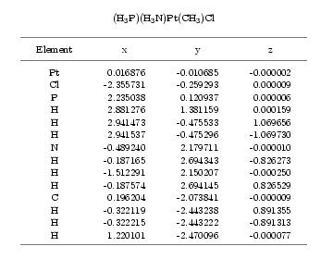

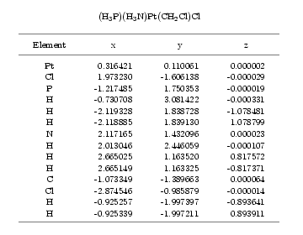

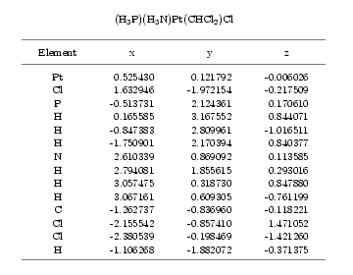

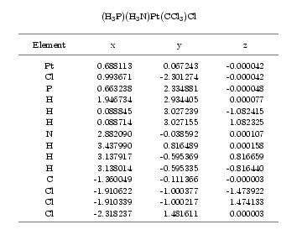

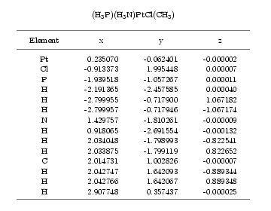

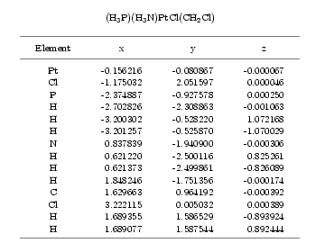

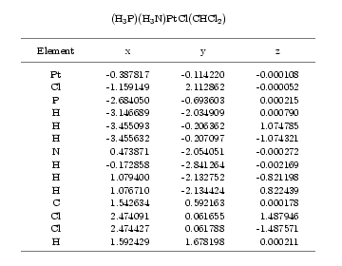

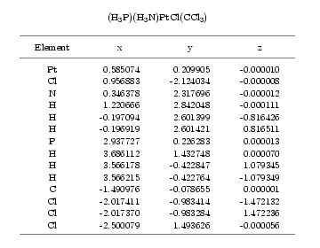

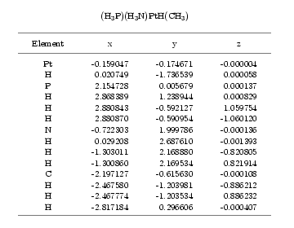

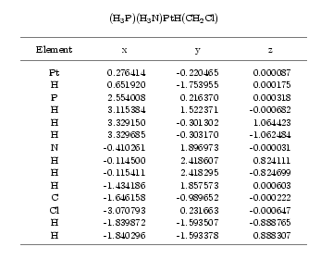

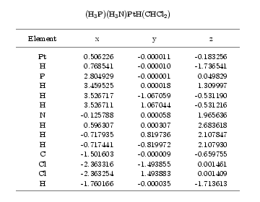

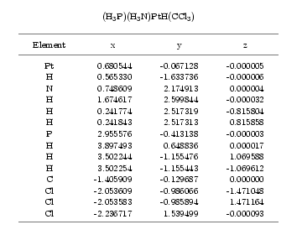

M. J. Frisch, G. W. Trucks, H. B. Schlegel, G. E.Scuseria, M. A. Robb, J. R. Cheeseman, V. G. Zakrzewski, J. A. Montgomery, R. E. Stratmann, J. C. Burant, S. Dapprich, J. M. Millam, A. D. Daniels, K. N. Kudin, M. C. Strain, O. Farkas, J. Tomasi, V. Barone, M. Cossi, R. Cammi, B. Mennucci, C. Pomelli, C. Adamo, S. Clifford, J. Ochterski, G. A. Petersson, P. Y. Ayala, Q. Cui, K. Morokuma, D. K. Malick, A. D. Rabuck, K. Raghavachari, J. B. Foresman, J. Cioslowski, J. V. Ortiz, B. B. Stefanov, G. Liu, A. Liashenko, P. Piskorz, I. Komaromi, R. Gomperts, R. L. Martin, D. J. Fox, T. Keith, M. A. Al-Laham, C. Y. Peng, A. Nanayakkara, C. Gonzalez, M. Challacombe, P. M. W. Gill, B. Johnson, W. Chen, M. W. Wong, J. L. Andres, C. Gonzalez, M. Head-Gordon, E. S. Replogle, J. A. Pople, Gaussian, Inc.: Pittsburgh, PA, 1998.

