Supplementary data
NOE derived distances and coupling constant values measured for Neomycin-B at 313 K and pH 4.7. Average distances and J values obtained from solvated unrestrained MD simulations and MD-tar runs including only coupling constants, and from in vacuo MD-tar simulations using J and NOEs are shown for comparison. Unrestrained simulations and MD-tar runs including only J values were carried out using explicit solvent, periodic boundary conditions, and Ewald sums for the treatment of electrostatic interactions (see the experimental part)

d(A) | Exp | MD (10ns) | MD-tar J (1ns) | MD-tar  (80 ns)
H1_{glc}-H4_{strp} | 2.5 | 2.7 | 2.8 | 2.6
H1_{glc}-H5_{strp} | 3.0 | 3.0 | 2.9 | 3.1
H1_{glc}-H3_{strp} | - | 4.4 | 4.3 | 4.3
H1_{glc}-H5_{rib} | 3.0 | 3.2 | 4.5 | 3.1
H1_{glc}-H1_{rib} | 3.9 | 3.9 | 4.0 | 3.7
H1_{glc}-H2_{rib} | 3.6 | 3.1 | 3.1 | 3.4
H1_{glc}-H3_{rib} | >3.5 | 3.6 | 3.2 | 3.1
H1_{rib}-H5_{strp} | 2.3 | 2.5 | 2.6 | 2.5
H1_{rib}-H4_{strp} | >4.0 | 4.5 | >4.0 | 4.4
H1_{rib}-H6_{strp} | 3.6 | 3.3 | 3.2 | 3.3
H2_{rib}-H6_{strp} | 3.3 | 3.3 | 3.3 | 3.4
H1_{rib}-H4_{rib} | 3.2 | 3.1 | 3.1 | 3.1
H1_{ido}-H3_{rib} | 2.6 | 2.7 | 2.7 | 2.5
H1_{ido}-H2_{rib} | 3.1 | 3.0 | 2.7 | 3.0
H1_{ido}-H4_{rib} | 3.9 | 4.1 | 4.3 | 3.7
J (Hz) | Exp | MD PBC (10ns) | MD-tar J PBC (1ns) | MD-tar  (80 ns)
H1_{rib}-H2_{rib} | 2.7 | 4.3 | 3.2 | 3.2
H2_{rib}-H3_{rib} | 4.5 | 4.0 | 4.3 | 4.0
H3_{rib}-H4_{rib} | 6.3 | 4.6 | 6.1 | 5.8
H4_{rib}-H5^{R}_{rib} | 5.5 | 4.5 | 2.1 | 5.2
H4_{rib}-H5^{S}_{rib} | 3.2 | 3.2 | 2.8 | 3.8

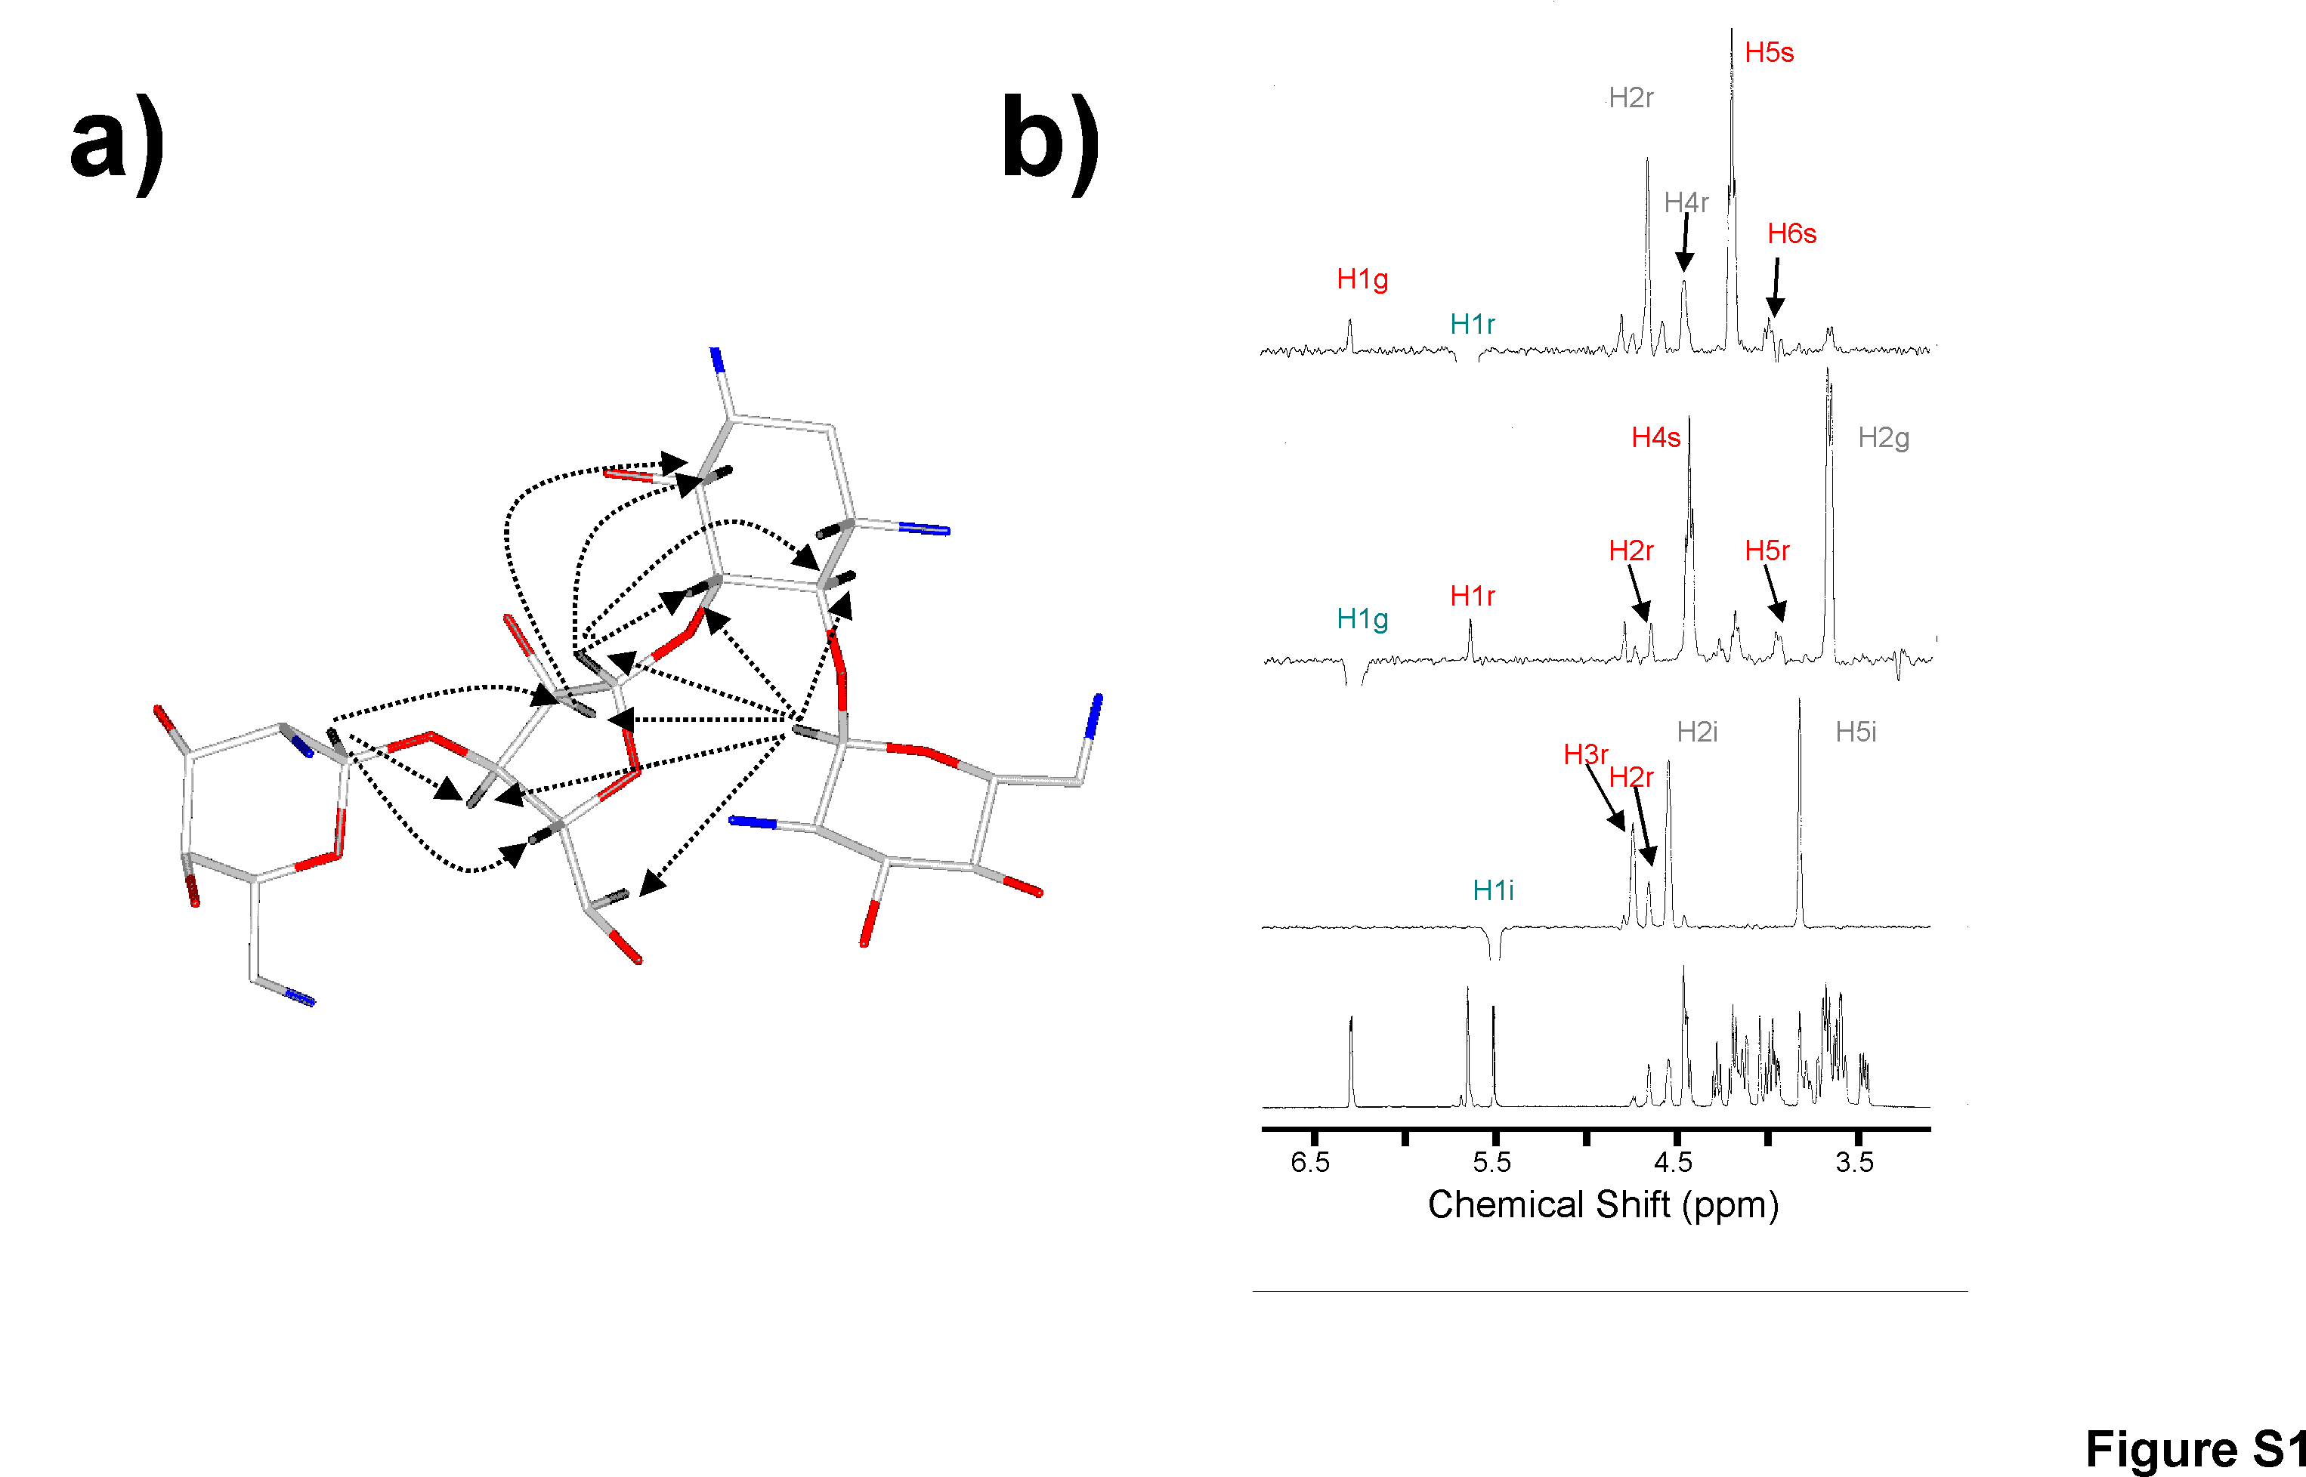
Figure S1.- a) Structurally relevant interproton distances measured in Neomycin B at 313 K and pH 4.7. b) Selective 1-D NOE experiments with the 1D-DPFGSE NOE pulse sequence, corresponding to the inversion of H1_{Rib}, H1_{Glc} and H1_{Ido}(from top to bottom).
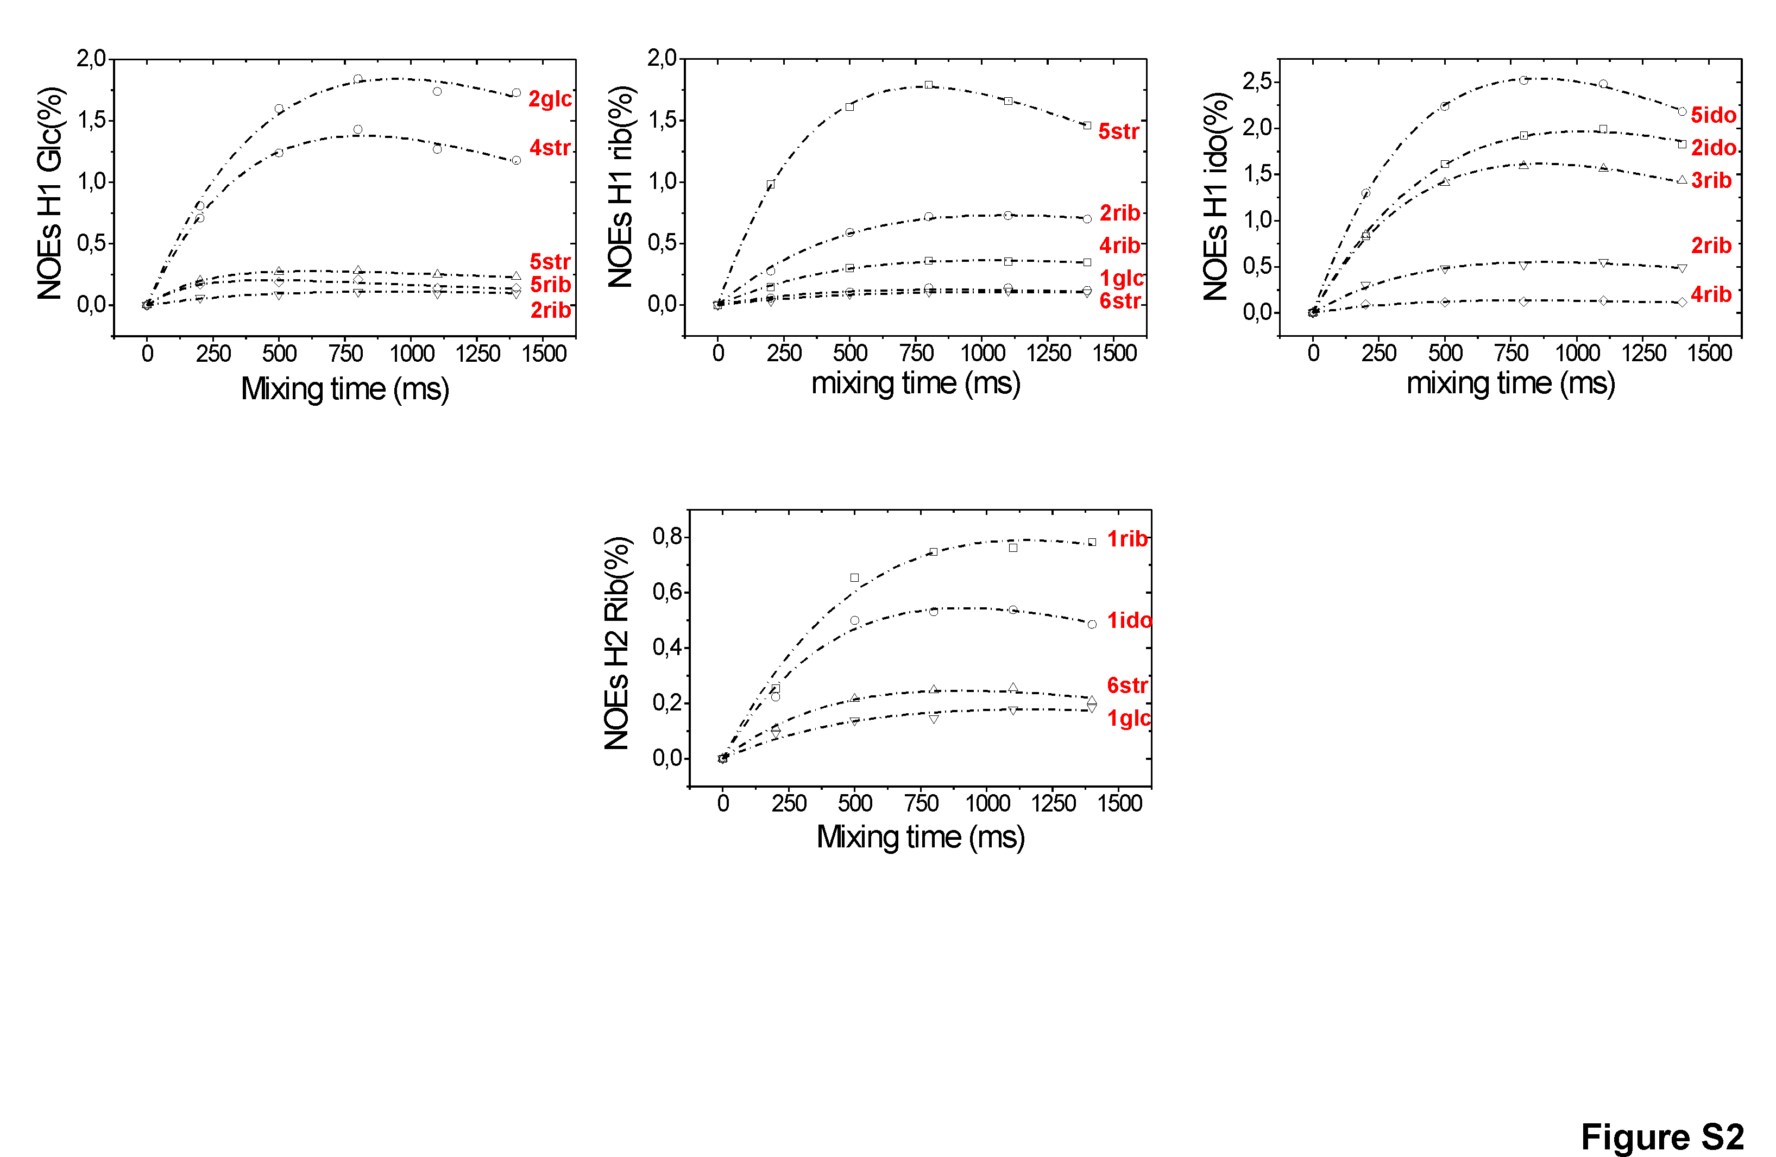
Figure S2.- Experimental build-up curves obtained from selective 1-D NOE experiments with the 1D-DPFGSE NOE pulse sequence at 5 mixing times, 313 K and pH 4.7 for Neomycin-B.

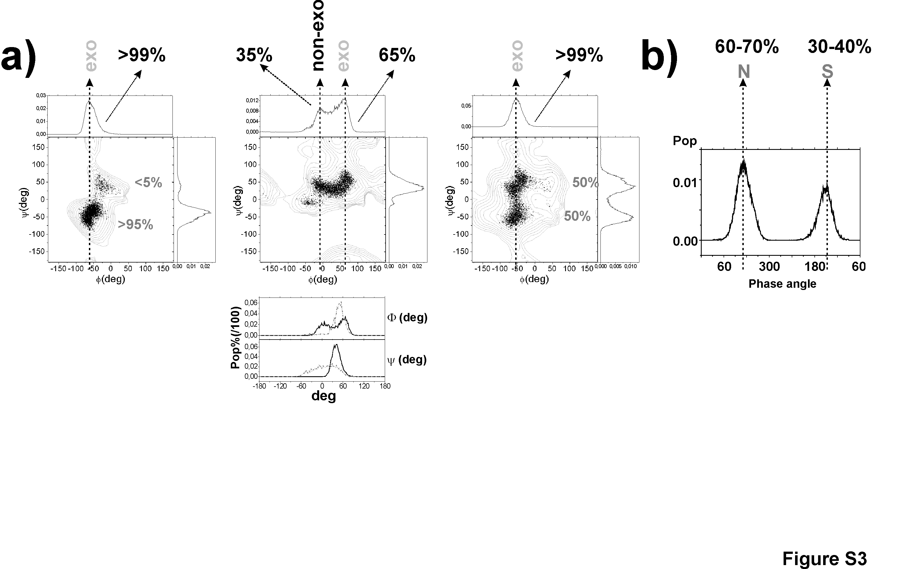
Figure S3.-a) Upper part.-Experimentally derived MD-tar distributions obtained from a 80ns length simulation for the Glc/Strp (left), Strp/Rib (middle) and Rib/Ido (Right) linkages. The presence of a very significant non-exo-anomeric population for the Strp/Rib linkage (middle) is highlighted in black. Bottom.-The unusual conformational behavior exhibited by the ribose unit is directly related to branching. Thus, this behavior is qualitatively reproduced by solvated MD-tar simulations including only J information. φ and ψ distributions are shown in black. Interestingly, solvated MD-tar simulations of the non-branched 2-6 dideoxy-2,6 diamino-L-Ido β(1-3) Rib  β(1-5) 2-deoxy-Strp fragment of Neomycin-B (rings II, III and IV) carried out in identical conditions, conclusively show that the overall rigidity around φ_{Rib}  increases independently of the puckering distribution considered and now all torsion values are consistent with the exo-anomeric effect. Obtained φ and ψ distributions for this linear trisaccharide fragment are shown in dotted gray b) Ribose puckering distribution from MD-tar simulations.
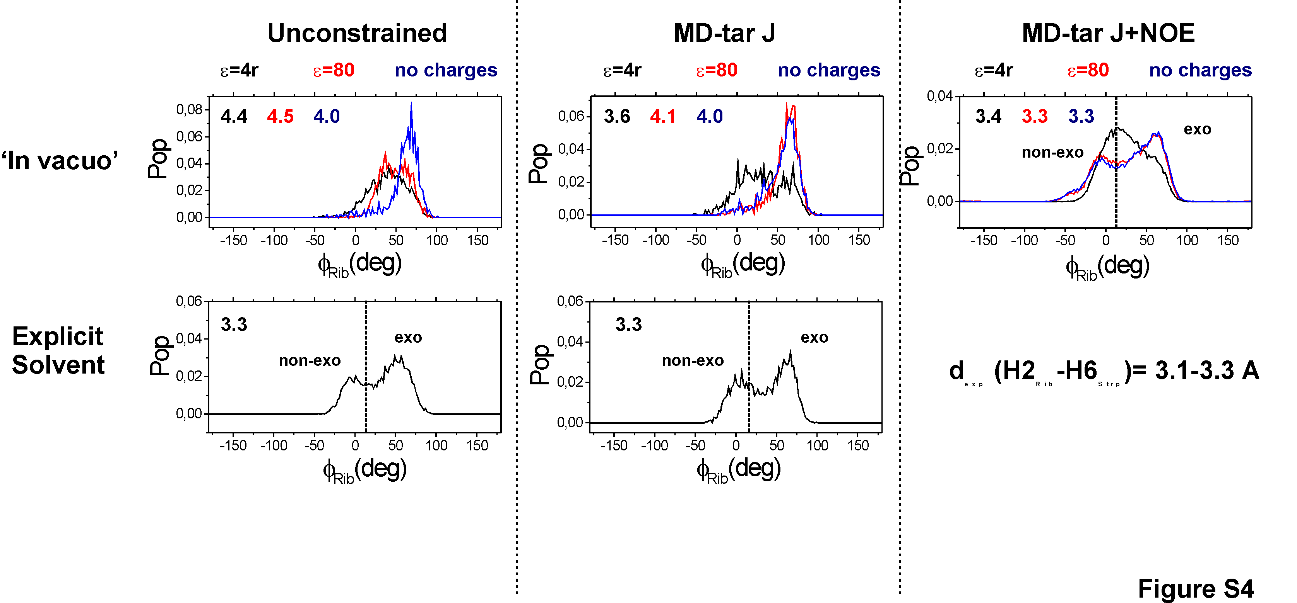
Figure S4.- φ_{Rib} distributions obtained from MD simulations carried out for Neomycin-B under a variety of different conditions (from left to right, unconstrained, including only Js or both Js and NOEs). In all cases the theoretical key distance H2_{Rib}-H6_{Strp} is indicated. The experimental value is shown in the Right-hand corner.
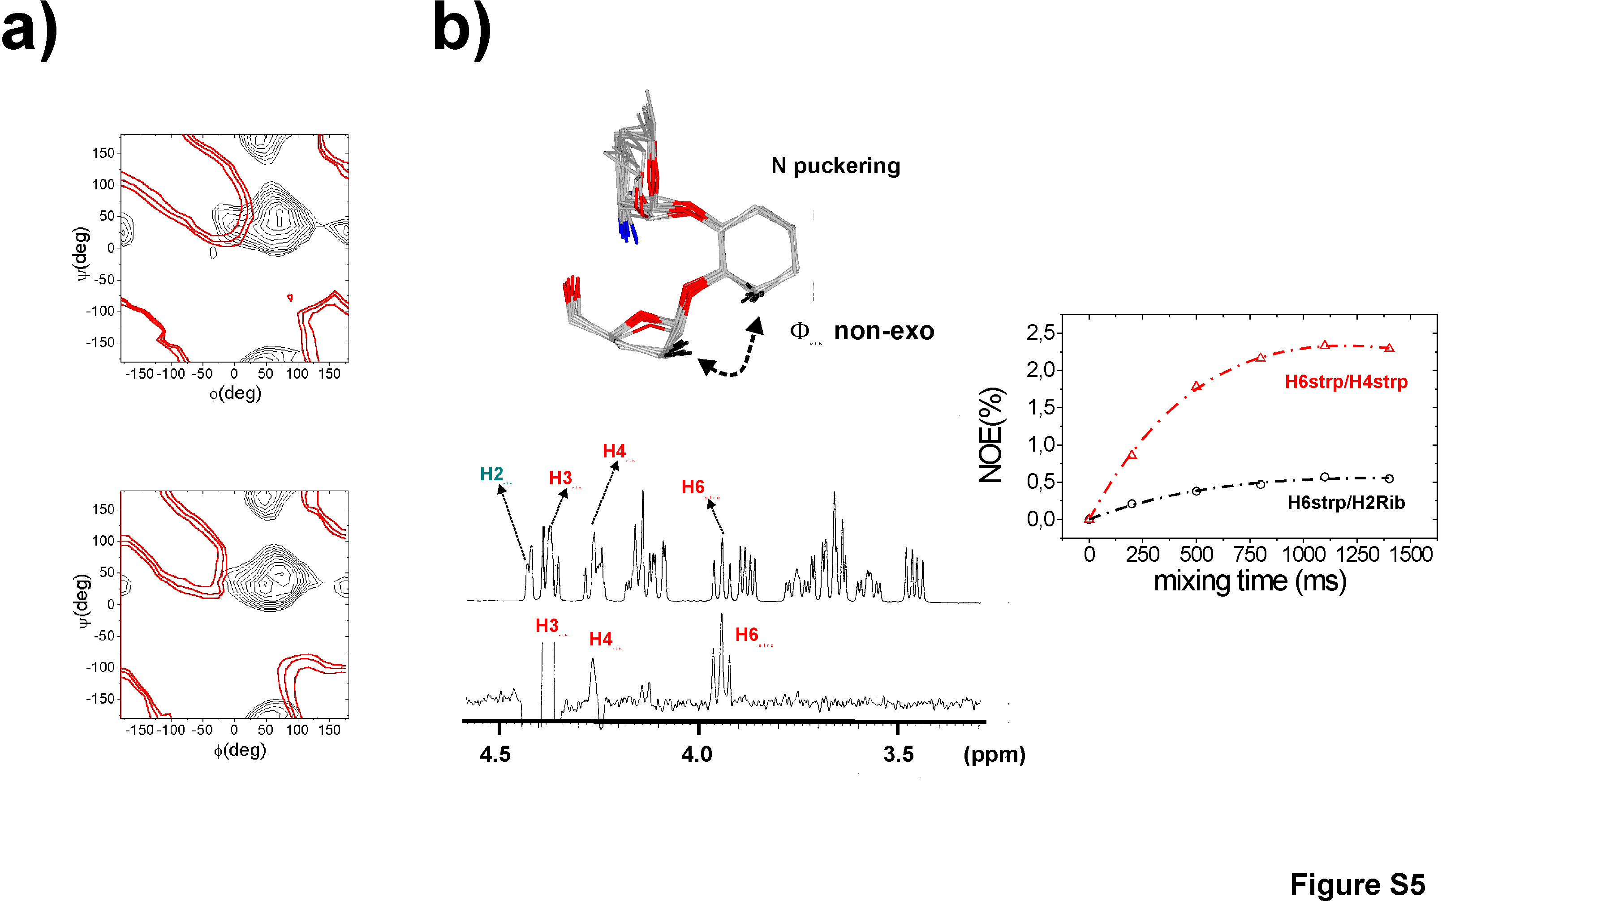
Figure S5.- a) Countours (red) corresponding to the H2_{Ri}b-H6_{Strp} distance superimposed on the steric MM3* maps of Neomycin-B with both 'N' (upper part of the figure) and 'S' (lower part of the figure) ribose puckerings. Contours levels are 3.1, 3.3 and 3.5 Å. b) (upper part) Schematic representation of the non-exoanomeric NOE H2_{Rib}-H6_{Strp}. (lower part) Selective 1-D NOE experiment with the 1D-DPFGSE NOE pulse sequence, corresponding to the inversion of H2_{Rib}, in the branched trisaccharide fragment of Neomycin, Ribostamycin at pH 4.7. The H2_{Rib}-H6_{Stpr} characteristic of non-exo-anomeric φ_{Rib} populations is shown. (Right) Experimental build-up curves corresponding to the interresidue H6_{Strp}-H2_{Rib} and the intraresidue H6_{Strp}-H4_{Strp} NOEs obtained from selective 1-D NOE experiments with the 1D-DPFGSE NOE pulse sequence at 5 mixing times, 313 K and pH 4.7.
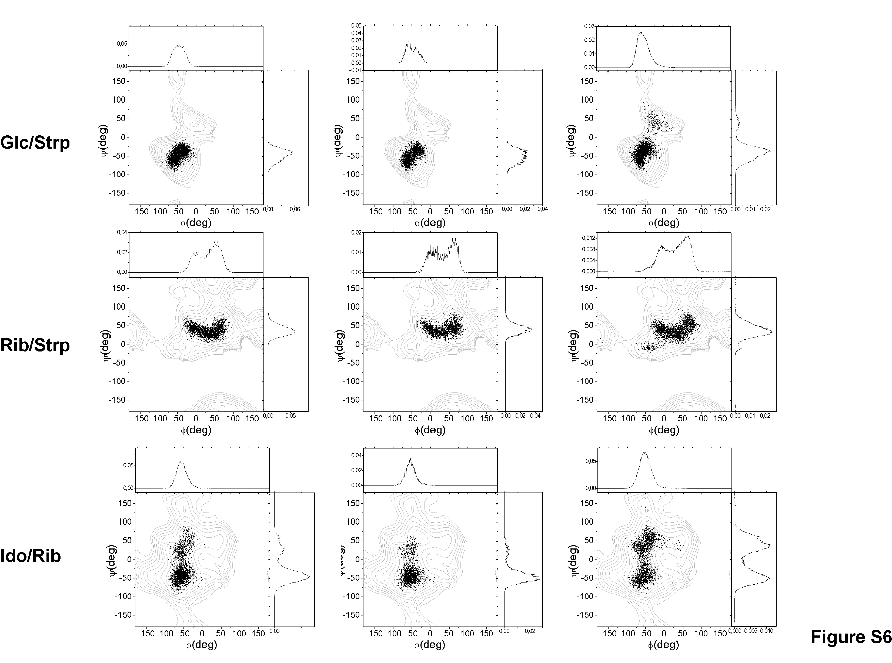
Figure S6.- Distribution of conformers for every particular glycosidic linkage obtained from a unconstrained 10 ns MD run (left), a 1 ns MD-tar simulation including J information (middle) and a 80 ns MD-tar trajectory including 14 distances and 5 J values (right) superimposed on the MM3* maps. Both unconstrained and MD-tar simulations including only J values were performed in presence of explicit TIP3P water molecules, Cl- counterions, Periodic, Boundary conditions, and the particle-mesh Ewald approach.

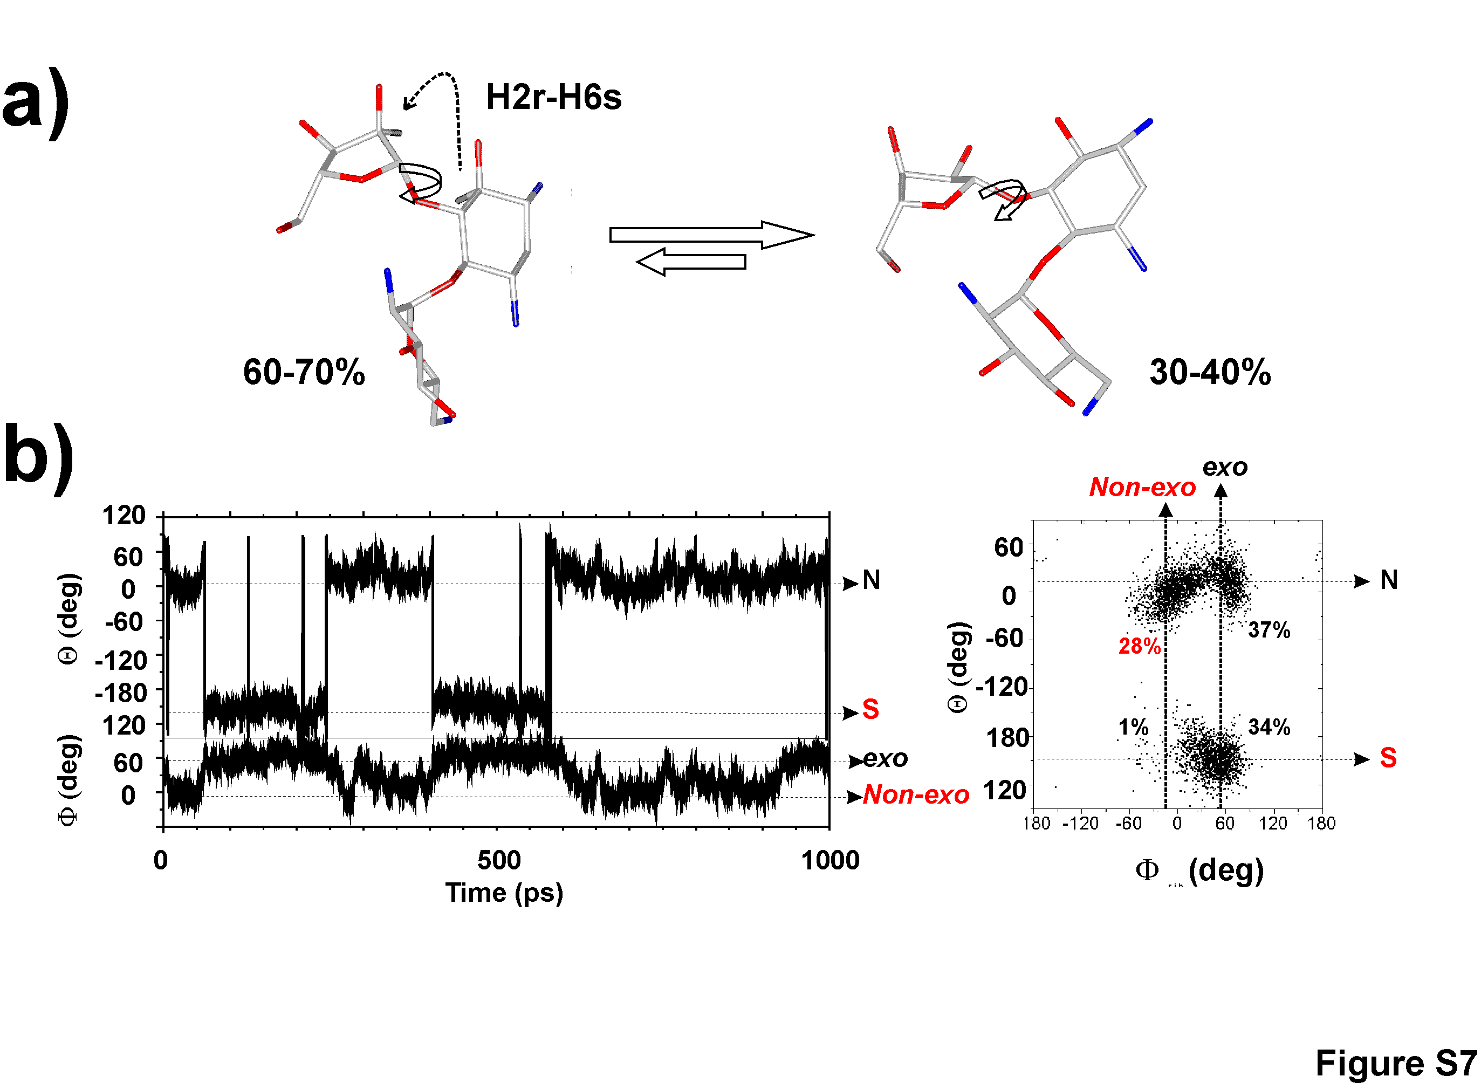
Figure S7.- a) Schematic representation of the two different states for the Ribose puckering. The H2_{rib}-H6_{str} NOE, characteristic of the φ_{rib} non-exo-anomeric orientation is shown. b) Left.-Variations in φ_{Rib} (bottom) and the Rib puckering Phase angle (top) during 1 ns of the MD-tar simulations. Deviations from the exo-anomeric region are strongly correlated with the ring puckering. Right.-Representation of the Phase angle (Θ) vs glycosidic torsion angle (φ) for the ribose unit. It can be observed that non-exo-anomeric φ_{rib} orientations are significantly populated only for a 'N' puckering.
Supplementary Experimental details
Atomic charges for Neomycin-B were derived from HF/6-31G(d) ESP calculations using the Gaussian-94 ¹ program. This program was also used for the B3LYP/6-31G(d,p) optimizations. All MD simulations were carried out using the sander module within the AMBER 5.0 package and the Cornell et. al. force field ². Parameters for the acetalic functions were taken from GLYCAM³. Minimized Neomycin-B geometries were employed as starting structures for the MD runs. In order to asses that the dependency of the results on the computational details MD simulations were performed under a variety of different conditions and protocols. Thus, for Neomycin-B the MD simulations were carried out:
-Unrestrained
-Including only J information, as time-averaged restraints. In this way, we warranted that the ribose puckering distribution is reproduced by the calculations.
-Including both J and NOE information, as time-averaged restraints.
In addition, different conditions were tested for both restrained and unrestrained simulations. Thus, calculations were run:
-Without charges.
-With charges and ε=80
-With charges and ε=4*r
-With charges, explicit solvent (TIP3P water), periodic boundary conditions, counter ions, and Ewald sums for the treatment of the electrostatic interactions.
Solvated unconstrained simulations corresponding to Neomycin-B and solvated MD-tar simulations of free Neomycin-B including only J information were carried out employing the following protocol. First, the oligosaccharide was immersed in a bath of 2000 TIP3P water molecules² and neutralized with Cl⁻ ions using standard parameters for the Cornell et al. force field. These ions were placed in the most favorable locations by using coulombic potential terms with the LEAP module⁴. All simulations were performed using periodic boundary conditions and the particle-mesh Ewald approach⁵ to introduce long-range electrostatic effects. The SHAKE algorithm⁶ for hydrogen atoms, which allows to use a 2 fs time step, was employed. Finally, a 9 Å cutoff was applied to Lennard-Jones interactions.
Equilibration of the system was carried out as follows in all cases; as a first step a short minimization with positional restraints on solute atoms was run to remove any potentially bad contact. The force constant for the positional constraints was 500 Kcal/mol Å. We ran then a 12.5 ps molecular dynamics calculation at 300 K maintaining positional restraints on the sugar in order to equilibrate the water box and ions. For these 2 steps, a 9 Å cut-off was used for the treatment of the electrostatic interactions. As a next step, the system was equilibrated using the mesh Ewald method, as water properties are slightly different with this treatment i.e. density, average water-water energy and water diffusion values are slightly lower. With this purpose, a short MD simulation (12.5 ps) was run at 300 K, also using the Ewald approach for long-range electrostatic effects. Then, the system was subjected to several minimization cycles (each using 1000 steepest descent iterations) gradually reducing positional restraints on the sugar from 500 kcal/mol Å to 0. Finally, unrestrained MD trajectories at constant pressure (1 atm) and temperature (300 K) were collected and analyzed using the Carnal program⁷. Simulation lengths were 10 ns for unconstrained simulations and 1 ns for MD-tar simulations including J infomation.
In addition in vacuo 80 ns MD-tar simulations of Neomycin-B were performed including 14 NOES and 5 J values corresponding to the ribose ring. Once again different trajectories were collected both without charges and with charges (ε=4r and ε=80). NOE-derived distances were included as time averaged distance constraints and scalar coupling constants as time averaged J coupling restraints. A <r⁻⁶>^{-1/6} average was used for the distances and a linear average was used for the coupling constants. The J values are related to the torsion τ by the well known Karplus relationship⁸:
J= Acos² (τ) + Bcos(τ) +C

A, B and C values were chosen to fit the extended Karplus-Altona relationship for every particular torsion. At the end of the simulations the averaged J values were calculated using both the regular Karplus and the complete Altona equations and compared to the experimental ones.
Trial simulations were run using different simulation lengths (between 1 and 80 ns) and different force constants for the distances (between 10 and 30 kcal/molÅ²) and J couplings (between 0.1 and 0.3 kcal/molHz²) constraints. Different values for the exponential decay constant (between 100 ps and 8 ns) were also tested. These preliminary runs showed that for this flexible molecule, the use of exponential decay constants shorter than 1 ns produced unstable trajectories and led in some cases to severe distortions of the sugar rings. In contrast, good results were obtained when using exponential decay constant values of 5 ns or larger. It has been estimated that simulation lengths of ca. one order of magnitude larger than the exponential decay constant should be used to generate reliable estimates of average properties⁹. Thus, the final trajectories were run using an exponential decay constant of 8 ns and a simulation length of 80 ns.
It is also known that when using large force constants for the J coupling constraints, the molecule can get trapped in high energy, physically improbable, incorrect minima¹⁰. In order to solve this false minima problem, low values (between 0.1 and 0.3 kcal/molHz²) were used for the J coupling restraints force constants.
Two final 80 ns MD-tar simulations (starting from different low energy conformations) were run under every particular condition (ε=4r, ε=80 and without charges). Population distributions obtained starting from different initial geometries were almost identical indicating that the simulation length is adequate for a proper convergence of the conformational parameters. Average distance and J values obtained in this way were found to correctly reproduce the experimental ones.
NMR experiments.- NOEs intensities were normalized with respect to the diagonal peak at 0 mixing time. Selective T1 measurements were performed on the anomeric and several other protons to get the above mentioned value. Experimental NOEs were fitted to a double exponential function, f(t)=p0(1-e^{p2t})(1-e^{p1t}) with p0,p1 and p2 being adjustable parameters. The initial slope was determined from the first derivative at time t=0, f'(0)=p0p1. From the initial slopes interproton distances r were obtained by employing the isolated spin pair approximation.

Supplementary References
1 Gaussian 94, Revision D.4, M. J. Frisch, G.W. Trucks, H.B. Schlegel, P.M.W. Gill, B.G. Johnson, M.A. Robb, J.R. Cheeseman, T. Keith, G.A. Petersson, J.A. Montgomery, K. Raghavachari, M.A. Al-Laham, V.G. Zakrzewski, J. V. Ortiz, J.B. Foresman, J. Cioslowski, B.B. Stefanov, A. Nanayakkara, M. Challacombe, C.Y. Peng, P.Y. Ayala, W. Chen, M.W. Wong, J.L. Andres, E.S. Replogle, R. Gomperts, R.L. Martin, D.J. Fox, J.S. Binkley, D.J. Defrees, J. Baker, J.P. Stewart, M. Head-Gordon, C. Gonzalez, J.A. Pople, Gaussian, Inc., Pittsburgh, PA, 1995.
2 W. D. Cornell, P. C. Cieplack, I. Bayly, I. R. Gould, K. Merz, D. M. Ferguson, D. C. Spellmeyer, T. Fox, J. W. Caldwell, and P. A. Kollman, J. Am. Chem. Soc. 1995,117,5179.
3 R. J. Woods, R. A. Dwek, C. J. Edge, D. Fraser-Reid, J. Phys. Chem. 1995, 99, 3832-3839.
4 C. E. A. F. Schafmeister, W. F. Ross, V. Romanovsky, , University of California, San Francisco 1995.
5 C. S. a. T. Darden, Annu. Rev. Biophys. Biomol. Struct. 1999, 28, 155.
6 J. P. Rykaert, G. Ciccote, J. C. Berendsen, J. Comp. Phys. 1977, 23, 327.
7 W. S. Ross, Carnal: coordinate Analysis Program, University of California, San Francisco, Department of Pharmaceutical Chemistry.
8 For the relation between H/H couplings and conformation, see: (a) M. Karplus, J. Chem. Phys.1959, 30, 11. (b) Haasnoot, C. A. G.; de Leeuw, F. A. A. M.; Altona, C. Tetrahedron, 1980, 36, 2783.
9 A. E. Torda, R. M. Scheek, W. F. van Gunsteren, Chem. Phys. Letters. 1989, 157, 289-294.
10 D. A. Pearlman, J. Biomol. NMR. 1994, 4, 279-299.

