Supplementary Material

High Tetraalkylaluminate Fluxionality in Half-Sandwich Complexes of the Trivalent Rare-Earth Metals†
Reiner Anwander,*ª Michael G. Klimpel,ª H. Martin Dietrich,ª Dmitry J. Shorokhov,^{b} and Wolfgang Scherer^{b}
ª Anorganisch-chemisches Institut, Technische Universität München, Lichtenbergstraße 4, D-85747 Garching, Germany. Fax: 49 89 28913473; Tel: 49 89 28913096; E-mail: reiner.anwander@ch.tum.de
^{b} Institut für Physik, Universität Augsburg, Universitätsstraße 1, D-86159 Augsburg, Germany. Fax: 49 821 5983227; Tel: 49 821 5983350; E-mail: wolfgang.scherer@physik.uni-augsburg.de

Experimental Details

General Procedures. All operations were performed with rigorous exclusion of air and water, using standard Schlenk, high-vacuum, and glovebox techniques (MB Braun MB150B-G-II; <1 ppm O₂, <1 ppm H₂O). Hexane was purified by using Grubbs columns. Toluene and THF were predried and distilled from Na/K alloy (benzophenone ketyl) under argon. C₆D₆ was obtained from Deutero GmbH, degassed, dried over Na/K alloy for 24 h, and filtered. HCp* and tetramethylcyclopentadiene were purchased from Aldrich and used as received. The chlorosilanes were distilled before usage. Ln[N(SiHMe₂)₂]₃(THF)₂ (1) were prepared according to published literature procedures by stirring the activated chlorides LnCl₃(THF)_{x} with 2.9 eq. LiN(SiHMe₂)₂ in THF. The products were purified by crystallisation from hexane. The silylated tetramethylcyclopentadienes (2) were obtained from the reaction of LiCpMe₄ with 1 eq. of the chlorosilane in hexane (12 h). The synthesis of CpMe₄SiPh₂H required 1 h reflux afterwards. The products were separated by filtration in hexane and obtained as yellow oils. ¹H and ¹³C NMR data were obtained in C₆D₆ solution at 25 °C from a FT-JEOL-JNM-GX-400 (¹H: 399.80 MHz; ¹³C: 100.51 MHz) and a FT-JEOL-JNM-GX-270 (¹H: 270 MHz; ¹³C: 67.5 MHz). ¹H and ¹³C shifts are referenced to internal solvent resonances and reported relative to TMS. IR spectra were recorded on a Perkin-Elmer 1650-FTIR spectrometer as Nujol mulls. Elemental analyses were performed in the microanalytical laboratory of the institute.

General procedure for synthesizing half-sandwich complexes (CpMe₄R)Ln[N(SiHMe₂)₂]₂ (3). 1 mmol of Ln[N(SiHMe₂)₂]₃(THF)₂ was dissolved in 5 ml of toluene and heated in a pressure tube with 1.1 mmol of the Cp derivative for 48 h. The solvent was removed in vacuo and the product complex crystallised from hexane at –35 °C. The silylated samples were not isolated and were characterized by NMR only.
Cp*Y[N(SiHMe₂)₂]₂ (3a). ¹H NMR (C₆D₆, 25 ºC): δ 4.49 (dsp, 4H, SiH), 2.13 (s, 15H, Cp-Me), 0.25 (d, 24H, NSiMe). ¹³C NMR (C₆D₆, 25 ºC): δ 119.9 (Cp-C), 11.4 (Cp-Me), 3.1 (NSiMe). IR (Nujol, cm⁻¹): 2066 s (SiH), 1833 m (SiH_{agostic}), 1737 w, 1247 vs, 1035 s, 900 vs, 840 s, 788 m, 765 m, 646 w, 623 w, 602 w, 410 w. Elemental analysis: calculated C (44.23), H (8.87), N (5.73); found C (46.50), H (8.97), N (4.71).
(Cp*)Lu[N(SiHMe₂)₂]₂ (4a). ¹H NMR (C₆D₆, 25 ºC): δ 4.59 (sp, 4H, SiH), 2.15 (s, 15H, Cp-Me), 0.26 (d, 24H, NSiMe). ¹³C NMR (C₆D₆, 25 ºC): δ 119.3 (Cp-C), 11.4 (Cp-Me), 3.0 (NSiMe). IR (Nujol, cm⁻¹): 2069 s (SiH), 1820 m (SiH_{agostic}), 1732 w, 1460 vs, 1377 s, 1246 vs, 1044 vs, 900 vs, 841 s, 790 m, 765 m, 721 m, 646 w, 623 w, 603 w, 409 w. Elemental analysis: calculated C (37.61), H (7.54), N (4.87); found C (39.48), H (7.70), N (4.08).
(CpMe₄SiHMe₂)Y[N(SiHMe₂)₂]₂ (3b). ¹H NMR (C₆D₆, 25 ºC): δ 4.83 (m, 1H, Cp-SiH(CH₃)₂), 4.50 (m, 4H, N-SiH(CH₃)₂), 2.29 (s, 6H, Cp(CH₃)₄), 2.02 (s, 6H, Cp(CH₃)₄), 0.35 (d, 6H, Cp-SiH(CH₃)₂), 0.25 (d, 24H, N-SiH(CH₃)₂). ¹³C NMR (C₆D₆, 25 ºC): δ 129.6 (Cp-C), 125.0 (Cp-C), 113.8 (Cp-C), 14.1 (Cp-Me), 11.7 (Cp-Me), 3.3 (N-SiH(CH₃)₂), 3.2 (Cp- SiH(CH₃)₂).
(CpMe₄SiHMe₂)Lu[N(SiHMe₂)₂]₂ (4b). ¹H NMR (C₆D₆, 25 ºC): δ 4.91 (m, 1H, Cp-SiH(CH₃)₂), 4.59 (m, 4H, N-SiH(CH₃)₂), 2.37 (s, 6H, Cp(CH₃)₄), 2.09 (s, 6H, Cp(CH₃)₄), 0.40 (d, 6H, Cp-SiH(CH₃)₂), 0.29 (d, 24H, N-SiH(CH₃)₂).
(CpMe₄SiMe₃)Y[N(SiHMe₂)₂]₂ (3c). ¹H NMR (C₆D₆, 25 ºC): δ 4.51 (m, 4H, N-SiH(CH₃)₂), 2.34 (s, 6H, Cp(CH₃)₄), 2.08 (s, 6H, Cp(CH₃)₄), 0.44 (s, 6H, Cp-Si(CH₃)₃), 0.26 (d, 24H, N-SiH(CH₃)₂). ¹³C NMR (C₆D₆, 25 ºC): δ 130.2 (Cp-C), 125.6 (Cp-C), 117.2 (Cp-C), 15.4 (Cp-Me), 12.0 (Cp-Me), 2.8 (N-SiH(CH₃)₂), 2.7 (Cp-Si(CH₃)₃).
(CpMe₄SiMe₃)Lu[N(SiHMe₂)₂]₂ (4c). ¹H NMR (C₆D₆, 25 ºC): δ 4.59 (m, 4H, N-SiH(CH₃)₂), 2.40 (s, 6H, Cp(CH₃)₄), 2.12 (s, 6H, Cp(CH₃)₄), 0.42 (s, 6H, Cp-Si(CH₃)₃), 0.30 (d, 24H, N-SiH(CH₃)₂).
(CpMe₄SiPh₂H)Y[N(SiHMe₂)₂]₂ (3d). ¹H NMR (C₆D₆, 25 ºC): δ 7.66 (m, 4H, SiH(C₆H₅)₂), 7.14 (m, 6H, SiH(C₆H₅)₂), 5.98 (s, 1H, SiH(C₆H₅)₂), 4.50 (m, 4H, SiH(CH₃)₂), 2.23 (s, 6H, CpH(CH₃)₄), 2.10 (s, 6H, CpH(CH₃)₄), 0.22 (d, 24H, SiH(CH₃)₂).

General procedure for synthesizing half-sandwich bisaluminate complexes Cp*Ln(AlMe₄)₂ (5, 6). 1 mmol of complex Cp*Ln[N(SiHMe₂)₂]₂ was stirred with 6 eq. of AlMe₃ in 10 mL of hexane at -35 ºC for 10 min giving a mixture of product Cp*Ln(AlMe₄)₂ and by-product [Me₂Al(µ-N(SiHMe₂)₂]₂. The solvent was removed in vacuo. The product was isolated by crystallisation from hexane at -35 ºC.
Cp*Y(AlMe₄)₂ (5). Colorless crystals, yield 78%. ¹H NMR (C₆D₆, 25 ºC): δ 1.72 (s, 15H, Cp-Me), -0.33 (s, 24H, AlMe). ¹³C NMR (C₆D₆, 25 ºC): δ 122.3 (Cp-C), 11.8 (Cp-Me), 0.13 (AlMe). IR (Nujol, cm⁻¹): 1462 vs, 1377 vs, 1258 w, 1233 w, 1193 m, 1022 w, 916 m, 857 m, 720 s, 580 m, 506 m, 469 w. Elemental analysis: calculated C (54.27), H (9.87); found C (52.76), H (10.35).
Cp*Lu(AlMe₄)₂ (6). Colorless crystals, yield 71%. ¹H NMR (C₆D₆, 25 ºC): δ 1.75 (s, 15H, Cp-Me), -0.18 (s, 24H, AlMe). ¹³C NMR (C₆D₆, 25 ºC): δ 120.9 (Cp-C), 11.8 (Cp-Me), 1.49 (AlMe). IR (Nujol, cm⁻¹): 1462 vs, 1377 vs, 1258 w, 1237 m, 1213 m, 1193 m, 1023 w, 913 w, 855 m, 721 s, 579 m, 499 w, 458 w. Elemental analysis: calculated C (42.36), H (6.22); found C (41.29), H (6.12).

Structure parameters of bridging Me groups in Cp*Lu(AlMe4)2 as obtained
from quantum chemical calculations and X-ray diffraction experiment

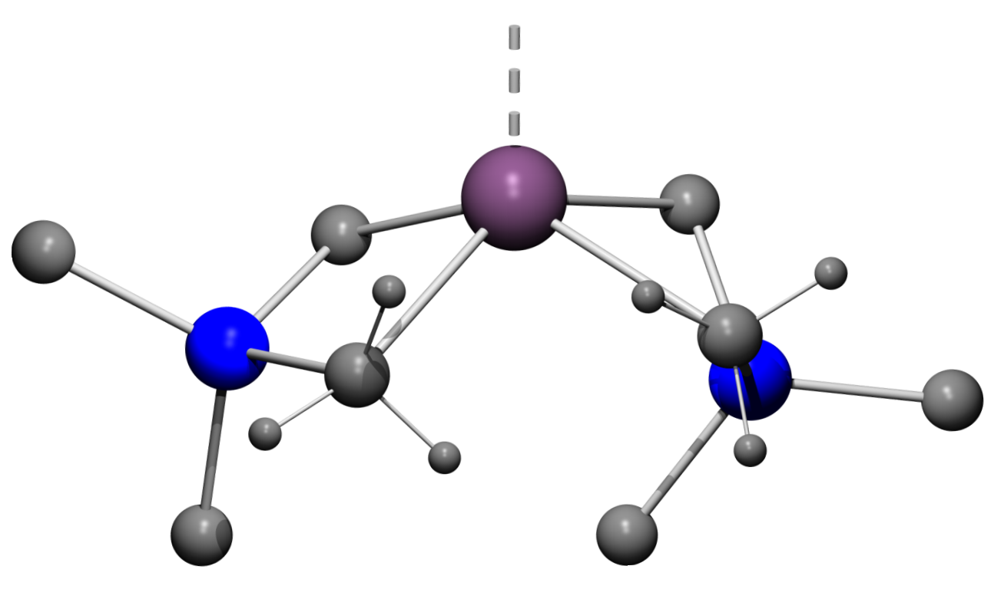
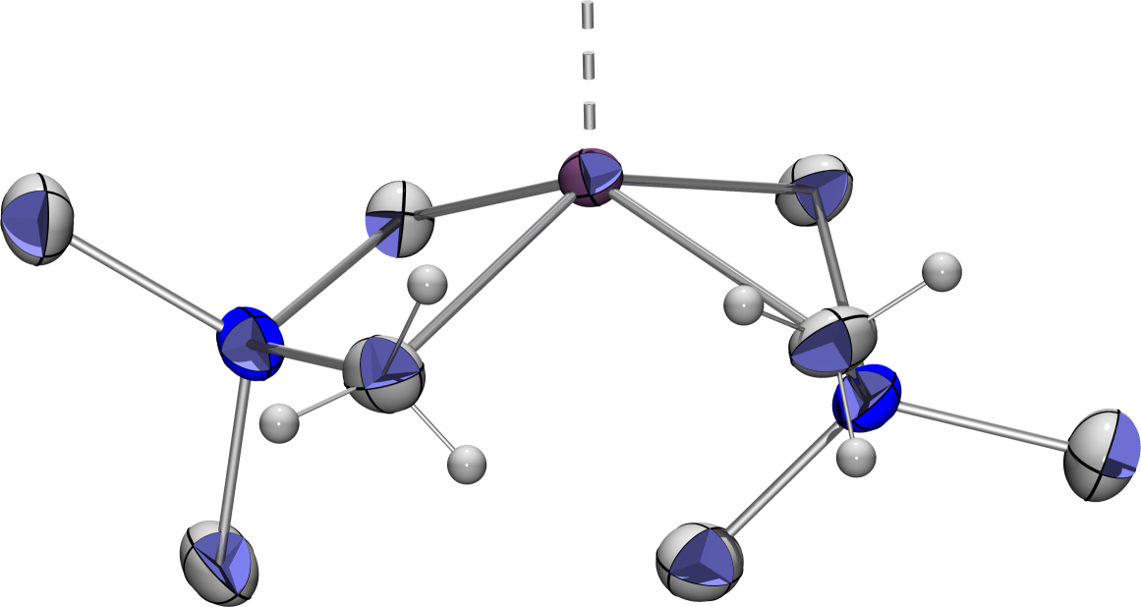
Lu
C15
C16
C17
C18
C12
C11
Al1
C14
C13
H16B
H16C
H16A
H11A
H11B
H11C
Al2
Cp*
Cp*
Lu
C15
C16
C17
C18
C12
C11
Al1
C14
C13
H16B
H16C
H16A
H11A
H11B
H11C
Al2

Calc.a |  |  |  | Exp.
∠Lu-C11-H11A | 74.8° | ∠Lu-C16-H16A | 135.3° | ∠Lu-C11-H11A | 73(2)° | ∠Lu-C16-H16A | 137(2)°
∠Lu-C11-H11B | 165.9° | ∠Lu-C16-H16B | 66.7° | ∠Lu-C11-H11B | 162(2)° | ∠Lu-C16-H16B | 69(2)°
∠Lu-C11-H11C | 89.8° | ∠Lu-C16-H16C | 117.7° | ∠Lu-C11-H11C | 90(2)° | ∠Lu-C16-H16C | 116(2)°
∠Al1-C11-H11A | 128.8° | ∠Al2-C16-H16A | 94.7° | ∠Al1-C11-H11A | 133(2)° | ∠Al2-C16-H16A | 91(2)°
∠Al1-C11-H11B | 89.4° | ∠Al2-C16-H16B | 141.8° | ∠Al1-C11-H11B | 86(2)° | ∠Al2-C16-H16B | 143(2)°
∠Al1-C11-H11C | 116.3° | ∠Al2-C16-H16C | 102.6° | ∠Al1-C11-H11C | 114(2)° | ∠Al2-C16-H16C | 103(2)°

aQuantum chemical calculations were carried out in Gaussian98 using the BPW91/SDD method.

