Supplementary data

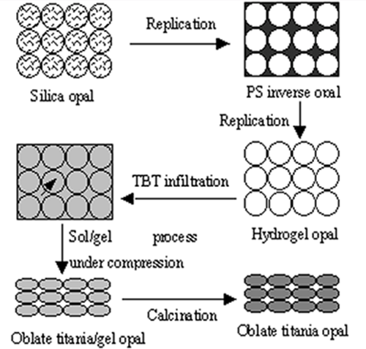

Scheme 1. Preparation procedure of the oblate titania opal materials. Polystyrene inverse opal is replicated from the silica opal template. After another template synthesis against the PS inverse opal, hydrogel opal is prepared. While the opal gel is infiltrated with TBT, a favorable sol/gel process is carried out under compression to form oblate titania/gel opal. After the titania/gel opal is calcined at varied temperature, oblate titania opal materials are prepared.

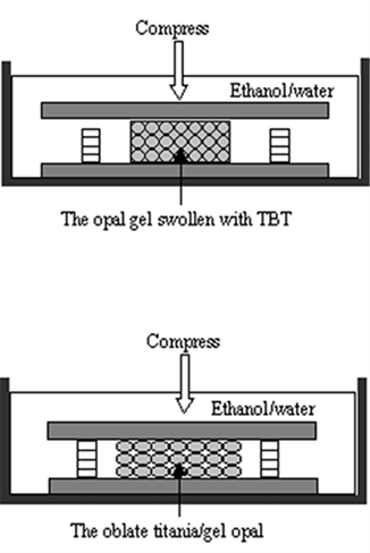

Scheme 2. An illustrative setup for the compression. The TBT swollen opal gel is confined between two glass slides, which are separated with spacers of designed height. While it is immersed in ethanol/water mixture (1:1 vol/vol) to allow the favorable titania sol/gel process, a compression is applied to the top substrate to deform the titania/gel particles resulting the oblate titania/gel opal. The aspect ratio is adjusted by altering the height of the spacers.

