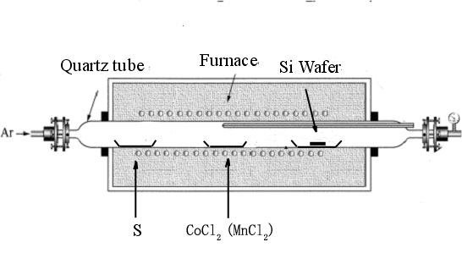
Apparatus for the synthesis of CoS and MnS nanowires.
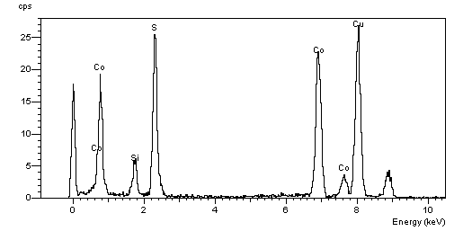
EDAX spectra for the as-prepared CoS nanowire.

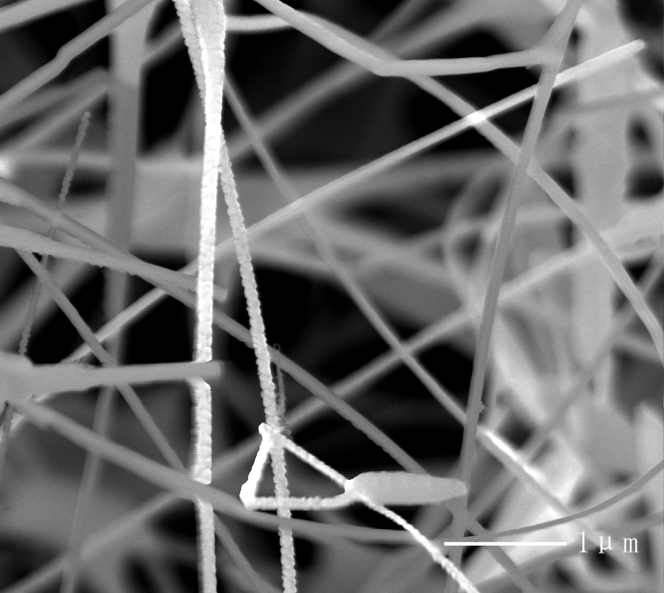
SEM images of the MnS nanowires

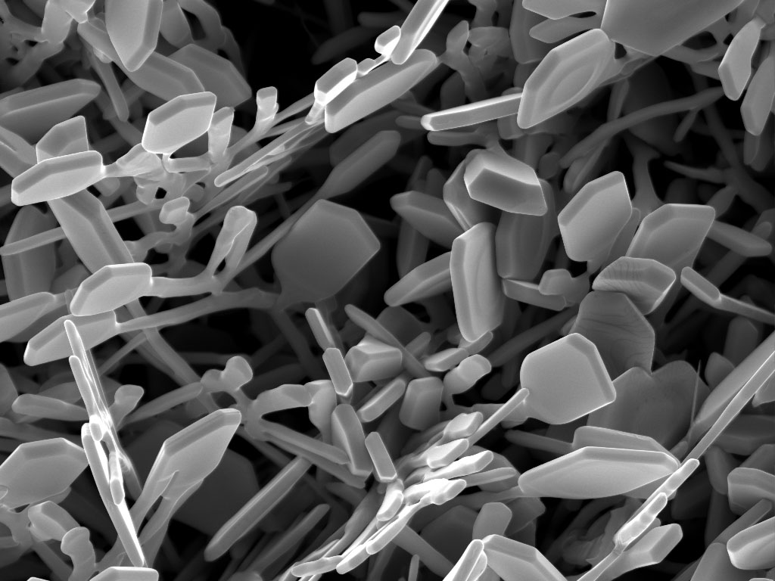
CoS plates deposited on substrate at 950 °C

