Electronic Supplementary information:

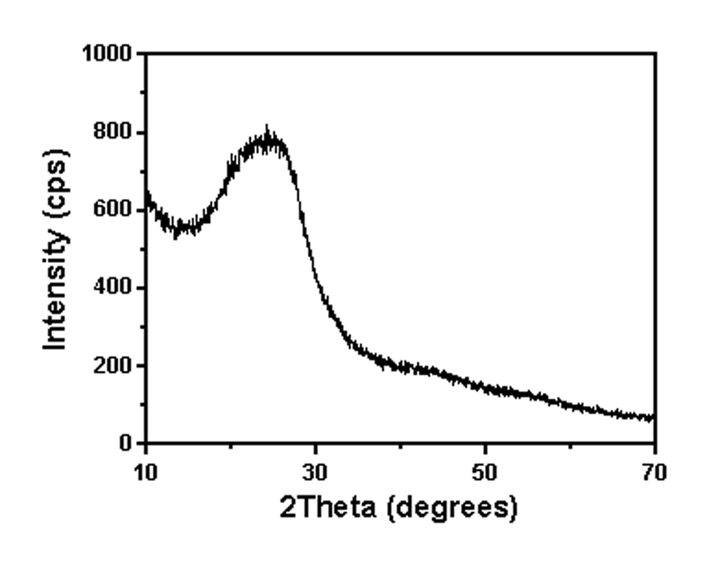
ESI: XRD patterns of the synthesized sample

