Supporting Information for:

Reversible formation of DNA G-quadruplex hairpin dimers from stilbenediether conjugates

Frederick D. Lewis* Yansheng Wu, and Ligang Zhang
Department of Chemistry, Northwestern University, Evanston, Illinois 60208-3113
Fig. S1 UV thermal dissociation profile for conjugate 6 in 0.1 M NaCl (10 mM phosphate buffer, pH 7.2). Rates of heating and cooling are 0.1 ºC/min.

Fig. S2 CD spectra of conjugates 2-4 in 0.1 M NaCl (10 mM phosphate buffer, pH 7.2). Rates of heating for 2 is 0.1 ºC/min.

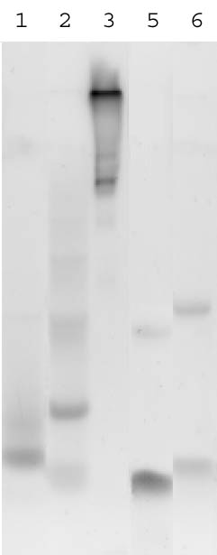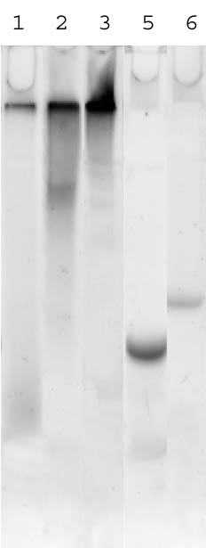

Fig. S3 Non-denaturing PAGE gels of conjugates 1-3, 5, and 6 in TE buffer (10 mM tris.HCl, 0.1 mM EDTA, pH 7.4 (a) and in TE buffer with 0.1 M NaCl (b). Fluorescence imaging utilizing the intrinsic Sd fluorescence.

