Convenient magnesiation of aromatic and heterocyclic rings bearing a hydroxy group in presence of LiCl

Supporting Information
Felix Kopp, Arkady Krasovskiy and Paul Knochel
Ludwig-Maximilians-Universität München, Department Chemie
Butenandtstrasse 5-13, Haus F, 81377 München (Germany)
Fax: (+49) 089 21 80 776 80
e-mail: paul.knochel@cup.uni-muenchen.de

General All reactions were carried out under an argon atmosphere in dried glassware. All starting materials were purchased from commercial sources and used without further purification. 2-Iodo-pyridin-3-ol¹ and 2-hydroxy-5-iodo-benzoic acid tert-butyl ester² were prepared according to literature procedures. Commercially available 5,7-diiodo-quinolin-8-ol was recrystallized from toluene before use. THF was continuously refluxed and freshly distilled from sodium benzophenone ketyl under nitrogen. Yields refer to isolated yields of compounds estimated to be > 95 % pure as determined by ¹H-NMR and high resolution mass spectroscopy (HRMS).

Typical procedure for the preparation of the functionalized diiodophenols³: 2,6-Diiodo-4-trifluoromethyl-phenol (1b):
4-Trifluoromethylphenol (2.43 g, 15.0 mmol) was dissolved in ethanol (30 mL), then iodine (7.62 g, 30.0 mmol, 2.00 equiv.) and silver(I)sulfate (9.36 g, 30.0 mmol, 2.00 equiv.) were added neat to the stirred solution. After the conversion was complete (tlc monitoring), the suspension was filtrated and the solvent removed in vacuo. After column chromatographical purification (silica; pentane/CH₂Cl₂, 1:9) the product was obtained as colourless solid (5.61 g, 13.6 mmol, 90 %)

mp: 104.0-104.5°C
¹H-NMR (CDCl₃, 400 MHz): δ / ppm = 7. 91 (s, 2 H); 6.05 (s, 1 H).
¹³C-NMR (CDCl₃, 100 MHz): δ / ppm = 156.5; 136.4 (q, J = 3.7 Hz); 126.2 (q, J = 33.7 Hz); 122.0 (q, J = 272.5 Hz); 81.75.
IR (KBr): ν/cm⁻¹ = 3450 (s); 3390 (w); 2926 (w); 2514 (w); 1784 (w); 1596 (w); 1574 (w); 1596 (w); 1553 (w); 1464 (w); 1404 (m); 1336 (s); 1316 (vs); 1272 (m); 1245 (m); 1200 (s); 1176 (m); 1143 (s); 1124 (vs); 1094 (s); 1049 (w); 889 (s); 765 (w); 716 706 (m); 644 (s); 599 (w); 531 (w).
MS (EI): m/z (%) = 414 (M⁺, 100); 395 (6); 286 (4); 258 (2); 207 (3); 160 (22); 141 (3); 132 (12); 127 (3); 112 (2); 81 (5); 63 (3); 62 (3); 53 (2); 41 (51).
HR-MS: (C₇H₃F₃I₂O) calculated 413.8225 found 413.8244.

Typical procedure for the preparation of the functionalized monoiodophenols: 4-Hydroxy-3-iodo-benzonitrile (1d):
4-Hydroxy-benzonitrile (1.79 g, 15.0 mmol) was dissolved in ethanol (75 mL), then iodine (3.81 g, 15.0 mmol, 1.00 equiv.) and silver(I)sulfate (4.68 g, 15.0 mmol, 2.00 equiv.) were added neat to the stirred solution. After the conversion was complete (tlc monitoring), the suspension was filtrated and the solvent removed in vacuo. After column chromatographical purification (silica; CH₂Cl₂) the product was obtained as colourless solid (2.16 g, 8.85 mmol, 59 %)

mp: 147.0-148.0°C, starting decomposition at 144 °C
¹H-NMR (CDCl₃, 400 MHz): δ / ppm = 10.62 (brs, 1 H); 7.82 (d, J = 2.0 Hz,1 H); 7.31 (dd, J = 2.0 Hz, J’ = 8.50 Hz,1 H); 6.84 (d, J = 8.5 Hz,1 H).
¹³C-NMR (CDCl₃, 100 MHz): δ / ppm = 160.7; 142.4; 133.2; 117.7; 115.1; 103.6; 83.9.
IR (KBr): ν/cm⁻¹ = 3412 (s); 3272 (s); 2226 (s); 1641 (w); 1592 (s); 1565 (w); 1498 (m); 1397 (s); 1295 (m); 1348 (w); 1295 (m); 1206 (m); 1134 (w); 1039 (w); 894 (w); 822 (m); 732 (w); 581 (w); 475 (w).
MS (EI): m/z (%) = 245 (M⁺, 100); 127 (5); 118 (8); 9 (15); 63 (15); 53 (3).
HR-MS: (C₇H₄INO) calculated 244,9338 found 244.9350.

General procedure 1 (GP1) for the I/Mg-exchange on unprotected phenols and the reaction with electrophiles:
In a dry argon-flushed Schlenk tube equipped with a septum and a magnetic stirring bar, the iodophenol derivative (1.50 mmol) was dissolved in a solution of LiCl in THF (3.0 mL, 0.5 m, 1.50 mmol, 1.0 equiv.) and cooled to -30 °C. Then, MeMgCl (0.54 mL, 2.8 m solution in THF, 1.50 mmol, 1.0 equiv.) was added dropwise. The reaction mixture was kept stirring at -30 °C for 40 min, then I-PrMgCl (1.57 mL, 1.05 m solution in THF, 1.65 mmol, 1.1 equiv.) was slowly added and the mixture was stirred for 30 min at –30 °C. After the exchange reaction was complete (tlc monitoring), the electrophile was added and the mixture was kept at -30 °C until the conversion was complete. MeOH (1 mL) was added, the resulting solution was poured into a mixture of saturated aqueous NH₄Cl and water (1:1) and extracted with CH₂Cl₂. The organic layer was dried (Na₂SO₄) and the solvent removed in vacuo. The product was purified by flash column chromatographical purification.

Preparation of 4-bromo-2-(hydroxy-phenyl-methyl)-6-iodo-phenol (3a): According to GP1 the Grignard reagent 2a was prepared from 4-bromo-2,6-diiodo-phenol (636 mg, 1.5 mmol) and reacted at -30 °C with benzaldehyde (191 mg, 1.80 mmol, 1.2 equiv.). Flash column chromatographical purification (silica; CH₂Cl₂) afforded 3a as a colorless, crystalline solid (497 mg, 1.23 mmol, 82 %).

mp: 154.0-154.5 °C
¹H-NMR (CDCl₃/dmso-d₆, 300 MHz): δ / ppm = 9.88 (brs, 1 H); 7.65 (d, J = 2.4 Hz, 1 H); 7.22-7.35 (m, 6 H); 6.96 (d, J = 2.4 Hz, 1 H), 5.82 (s, 1 H).
¹³C-NMR (CDCl₃, 75 MHz): δ / ppm = 154.0; 141.7; 139.1; 130.4; 129.6 ; 128.2; 127.7; 126.4; 111.4; 86.2; 75.1.
IR (KBr): ν/cm⁻¹ = 3388 (vs); 3027 (w); 2901 (w); 1629 (w); 1554 (w); 1494 (w); 1451 (s); 1411 (m); 1332 (w); 1295 (w); 1249 (m); 1230 (m); 1202 (s); 1138 (m); 1030 (w); 1020 (m); 919 (w); 888 (w); 834 (m); 808 (w); 748 (m); 731 (m); 700 (s); 684 (m); 666 (m); 570 (w); 547 (w); 455 (w).
MS (EI): m/z (%) = 402 (M-2H⁺, 100); 326 (30); 199 (5); 197 (5); 172 (9); 170 (10); 168 (5); 143 (5); 139 (23); 105 (84); 91 (7);; 77 (83); 74 (6); 63 (16); 62 (14); 51 (20).
HR-MS: (C₁₃H₈BrIO₂, [M-2H]⁺) calculated 401.8752 found 401.8756.

Preparation of 2-(5-bromo-2-hydroxy-3-iodo-benzyl)-acrylic acid ethyl ester (3b): According to GP1 the Grignard reagent 2a was prepared from 4-bromo-2,6-diiodo-phenol (636 mg, 1.50 mmol). After transmetallation with CuCN⋅2LiCl (1.65 mL, 1.65 mmol, 1.1 equiv., 1 M solution in THF; 30 min, -30 °C) it was reacted with 2-bromomethyl-acrylic acid ethyl ester (318 mg, 1.65 mmol, 1.1 equiv.) at –30 °C. Flash column chromatographical purification (silica; pentane/CH₂Cl₂, 2:1) afforded 3b as a colorless oil (382 mg, 0.93 mmol, 62 %).

¹H-NMR (CDCl₃, 400 MHz): δ / ppm = 7.68 (s, 1 H); 7.67 (d, J = 2.5 Hz, 1 H); 7.21 (d, J = 2.5 Hz, 1 H); 6.26 (s, 1 H), 5.77 (s, 1 H); 4.23 (q, J = 7.2 Hz, 2 H); 3.65 (s, 2 H); 1.29 (t, J = 7.2 Hz, 3 H).
¹³C-NMR (CDCl₃, 100 MHz): δ / ppm = 168.4; 152.8; 139.0; 138.2; 133.5; 127.8 ; 127.5; 112.9; 87.4; 61.9; 33.6; 14.0.
IR (KBr): ν/cm⁻¹ = 3478 (m); 3234 (m); 2981 (m); 2935 (m); 2870 (w); 1913 (w); 1712 (s); 1682 (vs); 1624 (s); 1584 (w); 1551 (m); 1451 (vs); 1421 (s); 1406 (s); 1373 (s); 1335 (vs); 1304 (s); 1273 (m); 1211 (vs); 1143 (vs); 1095 (m); 1021 (m); 955 (m); 932 (w); 896 (w); 861 (m); 823 (m); 743 (w); 696 (w); 669 (m); 592 (w), 546 (w).
MS (EI): m/z (%) = 412 (14, M⁺(⁸¹Br)), 410 (14, M⁺(⁷⁹Br)), 367 (13); 366 (96); 364 (100); 337 (26); 335 (26); 285 (31); 257 (18); 239 (5); 237 (5); 211 (6); 210 (6); 209 (6); 208 (5); 185 (5); 183 (7); 131 (12); 130 (10); 103 (7); 102 (26); 101 (5); 77 (6); 76 (7); 75 (8); 74 (5); 51 (5).
HR-MS: (C₁₂H₁₂BrIO₃) calculated 409.9000 found 409.9015.

Preparation of 2-(hydroxy-phenyl-methyl)-6-iodo-4-trifluoromethyl-phenol (3c): According to GP1 the Grignard reagent 2b was prepared from 2,6-diiodo-4-trifluoromethyl-phenol (426 mg, 1.50 mmol) and reacted at –30 °C with benzaldehyde (191 mg, 1.80 mmol, 1.2 equiv.). Flash column chromatographical purification (silica; pentane/CH₂Cl₂, 1:1) afforded 3c as a colorless, crystalline solid (426 mg, 1.08 mmol, 72 %).

mp: 146.5-147.0 °C
¹H-NMR (CDCl₃, 600 MHz): δ / ppm = 10.37 (brs, 1 H); 7.77 (d, J = 1.8 Hz, 1 H); 7.19-7.33 (m, 6 H); 7.06 (d, J = 1.8 Hz, 1 H); 5.87 (s, 1 H).
¹³C-NMR (CDCl₃, 151 MHz): δ / ppm = 157.8 ; 141.6; 134.8 (q, J = 4.0 Hz); 128.4; 128.01; 127.9; 126.6; 126.1 (q, J = 3.6 Hz); 124.8 (q, J = 272.8 Hz); 122.8 (q, J = 32.9 Hz); 85.3; 75.6.
IR (KBr): ν/cm⁻¹ = 3424 (s); 2929 (w); 2226 (w); 1614 (w); 1495 (w); 1450 (w); 1423 (w); 1324 (vs); 1266 (w); 1212 (w); 1164 (m); 1114 (s); 1094 (w); 1020 (w); 891 (w); 837 (w); 742 (w); 700 (m); 682 (w); 657 (m); 639 (w); 592 (w).
MS (EI): m/z (%) = 392 ([M-2H]⁺, 100); 391 (76); 364 (29); 363 (11); 188 (8); 187 (9); 160 (15); 132 (9); 131 (5); 106 (6); 105 (59); 81 (5); 77 (47); 63 (7); 51 (12).
HR-MS: (C₁₄H₈F₃IO₂, [M-2H]⁺) calculated 391.9521 found 391.9526.

Preparation of 2-(cyclohexyl-hydroxy-methyl)-6-iodo-4-trifluoromethyl-phenol (3d): According to GP1 the Grignard reagent 2b was prepared from 2,6-diiodo-4-trifluoromethyl-phenol (426 mg, 1.50 mmol) and reacted at –30 °C with cyclohexylaldehyde (202 mg, 1.80 mmol, 1.2 equiv.). Recrystallization from heptane afforded 3d as a colorless, crystalline solid (444 mg, 1.11 mmol, 74 %).

mp: 120.5-121.0°C
¹H-NMR (CDCl₃, 400 MHz): δ / ppm = 8.97 (brs, 1 H); 7.87 (d, J = 1.5 Hz, 1 H); 7.15 (d, J = 1.6 Hz, 1 H); 4.57 (d, J = 7.1 Hz, 1 H); 2.84 (brs, 1 H); 1.92 (d, J = 12.7 Hz, 1 H); 1.65-1.80 (m, 4 H); 1.39 (d, J = 12.7 Hz, 1 H); 0.96-1.28 (m, 5 H).
¹³C-NMR (CDCl₃, 100 MHz): δ / ppm = 157.2 ; 135.2 (q, J = 3.8 Hz); 126.6; 125.6 (q, J = 3.8 Hz); 123.3 (q, J = 33.3 Hz); 123.2 (q, J = 272.8 Hz); 85.7; 80.3; 43.7; 29.4; 28.2; 26.1.
IR (KBr): ν/cm⁻¹ = 3444 (s); 2929 (s); 2856 (m); 1616 (w); 1478 (w); 1451 (w); 1422 (w); 1327 (vs); 1282 (w); 1264 (w); 1204 (m); 1162 (s); 1115 (vs); 1095 (w); 1070 (w); 1012 (w); 964 (w); 904 (w); 890 (w); 748 (w); 680 (w); 656 (m); 546 (w); 578 (w).
MS (EI): m/z (%) = 383 (9); 382 ([M-F]⁺, 55); 363 (5); 325 (5); 314 (17); 301 (15); 226 (5); 213 (5); 212 (5); 200 (6); 199 (5); 186 (6); 173 (7); 157 (5); 151 (6); 145 (7); 144 (5); 131(5); 115 (7); 81 (100); 80 (10); 79 (9).
HR-MS: (C₁₄H₁₆F₃IO₂) calculated 400.0147 found 400.0145.

Preparation of 4-hydroxy-3-(hydroxy-phenyl-methyl)-5-iodo-benzonitrile (3e): According to GP1 the Grignard reagent 2c was prepared from 4-hydroxy-3,5-diiodo-benzonitrile (557 mg, 1.50 mmol) and reacted at –30 °C with benzaldehyde (191 mg, 1.80 mmol, 1.2 equiv.). Flash column chromatographical purification (silica; CH₂Cl₂) afforded 3e as a colorless, crystalline solid (421 mg, 1.20 mmol, 80 %).

mp: 131.0-132.0 °C
¹H-NMR (CDCl₃, 400 MHz): δ / ppm = 10.76 (brs, 1 H); 7.76 (d, J = 2.1 Hz, 1 H); 7.18-7.28 (m, 5 H); 7.00 (d, J = 2.1 Hz, 1 H); 5.81 (s, 1 H).
¹³C-NMR (CDCl₃, 100 MHz): δ / ppm = 159.1 ; 141.3; 141.1; 131.7; 128.6; 128.4; 128.0; 126.5; 117.4; 103.9; 85.5; 75.1.
IR (KBr): ν/cm⁻¹ = 3340 (vs); 3066 (m); 2240 (s); 1812 (w); 1602 (m); 1556 (w); 1493 (m); 1467 (vs); 1457 (vs); 1415 (m); 1385 (m); 1327 (w); 1281 (m); 1262 (m); 1193 (s); 1008 (m); 1037 (m); 1028 (m); 944 (w); 924 (w); 908 (w); 880 (w); 762 (m); 742 (m); 702 (vs); 644 (w); 622 (w); 598 (w); 483 (w).
MS (EI): m/z (%) = 349 ([M-2H]⁺, 100); 348 (74); 333 (7); 332 (9); 272 (19); 271 (18); 164 (7); 144 (6); 139(5); 117 (14); 106 (5); 105 (57); 89 (7); 88 (9); 78 (5); 77 (49); 62 (7); 51 (15).
HR-MS: (C₁₄H₈INO₂, [M-2H]⁺) calculated 348.9600 found 348.9599.

Preparation of 4-Hydroxy-3-(1-hydroxy-2,2-dimethyl-propyl)-5-iodo-benzonitrile (3f): According to GP1 the Grignard reagent 2c was prepared from 4-hydroxy-3,5-diiodo-benzonitrile (557 mg, 1.50 mmol) and reacted at –30 °C with pivaldehyde (142 mg, 1.65 mmol, 1.1 equiv.). Flash column chromatographical purification (silica; CH₂Cl₂) afforded 3f as a colorless, crystalline solid (353 mg, 1.07 mmol, 71 %).

mp: 132-133 °C
¹H-NMR (CDCl₃, 400 MHz): δ / ppm = 9.89 (s, 1 H); 7.88 (d, J = 2.0 Hz, 1 H); 7.15 (d, J = 2.0 Hz, 1 H); 4.54 (d, J = 3.6 Hz, 1 H); 3.46 (d, J = 3.6 Hz, 1 H); 0.94 (s, 9 H).
¹³C-NMR (CDCl₃, 100 MHz): δ / ppm = 159.6 ; 141.7; 133.5; 125.2; 117.8; 103.6; 86.2; 83.6; 37.4; 25.8.
IR (KBr): ν/cm⁻¹ = 3392 (vs); 3201 (m); 2964 (s); 2905 (w); 2871 (w); 2235 (vs); 1601 (m); 1567 (w); 1465 (vs); 1425 (s); 1386 (m); 1366 (m); 1310 (w); 1286 (m); 1241 (m); 1216 (w); 1192 (m); 1116 (m); 1053 (m); 1108 (m); 958 (w); 933 (w); 898 (w); 880 (m); 817 (w); 785 (m); 758 (m); 730 (w); 698 (m); 608 (w); 546 (w); 477 (w).
MS (EI): m/z (%) = 331 (8,M⁺); 313 (8); 276 (10); 275 (100); 274 (30); 273 (7); 272 (6); 171 (23); 146 (6); 128 (6); 119(10); 57 (63); 41 (16).
HR-MS: (C₁₂H₁₄INO₂) calculated 331.0069 found 331.0077.

Preparation of 3-allyl-4-hydroxy-5-iodo-benzonitrile (3g): According to GP1 the Grignard reagent 2c was prepared from 4-hydroxy-3,5-diiodo-benzonitrile (557 mg, 1.50 mmol). Then, CuCN⋅2LiCl (0.08 mL, 0.08 mmol, 5 mol%, 1 M solution in THF)and allyl bromide (218 mg, 1.80 mmol, 1.2 equiv.) were added at -30 °C. After standard workup, flash column chromatographical purification (silica; pentane/CH₂Cl₂;4:1) afforded 3g as a colorless, crystalline solid (351 mg, 1.23 mmol, 82 %).

mp: 88.0-89.0 °C
¹H-NMR (CDCl₃, 400 MHz): δ / ppm = 7.82 (d, J = 2.0 Hz, 1 H); 7.39 (d, J = 2.0 Hz, 1 H); 5.92-6.10 (m, 2 H); 5.10-5.19 (m, 2 H);3.43 (d, J = 6.6 Hz, 2 H).
¹³C-NMR (CDCl₃, 100 MHz): δ / ppm = 156.6 ; 140.1; 134.4; 134.3; 127.9; 117.7; 117.4; 106.0; 85.9; 34.0.
IR (KBr): ν/cm⁻¹ = 3344 (vs); 3064 (w); 2902 (w); 2229 (s); 1785 (w); 1643 (w); 1595 (m); 1552 (m); 1459 (s); 1433 (m); 1405 (m); 1343 (w); 1284 (s); 1256 (s); 1215 (m); 1155 (vs); 1099 (s); 1000 (m); 930 (s); 894 (m); 873 (m); 828 (w); 740 (w); 728 (m); 685 (m); 616 (m); 580 (w); 530 (w); 480 (w).
MS (EI): m/z (%) = 285 (100,M⁺); 300 (11); 258 (8); 257 (8); 158 (16); 130 (35); 115 (5); 103 (35); 102 (17); 76 (11); 77(13); 51 (7).
HR-MS: (C₁₀H₈INO) calculated 284.9651 found 284.9671.

Preparation of 5'-cyano-2'-hydroxy-3'-iodo-biphenyl-4-carboxylic acid ethyl ester (3h): According to GP1 the Grignard reagent 2c was prepared from 4-hydroxy-3,5-diiodo-benzonitrile (557 mg, 1.50 mmol). Then, ZnCl₂ (1.65 mL, 1.1 equiv., 1 M solution in THF) was added at –30 °C and the resulting solution was stirred 30 min at –30 °C. This mixture then was slowly added to a solution of Pd(dba)₂ (43.1 mg, 0.08 mmol, 5 mol%), trifuryl phosphine (34.8 mg, 0.15 mmol, 10 mol%) and ethyl 4-iodobenzoate (331 mg, 1.20 mmol, 0.8 equiv.) in THF (2 mL) and the resulting solution was stirred at r.t.. After standard workup, flash column chromatographical purification (silica; CH₂Cl₂) afforded 3h as a colorless, crystalline solid (335 mg, 0.85 mmol, 71 %).

mp: 172.5-173.0°C, starting decomposition at 155 °C
¹H-NMR (CDCl₃, 300 MHz): δ / ppm = 8.12(d, J = 8.1 Hz, 2 H); 7.98 (d, J = 1.9 Hz, 1 H); 7.51-7.56 (m, 3 H); 6.10 (brs, 1 H); 4.39 (q, J = 7.1 Hz, 2 H); 1.40 (t, J = 7.1 Hz, 3 H) .
¹³C-NMR (CDCl₃, 75 MHz): δ / ppm = 166.0; 155.5; 141.7; 139.6; 134.7; 130.7; 130.0; 129.0; 128.4; 117.0; 106.5; 86.5; 61.2; 14.3.
IR (KBr): ν/cm⁻¹ = 3407 (s); 3070 (w); 2984 (w); 2927 (w); 2229 (m); 1706 (vs); 1610 (m); 1592 (m); 1509 (w); 1457 (s); 1412 (w); 1398 (w); 1368 (w); 1312 (m); 1285 (vs); 1242 (m); 1184 (w); 1135 (s); 1119 (m); 1056 (w); 1022 (w); 883 (w); 862 (w); 774 (w); 739 (m); 705 (m); 618 (w); 608 (w); 508 (w).
MS (EI): m/z (%) = 393 (72, M⁺); 365 (33); 348 (100); 321 (9); 267 (6); 222 (12); 193 (32); 164 (22); 138 (5); 96 (3).
HR-MS: (C₁₆H₁₂INO₃) calculated 392.9862 found 392.9865.

Preparation of 4-hydroxy-3-(hydroxy-phenyl-methyl)-benzonitrile (3i): According to GP1 the Grignard reagent 2d was prepared from 4-hydroxy-3-iodo-benzonitrile (368 mg, 1.50 mmol) 1d and reacted at –30 °C with benzaldehyde (191 mg, 1.80 mmol, 1.2 equiv.). Flash column chromatographical purification (silica; pentane/CH₂Cl₂; 1:1) afforded 3i as a colorless resin (253 mg, 1.13 mmol, 75 %).

¹H-NMR (CDCl₃, 300 MHz): δ / ppm = 8.96 (s, 1 H); 7.32-7.43 (m, 6 H); 7.08 (d, J = 2.0 Hz, 1 H); 6.92 (d, J = 8.4 Hz, 1 H); 5.99 (s, 1 H); 3.51 (brs, 1 H).
¹³C-NMR (CDCl₃, 75 MHz): δ / ppm = 159.8 ; 140.7; 133.3; 132.5; 129.0; 128.9; 127.9; 126.8; 119.1; 118.3; 102.7; 76.3.
IR (KBr): ν/cm⁻¹ = 3321 (vs); 2850 (w); 2227 (m); 1605 (s); 1495 (m); 1453 (w); 1370 (w); 1493 (m); 1350 (w); 1287 (m); 1243 (m); 1208 (w); 1104 (w); 1016 (w); 905 (w); 836 (m); 699 (s); 1037 (m); 1028 (m); 944 (w); 924 (w); 908 (w); 880 (w); 762 (m); 593 (w).
MS (EI): m/z (%) = 225(M⁺, 1); 224 ([M-H]⁺, 10); (223 ([M-2H]⁺, 69); 222 ([M-3H]⁺, 100); 146 (22); 105 (28); 77 (28); 63 (8); 51 (8).
HR-MS: (C₁₄H₁₁NO₂) calculated 225,0790 found 225.0775.

Preparation of 3-allyl-4-hydroxy-5-(1-hydroxy-2,2-dimethyl-propyl)-benzonitrile (3j): According to GP1 the Grignard reagent 2e was prepared from 3-allyl-4-hydroxy-5-iodo-benzonitrile (428 mg, 1.50 mmol) and reacted at –30 °C with pivaldehyde (142 mg, 1.65 mmol, 1.1 equiv.). Flash column chromatographical purification (silica; pentane/CH₂Cl₂; 1:2) afforded 3j as a colorless, crystalline solid (258 mg, 1.05 mmol, 70 %).

mp: 131.0-132.0°C
¹H-NMR (CDCl₃, 300 MHz): δ / ppm = 9.38 (s, 1 H); 7.28 (d, J = 2.1 Hz, 1 H); 7.02 (d, J = 2.1 Hz, 1 H) ; 5.88-6.01 (m, 1 H); 5.02-5.12 (m, 2 H); 4.54 (d, J = 3.7 Hz, 1 H); 3.32-3.36 (m, 3 H); 0.95 (s, 9 H).
¹³C-NMR (CDCl₃, 75 MHz): δ / ppm = 158.7 ; 135.3; 132.6; 131.8; 129.8; 124.3; 119.7; 116.6; 101.1; 84.4; 37.3; 33.5; 25.9.
IR (KBr): ν/cm⁻¹ = 3403 (vs); 3226 (s); 2971 (s); 2871 (w); 2229 (vs); 1644 (w); 1600 (m); 1470 (s); 1446 (m); 1402 (m); 1388 (m); 1362 (m); 1313 (w); 1276 (w); 1250 (m); 1216 (w); 1187 (w); 1138 (m); 1063 (w); 998 (w); 916 (m); 875 (m); 786 (w); 717 (m); 668 (w); 614 (w); 540 (w).
MS (EI): m/z (%) = 245 (M⁺, 12); 227 (11); 212 (21); 189 (100); 188 (85); 184 (12); 171 (15); 170 (13); 161(30); 160 (78); 140 (8); 115 (8); 77(4); 57 (12).
HR-MS: (C₁₅H₁₉NO₂) calculated 245.1416 found 245.1417.

Preparation of 4-hydroxy-3-(hydroxy-phenyl-methyl)-5-iodo-benzoic acid ethyl ester (3k): According to GP1 the Grignard reagent 2f was prepared from 4-hydroxy-3,5-diiodo-benzoic acid ethyl ester (627 mg, 1.50 mmol) and reacted at –30 °C with benzaldehyde (191 mg, 1.80 mmol, 1.2 equiv.). Flash column chromatographical purification (silica; CH₂Cl₂) afforded 3k as a colorless, crystalline solid (435 mg, 1.09 mmol, 73 %).

mp: 147.0-150.0 °C with decomposition
¹H-NMR (CDCl₃, 300 MHz): δ / ppm = 8.89 (s, 1 H); 8.28 (d, J = 2.0 Hz, 1 H); 7.65 (d, J = 2.0 Hz, 1 H); 7.29-7.36 (m, 5 H); 5.98 (s, 1 H); 4.26 (q, J = 7.1 Hz, 2 H); 3.62 (s, 1 H); 1.32 (t, J = 7.1 Hz, 3 H).
¹³C-NMR (CDCl₃, 75 MHz): δ / ppm = 165.2 ; 157.9; 141.0; 139.9; 130.0; 128.8; 128.5; 127.0; 126.6; 123.7; 85.7; 76.1; 61.2; 14.3.
IR (KBr): ν/cm⁻¹ = 3388 (s); 2984 (w); 2939 (w); 1674 (s); 1603 (w); 1577 (w); 1494 (w); 1452 (m); 1395 (m); 1369 (s); 1309 (vs); 1266 (m); 1203 (w); 1153 (w); 1119 (w); 1093 (w); 1023 (m); 917 (w); 904 (w); 872 (w); 834 (w); 767 (m); 702 (s); 663 (w); 634 (w); 572 (w); 530 (w).
MS (EI): m/z (%) = 396 ([M-2H]⁺, 100); 367 (10); 351 (14); 319 (16); 291 (12); 273 (18); 168 (6); 139 (14); 119 (7); 105 (58); 91 (8); 77 (41); 63 (5); 51 (7).
HR-MS: (C₁₆H₁₃IO₄,[M-2H]⁺) calculated 395,9859 found 395.9860.

Preparation of 3-allyl-4-hydroxy-5-iodo-benzoic acid ethyl ester (3l): According to GP1 the Grignard reagent 2f was prepared from 4-hydroxy-3,5-diiodo-benzoic acid ethyl ester (627 mg, 1.50 mmol). Then, CuCN⋅2LiCl (0.08 mL, 0.08 mmol, 5 mol%, 1 M solution in THF) and allyl bromide (218 mg, 1.80 mmol, 1.2 equiv.) were added at -30 °C. After standard workup, flash column chromatographical purification (silica; CH₂Cl₂) afforded 3l as a colorless, crystalline solid (351 mg, 1.23 mmol, 74 %).

mp: 68.5-70.0 °C
¹H-NMR (CDCl₃, 400 MHz): δ / ppm = 8.23 (d, J = 2.0 Hz, 1 H); 7.78 (d, J = 2.0 Hz, 1 H); 5.92-6.02 (m, 1 H); 5.79 (s, 1 H); 5.09-5.14 (m, 2 H); 4.33 (q, J = 7.1 Hz, 2 H); 3.45 (d, J = 6.6 Hz, 2 H), (t, J = 7.1 , 3 H).
¹³C-NMR (CDCl₃, 100 MHz): δ / ppm = 165.0; 156.4; 138.1; 135.3; 132.3; 126.4; 124.7; 116.8; 85.7; 61.0; 35.4; 14.3.
IR (KBr): ν/cm⁻¹ = 3294 (s); 3078 (w); 3002 (w); 3977 (w); 3938 (w); 2908 (w); 1848 (w); 1796 (w); 1681 (vs); 1635 (w); 1602 (m); 1557 (m); 1474 (m); 1446 (m); 1418 (m); 1402 (w); 1370 (m)1324 (m); 1303(vs); 1264 (s); 1248 (s); 1203 (vs); 1336 (s); 1293 (w); 1028 (m); 995 (w); 960 (w); 939 (w); 926 (w); 912 (m); 873 (w); 812 (w); 768 (m); 752 (w); 685 (w); 648 (w); 623 (w); 551 (w).
MS (EI): m/z (%) = 332 (83, M⁺); 304 (22); 288 (14); 287 (100); 259 (10); 132 (22); 131 (19); 103 (11); 77(9); 51 (7).
HR-MS: (C₁₂H₁₃IO₃) calculated 331.9881 found 331.9909.

Preparation of 4-hydroxy-3-(hydroxy-phenyl-methyl)-benzoic acid ethyl ester (3m): According to GP1 the Grignard reagent 2g was prepared from 4-hydroxy-3-iodo-benzoic acid ethyl ester (438 mg, 1.50 mmol) and reacted at –30 °C with benzaldehyde (191 mg, 1.80 mmol, 1.2 equiv.). Flash column chromatographical purification (silica; CH₂Cl₂) afforded 3m as a colorless solid (253 mg, 0.93 mmol, 62 %).

mp: 112.5-114.0 °C
¹H-NMR (CDCl₃, 600 MHz): δ / ppm = 8.76 (brs, 1 H); 7.83 (dd, J = 8.5 Hz, J’ = 2.1 Hz, 1 H); 7.60 (d, J = 2.1 Hz, 1 H), 7.28-7.36 (m, 5 H); 6.87 (d, J = 8.5 Hz, 1 H); 5.98 (s, 1 H); 4.25 (dq, J = 7.1 Hz, J’ = 2.8 Hz, 2 H); 3.66 (brs, 1 H); 1.31 (t, J = 7.1 Hz, 3 H) .
¹³C-NMR (CDCl₃, 151 MHz): δ / ppm = 166.7 ; 159.9; 141.4; 131.0; 130.2; 128.8; 128.4; 126.6; 126.4; 121.9; 117.2; 77.1; 60.8; 14.3.
IR (KBr): ν/cm⁻¹ = 3342 (s); 3223 (s); 3057 (m); 3032 (w); 2990 (m); 2942 (w); 2907 (w); 1953 (w); 1902 (w); (1675 (vs); 1614 (m); 1594 (s); 1583 (s); 1499 (s); 1475 (m);1453 (w); 1395 (s); 1366 (s); 1308 (vs); 1275 (s); 1250 (s); 1211 (s); 1200 (s); 1164 (m); 1126 (s); 1108 (m); 1078 (w); 1012 (s); 950 (w); 919 (m); 868 (w); 848 (w); 839 (w); 815 (w); 769 (s); 750 (m); 700 (s); 661 (w); 644 (w); 633 (w); 626 (m); 552 (w); 479 (w).
MS (EI): m/z (%) = 272 (2, M⁺); 270 (100); 241 (26); 225 (41); 197 (10); 193 (23); 165 (26); 147 (46); 139 (10); 115 (10); 112 (9); 105 (65); 92 (9); 81 (6); 78 (6); 77 (68); 63 (11); 51 (15).
HR-MS: (C₁₆H₁₆O₄) calculated 272.1049 found 272.1095.

Preparation of 5-allyl-2-hydroxy-benzoic acid tert-butyl ester (3n): According to GP1 the Grignard reagent 2h was prepared from 2-hydroxy-5-iodo-benzoic acid tert-butyl ester (480 mg, 1.50 mmol). Then, CuCN⋅2LiCl (0.02 mL, 0.02 mmol, 1 mol%, 1 M solution in THF) and allyl bromide (218 mg, 1.80 mmol, 1.2 equiv.) were added at –30 °C. After standard workup, flash column chromatographical purification (silica; pentane) afforded 3n as a colorless oil (264 mg, 1.13 mmol, 75%).

¹H-NMR (CDCl₃, 300 MHz): δ / ppm = 10.89 (brs, 1 H); 7.55 (d, J = 2.1 Hz, 1 H); 7.24 (dd, J = 2.1 Hz, J’ = 8.4 Hz, 1 H); 6.88 (d, J = 8.5 Hz, 1 H); 5.87-6.00 (m, 1 H); 5.02-5.08 (m, 2 H); 3.31 (d, J = 6.6 Hz, 2 H); 1.61 (s, 9 H).
¹³C-NMR (CDCl₃, 75 MHz): δ / ppm = 169.8 ; 160.2; 137.4; 135.6; 130.2; 129.5; 117.5; 115.8; 113.5; 82.7; 39.2; 28.2.
IR (KBr): ν/cm⁻¹ = 3155 (w); 3081 (w); 3006 (w); 2980 (m); 2932 (w); 1670 (vs); 1640 (w); 1614 (m); 1595 (m); 1489 (s); 1456 (w); 1394 (w); 1371 (s); 1347 (s); 1303 (m); 1250 (s); 1223 (s); 1157 (vs); 1091 (m); 994 (w); 955 (w); 916 (m); 848 (m); 836 (m); 797 (m); 746 (w); 689 (w); 640 (w); 655 (w); 530 (w).
MS (EI): m/z (%) = 234 (M⁺, 9); 179 (16); 178 (95); 162 (9); 161 (72); 160 (100); 131 (21); 104 (27); 77(23); 57 (20); 51 (6).
HR-MS: (C₁₄H₁₈O₃) calculated 234,1256 found 234.1245.

Attempted preparation of 3-benzoyl-4-hydroxy-5-iodo-benzonitrile: According to GP1 the Grignard reagent 2c was prepared from 4-hydroxy-3,5-diiodo-benzonitrile (557 mg, 1.50 mmol). Then, CuCN⋅2LiCl (0.54 mL, 0.54 mmol, 30 mol%, 1 M solution in THF) was added and the resulting mixture stirred 15 min at –30 °C . Afterwards, benzoylchloride (252 mg, 1.80 mmol, 1.2 equiv.) was added at –30 °C. Flash column chromatographical purification (silica; pentane/CH₂Cl₂, 4:1) and recrystallyzation from heptane afforded 3-benzoyl-4-hydroxy-5-iodo-benzonitrile as yellow needles (141 mg, 0.40 mmol; 27 %) and benzoic acid 4-cyano-2-iodo-phenyl ester as a colorless, crystalline solid (132 mg, 25 %)

3-Benzoyl-4-hydroxy-5-iodo-benzonitrile
mp: 121.5-123 °C
¹H-NMR (CDCl₃, 300 MHz): δ / ppm = 8.24-8.27 (m, 2 H); 8.16 (d, J = 1.9 Hz, 1 H); 7.66-7.73 (m, 2 H); 7.53-7.58 (m, 2 H); 7.39 (d, J = 8.5 Hz, 1 H).
¹³C-NMR (CDCl₃, 75 MHz): δ / ppm = 163.5; 155.0; 143.0; 134.4; 133.2; 130.6; 128.8; 128.3; 123.8; 116.6; 111.6; 90.9.
IR (KBr): ν/cm⁻¹ = 3430 (w); 3054 (w); 2227 (m); 1823 (w); 1625 (vs); 1598 (m); 1575 (w); 1435 (s); 1411 (w); 1331 (vs); 1255 (s); 1204 (w); 1175 (M); 1117 (m); 1080 (w); 982 (w); 903 (w); 807 (w); 792 (w); 776 (w); 752 (w); 734 (w); 708 (w); 695 (m); 668 (m); 607 (w); 694 (w); 544 (w); 491 (w).
MS (EI): m/z (%) = 349 (2, M⁺); 245 (2); 221 (1); 193 (1); 170 (1); 105 (100); 77 (25); 51 (6).
HR-MS: (C₁₂H₁₄INO₂) calculated 348.9600 found 348.9576.

benzoic acid 4-cyano-2-iodo-phenyl ester
mp: 124.5-125.5 °C
¹H-NMR (CDCl₃, 300 MHz): δ / ppm = 13.39 (s, 1 H); 8.22 (d, J = 2.0 Hz, 1 H); 7.94 (d, J = 2.0 Hz, 1 H); 7.64-7.71 (m, 3 H); 7.53-7.60 (m, 2 H).
¹³C-NMR (CDCl₃, 75 MHz): δ / ppm = 200.0; 165.2; 147.4; 137.9; 135.9; 133.3; 129.3; 128.9; 118.8; 116.8; 104.3; 87.3.
IR (KBr): ν/cm⁻¹ = 3460 (w); 3108 (w); 3086 (w); 2232 (m); 1932 (w); 1742 (vs); 1600 (w); 1586 (w); 1564 (w); 1480 (m); 1450 (m); 1379 (w); 1315 (w); 1257 (s); 1216 (vs); 1175 (m); 1143 (w); 1074 (w); 1052 (vs); 1022 (s); 1002 (w); 938 (w); 888 (w); 882 (w); 869 (w); 820 (w); 797 (w); 752 (w); 707 (m); 699 (m)674 (w); 658 (w); 586 (w); 562 (w); 457 (w).
MS (EI): m/z (%) = 349 (100, M⁺); 348 (68); 272 (17);221 (4); 193 (7); 164 (5); 144 (4); 117 (9); 105 (38); 88(4); 77 (27); 51 (8).
HR-MS: (C₁₂H₁₄INO₂) calculated 348.9600 found 348.9588.

General procedure 2 (GP2) for the I/Mg-exchange on unprotected 2-Iodo-pyridin-3-ol and the reaction with electrophiles: In a dry argon-flushed Schlenk tube equipped with a septum and a magnetic stirring bar, 2-iodo-pyridin-3-ol (332 mg, 1.50 mmol) was dissolved in a solution of LiCl in THF (3.0 mL, 0.5 m, 1.50 mmol, 1.0 equiv.) and cooled to -20 °C. Then, MeMgCl (0.54 mL, 2.8 m solution in THF, 1.50 mmol, 1.0 equiv.) was added dropwise. The reaction mixture was kept stirring at -20 °C for 40 min, then I-PrMgCl (1.57 mL, 1.05 m solution in THF, 1.65 mmol, 1.1 equiv.) was slowly added and the mixture was stirred for 2 h and warmed up to 0 °C. After the exchange reaction was complete (tlc monitoring), the solution was cooled down again and the electrophile was added at -10 °C. The solution was slowly warmed up to 0 °C and stirring was continued until the conversion was complete. MeOH (1 mL) was added and the resulting solution was evaporated to dryness (high vacuum). The crude solid was redissolved (CH₂Cl₂/MeOH), adsorbed on silica and subjected to purification by column chromatography.

Preparation of 2-(hydroxy-phenyl-methyl)-pyridin-3-ol (5a): According to GP B the Grignard reagent 4 was prepared from 2-iodo-pyridin-3-ol (332 mg, 1.50 mmol) and reacted with benzaldehyde (191 mg, 1.80 mmol, 1.2 equiv.). Flash column chromatographical purification (CH₂Cl₂/MeOH; 19:1) afforded 5a as a colorless, crystalline solid (211 mg, 1.05 mmol, 70%).

mp: 130.5-132.0 °C
¹H-NMR (CDCl₃/dmso-d₆, 300 MHz): δ / ppm = 7.97 (dd, J = 1.4 Hz, J’ = 4.5 Hz, 1 H); 7.37-7.41 (m, 2 H); 7.14-7.28 (m, 3 H); 7.09 (dd, J = 1.4 Hz, J’ = 8.2 Hz, 1 H); 7.01 (dd, J = 4.6 Hz, J’ = 8.2 Hz, 1 H); 5.96 (s, 1 H).
¹³C-NMR (CDCl₃, 75 MHz): δ / ppm = 151.1 ; 147.7; 142.8; 138.8; 128.0; 127.2; 126.7; 123.6; 123.2; 73.8.
IR (KBr): ν/cm⁻¹ =3531 (m; 3463 (m); 3063 (m); 3032 (m); 2916 (m); 2787 (m); 2632 (m); 1953 (w); 1890 (w); 1813 (w); 1601 (w); 1580 (s); 1495 (w); 1458 (vs); 1401 (m); 1364 (m); 1331 (m); 1293 (s); 1257 (m); 1219 (s); 1194 (m); 1160 (w); 1116 (w); 1081 (w); 1048 (m); 1021 (m); 973 (w); 920 (w); 881 (w); 828 (w); 805 (m); 753 (w); 744 (m); 700 (s); 656 (m); 613 (m); 577 (w); 558 (w); 537 (w); 506 (w).
MS (EI): m/z (%) = 201 (M⁺, 20); 184 (100); 168 (12); 154 (31); 95 (7); 91 (14); 77 (13); 58 (6); 51 (6); 43 (15).
HR-MS: (C₁₂H₁₁NO₂) calculated 201.0790 found 201.0807.

Preparation of 2-(1-Hydroxy-butyl)-pyridin-3-ol (5b): According to GP2 the Grignard reagent 4 was prepared from 2-iodo-pyridin-3-ol (332 mg, 1.50 mmol) and reacted with butyraldehyde (86 mg, 1.20 mmol, 0.8 equiv.). Flash column chromatographical purification (CH₂Cl₂/MeOH; 19:1) afforded 5b as a colorless oil (140 mg, 0.84 mmol, 70%).

¹H-NMR (CDCl₃, 300 MHz): δ / ppm = 7.87 (dd, J = 1.4 Hz, J’ = 4.6 Hz, 1 H) ; 7.18 (dd, J = 1.4 Hz, J’ = 8.2 Hz, 1 H); 7.06 (dd, J = 4.6 Hz, J’ = 8.2 Hz, 1 H); 6.37 (brs, 2 H); 4.92 (dd, J = 5.2 Hz, J’ = 7.8 Hz, 1 H) ; 1.67-1.51 (m, 4 H); 0.86 (t, J = 7.3 Hz, 3 H).
¹³C-NMR (CDCl₃, 75 MHz): δ / ppm = 152.6 ; 148.0; 138.6; 125.0; 123.5; 75.0; 38.5; 18.5; 13.7.
IR (KBr): ν/cm⁻¹ = 3157 (m), 2960 (s); 2933 (s); 2873 (m); 2620 (w); 1580 (m); 1511 (w); 1455 (vs); 1331 (m); 1291 (s); 1271 (m); 1215 (m); 1165 (m); 1100 (m); 1068 (m); 1028 (m); 964 (w); 874 (w); 852 (w); 802 (m); 649 (w); 576 (w).
MS (EI): m/z (%) = 164 (5); 150 (15); 148 (13); 134 (31); 133 (25); 124 (100); 120 (90); 109 (13); 97 (26); 79 (12); 71 (22); 69 (22); 57 (25); 41 (33).
HR-MS: (C₉H₁₀NO₂) calculated 164,0712 found 164.0716.

Preparation of 2-allyl-pyridin-3-ol (5c): According to GP2 the Grignard reagent 4 was prepared from 2-iodo-pyridin-3-ol (332 mg, 1.50 mmol). Then, CuCN⋅2LiCl (15 μL, 15 μmol, 1 mol%, 1 M solution in THF)and allyl bromide (218 mg, 1.80 mmol, 1.2 equiv.) were added at –20 °C. After standard workup, flash column chromatographical purification (CH₂Cl₂/MeOH; 19:1) afforded 5c as a pale yellow, crystalline solid (150 mg, 1.11 mmol, 74 %).

mp: 85.0-87.0 °C
¹H-NMR (CDCl₃, 300 MHz): δ / ppm = 10.90 (brs, 1 H); 7.97 (dd, J = 1.3 Hz, J’ = 4.8 Hz, 1 H) ; 7.25 (dd, J = 1.2 Hz, J’ = 8.2 Hz, 1 H) ; 7.07 (dd, J = 4.8 Hz, J’ = 8.2 Hz, 1 H); 6.03-6.13 (m, 1 H); 5.06-5.15 (m, 2 H); 3.70 (d, J = 6.5 Hz, 2 H).
¹³C-NMR (CDCl₃, 75 MHz): δ / ppm = 152.9 ; 148.1; 138.1; 124.0; 123.8; 123.1; 116.3; 36.6.
IR (KBr): ν/cm⁻¹ = 3432 (w); 3075 (w); 3002 (w); 2976 (w); 2925 (m); 2787 (m); 2597 (m); 2509 (m); 1820 (m); 1638 (s); 1601 (w); 1577 (vs); 1459 (s); 1426 (w); 1412 (w); 1359 (s); 1295 (vs); 1282 (vs); 1228 (s); 1207 (m); 1170 (s); 1126 (m); 1082 (w); 1061 (w); 998 (m); 964 (w); 931 (m); 918 (s); 882 (w); 804 (m); 796 (s); 744 (m); 664 (m); 583 (w); 567 (w); 538 (w); 492 (w) 475 (w).
MS (EI): m/z (%) = 134 ([M-H]⁺, 100); 120 (10); 109 (10); 92 (3); 80 (9); 67 (4); 53 (4).
HR-MS: (C₈H₈NO, [M-H]⁺) calculated 134,0606 found 134.0596.

General procedure 3 (GP3) for the I/Mg-exchange on unprotected 5,7-diiodo-quinolin-8-ol and the reaction with electrophiles:
In a dry argon-flushed Schlenk tube equipped with a septum and a magnetic stirring bar, 5,7-diiodo-quinolin-8-ol (596 mg, 1.50 mmol) was suspended in a solution of LiCl in THF (6.0 mL, 0.25 m, 1.50 mmol, 1.0 equiv.) and cooled to -30 °C. Then, MeMgCl (0.54 mL, 2.8 m solution in THF, 1.50 mmol, 1.0 equiv.) was added dropwise and a clear solution formed. The reaction mixture was kept stirring at -30 °C for 40 min, then i-PrMgCl (1.57 mL, 1.05 m solution in THF, 1.65 mmol, 1.1 equiv.) was slowly added and the mixture was stirred for 60 min at –30 °C. After the exchange reaction was complete (tlc monitoring), the electrophile was added and the mixture was kept at -30 °C until the conversion was complete. MeOH (1 mL) was added and the resulting solution was poured into 60 mL of a slightly acidic aqueous EDTA solution (60 mL, 0.1 m and 1 mL 2 m HCl), then extracted with ether. The organic layer was dried (Na₂SO₄) and the solvent removed in vacuo. The crude residue was mostly redissolved in diethyl ether using ultrasonication. Insoluble impurities were removed by filtration and the filtrate evaporated to dryness. Recrystallization from HCCl₃ provided the desired products.

Preparation of 5-allyl-7-iodo-quinolin-8-ol (7a): According to GP3 the Grignard reagent 6 was prepared from 5,7-diiodo-quinolin-8-ol (596 mg, 1.50 mmol). Then, CuCN⋅2LiCl (15 μL, 15 μmol, 1 mol%, 1 M solution in THF) and allyl bromide (218 mg, 1.80 mmol, 1.2 equiv.) were added at –30 °C. After standard workup and recrystallization 7a was obtained as a pale yellow, crystalline solid (351 mg, 1.13 mmol, 75%).

mp: 140.0-144.0 °C
¹H-NMR (CDCl₃, 300 MHz): δ / ppm = 8.74 (dd, J = 1.5 Hz, J’ = 4.2 Hz, 1 H); 8.27 (dd, J = 1.5 Hz, J’ = 8.6 Hz, 1 H); 7.61 (s, 1 H); 7.47 (dd, J = 4.2 Hz, J’ = 8.6 Hz, 1 H); 5.95-6.05 (m, 1 H); 5.11 (dq, J = 1.6 Hz, J’ = 10.1 Hz, 1 H); 5.03 (dq, J = 1.6 Hz, J’ = 17.1 Hz, 1 H); 3.66 (d, J = 6.2 Hz, 2 H).
¹³C-NMR (CDCl₃, 75 MHz): δ / ppm = 151.8; 148.0; 137.7; 136.3; 135.8; 133.3; 128.0; 126.9; 121.8; 116.8; 76.3; 35.6.
IR (KBr): ν/cm⁻¹ = 3322 (s); 3084 (w); 3014 (w); 2922 (w); 2892 (w); 2853 (w); 1958 (w); 1928 (w); 1863 (w); 1645 (w); 1605 (w); 1588 (w); 1574 (w); 1497 (s); 1460 (s); 1429 (w); 1396 (vs); 1372 (s); 1328 (m); 1307 (w); 1293 (w); 1257 (s); 1213 (w); 1198 (m); 1183 (s); 1149 (w); 1178 (w); 1056 (m); 1917(w); 1000(w); 928 (m); 868 (w); 851 (w); 808 (w); 785 (m)720 (m); 684 (w); 667 (w); 646 (m); 608 (w); 566 (w); 507 (w).
MS (EI): m/z (%) = 310 (M⁺, 100); 284 (30); 184 (15); 154 (14); 129 (12); 102 (4); 77 (4); 51 (2).
HR-MS: (C₁₂H₁₀INO) calculated 310,9807 found 310.9787.

The allylation in 5-position was proven by 2D-NMR studies, illustrated by scheme 1 and the spectra shown below:

scheme 1: HMBC-correlations of 7a

HSQC-spectrum of 7a
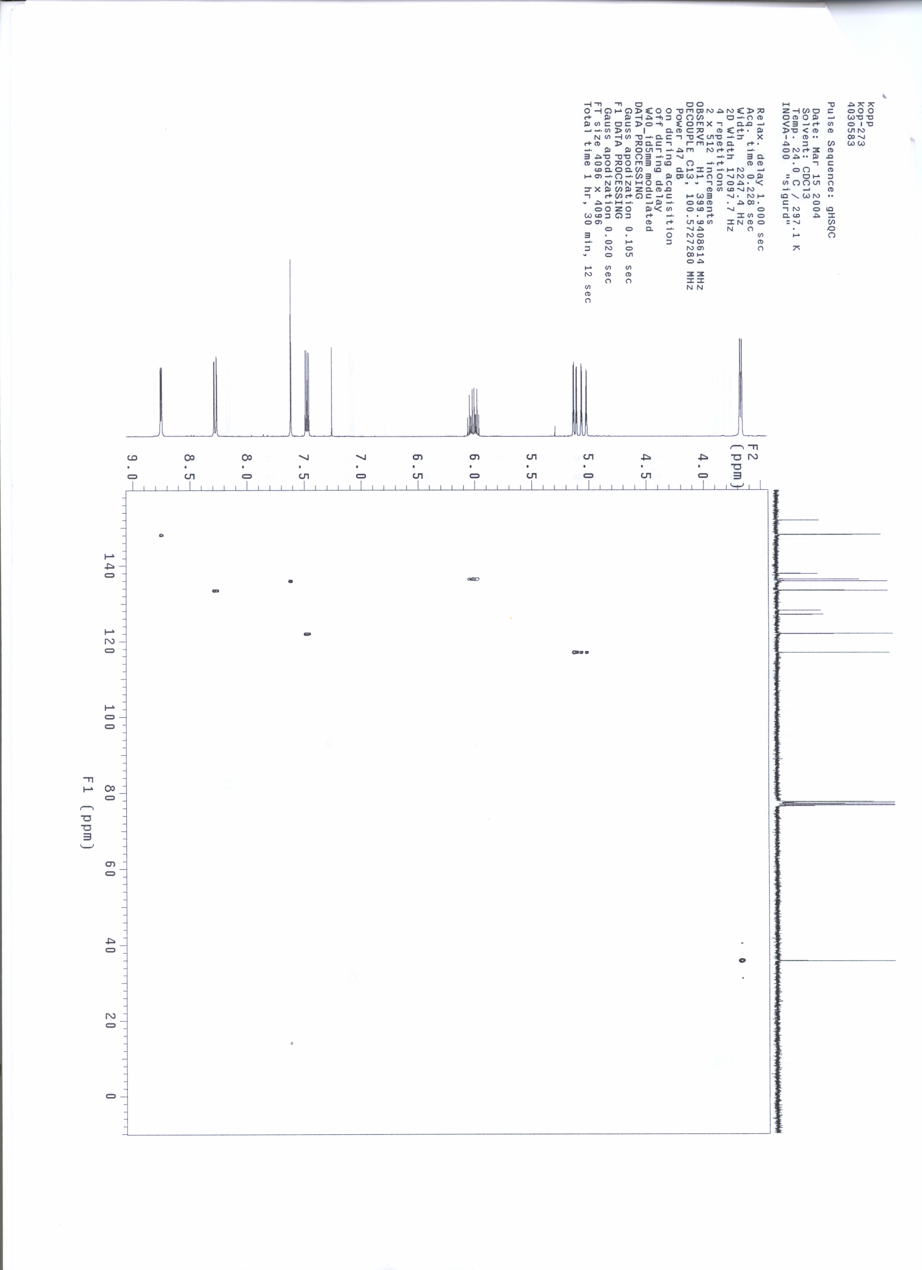

HMBC spectum of 7a:
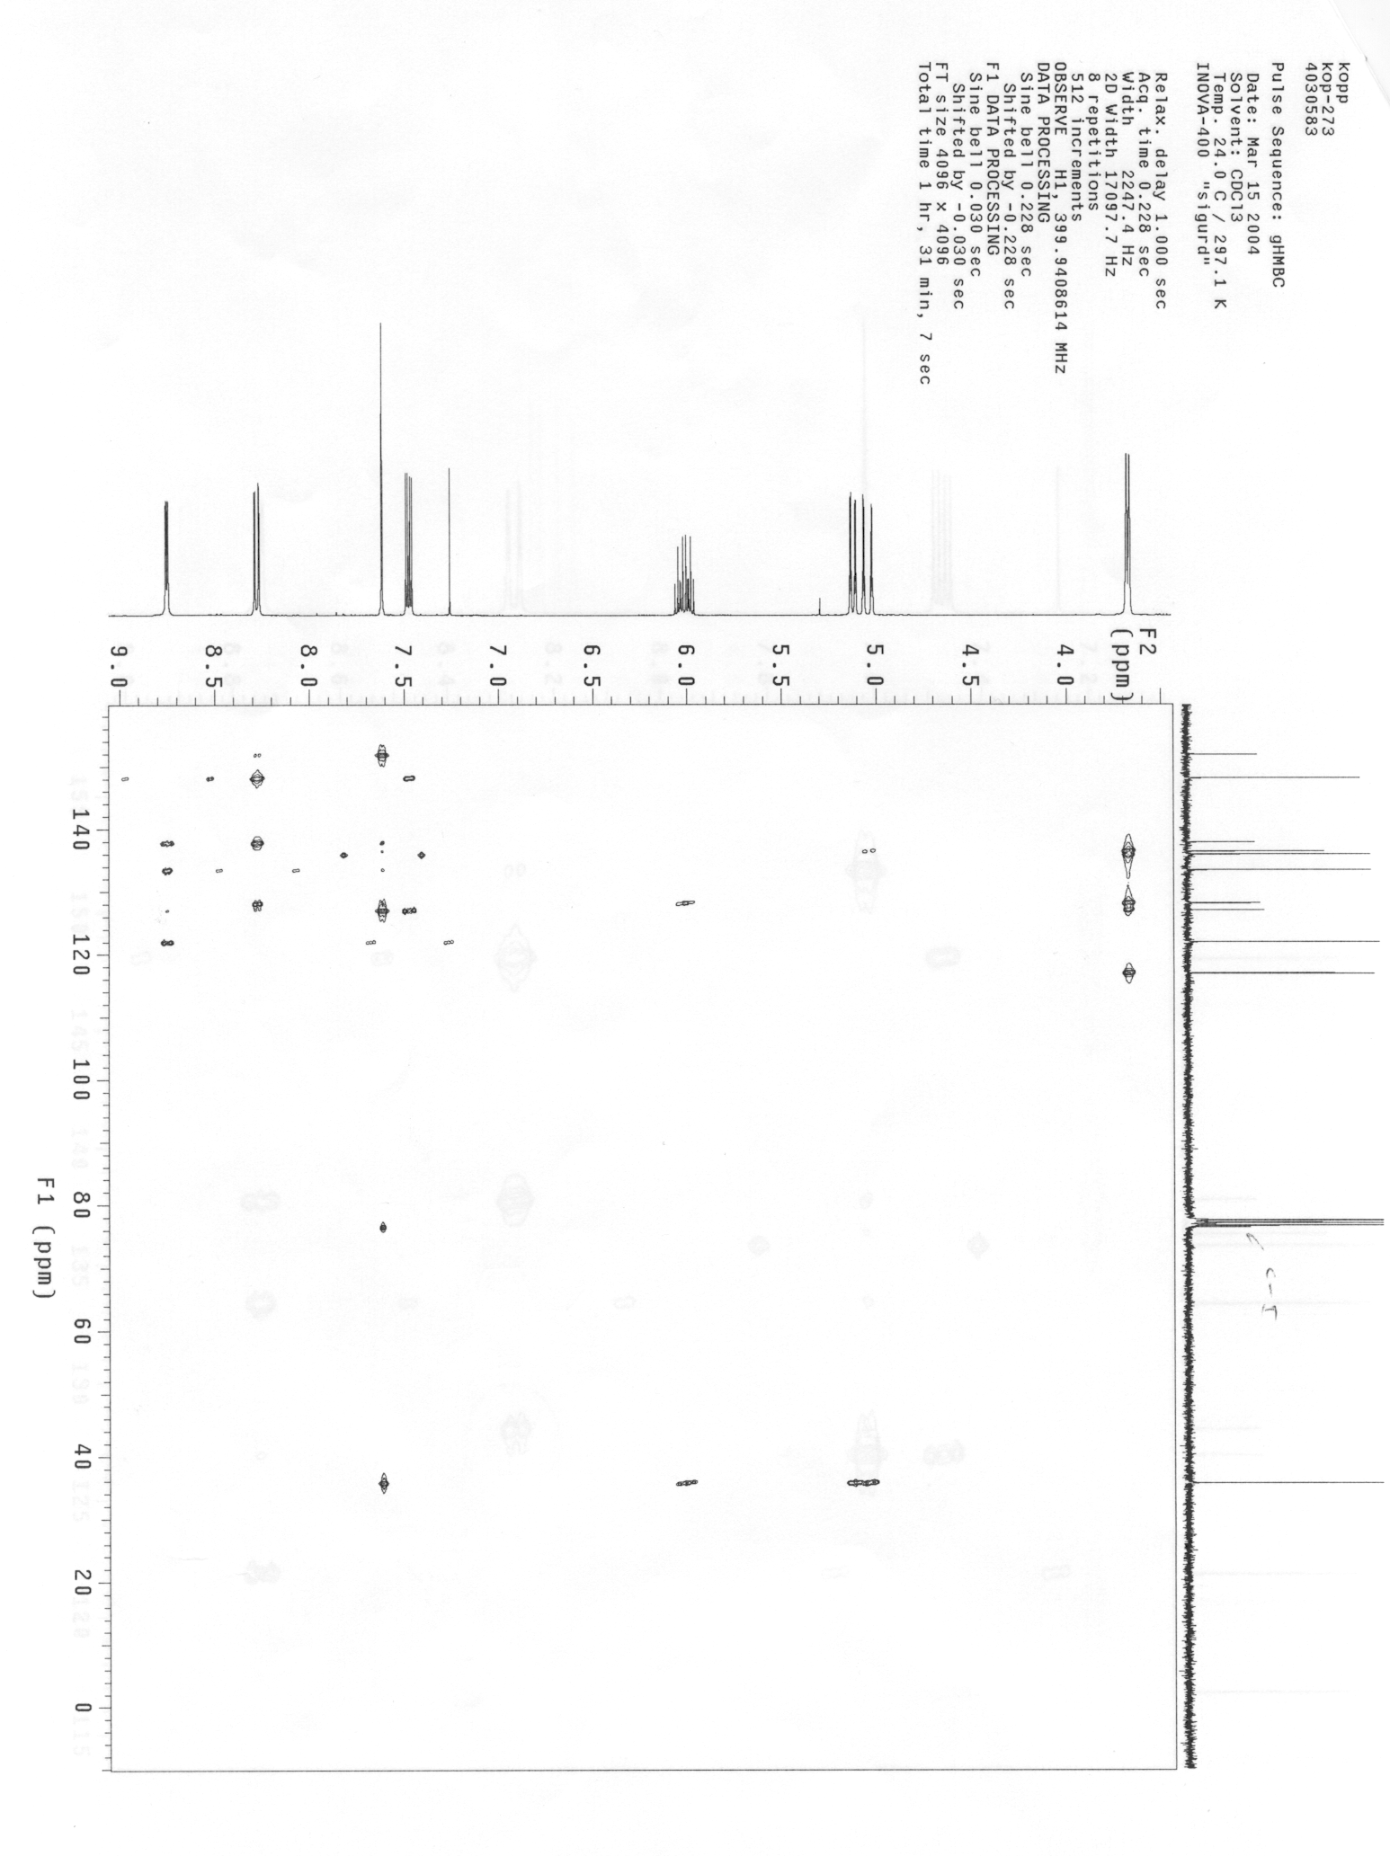

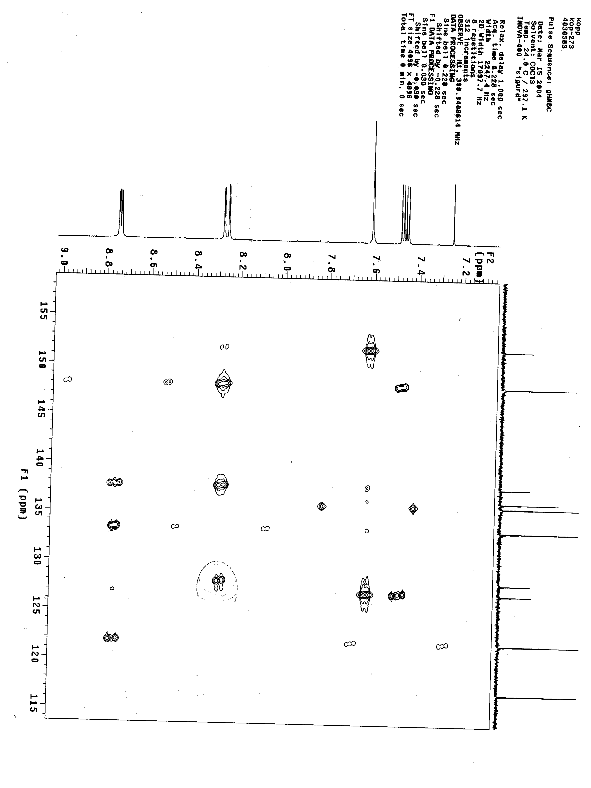
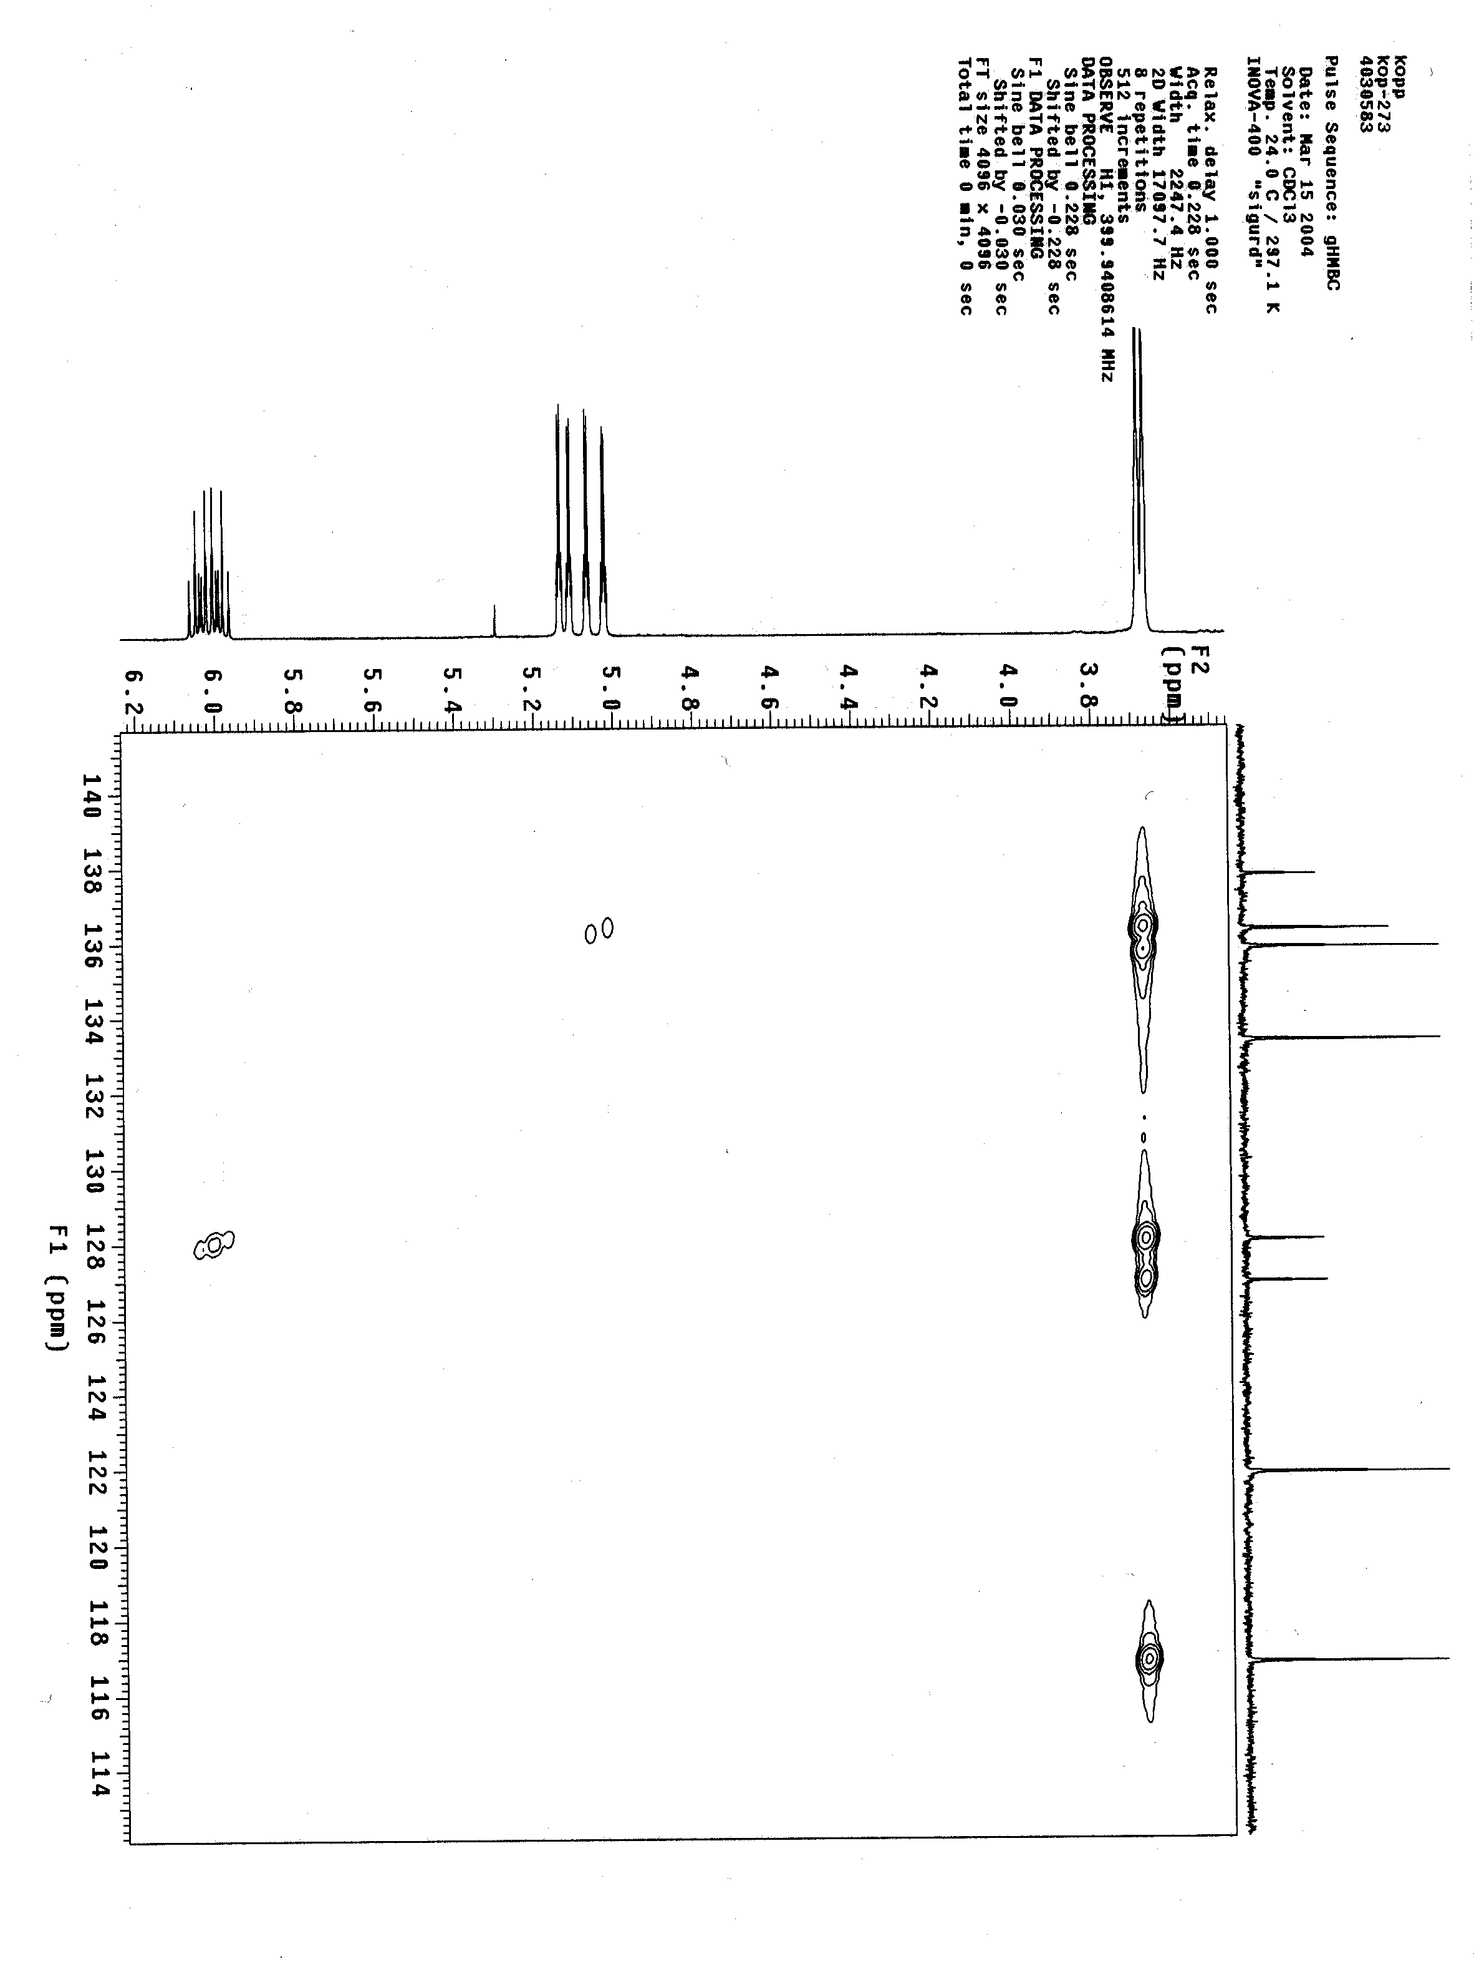
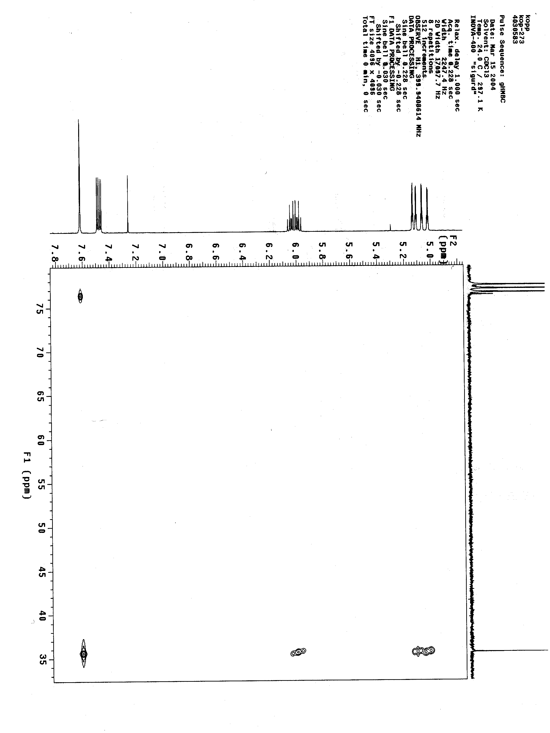

Preparation of 7-iodo-5-methylsulfanyl-quinolin-8-ol (7b): According to GP3 the Grignard reagent 6 was prepared and reacted with methanethiosulfonic acid S-methyl ester at –30 °C. After standard workup and recrystallization 7b was obtained as a pale yellow, crystalline solid (361 mg, 1.14 mmol, 76%).

mp: 148.5-149.0°C, starting decomposition at 130 °C
¹H-NMR (CDCl₃, 300 MHz): δ / ppm = 8.77 (d, J = 3.6 Hz, 1 H); 8.63 (d, J = 8.6 Hz, 1 H); 7.85 (s, 1 H); 7.53 (dd, J = 4.3 Hz, J’ = 8.6 Hz, 1 H); 2.46 (s, 1 H).
¹³C-NMR (CDCl₃, 75 MHz): δ / ppm = 152.5; 148.6; 137.8; 134.4; 128.0; 125.9; 122.3; 112.6; 77.20; 18.8.
IR (KBr): ν/cm⁻¹ = 3414 (m); 3060 (m); 2913 (m); 1951 (w); 1602 (w); 1565 (w); 1490 (s); 1394 (vs); 1375 (s); 1337 (s); 1271 (m); 1246 (w); 1207 (s); 1140 (w); 1046 (w); 970 (w); 956 (m); 846 (w); 806 (w); 782 (m); 731 (w); 717 (w); 690 (w);646 (m); 597 (w).
MS (EI): m/z (%) = 316 (M⁺, 89); 302 (100); 175 (8); 147 (30); 128 (4); 103 (9; 74 (5).
HR-MS: (C₁₀H₈INOS) calculated 316.9371 found 316.9363.

References and Notes:
[1] V. Koch, S. Schnatterer, Synthesis 1990, 499.
[2] R. Kluger, V. De Stefano, J. Org. Chem. 2000, 65, 216.
[3] This iodination method was already used for the preparation of corresponding aniline derivatives:
W. W. Sy, Synth. Commun. 1992, 22, 3215;
P. Knochel et al., Org. Lett. 2002, 4, 1819.

