Electronic Supplementary Information (ESI)
1. Synthesis of TrisE initiator: Triethanolamine (5.0 g, 33.5 mmol) and triethylamine (60 ml) were added to 200 ml dry THF. 2-Bromoisobutyryl bromide (24.7 ml, 45.98 g, 0.20 mol) was added dropwise to this mixture over 1 h at 0 ºC. After stirring for a further 2 h, the triethylammonium hydrochloride salt was removed by filtration and the resulting clear solution was concentrated under vacuum at 30 °C before washing with 0.1 M Na₂CO₃. The product was extracted three times with dichloromethane and the combined organic extract was dried with magnesium sulfate. Removal of the solvent under vacuum afforded a dark-reddish brown oil (15 g, yield: 75 %), which was stored at 4 °C prior to use.
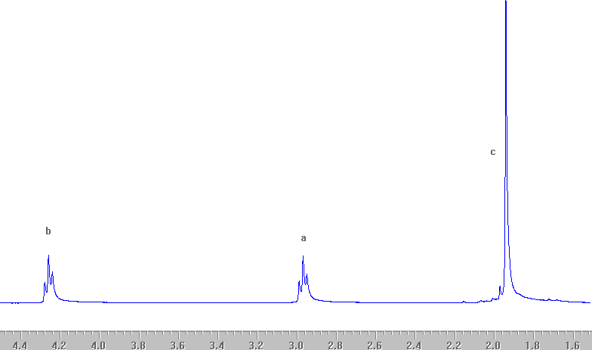

Figure 1. The ¹H NMR spectrum of the TrisE initiator

2. Synthesis of PPOMA macromonomer. Methacryloyl chloride (6.27 g, 60 mmol, 6.0 eq.) was added dropwise to a toluene solution (100 mL) of PPO (20.00 g, 10 mmol, 1.0 eq. M_{n} = 2,000, M_{w}/M_{n} = 1.10) and triethylamine (6.06 g, 60 mmol, 6.0 eq.) under nitrogen. This mixture was stirred for seven days at 20 ºC and then filtered to remove the triethylamine hydrochloride by-product. The solution was then washed three times with an aqueous solution of 0.1 M Na₂CO₃, followed by three washings with water. This solution was dried over MgSO₄ and the solvent was removed under reduced pressure. The final macromonomer product was obtained as a slightly yellow liquid (17.8 g, 85 %) and was stored in a freezer in the absence of light prior to use. ¹H NMR spectroscopy indicated a mean degree of esterification of at least 99 %.

3. Block copolymerization of MPC with other methacrylic monomers. The following examples illustrate the general synthetic protocols employed. MPC was polymerized first (3.7 g, 12.5 mmol; dissolved in 5.0 ml methanol) using the TrisE initiator and [MPC]:[TrisE]:[CuBr]:[bpy] relative molar ratios of 375:1:3:6. After 80 min., the monomer conversion was about 95 %, as judged by ¹H NMR. DMA (0.79 g, 50 mmol), DEA (0.93 g, 5.0 mmol) and PPOMA (0.621 g, 0.3 mmol) co-dissolved in 4.0 ml methanol were then added to this reaction solution. The overall target Dp for this statistical terpolymer was 103 (corresponding to 50 DMA units, 50 DEA units and 3 PPOMA units). The reaction mixture was maintained under a dry nitrogen purge for the duration of the polymerization. On exposure to air after 24 h, the reaction solution turned blue, indicating aerial oxidation of the ATRP catalyst. ¹H NMR studies indicated that the total monomer conversion exceeded 95 %. The reaction solution was passed through a silica gel column to remove the spent catalyst. Most of the solvent was then evaporated to obtain a concentrated (20-30 %) copolymer solution, which was precipitated into 500 ml n-hexane. This precipitation was repeated several times to ensure that any unreacted monomers (DMA, DEA, PPOMA) were removed. Finally, the purified star diblock copolymer was dried in a vacuum oven at room temperature to yield an off-white solid (5.37 g, 87 %).

Figure 2. Homopolymerisation of MPC via ATRP in methanol at 20 ºC using the trifunctional TrisE initiator: (a) conversion vs. time data and semi-logarithmic plot of monomer concentration vs. time. Conditions: (42 % MPC; target Dp = 375; TrisE:CuBr:bpy=1:3:6); (b) evolution of molecular weight and polydispersity vs. conversion; conditions as stated in (a).

4. Self-blocking (chain extension) experiments. MPC (1.85 g, 6.23 mmol) was polymerized in methanol (2.5 ml) using a [MPC]:[TrisE]:[Cu(I)Br]:[bpy] relative molar ratio of 180:1:3:6. After 50 min. the monomer conversion had reached about 95 %, as judged by ¹H NMR spectroscopy. At this point an aliquot of the polymerizing solution was extracted for subsequent characterization and a second batch of degassed MPC (1.85 g, 6.23 mmol; dissolved in 2.5 ml methanol) was added. NMR analysis after 20 h indicated that the residual vinyl signals (formerly at 5.6 and 6.1 ppm) were now absent, suggesting that the overall conversion was approximately 100 %.
Figure 3. Self-blocking experiments in methanol at 20 ºC using the trifunctional TrisE initiator. The conversion of the first batch of MPC prior to chain extension was 95 %. Overall final MPC conversion was 100 %. Conditions: first batch of MPC (1.85 g, 6.2 mmol), 2.5 mL methanol, target Dp = 187, [TrisE]:[Cu(I)]:[bpy] relative molar ratio = 1:3:6; second batch of MPC (1.85 g, 6.2 mmol).

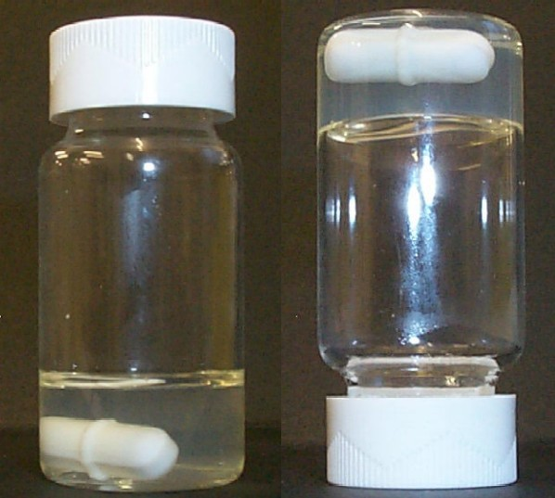

Figure 4. Digital photographs of (a) the free-flowing aqueous solution at room temperature and (b) the physical gel (note tube inversion) formed at 37 ºC by the I-(MPC₁₂₅-(DMA₅₀/DEA₅₀/PPOMA₃))₃ star diblock copolymer.

5 Static light scattering (SLS) studies. Static light scattering (SLS) studies were performed using a DAWN DSP laser photometer, equipped with a 5 mW He-Ne laser (λ = 633 nm) and eighteen photodiode detectors at scattering angles ranging from 22.5º to 147º. The dn/dc values of the final copolymer solutions were measureed using an Optilab DSP Interferometric refractometer (λ = 633 nm). Methanol was used as solvent in all cases.

Star Diblock Copolymer Architecture | M_{n} (theory) | dn/dc | M_{w}
I-(MPC₁₂₅-DMA₁₀₀)₃ | 158,000 | 0.155 | 232,000
I-[MPC₁₂₅-(DMA₉₇/PPOMA₃)]₃ | 175,000 | 0.148 | 246,000
I-[MPC₁₂₅(DMA₅₀/DEA₅₀)]₃ | 163,000 | 0.139 | 276,000
I-[MPC₁₂₅-(DMA₅₀/DEA₅₀/PPOMA₃)]₃ | 180,000 | 0.154 | 305,000

The actual M_{n} values should be at least as high as the theoretical target M_{n} values shown in the above Table. Bearing in mind the final copolymer polydispersities are probably around 1.5 (or higher), the M_{w} values for the above copolymers were expected to be at least 50 % higher than the target M_{n} values. Judging by the experimental M_{w} data obtained from SLS studies (see final column), this is indeed the case.
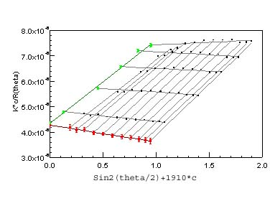
Figure 5. Typical Zimm plot obtained for the I-(MPC₁₂₅-DMA₁₀₀)₃ star diblock copolymer

6. PBS buffer: The buffer composition was 0.131 M NaCl, 0.0051 M Na₂HPO₄ and 0.015 M KH₂PO₄; the total ionic strength is 0.15 M; This protocol was taken from the Bacteriological Analytical Manual, 8th Ed., Revision A, 1998.
Figure 6: The detailed assignment of the ¹H NMR spectrum obtained for a 5 % solution of the I-[MPC₁₂₅-(DMA₅₀/DEA₅₀/PPOMA₃)]₃ star diblock copolymer dissolved in D₂O (pH 7.4) at 20 ºC

