Supplementary Information:

Concerning the relative importance of enantiomorphic site versus chain end control in the stereoselective polymerization of lactides: reactions of (R,R-salen)- and (S,S-salen)-aluminum alkoxides LAlOCH₂R complexes (R = CH₃ and S-CHMeCl)

Malcolm H. Chisholm,* Nathan J. Patmore and Zhiping Zhou

Department of Chemistry, The Ohio State University, 100 W 18th Ave., Columbus, Ohio 43210, USA.

Experimental
All syntheses and solvent manipulations were carried out under a nitrogen atmosphere using standard Schlenk-line and drybox techniques. Solvents were dried in the standard procedures. Trimethylaluminum (2.0 M solution in hexane, Aldrich), 4-dimethylaminopyridine (Aldrich), (R,R)-N,N’-bis(3,5-di-tert-butyl-salicylidene)-1,2-cyclohexenediamine (Aldrich), (S,S)-N,N’-bis(3,5-di-tert-butyl-salicylidene)-1,2-cyclohexenediamine (Aldrich), and (S) 2-chloro-1-propanol (Aldrich) were used as received. Lactides (L and rac, Aldrich) were sublimed three times under reduced pressure prior to use. Deuterated solvents were stored over 4 Å molecular sieves for 24 h prior to use.
X-ray crystallographic studies. The data collection crystals for (R,R-salen)AlOCH₂C(S)HMeCl and (S,S-salen)AlOCH₂C(S)HMeCl were both yellow chunks, which had been cut from a large crystal. Examination of the diffraction pattern on a Nonius Kappa CCD diffractometer indicated a monoclinic crystal system. All work was done at 200 K using an Oxford Cryosystems Cryostream Cooler. The data collection strategy was set up to measure a hemisphere of reciprocal space with a redundancy factor of 3.5 for (R,R-salen)AlOCH₂C(S)HMeCl and 4.2 for (S,S-salen)AlOCH₂C(S)HMeCl, which means that 90% of the reflections were measured at least 3.5 and 4.2 times, respectively. A combination of phi and omega scans with a frame width of 1.0 degree was used. Data integration was done with Denzo, and scaling and merging of the data was done with Scalepack.
The structure of (R,R-salen)AlOCH₂C(S)HMeCl was solved in P2₁ by the direct methods in SHELXS-97. The asymmetric unit contains two molecules of the Al complex. Two of the ^{t}Bu groups, one on each molecule, are disordered over two positions, and the corresponding carbon atoms were refined with isotropic displacement parameters. All non-hydrogen atoms were refined anistropically.
The structure of (S,S-salen)AlOCH₂C(S)HMeCl was solved in P2₁ by the direct methods in SHELXS-97. The asymmetric unit contains two molecules of the Al complex. Two of the ^{t}Bu groups, one on each molecule, are disordered over two positions, and the corresponding carbon atoms were refined with isotropic displacement parameters. All non-hydrogen atoms were refined anistropically.
Experimental data relating to both structure determinations are displayed in Table S1. Selected bond distances and angles for (R,R-salen)AlOCH₂C(S)HMeCl and (S,S-salen)AlOCH₂C(S)HMeCl are summarized in Table S2. CCDC 243022 and CCDC 246786 contain the supplementary crystallographic data for (R,R-salen)AlOCH₂C(S)HMeCl and (S,S-salen)AlOCH₂C(S)HMeCl, respectively. These data can be obtained free of charge via www.ccdc.cam.ac.uk/data_request/cif, by emailing data_request@ccdc.cam.ac.uk.

Synthesis of (R,R-salen) aluminum ethoxide. To a solution of (R,R-salen)H₂ (1.0 g, 1.8 mmol) in 20 mL of dichloromethane was added a solution of trimethylaluminum (AlMe₃ 2.0 M solution in hexane, 1.1 mL, 2.2 mmol), and the mixture was stirred for 3 h at room temperature. A yellow powder was obtained after the removal of volatile fractions under vacuum. The powder was redissolved in hexane, followed by the addition of 0.2 mL of ethanol (3.4 mmol), stirred for 3 h. A yellow precipitate was obtained as the product in 75% yield. ¹H NMR (CDCl₃, δ, ppm): 0.85 (t, CH₃-CH₂), 3.45 (m, CH₃CH₂), 1.29 (d, C(CH₃)), 1.53 (d, C(CH₃)), 1.44, 2.06, 2.42, 2.58, 3.05, 3.83 (cyclohexyl), 6.99, 7.04, 7.47, 7.50 (aromatic), 8.15, 8.35 (HC=N). ¹³C{¹H} NMR (CDCl₃, δ, ppm): 20.80 (CH₃CH₂), 23.76, 24.29, 27.28, 28.85 (CH₂ in cyclohexyl), 29.71, 29.93, 31.39, 31.45 ((CH₃)₃C), 33.95, 33.98, 35.58, 35.66 ((CH₃)₃C), 57.66(H₂C-O), 62.63, 65.78 (HC-N), 118.15, 118.40, 127.29, 127.70, 129.66, 130.90, 137.53, 138.05, 140.66, 140.86, 162.42, 164.23 (phenyl), 162.86, 167.95 (HC=N). Elemental analysis: Calcd.: C, 73.99; H, 9.31; N, 4.54. Found: C, 73.48; H, 9.33; N, 4.48%.
Synthesis of (S,S-salen) aluminum ethoxide. To a solution of (S,S-salen)H₂ (1.0 g, 1.8 mmol) in 20 mL of dichloromethane was added a solution of trimethylaluminum (AlMe₃ 2.0 M solution in hexane, 1.1 mL, 2.2 mmol), and the mixture was stirred for 3 h at room temperature. A yellow powder was obtained after the removal of volatile fractions under vacuum. The powder was redisolved in hexane, followed by the addition of 0.2 mL of ethanol (3.4 mmol), stirred for 3 h. A yellow precipitate was obtained as the product in 73% yield. ¹H NMR (CDCl₃, δ, ppm): 0.85 (t, CH₃-CH₂), 3.44 (m, CH₃CH₂), 1.29 (d, C(CH₃)), 1.53 (d, C(CH₃)), 1.44, 2.06, 2.43, 2.58, 3.05, 3.83 (cyclohexyl), 6.99, 7.04, 7.48, 7.50 (aromatic), 8.15, 8.35 (HC=N). ¹³C{¹H} NMR (CDCl₃, δ, ppm): 20.80 (CH₃CH₂), 23.76, 24.29, 27.28, 28.85 (CH₂ in cyclohexyl), 29.71, 29.93, 31.39, 31.45 ((CH₃)₃C), 33.95, 33.98, 35.58, 35.66 ((CH₃)₃C), 57.66(H₂C-O), 62.63, 65.78 (HC-N), 118.15, 118.40, 127.29, 127.70, 129.66, 130.90, 137.53, 138.05, 140.65, 140.86, 162.42, 164.23 (phenyl), 162.86, 167.95 (HC=N). Elemental analysis: Calcd.: C, 73.99; H, 9.31; N, 4.54. Found: C, 73.25; H, 9.24; N, 4.42%.
Synthesis of (R,R-salen)AlOCH₂C(S)HMeCl. To a solution of (R,R-salen)H (1.0 g, 1.8 mmol) in 20 mL of dichloromethane was added a solution of trimethylaluminum (AlMe₃ 2.0 M solution in hexane, 1.1 mL, 2.2 mmol), and the mixture was stirred for 3 h at room temperature. A yellow powder was obtained after the removal of volatile fractions under vacuum. The powder was redisolved in hexane, followed by the addition of 0.19 mL of (S) 2-chloro-1-propanol (2.2 mmol), stirred for 3 h. A yellow precipitate was obtained as the product in 75% yield. Crystals of this complex were obtained by slow evaporation of the solvent from a concentrated benzene solution of the complex.. ¹H NMR (CDCl₃, δ, ppm): 1.17 (d, CH₃-CHCl) 3.40, 3.50 (m, OCH₂), 3.68 (m, CHCl), 1.29 (d, C(CH₃)), 1.51 (d, C(CH₃)), 1.44, 2.07, 2.43, 2.58, 3.06, 3.90 (cyclohexyl), 7.00, 7.05, 7.48, 7.51 (aromatic), 8.17, 8.35 (HC=N). ¹³C{¹H} NMR (CDCl₃, δ, ppm): 21.43 (CH₃CH), 23.75, 24.27, 27.27, 28.80 (CH₂ in cyclohexyl), 29.67, 29.94, 31.36, 31.43 ((CH₃)₃C), 33.96, 33.99, 35.56, 35.64 ((CH₃)₃C), 61.10, 62.64 (HC-N), 65.86 (HC-Cl), 69.25(H₂C-O), 118.12, 118.35, 127.37, 127.75, 129.84, 131.11, 137.82, 138.29, 140.59, 140.79, 162.27, 163.92 (phenyl), 163.02, 168.19 (HC=N). Elemental analysis: Calcd.: C, 70.41; H, 8.79; N, 4.21. Found: C, 69.16; H, 8.44; N, 4.03%.
Synthesis of (S,S-salen)AlOCH₂C(S)HMeCl. To a solution of (S,S-salen)H₂ (1.0 g, 1.8 mmol) in 20 mL of dichloromethane was added a solution of trimethylaluminum (AlMe₃ 2.0 M solution in hexane, 2.2 mL, 2.2 mmol), and the mixture was stirred for 3 h at room temperature. A yellow powder was obtained after the removal of volatile fractions under vacuum. The powder was redisolved in hexane, followed by the addition of 0.19 mL of (S) 2-chloro-1-propanol (2.2 mmol), stirred for 3 h. A yellow precipitate was obtained as the product in 70% yield. Crystals of this complex were obtained by slowly evaporation of the solvent from a concentrated benzene solution of the complex. ¹H NMR (CDCl₃, δ, ppm): 1.22 (d, CH₃-CHCl), 3.46 (m, OCH₂), 3.69 (m, CHCl), 1.29 (d, C(CH₃)), 1.52 (d, C(CH₃)), 1.44, 2.06, 2.43, 2.58, 3.06, 3.93 (cyclohexyl), 7.00, 7.05, 7.48, 7.51 (aromatic), 8.17, 8.36 (HC=N). ¹³C{¹H} NMR (CDCl₃, δ, ppm): 21.40 (CH₃CH), 23.78, 24.30, 27.28, 28.74 (CH₂ in cyclohexyl), 29.67, 29.97, 31.38, 31.43 ((CH₃)₃C), 33.97, 34.00, 35.57, 35.65 ((CH₃)₃C), 61.52 (HC-Cl), 62.55, 65.87(HC-N), 69.56(H₂C-O), 118.18, 118.33, 127.41, 127.79, 129.84, 131.05, 137.75, 138.33, 140.54, 140.83, 162.19, 164.00 (phenyl), 163.00, 168.28 (HC=N). Elemental analysis: Calcd.: C, 70.41; H, 8.79; N, 4.21. Found: C, 69.64; H, 8.73; N, 4.02%.
Ring-opening reactions of 1 equiv of lactides. 20 mg of lactide (L or rac, 0.14 mmol) and 5 mg of (salen)AlOCH₂R (~0.008 mmol) were dissolved in 1 mL of solvent in a J-Young NMR tube and allowed to react at room temperature for 12 h in the cases of (salen)AlOCH₂CH₃, or 3 d in the cases of (salen)AlOCH₂CHMeCl. The solvent was removed under vacuum, and the resulting mixture was redissolved in 1 mL of CDCl₃ for ¹H NMR measurement. The products in the reactions of L-lactide and all those four (salen)AlOCH₂R complexes were analyzed by ¹H NMR as references for identifying products in the reactions involving rac-lactide.
Ring-opening polymerization reactions of rac-lactide. Typically (salen)AlOCH₂R (20 mg, 0.03 mmol) and rac-lactide (0.45 g, 3.1 mmol) were allowed to react in 15 mL of toluene at 80ºC for 10 d, yielding polylactide with 40% conversion. The obtained polymers were analyzed by NMR and GPC (M_{n} = 9 000 to 11 000 Da, PDI = 1.13 to 1.16).
Table S1 Crystallographic details for (R,R-salen)AlOCH₂C(S)HMeCl and (S,S-salen)AlOCH₂C(S)HMeCl.
 | (R,R)-S | (S,S)-S
Empirical formula | C₃₉H₅₈AlClN₂O₃ | C₃₉H₅₈AlClN₂O₃
Formular weight | 665.30 | 665.30
Temperature (K) | 200 | 200
Wavelenghth (Å) | 0.71073 | 0.71073
Crystal system | monoclinic | monoclinic
Space group | P2₁ | P2₁
Unit cell dimensions
a (Å) | 14.923(1) | 14.927(1)
b (Å) | 11.021(1) | 10.941(1)
c (Å) | 23.440(1) | 23.393(1)
ß (º) | 93.397(1) | 93.69(1)
V (Å³) | 3848.6(7) | 3812.5(7)
Z | 4 | 4
D_{calc} (mg m⁻³) | 1.148 | 1.159
Absorption coefficient (mm⁻¹) | 0.159 | 0.160
F(000) | 1440 | 1440
Crystal size (mm⁻³) | 0.38x0.19x0.15 | 0.38x0.31x0.27
Theta range for data collection (º) | 1.58-22.99 | 1.57-25.03
Index ranges | -16≤h≤16, -12≤k≤12,  -25≤l≤25 | -17≤h≤17, -13≤k≤12,  -27≤l≤27
Reflections collected | 60183 | 60079
Independent reflections | 10692[R_{int}=0.073] | 13387[R_{int}=0.058]
Refinement method | Full-matrix least-squares on F² | Full-matrix least-squares on F²
Data/restraints/parameters | 10692/1/886 | 13387/1/826
Flack parameter | 0.00(9) | 0.00(8)
Goodness-of-fit on F² | 1.021 | 1.020
Final R indices [I>2σ(I)] | R₁=0.0508, wR₂=0.1237 | R₁=0.0555, wR₂=0.1321
R indices (all data) | R₁=0.0749, wR₂=0.1364 | R₁=0.0852, wR₂=0.1467
Largest difference peak and hole (e/Å³) | 0.412 and -0.506 | 0.565 and -0.371

Table S2 Selected bond distances (Å) and angles (deg) for (R,R-salen)AlOCH₂C(S)HMeCl and (S,S-salen)AlOCH₂C(S)HMeCl. (The atom numbers are corresponding to Fig. 1)

(R,R)-S |  | (S,S)-S
Al1─O1 | 1.797(3) | Al2─O5 | 1.798(3)
Al1─O2 | 1.804(3) | Al2─O6 | 1.820(3)
Al1─O3 | 1.746(3) | Al2─O4 | 1.748(3)
Al1─N1 | 2.021(3) | Al2─N3 | 2.004(3)
Al1─N2 | 1.999(3) | Al2─N4 | 2.010(3)
O3─C38 | 1.377(6) | O4─C76 | 1.401(5)
C38─C39 | 1.501(7) | C76─C77 | 1.488(6)
C39─C40 | 1.497(7) | C77─C78 | 1.504(7)
Cl1─C39 | 1.809(5) | Cl2─C77 | 1.811(4)
O3─Al1─O1 | 109.7(1) | O4─Al2─O5 | 111.0(1)
O3─Al1─O2 | 107.2(1) | O4─Al2─O6 | 106.5(1)
O3─Al1─N1 | 96.5(1) | O4─Al2─N3 | 97.0(1)
O3─Al1─N2 | 104.3(1) | O4─Al2─N4 | 103.2(1)
O1─Al1─O2 | 89.8(1) | O5─Al2─O6 | 89.8(1)
O1─Al1─N1 | 88.8(1) | O5─Al2─N3 | 88.8(1)
O1─Al1─N2 | 144.9(2) | O5─Al2─N4 | 144.9(1)
O2─Al1─N2 | 88.2(1) | O6─Al2─N4 | 88.2(1)
O2─Al1─N1 | 155.2(1) | O6─Al2─N3 | 155.3(1)
N1─Al1─N2 | 78.9(1) | N3─Al2─N4 | 79.0(1)
C38─O3─Al1 | 127.3(3) | C76─O4─Al2 | 124.4(3)
O3─C38─C39 | 113.6(4) | O4─C76─C77 | 113.0(4)
C38─C39─C40 | 112.6(5) | C76─C77─C78 | 112.0(4)
C38─C39─Cl1 | 110.2(3) | C76─C77─Cl2 | 111.0(3)
C40─C39─Cl1 | 111.5(4) | C78─C77─Cl2 | 111.4(3)

Scheme S1 Ring opening of 1 equiv of lactide by (salen)AlOCH₂R (R = CH₃, or C(S)HMeCl).

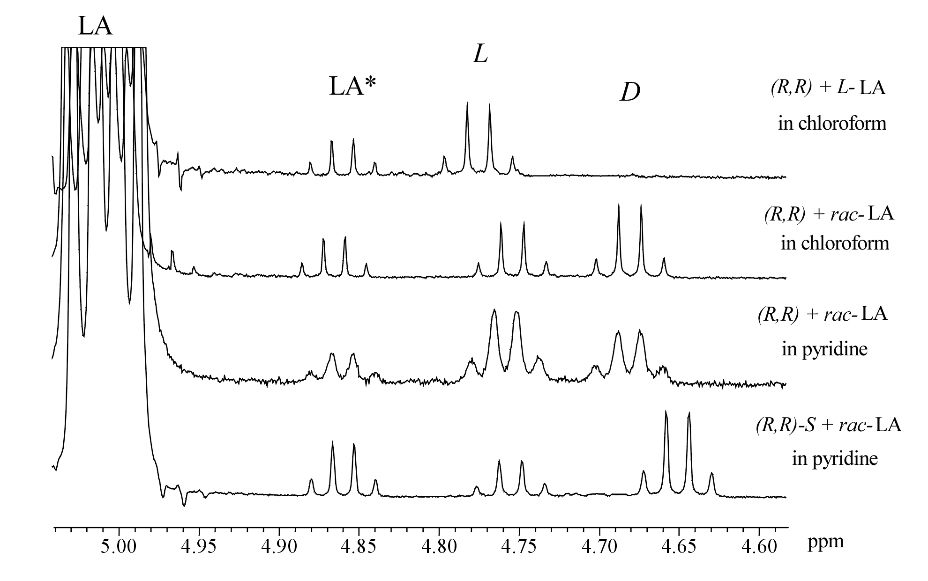
Fig. S1 Selected ¹H (500MHz, CDCl₃) NMR spectra showing methine proton region (H_{b} in Scheme S1) in the products in ring-opening reactions of 1 equiv of lactide by (salen)AlOCH₂R. LA, unreacted lactide; LA*, LA satellite signals; L, L-LA ring opened product; D, D-LA ring opened product.

Fig. S2 ¹H (500MHz, CDCl₃) NMR spectra of the homodecoupled methine proton (CH) resonance of poly(rac-lactide) prepared in toluene using: (A) (R,R-salen)AlOCH₂CH₃, (B) (R,R-salen)AlOCH₂C(S)HMeCl, and (C) (S,S-salen)AlOCH₂C(S)HMeCl.

