Supporting Information
for
Homochiral 1D-Helical Metal-Organic Frameworks from Achiral Components. Formation of Chiral Channel via C-H ··· Cl Interaction

V. Balamurugan and Rabindranath Mukherjee*
Department of Chemistry, Indian Institute of Technology Kanpur, Kanpur 208 016, India. Fax/Tel: 91 512 259 7437
E-mail: rnm@iitk.ac.in

________________________________________________

Figures captions:
Fig. S1 X-ray structure of [(L⁶)ZnCl₂]∞ (1a) with C-H … Cl interactions; selected bond lengths [Å] and angles [º]: Zn-N(1) 2.037(5), Zn-N(4) 2.034(6), Zn-Cl(1) 2.228(2), Zn-Cl(2) 2.229(2), N(1)-Zn-N(4) 105.9(2), N(1)-Zn-Cl(1) 112.54(17), N(1)-Zn-Cl(2) 104.99(16), N(4)-Zn-Cl(1) 111.23(17), N(4)-Zn-Cl(2) 107.34(18), Cl(1)-Zn-Cl(2) 114.25(9). All the hydrogen atoms except those involved in hydrogen bonding have been omitted for clarity.
Fig. S2 X-ray structure of [(L⁶)ZnCl₂]∞ (1b) with C-H … Cl interactions; selected bond lengths [Å] and angles [º]: Zn-N(1) 2.0320(17), Zn-N(4) 2.0316(17), Zn-Cl(1) 2.2406(6), Zn-Cl(2) 2.2366(6), N(1)-Zn-N(4) 106.59(7), N(1)-Zn-Cl(1) 111.99(5), N(1)-Zn-Cl(2) 104.86(5), N(4)-Zn-Cl(1) 111.55(5), N(4)-Zn-Cl(2) 106.95(5), Cl(1)-Zn-Cl(2) 114.35(2).
Fig. S3 X-ray structure of [(L)Cu^{II}Cl₂]∞. (Adapted from Ref. 12)
Fig. S4 ¹H NMR spectrum (400 MHz) of [(L⁶)ZnCl₂]∞ (2) in (CD₃)₂SO (298K) (only relevant portion is shown). Assignments are indicated.

Fig. S1

Fig. S2
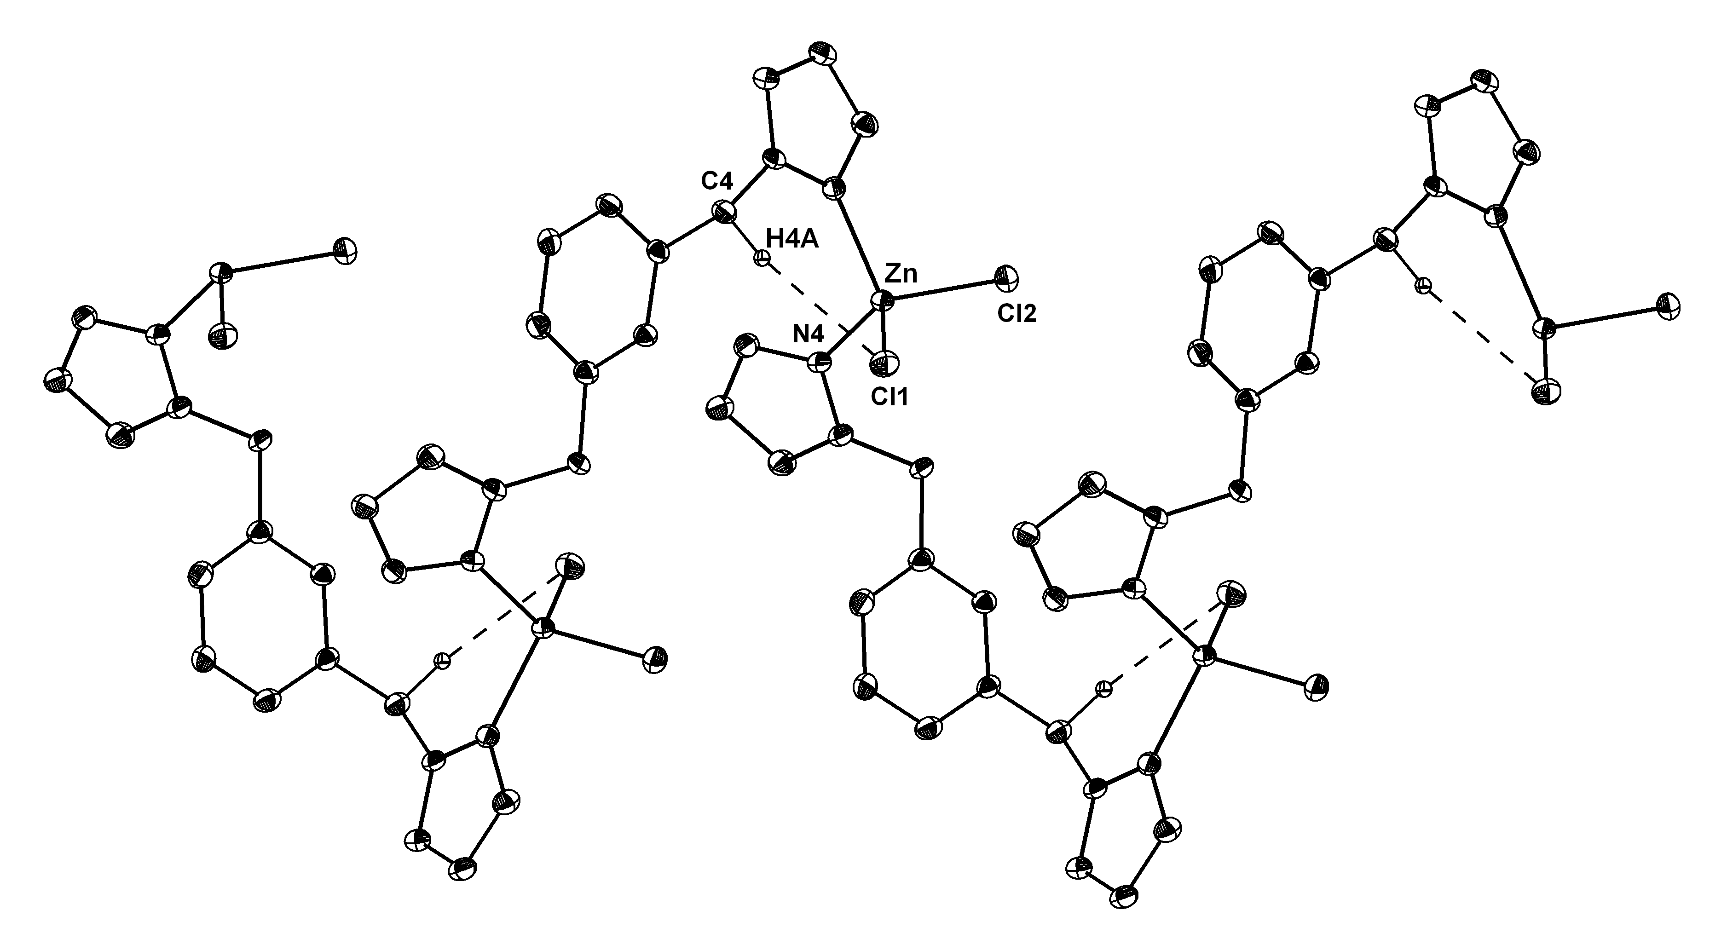
Fig. S3
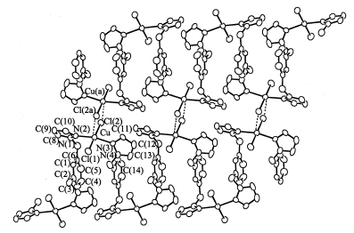

Fig. S4

