Supplementary data
Stabilization of very rare tautomers of uracil by an excess electron

Rafał A. Bachorz,^{a,b,c} Janusz Rak,ª and Maciej Gutowski^{a,c}

ªDepartment of Chemistry, University of Gdańsk, 80-952 Gdańsk, Poland

^{b}Department of Chemistry, Quantum Chemistry Group, Adam Mickiewicz University, Poznań, Poland

^{c}Chemical Sciences Division, Fundamental Sciences Directorate, Pacific Northwest National Laboratory, Richland, Washington 99352,USA
Table S1. Relative stability [kcal/mol] and vertical detachment energy [meV] of anionic tautomers of uracil calculated at the B3LYP/6-31++G** level of theory. For each tautomer only the most stable rotamer is presented.
Tautomer | ΔE | ΔE+ΔE_{vib} | ΔG | ΔH | VDE
$${\text{aU}}_{n1}^{c5}$$ | 0.00 | 0.00 | 0.00 | 0.00 | 1512
$${\text{aU}}_{\text{can}}$$ | 2.57 | 2.93 | 2.74 | 3.12 | 747
$${\text{aU}}_{n3}^{c5}$$ | 6.40 | 6.49 | 6.40 | 6.55 | 2637
$${\text{aU}}_{n1}^{c6}$$ | 10.43 | 9.79 | 9.43 | 9.91 | 3675
$${\text{aU}}_{n1n3}^{c5o7}$$ | 10.82 | 10.64 | 10.62 | 10.66 | 1683
$${\text{aU}}_{n3}^{c6}$$ | 12.00 | 11.95 | 11.79 | 12.00 | 3960
$${\text{aU}}_{n3}^{o8}$$ | 14.16 | 14.17 | 14.25 | 14.33 | 708
$${\text{aU}}_{n1n3}^{c5c6}$$ | 15.85 | 15.70 | 15.66 | 15.66 | 4375
$${\text{aU}}_{n1}^{o7}$$ | 18.81 | 18.07 | 18.05 | 18.34 | 266
$${\text{aU}}_{n1n3}^{c6o7}$$ | 19.60 | 19.27 | 19.19 | 19.31 | 3407
$${\text{aU}}_{n1}^{o8}$$ | 20.47 | 19.48 | 19.25 | 19.76 | 883
$${\text{aU}}_{n1n3}^{c5o8}$$ | 23.46 | 22.79 | 22.87 | 22.78 | 1118
$${\text{aU}}_{n1n3}^{o7o8}$$ | 26.51 | 26.18 | 26.47 | 26.19 | -134
$${\text{aU}}_{n1n3}^{c6o8}$$ | 31.14 | 29.61 | 28.93 | 29.81 | 3304
$${\text{aU}}_{n1n3}^{c2o7}$$ | 32.01 | 31.54 | 31.94 | 31.54 | 3775
$${\text{aU}}_{c6}^{c5}$$ | 35.67 | 35.98 | 36.04 | 35.98 | 1178
$${\text{aU}}_{c5}^{c6}$$ | 36.02 | 36.22 | 35.94 | 36.39 | 2908
$${\text{aU}}_{n1n3}^{c4o8}$$ | 37.64 | 36.51 | 36.68 | 36.69 | 3722
$${\text{aU}}_{c6n1}^{c2o7}$$ | 38.56 | 38.93 | 39.26 | 39.07 | 3060
$${\text{aU}}_{c6n1}^{c4o8}$$ | 39.10 | 39.47 | 39.87 | 39.57 | 3090
$${\text{aU}}_{c5n3}^{c6o8}$$ | 46.06 | 46.33 | 46.01 | 46.46 | 2977
$${\text{aU}}_{c6n3}^{c4o8}$$ | 50.39 | 50.11 | 50.41 | 50.28 | 3276
$${\text{aU}}_{c5n1}^{c4o8}$$ | 50.91 | 50.86 | 50.76 | 51.09 | 3547
$${\text{aU}}_{c5n1}^{c2o7}$$ | 52.56 | 52.96 | 53.39 | 53.04 | 3486
$${\text{aU}}_{c6n3}^{c5o7}$$ | 53.86 | 53.66 | 53.73 | 53.75 | 1211
$${\text{aU}}_{c6n3}^{c2o7}$$ | 54.17 | 54.03 | 54.39 | 54.19 | 3106
$${\text{aU}}_{c6n3}^{c5o8}$$ | 56.52 | 50.87 | 51.06 | 50.85 | 822
$${\text{aU}}_{c5n1}^{c6o7}$$ | 56.62 | 56.49 | 56.40 | 56.62 | 2619
$${\text{aU}}_{c5n3}^{c4o8}$$ | 57.80 | 57.72 | 57.95 | 57.98 | 3961
$${\text{aU}}_{c5n1n3}^{c6o7o8}$$ | 58.88 | 58.88 | 58.75 | 58.96 | 2658
$${\text{aU}}_{c5n1}^{c6o8}$$ | 59.18 | 58.49 | 58.32 | 58.68 | 3238
$${\text{aU}}_{c6n1}^{c5o7}$$ | 61.97 | 60.74 | 60.65 | 61.06 | 1521
$${\text{aU}}_{c5n3}^{c2o7}$$ | 63.15 | 63.03 | 63.37 | 63.24 | 3671
$${\text{aU}}_{c5n3}^{c6o7}$$ | 64.33 | 64.02 | 63.86 | 64.19 | 2325
$${\text{aU}}_{c6n1}^{c5o8}$$ | 66.95 | 65.57 | 65.29 | 65.92 | 1737
$${\text{aU}}_{c6n1n3}^{c5o7o8}$$ | 69.59 | 68.38 | 68.43 | 68.58 | 1348
$${\text{aU}}_{c5c6n1n3}^{c2c4o7o8}$$ | 73.91 | 71.89 | 70.59 | 73.03 | 3064
$${\text{aU}}_{n3}^{o7}$$ | The tautomer could not be identified.

Table S2. Relative stability [kcal/mol] and dipole moment [D] of neutral tautomers of uracil calculated at the B3LYP/6-31++G** level of theory. For each tautomer only the most stable rotamer is presented.
Tautomer | ΔE | ΔE+ ΔE_{vib} | ΔG | ΔH | μ
$${\text{nU}}_{\text{can}}$$ | 0.00 | 0.00 | 0.00 | 0.00 | 4.66
$${\text{nU}}_{n1}^{o7}$$ | 11.09 | 10.91 | 11.03 | 10.85 | 3.42
$${\text{nU}}_{n3}^{o8}$$ | 11.94 | 11.75 | 11.82 | 11.70 | 5.07
$${\text{nU}}_{n1n3}^{o7o8}$$ | 12.77 | 12.66 | 12.89 | 12.54 | 1.30
$${\text{nU}}_{n1}^{c5}$$ | 17.91 | 16.86 | 16.23 | 17.03 | 3.81
$${\text{nU}}_{n3}^{o7}$$ | 19.53 | 19.09 | 19.04 | 19.15 | 6.72
$${\text{nU}}_{n1}^{o8}$$ | 21.39 | 20.71 | 20.69 | 20.78 | 7.46
$${\text{nU}}_{n1n3}^{c5o7}$$ | 34.43 | 33.18 | 32.61 | 33.32 | 3.20
$${\text{nU}}_{n1n3}^{c5o8}$$ | 35.09 | 33.81 | 33.29 | 33.95 | 6.16
$${\text{nU}}_{n3}^{c5}$$ | 45.05 | 42.75 | 42.08 | 43.21 | 9.28
$${\text{nU}}_{c6}^{c5}$$ | 47.66 | 46.49 | 45.86 | 46.73 | 0.51
$${\text{nU}}_{c5c6n1n3}^{c2c4o7o8}$$ | 48.15 | 45.71 | 44.41 | 46.71 | 5.07
$${\text{nU}}_{c6n3}^{c2o7}$$ | 48.47 | 45.48 | 44.40 | 46.19 | 2.95
$${\text{nU}}_{n3}^{c6}$$ | 58.29 | 57.02 | 56.68 | 57.18 | 6.20
$${\text{nU}}_{c6n3}^{c5o8}$$ | 61.21 | 59.89 | 59.28 | 60.10 | 3.01
$${\text{nU}}_{c6n3}^{c4o8}$$ | 63.00 | 59.60 | 57.32 | 60.82 | 2.15
$${\text{nU}}_{c6n1}^{c5o8}$$ | 66.85 | 63.59 | 61.77 | 64.81 | 4.95
$${\text{nU}}_{c6n3}^{c5o7}$$ | 68.81 | 67.25 | 66.88 | 67.46 | 4.02
$${\text{nU}}_{n1n3}^{c2o7}$$ | 78.19 | 76.39 | 76.32 | 76.48 | 3.87
$${\text{nU}}_{c6n1}^{c5o7}$$ | 81.56 | 79.11 | 78.36 | 79.51 | 3.83
$${\text{nU}}_{n1n3}^{c5c6}$$ | 82.47 | 80.24 | 79.58 | 80.46 | 4.94
$${\text{nU}}_{c6n1}^{c4o8}$$ | 82.53 | 80.38 | 80.11 | 80.74 | 3.68
$${\text{nU}}_{c6n1}^{c2o7}$$ | 82.98 | 80.86 | 80.62 | 81.22 | 1.96
$${\text{nU}}_{c5n3}^{c4o8}$$ | 85.94 | 84.30 | 84.24 | 84.46 | 4.52
$${\text{nU}}_{c5n1n3}^{c6o7o8}$$ | 88.06 | 85.77 | 85.61 | 85.96 | 1.57
$${\text{nU}}_{c5}^{c6}$$ | 88.81 | 86.01 | 85.49 | 86.46 | 3.89
$${\text{nU}}_{n1n3}^{c6o7}$$ | 89.44 | 85.73 | 85.12 | 86.16 | 6.70
$${\text{nU}}_{c5n1}^{c6o8}$$ | 92.61 | 90.51 | 89.97 | 90.96 | 4.41
$${\text{nU}}_{n1n3}^{c6o8}$$ | 95.02 | 91.21 | 90.99 | 91.50 | 6.21
$${\text{nU}}_{c5n3}^{c6o8}$$ | 102.12 | 99.37 | 98.89 | 99.78 | 3.73
$${\text{nU}}_{c5n1}^{c6o7}$$ | 102.51 | 99.41 | 99.07 | 99.81 | 3.84
$${\text{nU}}_{n1n3}^{c4o8}$$ | 102.53 | 98.57 | 98.22 | 98.96 | 5.18
$${\text{nU}}_{c5n3}^{c6o7}$$ | 103.48 | 100.69 | 100.34 | 101.13 | 6.38
$${\text{nU}}_{c5n3}^{c2o7}$$ | 104.29 | 101.91 | 101.54 | 102.29 | 5.10
$${\text{nU}}_{c6n1n3}^{c5o7o8}$$ | 110.06 | 106.85 | 106.23 | 107.29 | 2.42
$${\text{nU}}_{c5n1}^{c4o8}$$ | 114.60 | 111.61 | 110.66 | 112.17 | 3.55
$${\text{nU}}_{c5n1}^{c2o7}$$ | 114.69 | 111.76 | 110.96 | 112.34 | 2.37
$${\text{nU}}_{n1}^{c6}$$ | The tautomer could not be identified.

Table S3. The exponents of additional s and p symmetry functions localized on the H(C6) atom and used in calculations for the dipole-bound state based on the canonical tautomer.

Symmetry | Exponents
s | 0.0076325
s | 0.0023600
s | 0.00072973
s | 0.00022564
p | 0.02974
p | 0.0076325
p | 0.002360
p | 0.00072973
p | 0.00022564

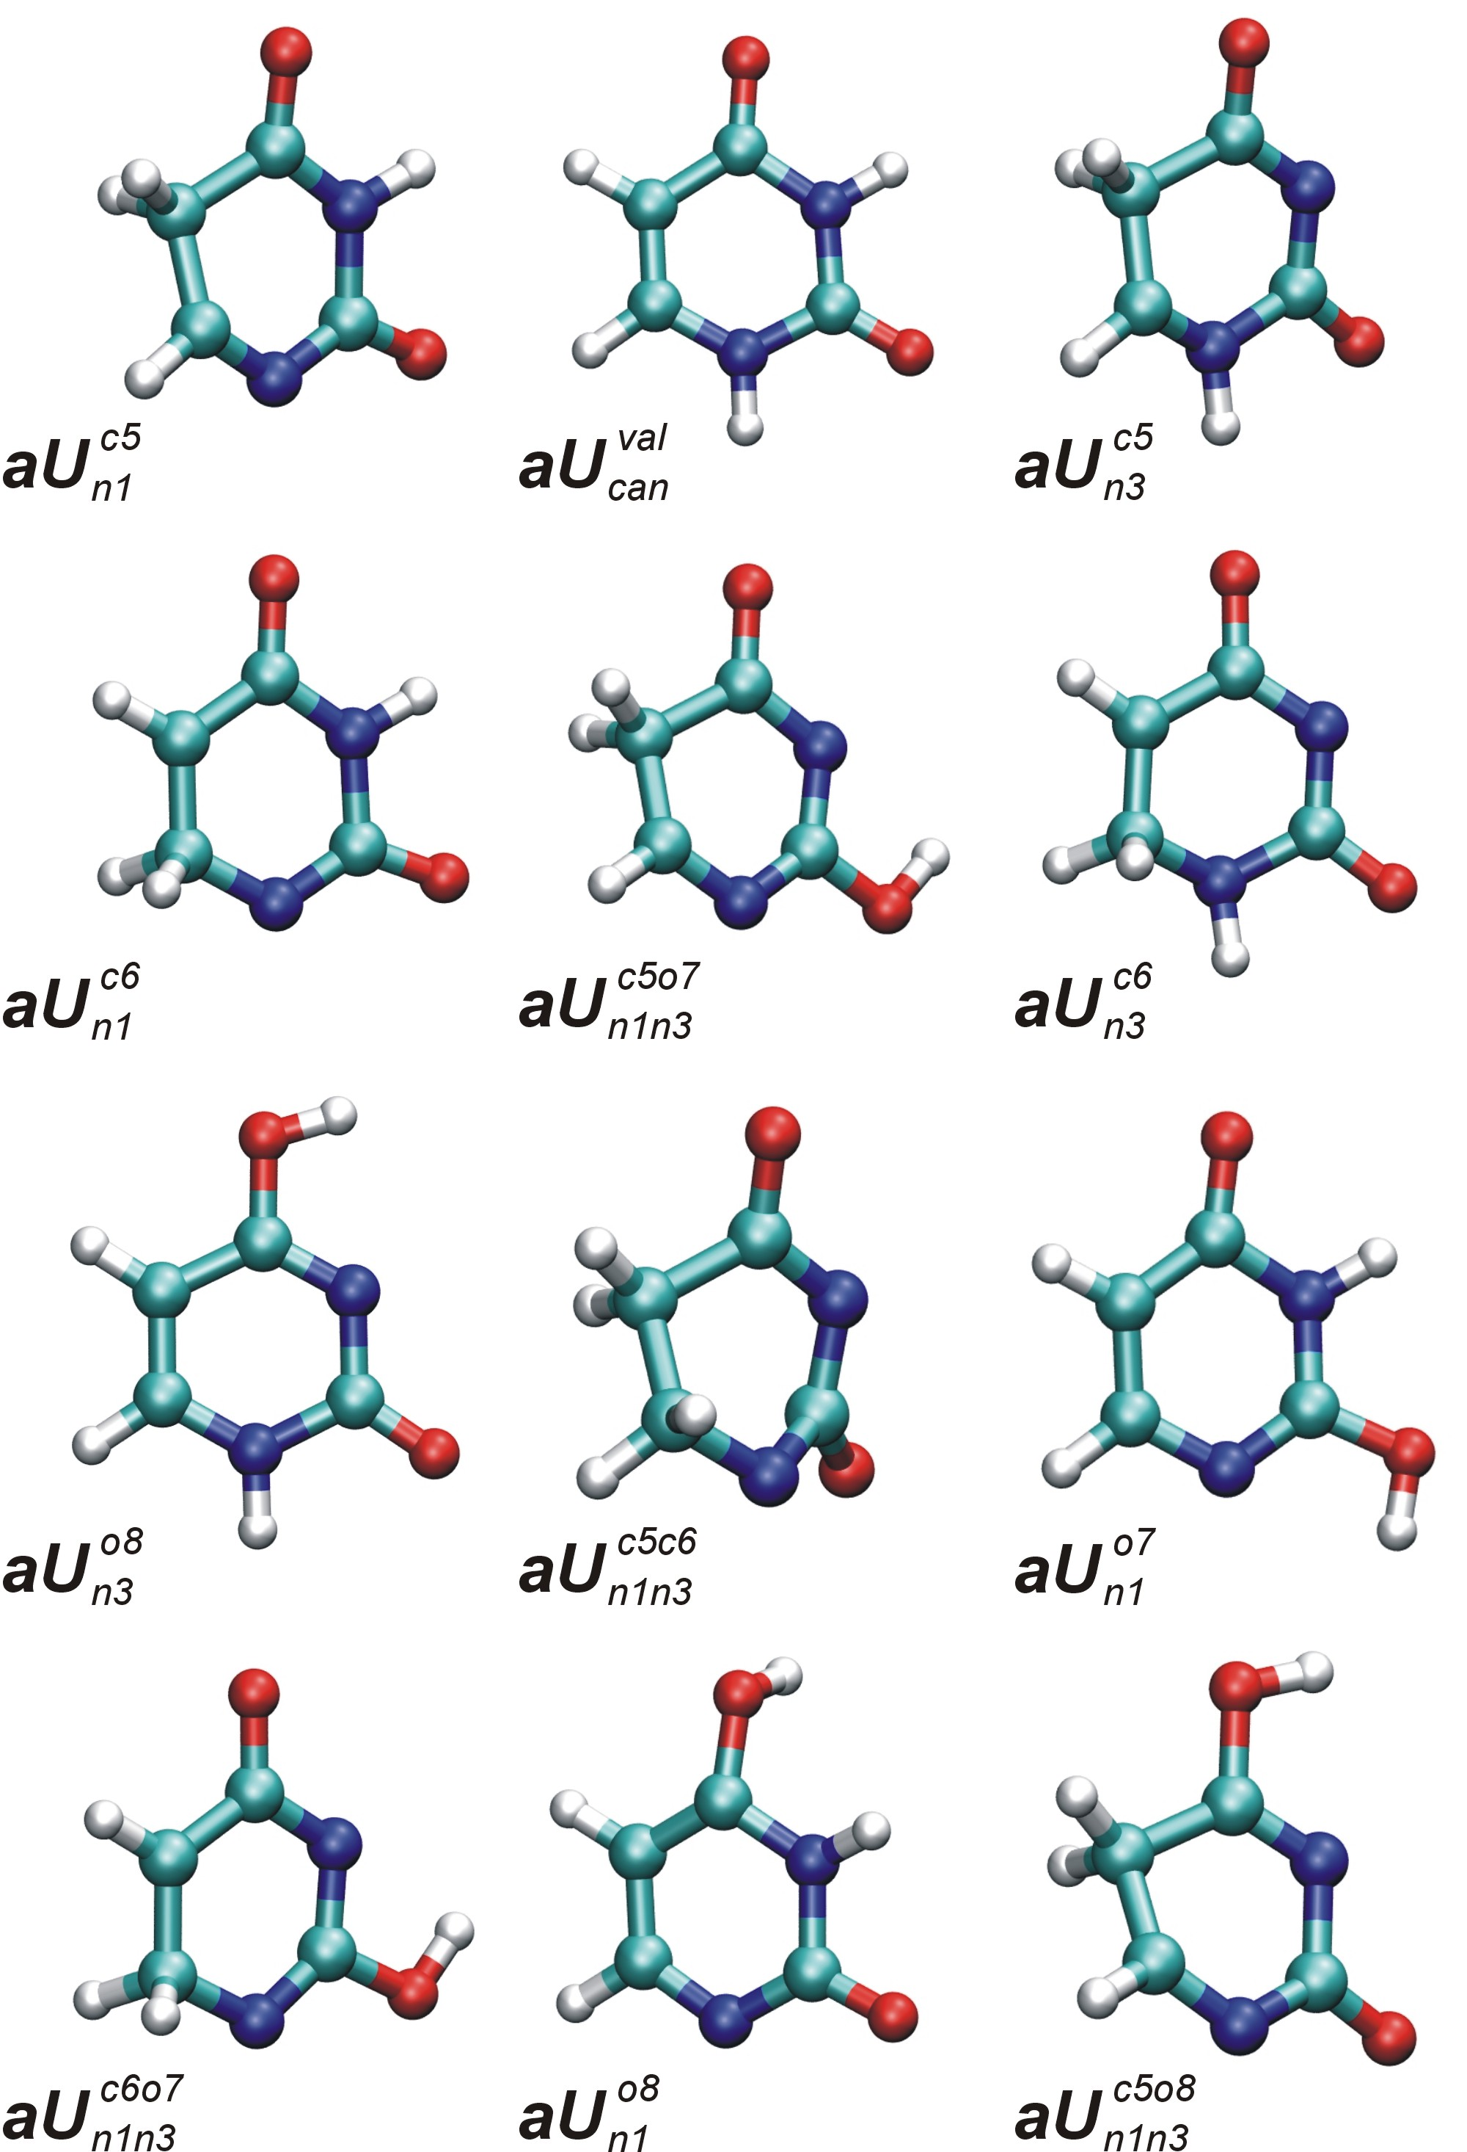

Figure S1. The most stable tautomers of anionic uracil considered at the initial B3LYP/6-31++G** level of theory.
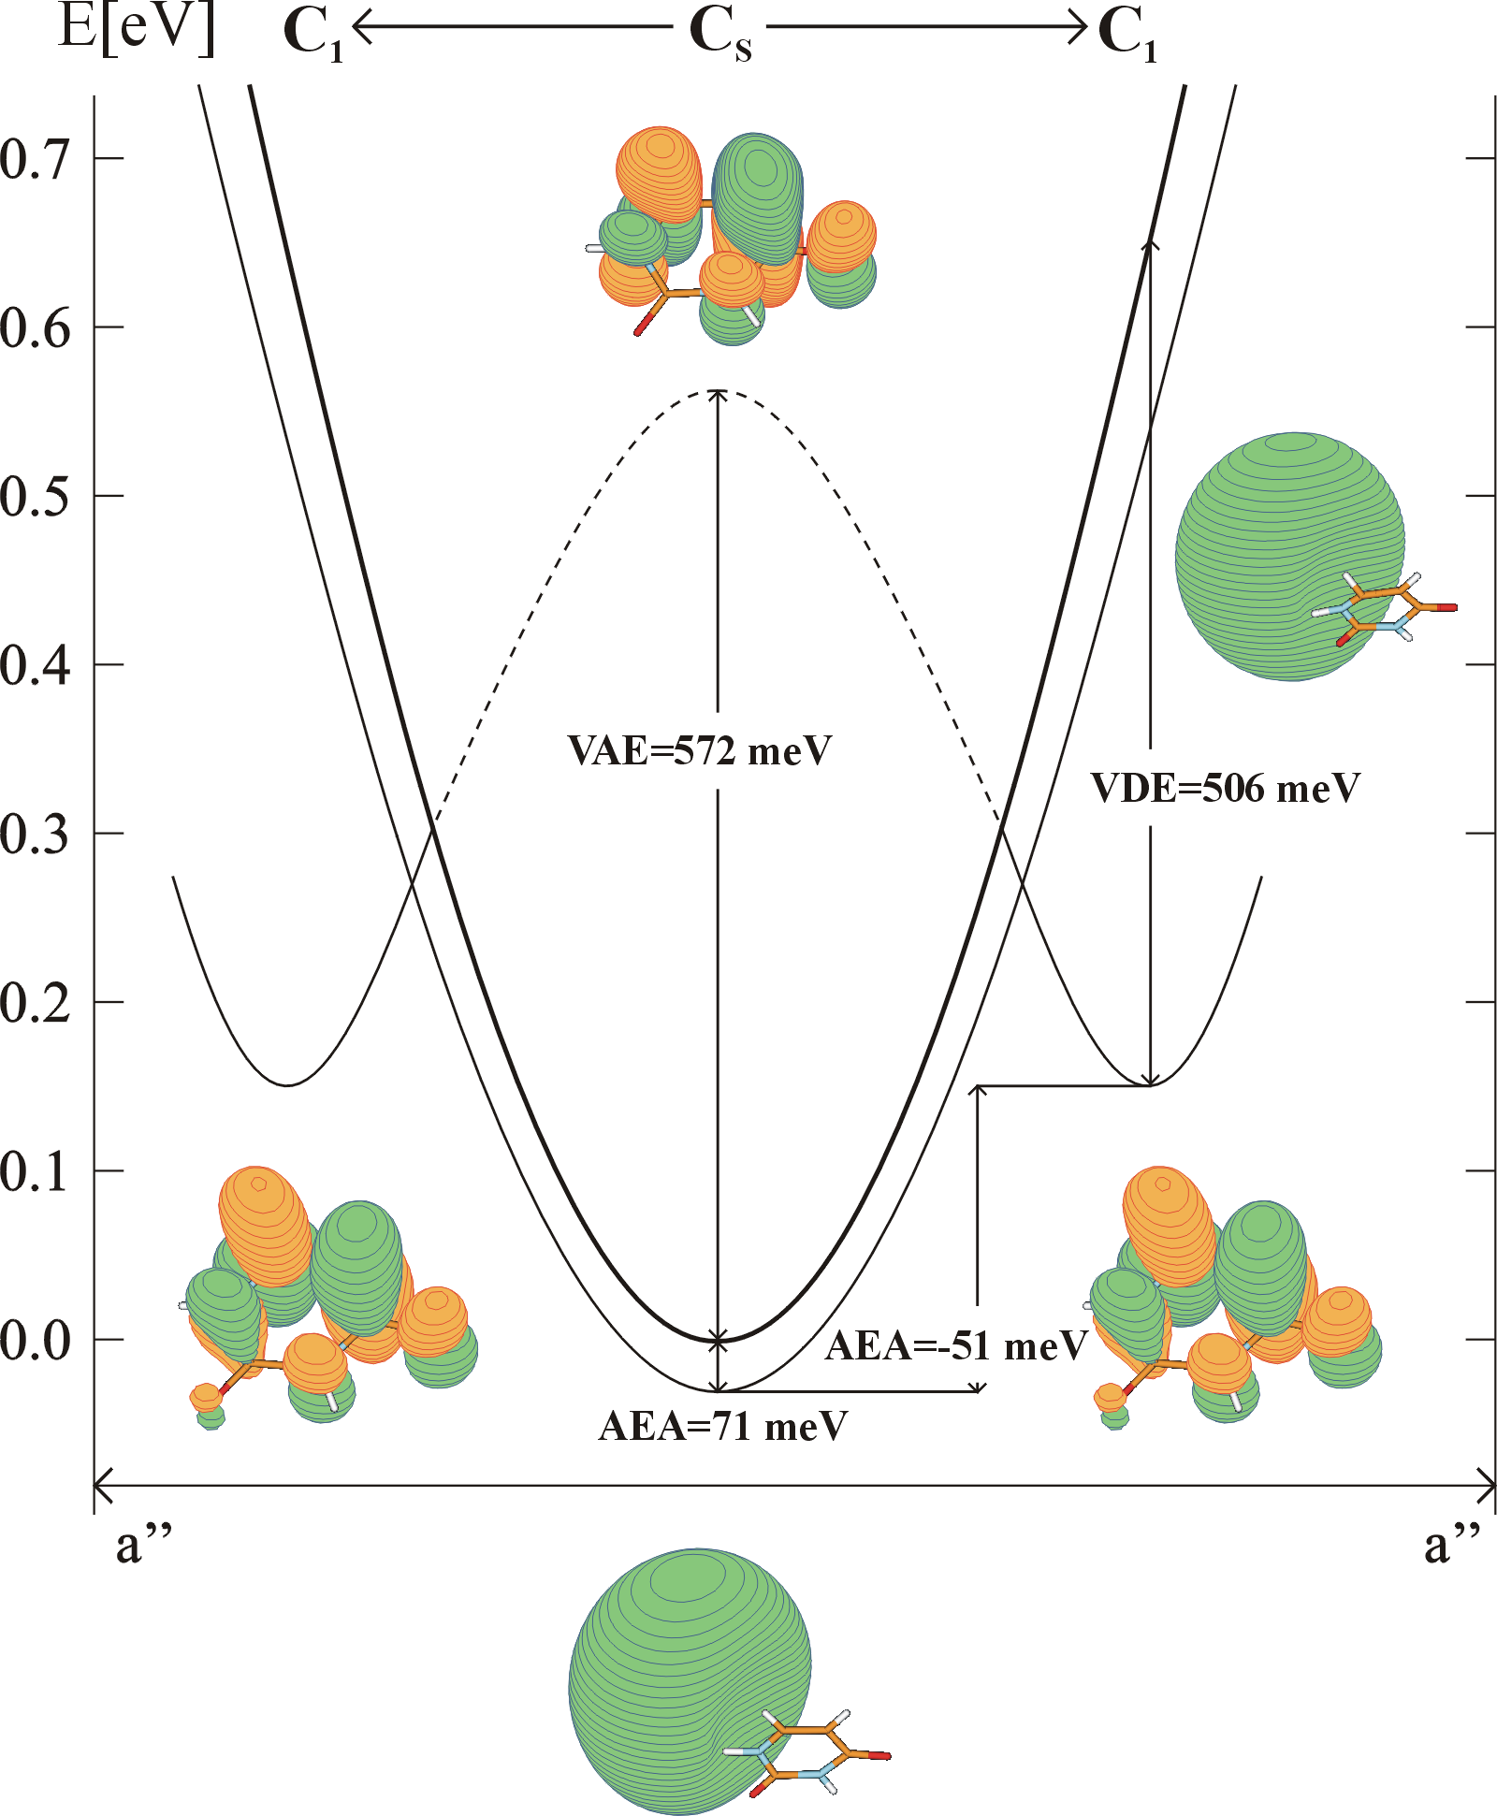

Fig. 1 (color). Evolution of the dipole-bound and valence anions of the canonical tautomer of uracil along the puckering mode, which in the vicinity of the C_{s} structure may be viewed as a superposition of normal modes of a” symmetry. The thick curve represents a cut of the potential energy surface of the neutral. The thin curves represent anionic states, which undergo a crossing before a C₁ minimum develops for the valence anion. The dashed thin line indicates that the valence anion is electronically unbound with respect to the neutral. The energies based on the CCSD(T) results reported in this study. The values of AEA include a contribution from zero-point vibrations.
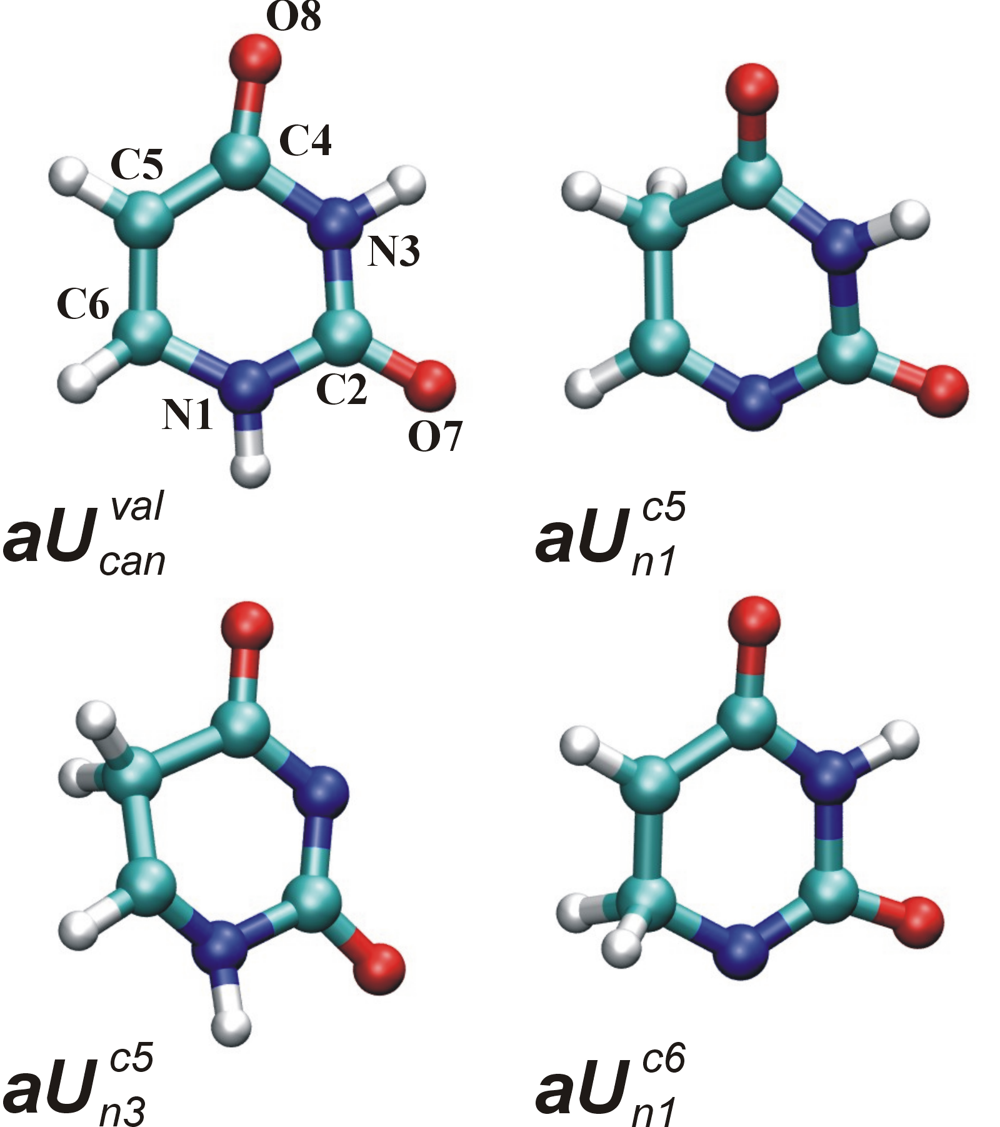

Fig. 2 (color). Tautomers of anionic uracil considered at higher than B3LYP levels of theory.
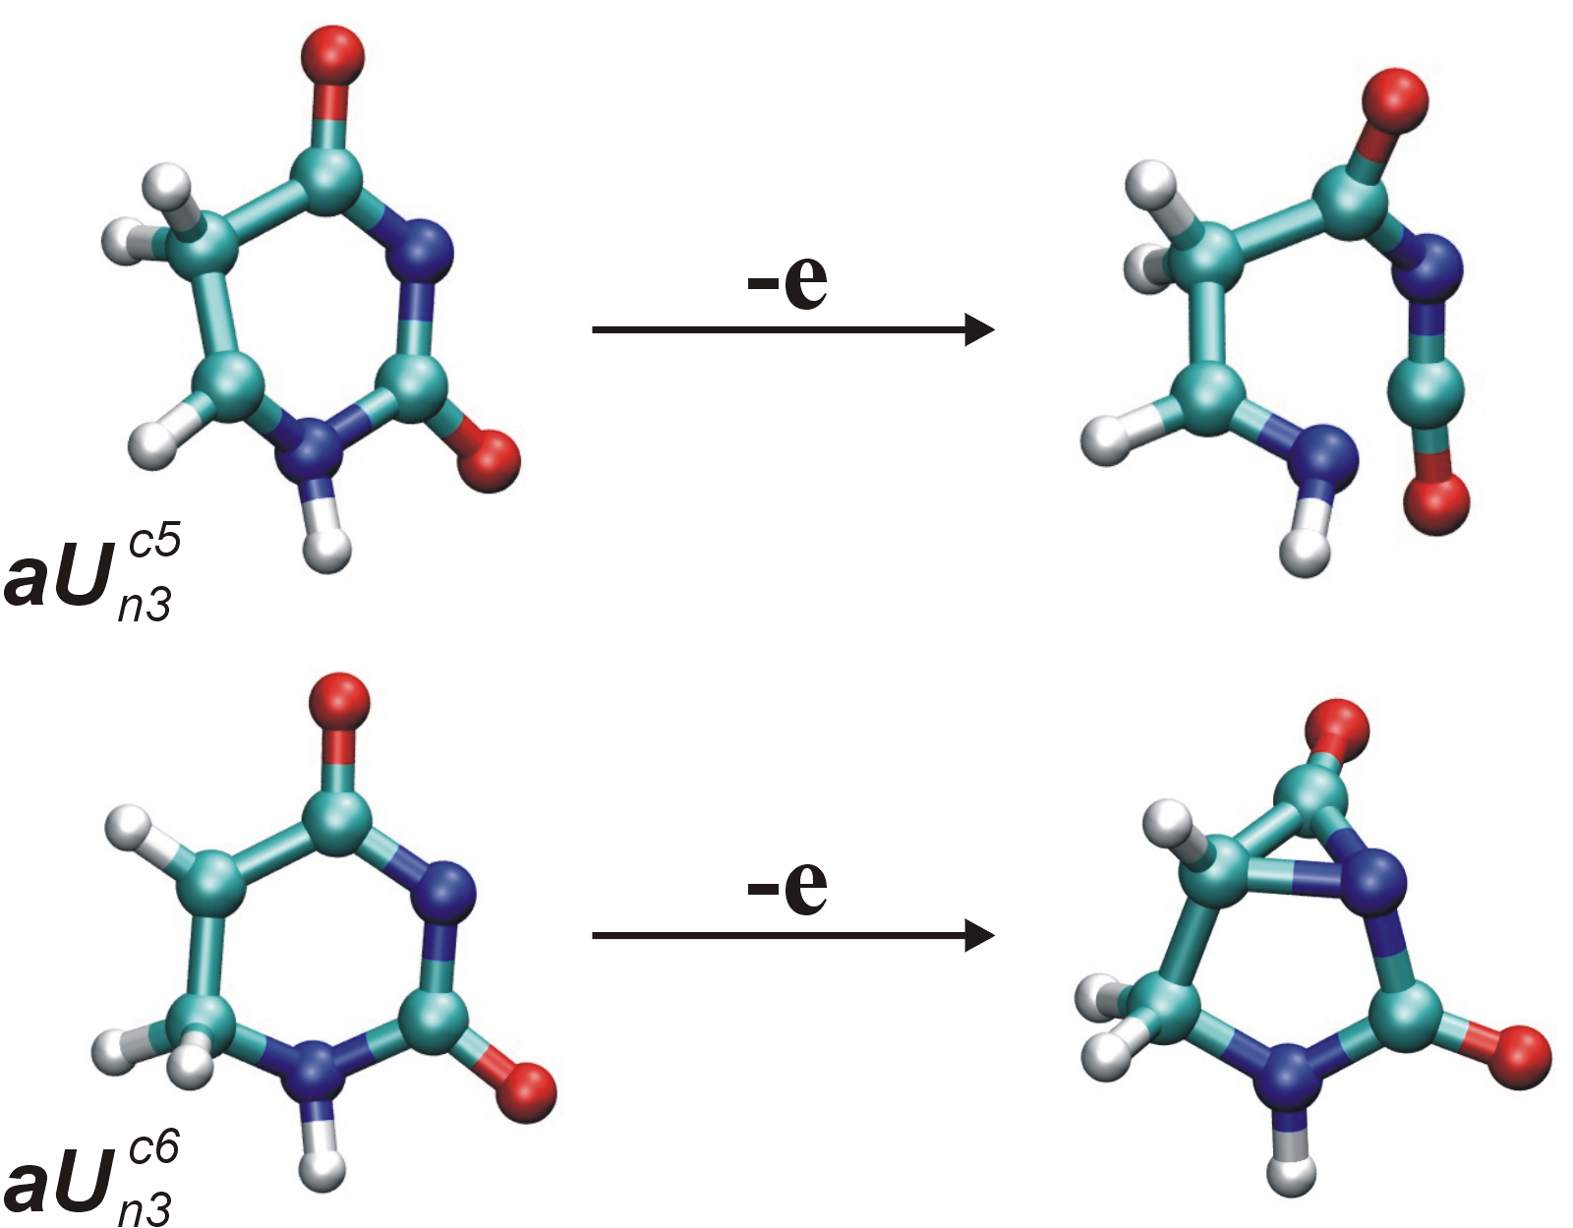

Fig. 4 (color). Excess electron detachment leads to a decomposition of the six-member ring structure of some anionic tautomers of uracil with carbon atoms protonated. The results of MP2/AVDZ optimizations.

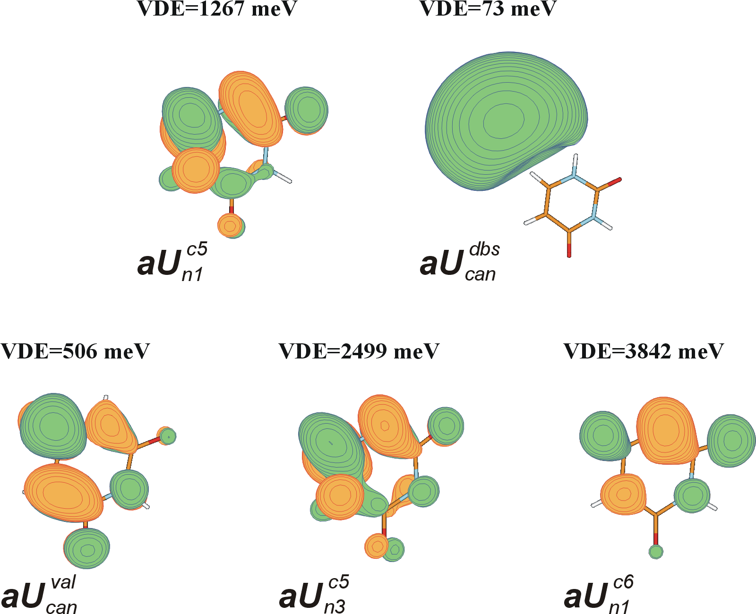

Fig. 6 (color). Singly-occupied orbitals for anions of uracil plotted with a spacing of 0.03 bohr^{-3/2} for valence states and with 0.0084 bohr^{-3/2} for the dipole-bound state. The values of electron vertical detachment energies (VDE) are also provided.
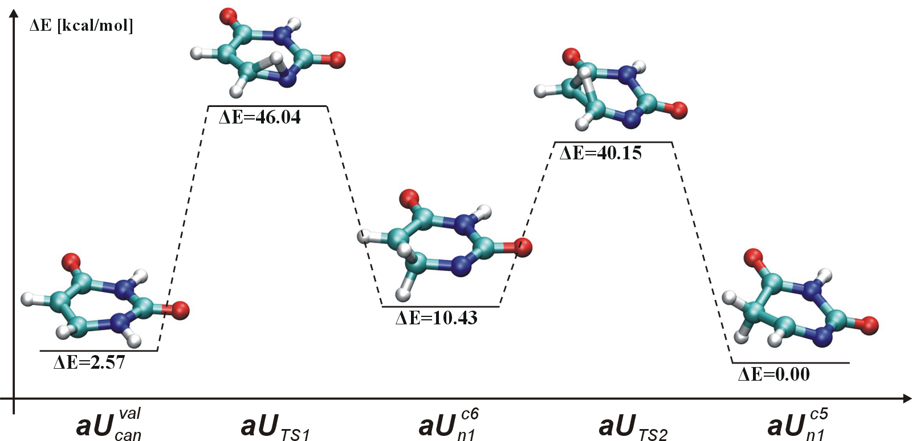

Fig. 7 (color). Transition states for the →→ unimolecular tautomerizations determined at the B3LYP/6-31++G** level of theory.

END OF SUPPLEMENTARY INFORMATION

