SUPPLEMENTAL MATERIALS

The Isolation, Characterisation, Gas Phase Electron Diffraction and Solid State X-Ray Crystal Structure of the Thermally Stable Free Radical CF₃CSNSCCF₃

S. Brownridge, H. Du, S. A. Fairhurst, R. C. Haddon , H. Oberhammer, S. Parsons, J. Passmore*, M. J. Schriver,
L. H. Sutcliffe, and N. P. C. Westwood.

Table of Contents

Page
1 S-Table 1. Vapour Pressure Data for 4d.
2 S-Table 2. Variable Temperature Magnetic Susceptibility Data for 4d.
4 S-Table 3. Interatomic distances (Å) and vibrational amplitudes for 4d.
5 S-Table 4. The chemistry of 4d.
7 S-Table 5. Comparison of physical data for 4d with diamagnetic compounds.
8 S-Table 6. Optimised geometries and energies of 3d, 4d, 4a, 4j, 20a, 20d, 20j, 21d, 22a, 22d, 22j, and 24
22 S-Figure 1. Experimental (...) and calculated (___) molecular intensities for 4d sM(s) and differences.
23 S-Figure 2. MOs of 3d, 4d (UMPW1PW91/6-31+G*) and 4a (UB3PW91/6-31G*)
- S-Figure 3. Tetramers in 4d packed to give regions of S^{δ+}…N^{δ-} and S…S contacts, and regions containing fluoride atoms.
- A more complete account of X-Ray crystal structure determination

S-Table 1. Vapour Pressure Data for 4d.

Temperature |  | 1000/T (K) | Height Column 1 | Height Column 2 | Vapour Pressure | ln(V.P.)
°C | K |  | mm | mm | mm Hg.
Liquid Phase
24 | 297 | 3.365 | 305.9 | 286.0 | 19.9 | 2.99
40 | 313 | 3.193 | 318.5 | 278.8 | 39.7 | 3.68
45 | 318 | 3.143 | 322.2 | 274.6 | 47.6 | 3.86
50 | 323 | 3.095 | 329.2 | 267.8 | 61.4 | 4.12
55 | 328 | 3.047 | 337.6 | 259.4 | 78.2 | 4.36
61 | 334 | 2.993 | 347.8 | 250.3 | 97.5 | 4.58
65 | 338 | 2.957 | 357.5 | 239.0 | 118.5 | 4.77
70 | 343 | 2.914 | 369.6 | 227.3 | 142.3 | 4.96
75 | 348 | 2.872 | 384.7 | 212.5 | 172.2 | 5.15
80 | 353 | 2.832 | 403.3 | 194.9 | 208.4 | 5.34
85 | 358 | 2.792 | 423.3 | 171.8 | 251.5 | 5.53
87 | 360 | 2.777 | 433.7 | 159.8 | 273.9 | 5.61
88 | 361 | 2.769 | 437.2 | 157.5 | 279.7 | 5.63
Solid Phaseª
-12.3 | 261 | 3.834 | 557.3 | 558.9 | 1.08 | 0.08
-10.0 | 263 | 3.800 | 557.3 | 558.8 | 1.30 | 0.26
-8.4 | 265 | 3.777 | 557.2 | 559.2 | 1.45 | 0.37
-7.2 | 266 | 3.760 | 557.1 | 558.9 | 1.89 | 0.64
-3.8 | 269 | 3.713 | 557.1 | 559.2 | 1.95 | 0.67
0.0 | 273 | 3.661 | 556.5 | 559.8 | 3.10 | 1.13
2.9 | 276 | 3.623 | 556.3 | 560.0 | 3.45 | 1.24
6.9 | 280 | 3.571 | 555.5 | 560.5 | 5.20 | 1.65

a, The vapour pressure of the sample at 24°C was measured prior to and after the experiment and 20 hours after the experiment and was constant within experimental error (19.1 ± 0.1 mmHg).
S-Table 2. Variable Temperature Magnetic Susceptibility Data for 4d.

Temperature [K] | χ [mole⁻¹] x 10⁻⁶
296.07 | 7.85469E+02
295.15 | 7.65646E+02
294.30 | 7.85622E+02
293.46 | 7.85550E+02
290.43 | 7.85000E+02
289.39 | 7.84626E+02
288.38 | 7.84287E+02
287.35 | 7.83783E+02
284.17 | 7.82000E+02
283.09 | 7.81215E+02
282.07 | 7.80303E+02
281.03 | 7.79328E+02
278.05 | 7.76035E+02
277.11 | 7.74851E+02
276.18 | 7.73491E+02
275.26 | 7.72142E+02
272.59 | 7.67694E+02
271.73 | 7.66102E+02
270.89 | 7.64476E+02
270.04 | 7.62776E+02
267.57 | 7.03497E+02
266.91 | 4.85899E+02
266.20 | 3.11417E+02
265.50 | 1.51031E+02
263.13 | -1.96064E+01
262.35 | -3.27134E+01
261.59 | -4.00274E+01
260.85 | -4.49946E+01
258.62 | -5.46596E+01
257.91 | -5.72140E+01
257.20 | -5.95208E+01
256.51 | -6.16293E+01
254.41 | -6.70806E+01
253.75 | -6.88283E+01
253.07 | -7.17179E+01
252.41 | -7.35046E+01
250.42 | -7.72509E+01
249.76 | -7.85204E+01
249.13 | -7.96617E+01
248.46 | -8.07746E+01
246.33 | -8.36557E+01
245.49 | -8.48743E+01
244.59 | -8.60189E+01
243.62 | -8.72481E+01
240.44 | -9.05872E+01
239.36 | -9.18305E+01
238.24 | -9.29223E+01
237.14 | -9.39401E+01
233.65 | -9.64936E+01
232.51 | -9.74093E+01
231.35 | -9.82016E+01
230.18 | -9.89306E+01
226.56 | -1.00727E+02
225.39 | -1.01534E+02
219.43 | -1.04027E+02
219.43 | -1.04027E+02
218.25 | -1.04475E+02
212.46 | -1.06028E+02
211.39 | -1.06352E+02
210.31 | -1.06577E+02
209.24 | -1.06778E+02
206.02 | -1.07261E+02
204.99 | -1.07550E+02
203.98 | -1.07718E+02
202.90 | -1.07866E+02
199.95 | -1.08020E+02
198.98 | -1.08270E+02
198.02 | -1.08430E+02
197.06 | -1.08486E+02
194.15 | -1.08536E+02
193.20 | -1.08842E+02
192.26 | -1.08958E+02
191.32 | -1.09036E+02
188.49 | -1.08972E+02
187.58 | -1.09275E+02
186.70 | -1.09402E+02
185.82 | -1.09486E+02
183.18 | -1.09448E+02
182.30 | -1.09684E+02
181.46 | -1.09839E+02
180.61 | -1.09934E+02
178.05 | -1.09814E+02
177.24 | -1.10142E+02
176.41 | -1.10265E+02
175.59 | -1.10251E+02
173.11 | -1.10226E+02
172.33 | -1.10448E+02
171.52 | -1.10497E+02
170.74 | -1.10536E+02
168.34 | -1.10455E+02
167.55 | -1.10631E+02
166.78 | -1.10719E+02
166.00 | -1.10740E+02
163.65 | -1.10511E+02
162.78 | -1.10610E+02
161.68 | -1.10536E+02
160.50 | -1.10620E+02
156.65 | -1.10455E+02
155.36 | -1.10596E+02
154.06 | -1.10550E+02
152.77 | -1.10536E+02
148.79 | -1.10216E+02
147.50 | -1.10321E+02
146.21 | -1.10328E+02
144.91 | -1.10303E+02
141.02 | -1.09899E+02
139.76 | -1.10092E+02
138.52 | -1.09617E+02
132.32 | -1.09765E+02
131.13 | -1.09733E+02
129.93 | -1.09680E+02
126.37 | -1.09141E+02
125.21 | -1.09251E+02
124.08 | -1.09286E+02
122.95 | -1.09342E+02
119.57 | -1.08997E+02
118.54 | -1.09007E+02
117.51 | -1.09021E+02
116.50 | -1.09004E+02
113.32 | -1.08479E+02
112.29 | -1.08518E+02
111.26 | -1.08528E+02
110.23 | -1.08437E+02
107.02 | -1.08060E+02
106.00 | -1.08102E+02
104.95 | -1.08102E+02
103.92 | -1.08120E+02
99.70 | -1.07694E+02
98.67 | -1.07651E+02
97.65 | -1.07680E+02
94.48 | -1.07038E+02
93.47 | -1.07162E+02
92.44 | -1.07229E+02
91.41 | -1.07084E+02
88.30 | -1.06539E+02
87.28 | -1.06489E+02
86.27 | -1.06419E+02
85.28 | -1.06405E+02
82.13 | -1.05862E+02
81.12 | -1.05961E+02
80.07 | -1.05834E+02
79.09 | -1.05785E+02
76.05 | -1.05175E+02
75.05 | -1.05200E+02
74.05 | -1.05066E+02
73.10 | -1.04996E+02
70.12 | -1.04309E+02
69.15 | -1.04299E+02
68.18 | -1.04154E+02
67.23 | -1.04073E+02
64.33 | -1.03369E+02
63.38 | -1.03316E+02
62.47 | -1.03140E+02
61.54 | -1.02992E+02
57.86 | -1.02192E+02
57.00 | -1.02080E+02
56.16 | -1.01900E+02
57.00 | -1.02080E+02
49.09 | -9.96669E+01
48.34 | -9.95612E+01
47.61 | -9.93710E+01
46.88 | -9.90682E+01
44.69 | -9.81418E+01
43.22 | -9.77686E+01
40.36 | -9.63632E+01
38.95 | -9.59794E+01
38.27 | -9.55084E+01
35.55 | -9.38942E+01
34.63 | -9.35739E+01
33.72 | -9.29504E+01
32.82 | -9.23658E+01
30.17 | -9.02315E+01
29.16 | -8.94812E+01
27.99 | -8.85268E+01
26.87 | -8.74102E+01
23.25 | -8.31098E+01
22.06 | -8.15530E+01
20.90 | -7.97499E+01
19.79 | -7.77774E+01
16.85 | -7.12429E+01
16.02 | -6.90427E+01
15.20 | -6.66266E+01
14.35 | -6.38150E+01
12.40 | -5.58672E+01
11.93 | -5.36298E+01
11.54 | -5.14949E+01
11.23 | -4.95971E+01
10.69 | -4.63830E+01
10.55 | -4.60660E+01
10.49 | -4.58419E+01
10.44 | -4.57453E+01
7.79 | -2.19156E+01
7.18 | -1.41484E+01
6.77 | -7.54388E+00
6.46 | -1.74799E+00
5.96 | 8.76886E+00
5.87 | 9.98538E+00
5.84 | 1.08004E+01
5.79 | 1.12058E+01
4.93 | 3.65048E+01
4.60 | 4.25710E+01
4.60 | 4.52150E+01
4.55 | 4.65581E+01
227.46 | -9.78284E+01
227.30 | -9.84341E+01
227.82 | -9.87834E+01
228.32 | -9.88251E+01
240.14 | -9.03616E+01
241.64 | -8.89389E+01
243.15 | -8.72976E+01
244.68 | -8.54132E+01
249.29 | -7.86789E+01
250.78 | -7.61682E+01
252.23 | -7.34484E+01
253.67 | -7.03610E+01
258.14 | -5.85184E+01
259.58 | -5.39701E+01
260.52 | -4.91999E+01
261.29 | -4.56377E+01
263.75 | -3.41354E+01
264.59 | -2.98667E+01
265.43 | -2.49625E+01
266.28 | -2.00007E+01
268.79 | 4.09624E+01
269.63 | 8.54416E+00
270.47 | 1.77222E+01
271.32 | 2.81471E+01
274.27 | 7.39417E+01
275.28 | 9.58127E+01
276.29 | 1.22252E+02
277.30 | 1.54009E+02
280.37 | 2.97735E+02
281.35 | 3.63243E+02
282.31 | 4.37659E+02
283.25 | 5.15576E+02
286.15 | 7.50222E+02
287.11 | 7.82469E+02
288.09 | 7.83701E+02
289.05 | 7.84251E+02
291.92 | 7.85075E+02
292.83 | 7.85308E+02
293.74 | 7.85437E+02
294.62 | 7.85495E+02
297.23 | 7.85351E+02
298.06 | 7.85286E+02
298.89 | 7.85096E+02
299.71 | 7.84938E+02
302.27 | 7.84138E+02
303.08 | 7.83917E+02
303.89 | 7.83463E+02
304.67 | 7.83086E+02
308.87 | 7.81088E+02
310.58 | 7.79964E+02
312.21 | 7.78655E+02
313.72 | 7.77344E+02

S-Table 3. Interatomic distances (Å) and vibrational amplitudes for 4d.ª

 | Distance | Amplitude |  | Distance | Amplitude
C1=C2 | 1.32 | 0.036^{b} | S1..F13 | 2.78 | 0.21 (7)
C-F | 1.33 | 0.049 (5) | S1..F11 | 3.69 | 0.18 (2)
C1-C11 | 1.48 | 0.050^{b} | S1..F21 | 4.62 | 0.21 (5)
S1-N | 1.63 | 0.050 (7) | S1..F23 | 4.85 | 0.14 (3)
S1-C1 | 1.75 | 0.050 (7) | C1..F21 | 3.01 | 0.12 (5)
F11..F12 | 2.15 | 0.057 (4) | C11..F21 | 3.22 | 0.12 (5)
C1..F13 | 2.31 | 0.064 (8) | C1..F23 | 3.58 | 0.14 (4)
C1..F11 | 2.33 | 0.064 (8) | C11..F23 | 4.41 | 0.14 (4)
C1..C21 | 2.52 | 0.070^{b} | N..F13 | 4.29 | 0.14 (4)
C1..N | 2.53 | 0.070^{b} | N..F11 | 4.71 | 0.14 (4)
C11..C21 | 3.12 | 0.070^{b} | F12..F22 | 2.76 | 0.19 (7)
S1..C2 | 2.60 | 0.057 (12) | F12..F21 | 3.49 | 0.19 (7)
S1..S2 | 2.79 | 0.067 (6) | F13..F21 | 4.50 | 0.19 (7)
S1..C11 | 2.77 | 0.067 (6) | F13..F23 | 5.67 | 0.12^{b}
S1..C21 | 4.05 | 0.091 (19)
N..C11 | 3.93 | 0.091 (19)

a) Error limits are 3σ values, numbering of atoms is given in Fig. 6.
b) Not refined.

S-Table 4. The chemistry of 4d.

4d  g, mmol | Compound  (g, mmol) | Solvent(g) | Procedurea | Colour Changesb | Apparent Reaction Timec | Product(s) (g, mmol, % yield)
0.050, 0.21 | AsF₅ (0.100, 0.59) | SO₂ (2.36) | A | opaque black → clear colourless | < 1 min. | soluble white solid, 3d[AsF₆]^{d} (0.090, 0.21, 100)
0.108, 0.45 | Cl₂ (0.257, 3.63) | SO₂ (0.72) | A | opaque black → light yellow | < 1 min. | soluble orange solid, 3d[Cl]^{e} (0.111, 0.40, 90)
0.182, 0.76 | Br₂ (0.733, 4.58) | CH₂Cl₂ (2.72) | A | opaque black → dark red | < 1 min. | soluble red-black solid, 3d[Br]^{f} (0.236, 0.74, 97)
0.490, 2.02 | I₂ (0.262, 1.04) | SO₂ (7.08) | A | opaque black | 28 hr. | 4d (0.38, 1.62, 80)^{g}, no reaction
0.019, 0.08 | O₂ (0.096, 3.0) | - | B | unknown | < 1 min. | a complex mixture (?) of non volatile
0.008, 0.034 | O₂ (0.0018, 0.11) | CCl₃F (48.02) | C | very light blue | 6 hr. | 4d (ESR)^{i}, no reaction
0.044, 0.18 | O₂ (0.0038, 0.24) | SO₂ (0.44) | D | opaque black → clear yellow | < 1 min ^{j} | a complex mixture of greater than 10 diamagnetic products (¹⁹F NMR)^{k}
0.060, 0.25 | H₂O (0.017, 0.93) | CH₂Cl₂ (0.67) | D | opaque black → opaque black (ppt.) | 20 hr. | a complex mixture of greater than 30 diamagnetic products (¹⁹F NMR).^{l}
0.024, 0.10 | air | CH₂Cl₂ (0.75) | D | opaque black → yellow | 1 hr. | a complex mixture of greater than 30 diamagnetic products (¹⁹F NMR).^{m}
0.125, 0.52 | Hg (68.14, 340) | - | E | opaque black liquid | 48 hr. | 4d (0.111, 0.46, 88),^{g} no reaction
0.178, 0.74 | NO (0.087, 2.90) | CCl₃F (0.98) | A | opaque black | 20 hr. | 4d (0.010, 0.043, 6),^{g, n} no reaction
0.085, 0.35 | Cu⁰ (0.330, 5.16) | SO₂ (3.94) | A | opaque black | 20 hr. | 4d (0.078 g, 0.32, 91),^{g,o} no reaction

a) Procedures:
[A] Reaction between solution of 4d and compound in two-bulb vessel.
[B] Reaction between gaseous 4d and O₂ in an infrared cell.
[C] Reaction between aliquots of O₂ (0.01, 0.02, 0.04 and 0.04 mmol) isolated in side arms attached to a bulb containing 48 gm CCl₃F and 0.034 mmol 4d above an ESR tube. The addition of each aliquot was made at room temperature and each chamber was washed several times with the solvent. The reaction vessel was repeatedly inverted to ensure good mixing before the ESR spectrum was obtain in situ after standing one hour. The reaction mixture was allowed to rest for one hour before the addition of the next aliquot.
[D] Reaction between solution of 4d and compound in a 5 mm o.d. thick walled NMR tube. The addition of O₂ was made by expanding gaseous O₂ into tube at -190ºC. The addition of H₂O was made by syringe through a static layer of N₂. The addition of air was made by exposure of solution to room air for one hour.
[E] Reaction between neat 4d and Hg at r.t. in a one bulb vessel. The vessel was agitated regularly to affect reaction.
b) The quoted colour changes are those of the solution.
c) The apparent reaction times estimated from colour changes or the duration of the experiment.
d) The product was proven to be 3d[AsF₆] by comparison of the IR and NMR spectra with those from an authentic sample. Attempts to grow crystals suitable for crystallographic analysis resulted in clear colourless fibrous plates that are multiple crystals: a = 6.908 (3), b = 24.483(10), c= 7.182(3)Å, α = 90, β = 108.28 (3), γ = 90°; V = 1153.5 (9) Å³.
e) The product was purified by sublimation in a static vacuum at 80°C. The air sensitive (IR), orange crystalline solid was shown to be 3d[Cl] by elemental analysis, IR, NMR and M.S. This compound was also prepared in lower yield from the reaction of 3d[AsF₆] (0.420g, 1.00 mmol) and KCl (0.075g, 1.00 mmol) in 3.128g SO₂. The orange crystalline product (0.174g, 0.63 mmol, 63 % yield) was recovered by sublimation from the nonvolatile reaction residue.
f) The product was purified by sublimation in a static vacuum at 80°C. The air stable (IR) red-black crystalline solid was shown to be 3d[Br] by elemental analysis, IR, NMR and mass spectroscopy. This compound was also quantitatively prepared from the reaction of 3d[AsF₆] (0.86g, 2.05 mmol) and KBr (0.30 g, 2.52 mmol) in 5.50 g SO₂ . The red-black crystalline solid (0.60g, 1.88 mmol, 94 % yield) was recovered by sublimation from the nonvolatile reaction residue.
g) The product was recovered by fractional distillation as described in section experimental. The product was identified as 4d by IR data.
h) The intensity of the infrared spectrum was observed to drop by approximately 10². The infrared spectrum after the reaction was not observed to change upon evacuation of the cell, indicating that the products of reaction are non-volatile.
i) The ESR spectrum did not observably change (± 5%) during the experiment.
j) A strongly exothermic reaction was observed upon warming to r.t.
k) ¹⁹F NMR spectrum (SO₂, CCl₃F); δ = -55.8, -57.7, -57.8, -57.9, -62.7, -63.1 ppm, only the major resonances are reported, all resonances were singlet. An integration analysis indicated greater than 80% of fluorine present was observed.
l) ¹⁹F NMR spectrum (CH₂Cl₂, CCl₃F); δ = -54.8, -62.4, -62.5, -66.1, -66.8, -76.5, -76.8, -76.9, -80.3 ppm, only the major resonances are reported, all resonances were singlet. An integration analysis indicated greater than 80% of fluorine present was observed.
m) ¹⁹F NMR spectrum (CH₂Cl₂, CCl₃F); δ = -55.1 [(CF₃CSSCCF₃)_{n}, ?], - 62.1 ([CF₃CSSCCF₃], ?) ppm, only major resonances are reported, all observed resonances were singlets. An integration analysis indicated that greater than 80% of fluorine present was observed.
n) The low yield of this recovery may be due to the lower vapour pressure of CCl₃F than SO₂, causing distillation to be less efficient and subsequent product loss during the fractional distillation.
o) The Cu was powdered and flame dried under vacuum prior to use. The yield was determined from mass changes in the vessel, and the product was not isolated. The volatile materials were shown to be CCl₃F and 4d by comparison of the gas phase infrared spectrum with authentic samples. Although the masses indicate that no reaction occurred, the initially bright metal surface was coated with a black insoluble solid after the reaction.

S-Table 5. Comparison of Physical Data for 4d with Diamagnetic Compounds.

Compound | T_{bp} [K] | ΔH_{vap} [kJ/mol] | Trouton’s Constantª | Ref ^{b}
CF₃CSNSCCF₃ 4d | 391 | 38.1 | 97 | This work
[CF₃SCF₃] | 251 | 23.6 | 94.1 | (69)
[CF₃SSCF₃] | 308 | 28.8 | 93.7 | (69)
[CF₃ClC=CClCF₃] | 341 | 32.6 | 95.6 | (70)
[CF₃C₆H₅] | 375 | 32.6 | 96 | (70)
C₈F₁₈ | 379 | 33.4 | 88 | (70)
ClF₃ | 197 | 19.1 | 96.7 | (71)
N₂F₂ (cis) | 178 | 16.3 | 91.6 | (72)
AsF₅ | 152 | 15.0 | 98.7 | (71)

a) Trouton’s constant is the enthalpy of vaporisation (in joules) divided by the boiling point (in Kelvin).
b) References:
69. F. Dickinson, R. Hill and J. Muray, J. Chem. Soc., 1958, 1441.
70. CRC Handbook of Chemistry and Physics, eds. D. R. Lide, H. P. R. Frederikse, 75th ed., CRC Press, Cleveland, Ohio, 1995.
71. H. C. Clark, Chem. Rev., 1958, 58, 869.
72. C. J. Hoffman and R. G. Neville, Chem. Rev., 1962, 62, 1.

S-Table 6. Optimised geometries and energies of 3d, 4d, 4a, 4j, 20a, 20d, 20j, 21d, 22a, 22d, 22j, and 24

S-Table 6.1 Optimized geometry of 4d (UB3PW91/6-31G*)

SCF Done: E(UB+HF-PW91) = -1602.13246540 A.U. after 8 cycles
Convg = 0.8954E-08 -V/T = 2.0051
S**2 = 0.7555
-------------------------------------------------------------------------
Center Atomic Coordinates (Angstroms) Mulliken
Number Number X Y Z Charges
-------------------------------------------------------------------------
1 6 0.674196 0.259858 0.016579 -0.302978
2 6 -0.674196 0.259858 -0.016580 -0.302979
3 16 -1.398981 1.855564 -0.034818 0.490073
4 7 -0.000001 2.774399 0.000000 -0.593929
5 16 1.398980 1.855565 0.034818 0.490074
6 6 1.590096 -0.937441 -0.010268 0.862665
7 9 1.678294 -1.461217 -1.239643 -0.241565
8 9 1.177483 -1.899229 0.823207 -0.247584
9 9 2.829413 -0.565544 0.363330 -0.263646
10 6 -1.590095 -0.937442 0.010268 0.862664
11 9 -1.678297 -1.461213 1.239645 -0.241565
12 9 -2.829412 -0.565546 -0.363336 -0.263646
13 9 -1.177479 -1.899233 -0.823202 -0.247584
-------------------------------------------------------------------------

S-Table 6.2 Optimized geometry of 4d (UMPW1PW91/6-31+G*)

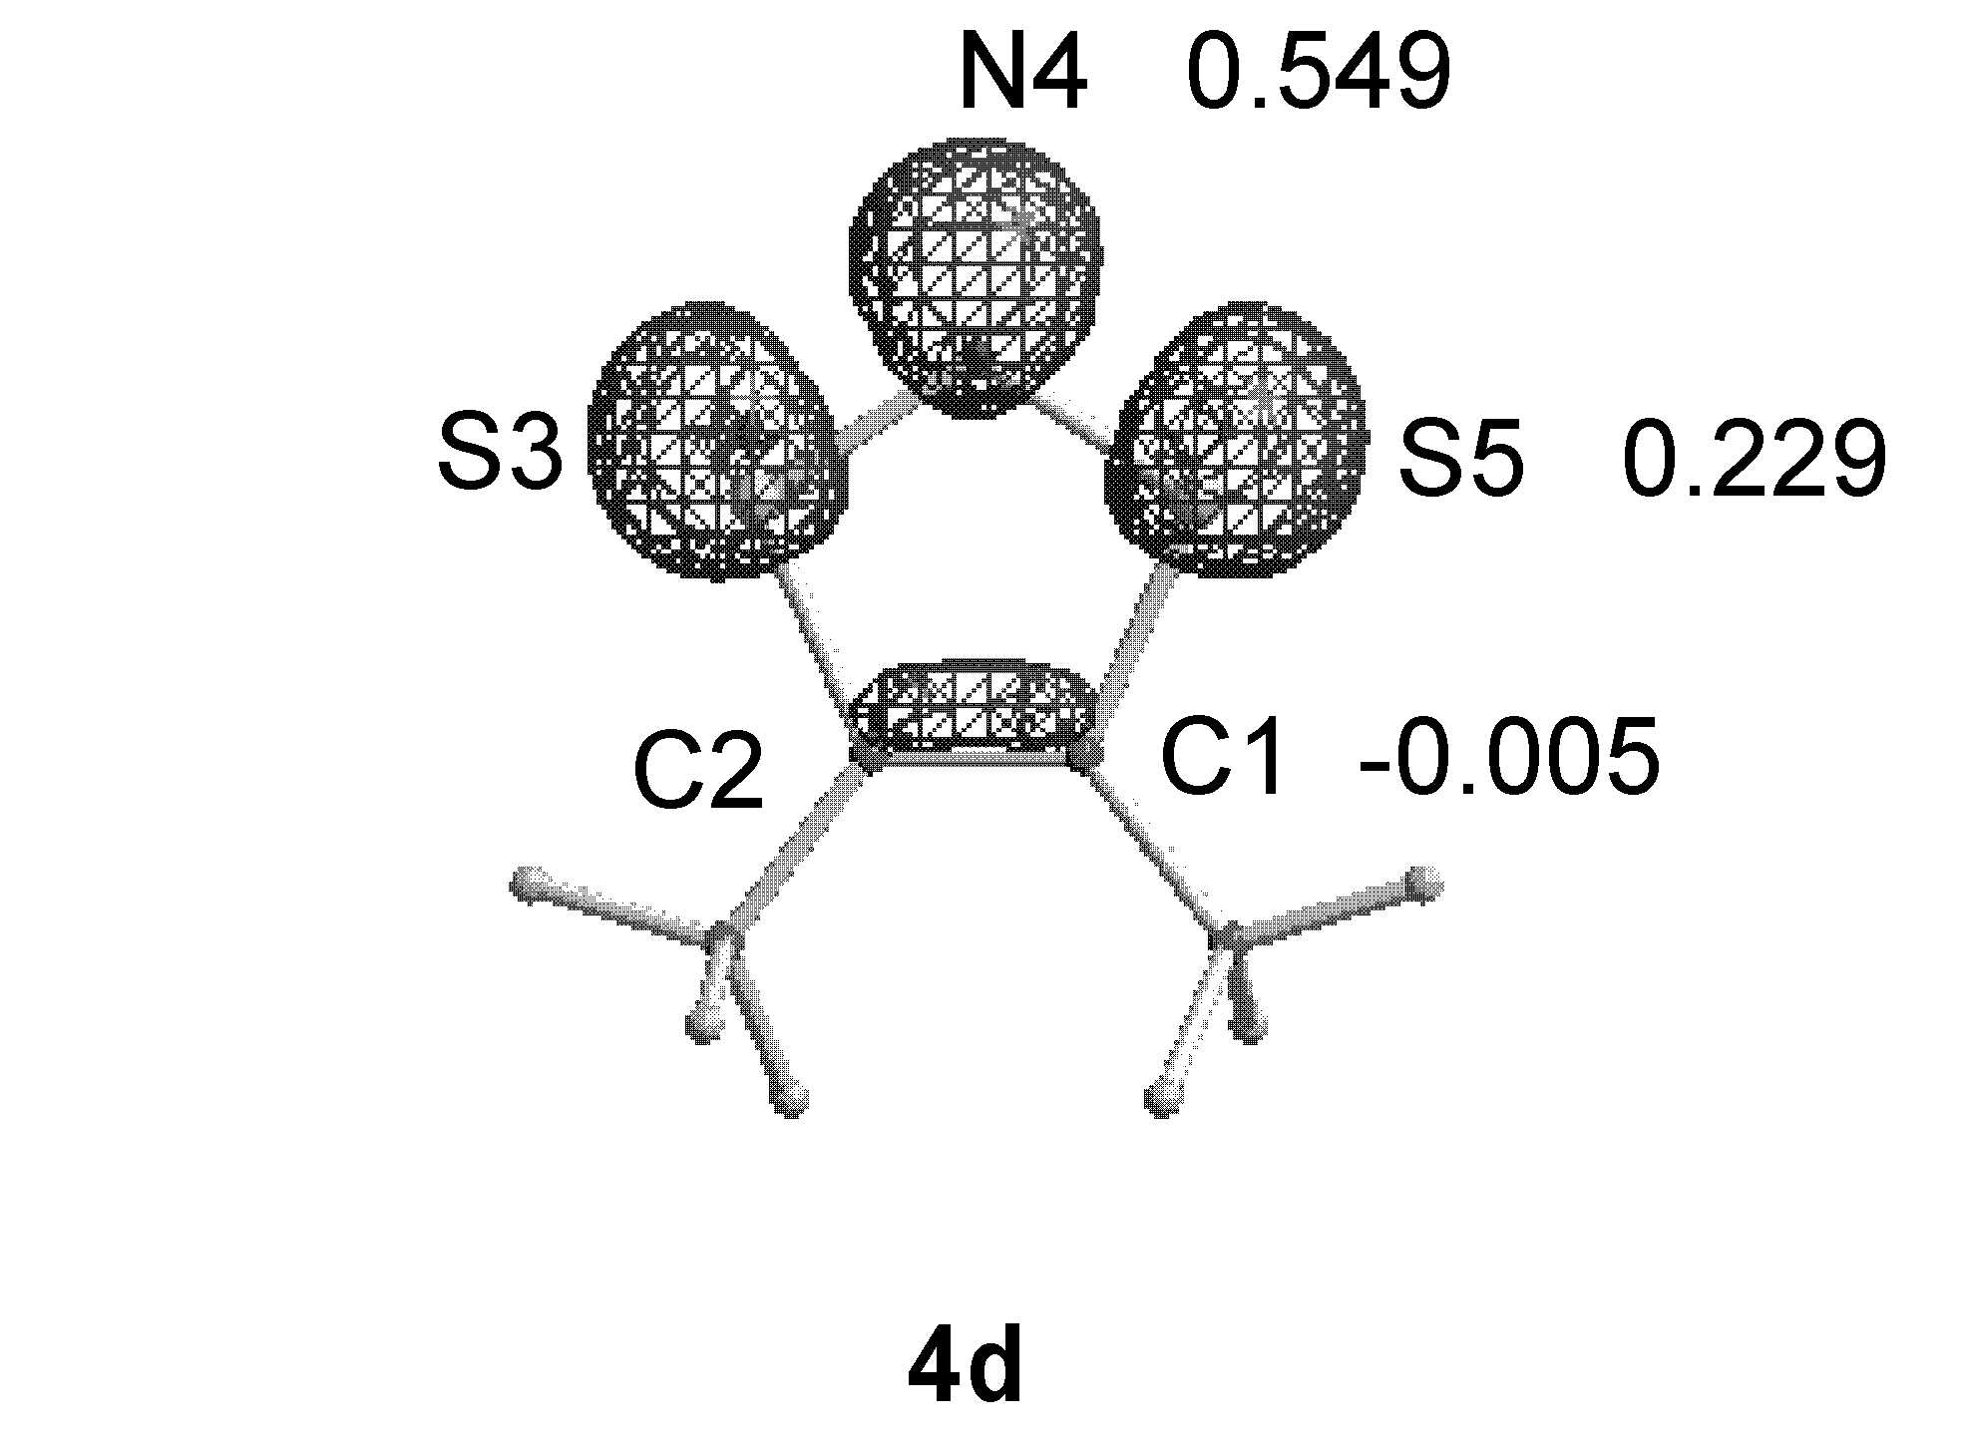

SCF Done: E(UmPW+HF-PW91) = -1602.39335786 A.U. after 12 cycles
Convg = 0.3424D-08 -V/T = 2.0054
S**2 = 0.7574

----------------------------------------------------------------------------------
Center Atomic Coordinates (Angstroms) Mulliken Spin
Number Number X Y Z Charges Density
----------------------------------------------------------------------------------
1 6 0.674321 0.257711 0.013159 -0.479848 -0.004760
2 6 -0.674321 0.257711 -0.013159 -0.479847 -0.004760
3 16 -1.396407 1.851151 -0.028767 0.430783 0.228685
4 7 0.000000 2.757425 0.000000 -0.428706 0.549138
5 16 1.396407 1.851152 0.028767 0.430783 0.228685
6 6 1.597547 -0.932762 -0.007680 1.074924 0.000953
7 9 1.721709 -1.439667 -1.241885 -0.234607 0.000601
8 9 1.179896 -1.911418 0.801075 -0.263127 0.002001
9 9 2.826234 -0.562149 0.397642 -0.313773 -0.002050
10 6 -1.597547 -0.932762 0.007680 1.074924 0.000953
11 9 -1.721711 -1.439664 1.241886 -0.234607 0.000601
12 9 -2.826233 -0.562150 -0.397645 -0.313773 -0.002050
13 9 -1.179894 -1.911420 -0.801072 -0.263127 0.002001
----------------------------------------------------------------------------------

S-Table 6.3 Optimized geometry of 3d (UB3PW91/6-31G*)

SCF Done: E(UB+HF-PW91) = -1601.86083401 A.U. after 15 cycles
Convg = .3502E-08 -V/T = 2.0051
S**2 = .0000

----------------------------------------------------------------
Center Atomic Coordinates (Angstroms)
Number Number X Y Z
----------------------------------------------------------------
1 6 0.685544 0.259060 -0.012258
2 6 -0.685545 0.259058 0.012264
3 16 -1.363417 1.836651 0.027961
4 7 0.000002 2.690786 0.000102
5 16 1.363418 1.836648 -0.028019
6 6 1.626254 -0.950481 0.008607
7 9 1.256995 -1.832991 -0.906822
8 9 2.861968 -0.509713 -0.260986
9 9 1.611756 -1.507920 1.210447
10 6 -1.626255 -0.950481 -0.008600
11 9 -2.861968 -0.509711 0.260988
12 9 -1.611747 -1.507919 -1.210444
13 9 -1.257007 -1.832992 0.906831
----------------------------------------------------------------

S-Table 6.4 Optimized geometry of 3d (UMPW1PW91/6-31+G*)

SCF Done: E(UmPW+HF-PW91) = -1602.11144244 A.U. after 15 cycles
Convg = 0.8389D-08 -V/T = 2.0054
S**2 = 0.0000

----------------------------------------------------------------------
Center Atomic Coordinates (Angstroms) Mulliken
Number Number X Y Z Charges
----------------------------------------------------------------------
1 6 0.685439 0.256814 0.009512 -0.504745
2 6 -0.685443 0.256811 -0.009529 -0.504731
3 16 -1.360239 1.832467 -0.024346 0.739435
4 7 -0.000011 2.677911 0.000002 -0.307978
5 16 1.360221 1.832478 0.024344 0.739434
6 6 1.632595 -0.945794 -0.007056 1.106647
7 9 1.663116 -1.477772 -1.219989 -0.185015
8 9 1.247045 -1.852748 0.874597 -0.214925
9 9 2.857281 -0.509271 0.308958 -0.287406
10 6 -1.632586 -0.945805 0.007052 1.106631
11 9 -1.663130 -1.477736 1.220010 -0.185019
12 9 -2.857270 -0.509310 -0.309007 -0.287401
13 9 -1.247005 -1.852791 -0.874553 -0.214927
----------------------------------------------------------------------

S-Table 6.5 Optimised geometry of 4a (UB3PW91/6-31G*)

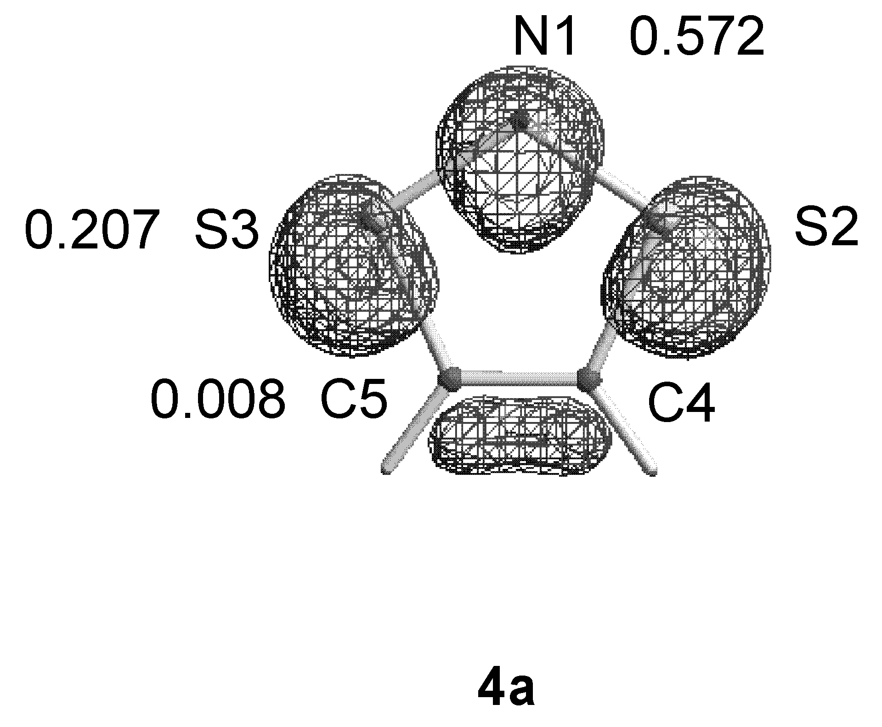

SCF Done: E(UB+HF-PW91) = -928.317972104 A.U. after 9 cycles
Convg = 0.8795D-08 -V/T = 2.0039
S**2 = 0.7548

----------------------------------------------------------------------------------
Center Atomic Coordinates (Angstroms) Mulliken Spin
Number Number X Y Z Charges Density
----------------------------------------------------------------------------------
1 7 0.000000 0.000000 1.264584 -0.606025 0.572695
2 16 0.000014 -1.398759 0.328936 0.424850 0.207363
3 16 -0.000014 1.398759 0.328936 0.424850 0.207363
4 6 0.000000 -0.671708 -1.258176 -0.347597 0.008495
5 6 0.000000 0.671708 -1.258176 -0.347597 0.008495
6 1 -0.000006 -1.302758 -2.139972 0.225760 -0.002205
7 1 0.000006 1.302758 -2.139972 0.225760 -0.002205
----------------------------------------------------------------------------------
S-Table 6.6 Optimised geometry of 4j (UB3PW91/6-31G*)

SCF Done: E(UB+HF-PW91) = -1006.93037242 A.U. after 15 cycles
Convg = 0.5707D-08 -V/T = 2.0044
S**2 = 0.7544
----------------------------------------------------------------------
Center Atomic Coordinates (Angstroms) Mulliken
Number Number X Y Z Charges
----------------------------------------------------------------------
1 6 0.673305 0.675504 0.000002 -0.128838
2 6 0.673305 -0.675503 -0.000002 -0.128838
3 16 -0.937846 -1.389054 -0.000009 0.397273
4 7 -1.879104 -0.000001 0.000002 -0.603626
5 16 -0.937847 1.389054 0.000007 0.397273
6 6 1.846470 1.606250 -0.000010 -0.567495
7 1 1.836898 2.254891 -0.884280 0.204089
8 1 2.789970 1.054620 0.000011 0.192694
9 1 1.836889 2.254947 0.884215 0.204089
10 6 1.846470 -1.606249 0.000011 -0.567495
11 1 1.836917 -2.254867 0.884298 0.204090
12 1 1.836872 -2.254970 -0.884197 0.204089
13 1 2.789970 -1.054619 -0.000045 0.192694
----------------------------------------------------------------------

S-Table 6.7 Optimised geometry of 20a (UB3PW91/6-31G*)

SCF Done: E(UB+HF-PW91) = -1856.63601754 A.U. after 9 cycles
Convg = 0.5184D-08 -V/T = 2.0040
S**2 = 0.0000
-----------------------------------------------------------------------
Center Atomic Coordinates (Angstroms) Mulliken
Number Number X Y Z Charges
-----------------------------------------------------------------------
1 7 -0.568986 -0.786051 -0.427450 -0.462969
2 16 -0.902269 0.633016 -1.435176 0.330659
3 16 -2.016173 -1.161446 0.483529 0.363123
4 7 0.568986 -0.786052 0.427451 -0.462968
5 6 -2.121268 1.325636 -0.368717 -0.330042
6 6 -2.653414 0.481534 0.521683 -0.336833
7 16 0.902270 0.633015 1.435177 0.330659
8 16 2.016172 -1.161446 -0.483531 0.363123
9 1 -2.365288 2.378883 -0.457796 0.216927
10 1 -3.405897 0.735351 1.260559 0.219135
11 6 2.121269 1.325635 0.368718 -0.330042
12 6 2.653414 0.481533 -0.521684 -0.336833
13 1 2.365288 2.378882 0.457796 0.216927
14 1 3.405896 0.735351 -1.260560 0.219135
-----------------------------------------------------------------------
S-Table 6.8 Optimised geometry of 20d (UB3PW91/6-31G*)

SCF Done: E(UB+HF-PW91) = -3204.27011246 A.U. after 8 cycles
Convg = 0.5045D-08 -V/T = 2.0051
S**2 = 0.0000

----------------------------------------------------------------------
Center Atomic Coordinates (Angstroms) Mulliken
Number Number X Y Z Charges
----------------------------------------------------------------------
1 7 -0.425322 -1.896805 -0.619213 -0.470214
2 16 -0.482776 -0.471541 -1.644728 0.402151
3 16 -2.049372 -2.297202 -0.149832 0.428236
4 6 -1.907788 0.237011 -0.870929 -0.285952
5 6 -2.653481 -0.632011 -0.167896 -0.285376
6 6 -2.161879 1.712206 -1.074017 0.865567
7 6 -3.864630 -0.360202 0.679693 0.857458
8 9 -1.128969 2.263908 -1.737104 -0.262756
9 9 -2.300558 2.358897 0.090206 -0.248100
10 9 -3.264983 1.926564 -1.802818 -0.246442
11 9 -4.659515 -1.451175 0.678908 -0.265826
12 9 -4.582773 0.674950 0.238121 -0.246335
13 9 -3.521544 -0.116925 1.953722 -0.242980
14 7 0.450298 -1.914799 0.507249 -0.471049
15 16 0.489876 -0.542277 1.602458 0.398100
16 16 2.079665 -2.271120 0.015463 0.434476
17 6 1.908536 0.216771 0.864191 -0.278862
18 6 2.675347 -0.607935 0.130860 -0.294487
19 6 2.048041 1.701273 1.059144 0.857056
20 6 3.966502 -0.287898 -0.583227 0.866519
21 9 1.617013 2.032445 2.293363 -0.263880
22 9 1.295801 2.377751 0.177722 -0.242080
23 9 3.309541 2.121421 0.935049 -0.247274
24 9 4.389993 -1.380993 -1.250011 -0.266347
25 9 4.936816 0.059208 0.269904 -0.244469
26 9 3.816180 0.702859 -1.471167 -0.247134
----------------------------------------------------------------------
S-Table 6.9 Optimised geometry of 20j (UB3PW91/6-31G*)

SCF Done: E(UB+HF-PW91) = -2013.86059208 A.U. after 16 cycles
Convg = 0.2514D-08 -V/T = 2.0045
S**2 = 0.0000

----------------------------------------------------------------------
Center Atomic Coordinates (Angstroms) Mulliken
Number Number X Y Z Charges
----------------------------------------------------------------------
1 7 -0.501578 -1.251061 -0.511342 -0.463237
2 16 -0.674020 0.158729 -1.553656 0.307026
3 16 -2.067622 -1.593850 0.170963 0.338703
4 6 -2.031599 0.906149 -0.676770 -0.106777
5 6 -2.700058 0.070165 0.135285 -0.114284
6 6 -2.278217 2.362218 -0.919979 -0.564747
7 6 -3.878874 0.358841 1.011018 -0.564983
8 1 -2.347965 2.579301 -1.993465 0.193921
9 1 -1.464241 2.975306 -0.513588 0.197928
10 1 -3.213479 2.688372 -0.456815 0.188916
11 1 -4.679516 -0.374737 0.851373 0.194759
12 1 -4.294425 1.348293 0.802046 0.188436
13 1 -3.604800 0.318603 2.072406 0.204338
14 7 0.501579 -1.251062 0.511342 -0.463237
15 16 0.674021 0.158728 1.553656 0.307026
16 16 2.067622 -1.593850 -0.170963 0.338703
17 6 2.031599 0.906149 0.676771 -0.106777
18 6 2.700058 0.070165 -0.135285 -0.114284
19 6 2.278217 2.362218 0.919980 -0.564747
20 6 3.878873 0.358842 -1.011019 -0.564983
21 1 2.347965 2.579301 1.993466 0.193921
22 1 1.464241 2.975306 0.513589 0.197928
23 1 3.213478 2.688372 0.456815 0.188916
24 1 4.679516 -0.374736 -0.851374 0.194759
25 1 4.294423 1.348294 -0.802047 0.188436
26 1 3.604798 0.318603 -2.072406 0.204338
----------------------------------------------------------------------
S-Table 6.10 Optimised geometry of 21d (UB3PW91/6-31G*)

SCF Done: E(UB+HF-PW91) = -3204.26791362 A.U. after 11 cycles
Convg = 0.8575D-08 -V/T = 2.0051
S**2 = 2.0111

----------------------------------------------------------------------
Center Atomic Coordinates (Angstroms) Mulliken
Number Number X Y Z Charges
----------------------------------------------------------------------
1 16 -2.590257 1.846447 0.023910 0.487401
2 7 -1.315645 0.761203 0.000095 -0.614185
3 6 -3.914220 0.699448 0.017242 -0.304199
4 16 -1.791839 -0.845482 -0.017371 0.529938
5 6 -3.525616 -0.592329 -0.001442 -0.312211
6 6 -5.321237 1.237729 -0.022804 0.861906
7 6 -4.416765 -1.808121 0.036607 0.860328
8 9 -6.134166 0.575007 0.807910 -0.248131
9 9 -5.839689 1.167559 -1.255891 -0.242339
10 9 -5.318573 2.534381 0.343119 -0.264257
11 9 -4.901321 -2.024254 1.266462 -0.242515
12 9 -5.451801 -1.694854 -0.804246 -0.248626
13 9 -3.710309 -2.898337 -0.318840 -0.263105
14 16 2.590150 -1.844543 -0.090899 0.487395
15 7 1.315664 -0.759288 -0.062097 -0.614190
16 6 3.914153 -0.698954 -0.034940 -0.304204
17 16 1.791965 0.846243 0.000421 0.529938
18 6 3.525693 0.592277 0.008260 -0.312219
19 6 5.320218 -1.238916 0.014191 0.861913
20 6 4.417755 1.807973 0.014352 0.860361
21 9 6.146111 -0.556588 -0.787356 -0.248122
22 9 5.819411 -1.199047 1.256544 -0.242357
23 9 5.323067 -2.526250 -0.383271 -0.264254
24 9 4.923323 2.053113 -1.201511 -0.242498
25 9 5.438234 1.673762 0.869791 -0.248651
26 9 3.705674 2.889875 0.383759 -0.263119
---------------------------------------------------------------------

S-Table 6.11 Optimised geometry of 22a (UB3PW91/6-31G*)

SCF Done: E(UB+HF-PW91) = -1856.65400199 A.U. after 10 cycles
Convg = 0.5299D-08 -V/T = 2.0039
S**2 = 2.0092

----------------------------------------------------------------------
Center Atomic Coordinates (Angstroms) Mulliken
Number Number X Y Z Charges
----------------------------------------------------------------------
1 6 0.603299 -0.953557 -0.486366 -0.338957
2 6 0.477153 0.583971 -0.612553 -0.347341
3 16 2.092455 1.399910 -0.453441 0.381748
4 7 2.898255 0.213173 0.412088 -0.558324
5 16 2.223354 -1.314775 0.310195 0.369375
6 1 0.507605 -1.548326 -1.398108 0.242617
7 1 -0.006191 0.911407 -1.537484 0.250878
8 6 -0.477147 0.583962 0.612578 -0.347339
9 6 -0.603311 -0.953566 0.486350 -0.338958
10 16 -2.223370 -1.314769 -0.310192 0.369382
11 7 -2.898243 0.213191 -0.412103 -0.558325
12 16 -2.092444 1.399915 0.453442 0.381747
13 1 0.006193 0.911381 1.537517 0.250878
14 1 -0.507568 -1.548361 1.398071 0.242617
----------------------------------------------------------------------

S-Table 6.12 Optimised geometry of 22d (UB3PW91/6-31G*)

SCF Done: E(UB+HF-PW91) = -3204.24792474 A.U. after 8 cycles
Convg = 0.5937D-08 -V/T = 2.0051
S**2 = 2.0090

----------------------------------------------------------------------
Center Atomic Coordinates (Angstroms) Mulliken
Number Number X Y Z Charges
----------------------------------------------------------------------
1 6 0.727915 0.744879 0.298654 -0.326325
2 6 0.781894 -0.803135 0.148688 -0.324989
3 16 1.426303 -1.590372 1.709523 0.455315
4 7 1.442471 -0.283343 2.719154 -0.551582
5 16 0.813011 1.122750 2.140649 0.445667
6 6 1.809828 1.656439 -0.327133 0.885376
7 6 1.677478 -1.426656 -0.948453 0.878778
8 6 0.781893 -0.803003 -0.148733 -0.325015
9 6 0.727687 0.745007 -0.298486 -0.326305
10 16 0.812643 1.123038 -2.140528 0.445638
11 7 1.443746 -0.282444 -2.718683 -0.551585
12 16 1.426322 -1.589999 -1.709759 0.455318
13 6 1.677642 -1.426601 0.948243 0.878796
14 6 1.809542 1.656633 0.327331 0.885412
15 9 2.039282 1.430074 -1.624161 -0.241268
16 9 1.406817 2.933367 -0.203003 -0.255028
17 9 2.976533 1.511914 0.308121 -0.238507
18 9 1.383754 -1.045082 -2.192169 -0.231802
19 9 2.963022 -1.130007 -0.733724 -0.242723
20 9 1.535722 -2.764354 -0.884902 -0.252906
21 9 1.383953 -1.045330 2.192058 -0.231816
22 9 2.963121 -1.129697 0.733472 -0.242725
23 9 1.536108 -2.764312 0.884471 -0.252909
24 9 1.406529 2.933557 0.203272 -0.255025
25 9 2.976215 1.512131 -0.308010 -0.238527
26 9 2.039066 1.430235 1.624341 -0.241265
----------------------------------------------------------------------

S-Table 6.13 Optimised geometry of 22j (UB3PW91/6-31G*)

SCF Done: E(UB+HF-PW91) = -2013.85841319 A.U. after 9 cycles
Convg = 0.8968D-08 -V/T = 2.0045
S**2 = 2.0092

----------------------------------------------------------------------
Center Atomic Coordinates (Angstroms) Mulliken
Number Number X Y Z Charges
----------------------------------------------------------------------
1 6 -0.621729 0.874495 -0.480891 -0.150801
2 6 -0.492675 -0.677510 -0.618097 -0.160921
3 16 -2.128373 -1.481163 -0.373721 0.374364
4 7 -2.926432 -0.298793 0.493248 -0.567159
5 16 -2.226167 1.213810 0.412147 0.349480
6 6 -0.610573 1.741109 -1.732276 -0.522212
7 6 0.064774 -1.193903 -1.941745 -0.544794
8 6 0.492675 -0.677510 0.618096 -0.160921
9 6 0.621729 0.874495 0.480891 -0.150801
10 16 2.226166 1.213810 -0.412147 0.349480
11 7 2.926433 -0.298792 -0.493245 -0.567159
12 16 2.128373 -1.481163 0.373720 0.374365
13 6 -0.064774 -1.193904 1.941744 -0.544794
14 6 0.610573 1.741108 1.732277 -0.522212
15 1 0.284991 1.562435 -2.333822 0.207168
16 1 -0.626805 2.804351 -1.465470 0.191052
17 1 -1.495139 1.537183 -2.343197 0.202201
18 1 1.049399 -0.772693 -2.161982 0.218489
19 1 -0.615598 -0.944822 -2.761056 0.198075
20 1 0.179524 -2.282397 -1.908517 0.205059
21 1 -1.049398 -0.772694 2.161982 0.218489
22 1 0.615598 -0.944824 2.761054 0.198075
23 1 -0.179524 -2.282399 1.908515 0.205059
24 1 0.626806 2.804349 1.465473 0.191052
25 1 1.495139 1.537179 2.343199 0.202201
26 1 -0.284991 1.562433 2.333824 0.207168
----------------------------------------------------------------------

S-Table 6.14 Optimised geometry of 24 (UB3PW91/6-31G*)

SCF Done: E(UB+HF-PW91) = -1856.64065558 A.U. after 20 cycles
Convg = 0.7968D-08 -V/T = 2.0040
S**2 = 2.0095

----------------------------------------------------------------------
Center Atomic Coordinates (Angstroms) Mulliken
Number Number X Y Z Charges
----------------------------------------------------------------------
1 7 -4.058516 -0.125003 0.806148 -0.610932
2 16 -4.151500 0.138949 -0.853471 0.407637
3 16 -2.466412 -0.218385 1.347612 0.409518
4 6 -2.444356 0.193318 -1.222882 -0.353430
5 6 -1.632321 0.021709 -0.166448 -0.377741
6 1 -2.120356 0.355919 -2.244696 0.220035
7 1 -0.544130 0.022552 -0.189496 0.284563
8 7 1.790111 0.018249 -0.155589 -0.637757
9 16 2.712755 1.399754 0.110438 0.442673
10 16 2.723491 -1.377072 -0.268698 0.442805
11 6 4.294107 0.665580 0.140806 -0.346011
12 6 4.299158 -0.665622 -0.041214 -0.346120
13 1 5.170278 1.284293 0.298878 0.232386
14 1 5.180179 -1.297345 -0.054270 0.232374
----------------------------------------------------------------------

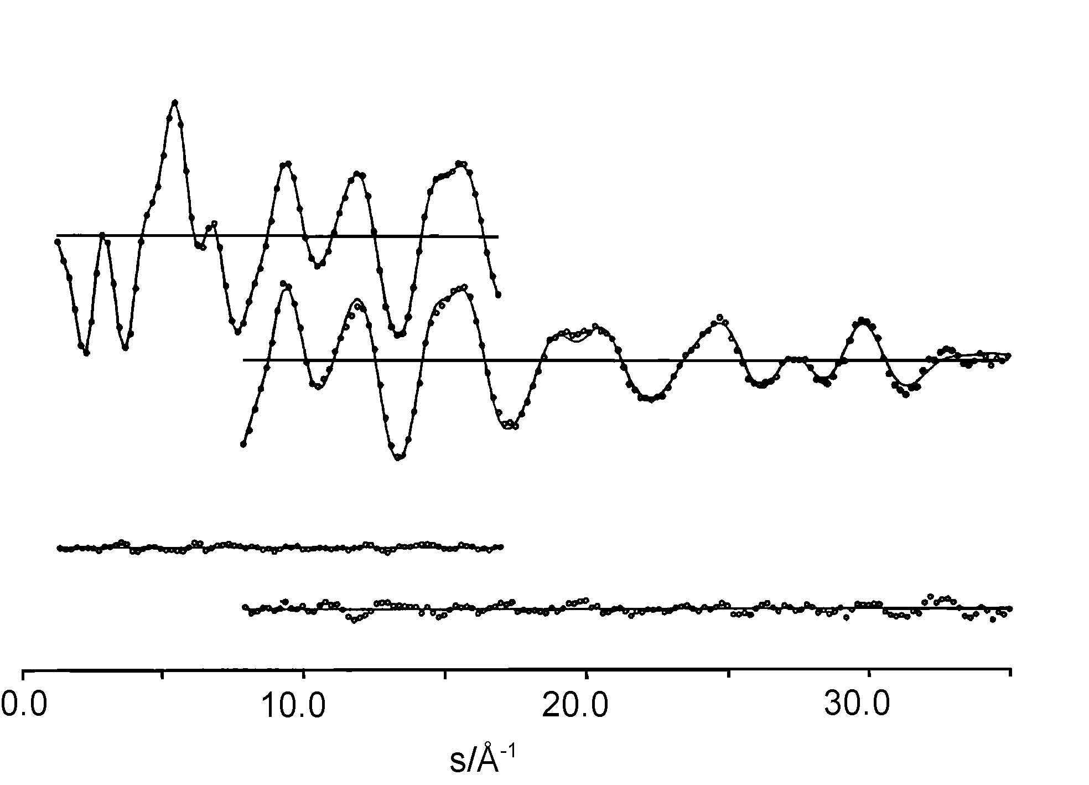

S-Figure 1. Experimental (...) and calculated (___) molecular intensities for 4d sM(s) and differences.

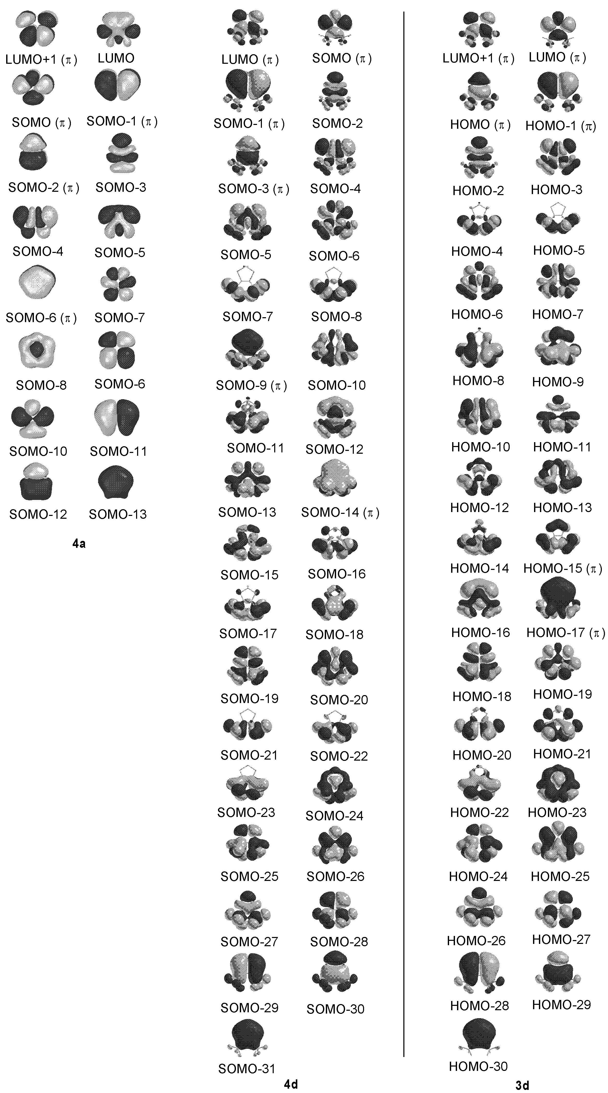

S-Figure 2. MOs of 3d, 4d (UMPW1PW91/6-31+G*) and 4a (UB3PW91/6-31G*)

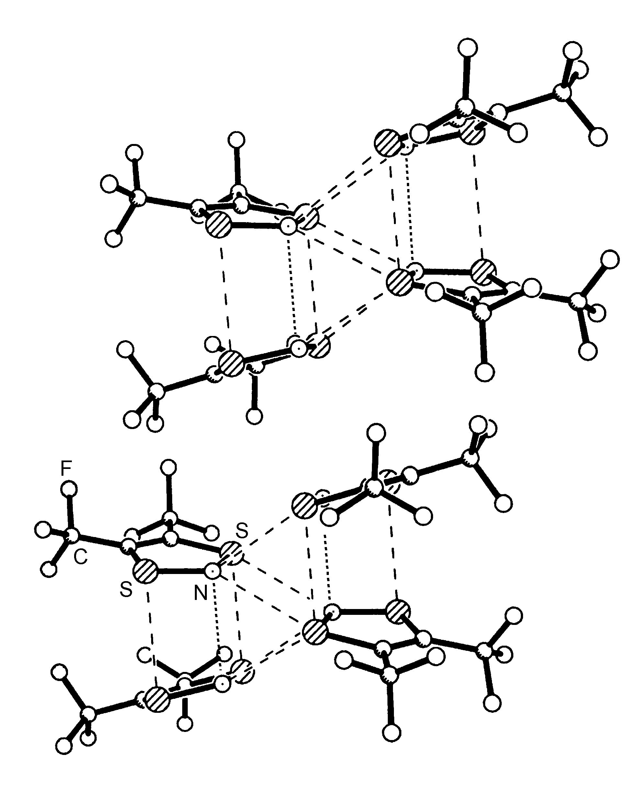

S-Figure 3. Tetramers in 4d packed to give regions of S^{δ+}…N^{δ-} and S…S contacts, and regions containing fluoride atoms.

X-Ray crystal structure determination
Growth of crystals for X-ray diffraction A sample of 4d held in a Pyrex capillary (o.d. 0.3 mm) was mounted on a Stoe Stadi diffractometer equipped with an Oxford Cryosystems low-temperature device (35). It is usual in studies such as this to cool the sample, controlling the crystal growth front by careful adjustment of the temperature gradient. The rate of crystal growth can normally be observed visually, but here the intense colour of the sample made this impossible. The sample was therefore cooled through its melting point at various ramping rates, and the crystallinity assessed at each stage from a rotation photograph. The results of most of these experiments were polycrystalline masses, but an indexable (36) diffraction pattern was obtained by cooling from 280 to 270 K at 20 K h⁻¹.
Crystal and data collection parameters. C₄F₆NS₂, M = 240.17. Triclinic, a = 7.976(3), b = 8.806(3), c = 11.830(4) Å, α = 102.15(2), β = 93.40(2), γ = 108.16(2)°, U = 764.8(4) Å³ [from ± ω values of 24 reflections (15° < θ < 16°), λ = 0.71073 Å]. T = 220.0(2) K, space group P-1, graphite monochromated Mo-Kα radiation, Z = 4, D^{c} = 2.086 mg m⁻³, F(000) = 486. Blue-black cylinder with radius 0.15 mm, μ = 0.752 mm⁻¹. Reflections were measured with ω-θ scans in the range 2.51 < θ < 25.03°; 5384 data were measured, of which 2697 were unique (R_{int} = 0.0421).
Structure solution and refinement: The structure was solved by Patterson methods (DIRDIF-96) (37) and refined by full-matrix least squares against F² (SHELXTL) (38) with anisotropic displacement parameters (adps) on all atoms. All trifluoromethyl groups were rotationally disordered about their three fold axes and their occupancies were refined, giving values for the major occupancies of 0.61(3), 0.64(3), 0.75(1), and 0.71(3) after reasonable convergence. During refinement these groups were restrained to be geometrically similar and three fold symmetric, while ‘opposite’ fluorine atoms were restrained to have equal thermal ellipsoids. The refinement converged to a conventional R-factor of 0.0404 [based on F and 1953 data with F > 4σ(F)], and wR2 = 0.1085 (based on F² and all 2690 data used during refinement). The final difference map extrema were 0.347 and -0.254 e Å⁻³.
An attempt was made to collect data at 150 K, but the peak profiles deteriorated significantly on cooling, possibly due to thermal stress or a near-by phase change, and so this experiment was abandoned.
Atomic coordinates, thermal parameters and bond lengths and angles have been deposited at the Cambridge Crystallographic Data Centre. See Instructions for Authors, J. Chem. Soc. Dalton Trans., 1999, Issue 1. Any request to the CCDC for this material should quote the full literature citation and the reference number nnn/nnn.

