Paper b100635p

Anion influence on co-ordination polymers of Ag(I) with 1,4-dithiacyclohexane.

Neil R. Brooks,ª Alexander J. Blake,ª Neil R. Champness,*ª John W. Cunningham,ª Peter Hubberstey,*ª Simon. J. Teat,^{b} Claire Wilson ª and Martin Schröder*ª
Supplementary Figures

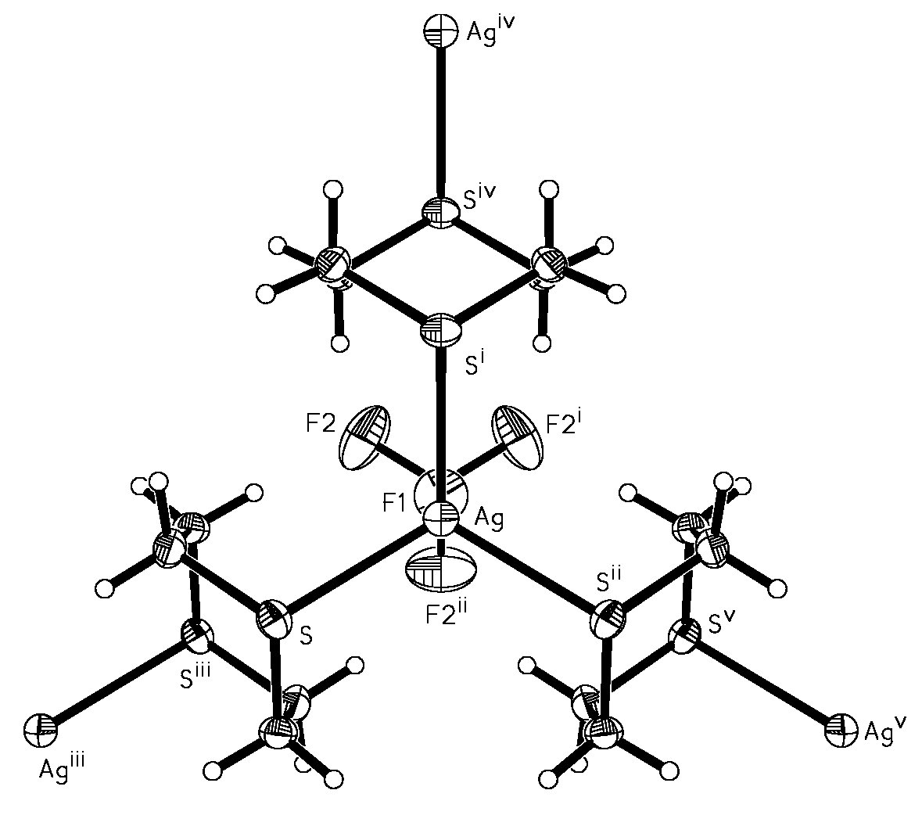
Figure S1(a): View of the silver co-ordination sphere and 1,4-dithiane connectivity in {[Ag₂(μ₂-1,4-dithiane)₃](BF₄)₂}∞. (Displacement ellipsoids shown at the 50% probability level; symmetry codes: i 1-y, x-y, z; 1-x+y, 1-x, z; iii 1.667-x, 0.333-y, 0.333-z; iv 0.667+y, 1.333-x+y, 0.333-z; v -0.333+x-y, -0.667+x, 0.333-z.)

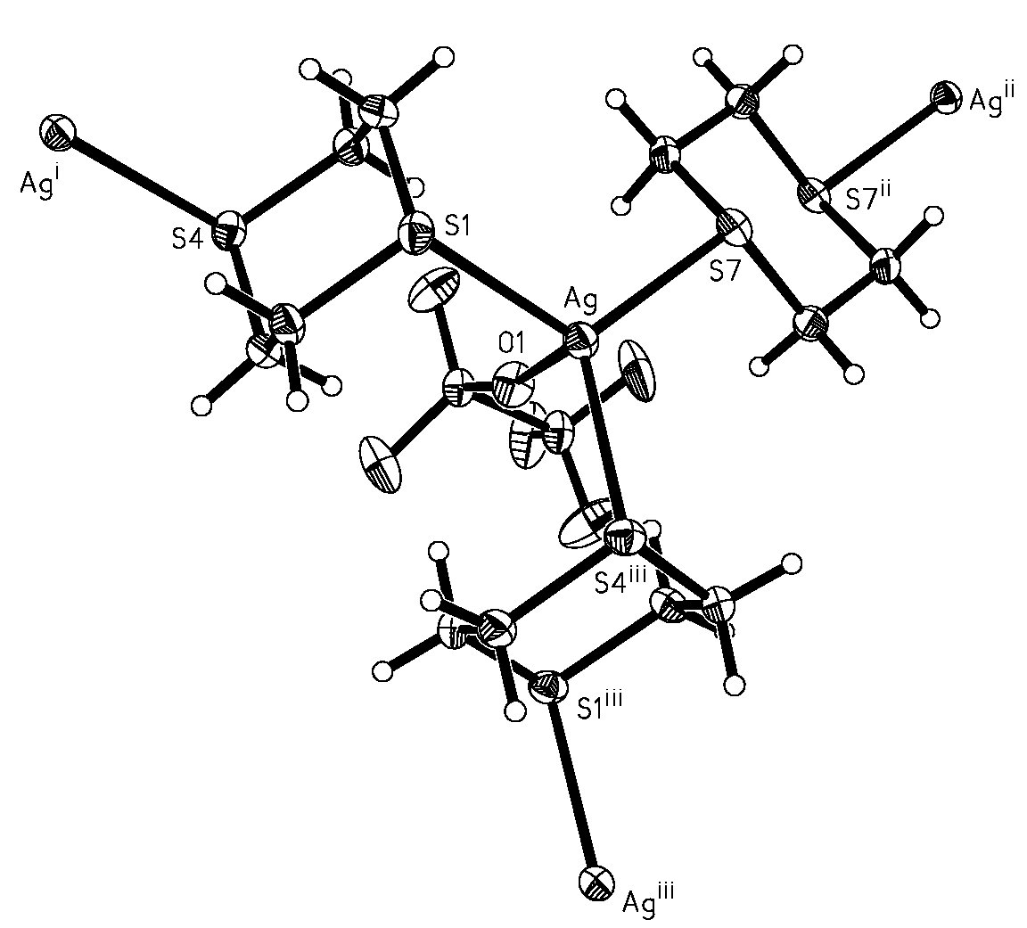
Figure S1(b): View of the silver co-ordination sphere and 1,4-dithiane connectivity in {[Ag₂(μ₂-1,4-dithiane)₃](CF₃SO₃)₂}∞. (Displacement ellipsoids shown at the 50% probability level; symmetry codes: i 0.5-x, -0.5-y, 0.5-z; ii –x 1-y, -z; iii 0.5-x, 0.5+y, 0.5-z.)

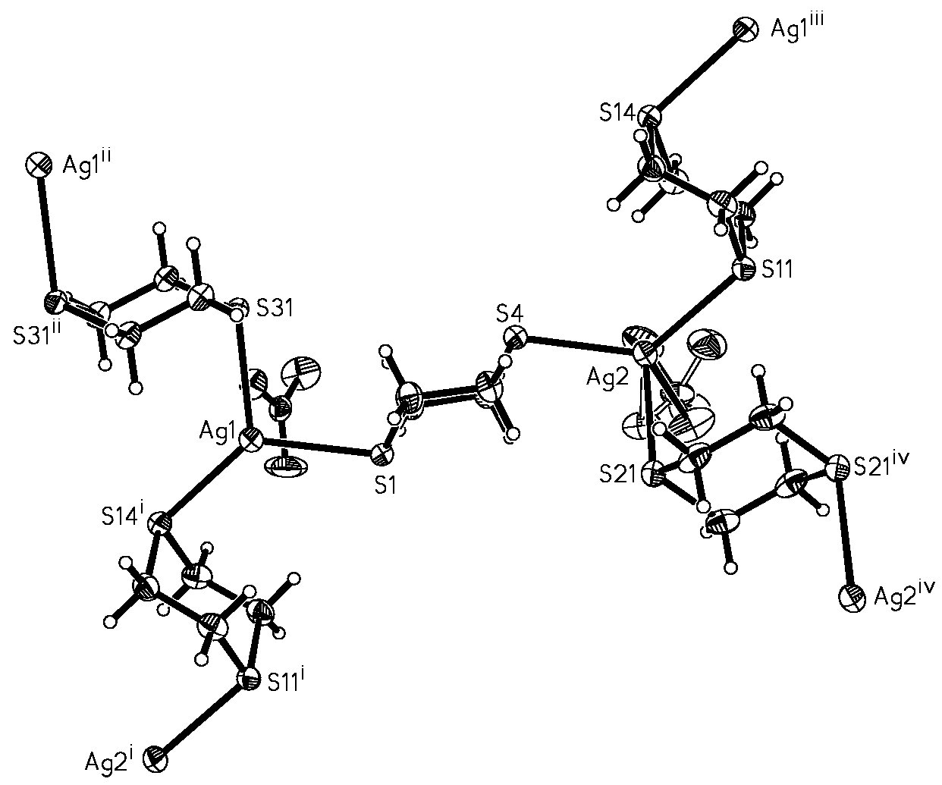
Figure S1(c): View of the silver co-ordination spheres and 1,4-dithiane connectivity in {[Ag₂(μ₂-1,4-dithiane)₃](NO₃)₂}∞. (Displacement ellipsoids shown at the 50% probability level; symmetry codes: i –1+x, y, z; ii –1-x, -y, 2-z; iii 1+x, y, z; iv –x, -1-y, 1-z.)

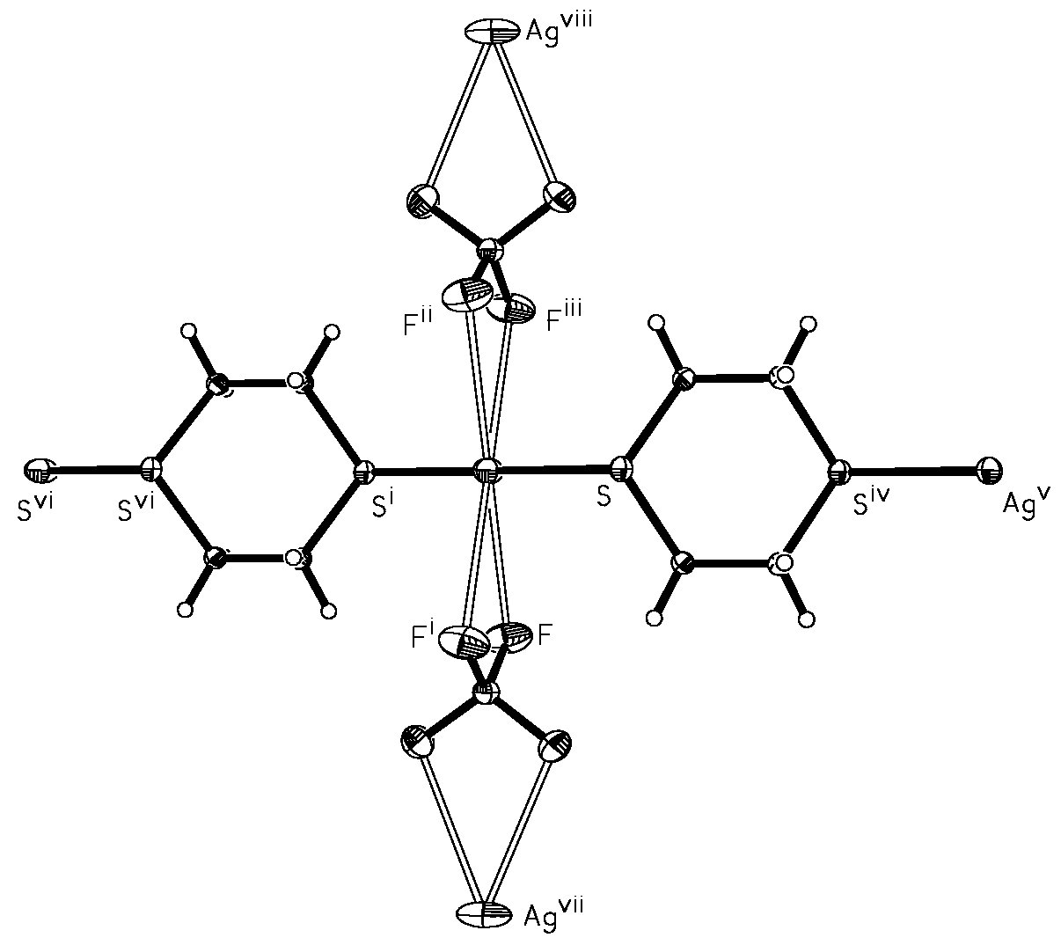
Figure S2(a): View of the silver co-ordination sphere and 1,4-dithiane and [BF₄⁻] connectivities and in {[Ag(μ₂-1,4-dithiane)](BF₄)}∞. (Displacement ellipsoids shown at the 50% probability level; symmetry codes: i 1-x, 2-y, -z; ii 1-x, 2-y, z; iii x, y, -z; iv –x, 2-y, -z; v –1+x, y, z; vi 1+x, y, z; vii –0.5+y, 0.5+x, 0.5-z.)

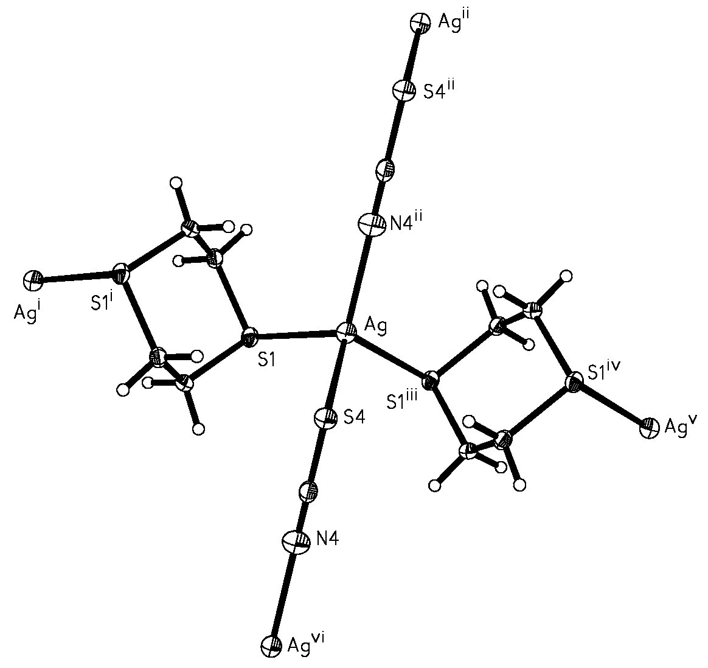
Figure S2(b): View of the silver co-ordination sphere and 1,4-dithiane and [SCN⁻] connectivities in {[Ag(μ₂-1,4-dithiane)](SCN)}∞. (Displacement ellipsoids shown at the 50% probability level; symmetry codes: i 1-x, -y, 1-z; ii 2-x, -y, 1-z; iii x, 0.5-y, -0.5+z; iv x, 0.5-y, 0.5 +z.)

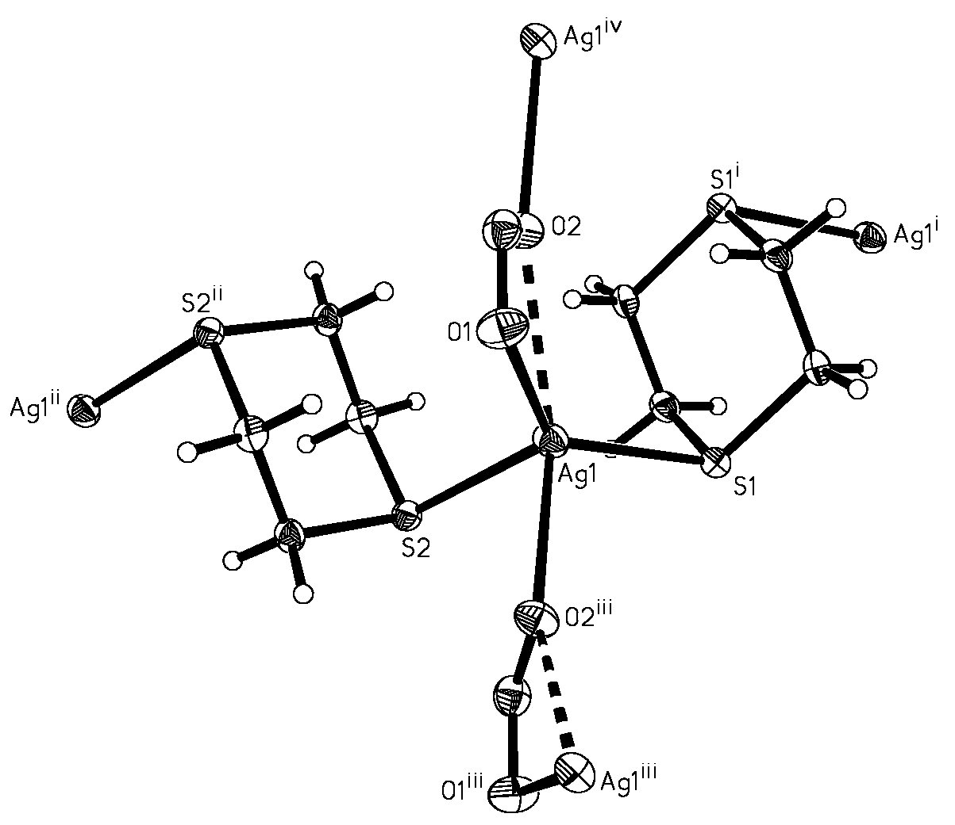
Figure S2(c): View of the silver co-ordination sphere and 1,4-dithiane and [NO₂⁻] connectivities in {[Ag(μ₂-1,4-dithiane)](NO₂)}∞. (Displacement ellipsoids shown at the 50% probability level; symmetry codes: i 1-x, -y, 1-z; ii 2-x, -y, 1-z;iii x, 0.5-y, -0.5+z; iv x, 0.5-y, 0.5+z.)

