Isomer formation in the binding of [PtCl₂(cis-cyclohexane-1,3-diamine)] to oligonucleotides and the X-ray crystal structure of [PtCl₂(cis-cyclohexane-1,3-diamine)].dimethylformamide

S. Tsuey Cham, Connie I. Diakos, Leanne T. Ellis, Ronald R. Fenton, Vivienne P. Munk, Barbara A. Messerle† and Trevor W. Hambley*

Centre for Heavy Metals Research, School of Chemistry, University of Sydney, Sydney, NSW 2006, Australia
Figure S1: HPLC chromatogram of dGpG

Figure S2: HPLC chromatogram for the products of the reaction between
cis-[Pt(NH₃)₂(H₂O)₂]²⁺ and dGpG

Figure S3: HPLC chromatogram for the reaction products from the competition experiment between cis-[PtCl₂(1,3-dach)], cis-[PtCl₂(NH₃)₂] and dGpG

Figure S4: HPLC chromatogram for the products of the reaction between
cis-[Pt(H₂O)₂(1,3-dach)]²⁺ and dGpG

Figure S5: HPLC chromatogram for the reaction products of the competition experiment involving cis-[Pt(H₂O)₂(1,3-dach)]²⁺, cis-[Pt(NH₃)₂(H₂O)₂]²⁺ and dGpG
Proton | Chemical Shift (ppm) | Orientation
1 | 3.76 | axial
2 | 2.54, 2.51 (d) | equatorial
3 | 1.65 | equatorial
4 | 1.48 | axial
5 | 1.42 | axial
6 | 1.33 | axial
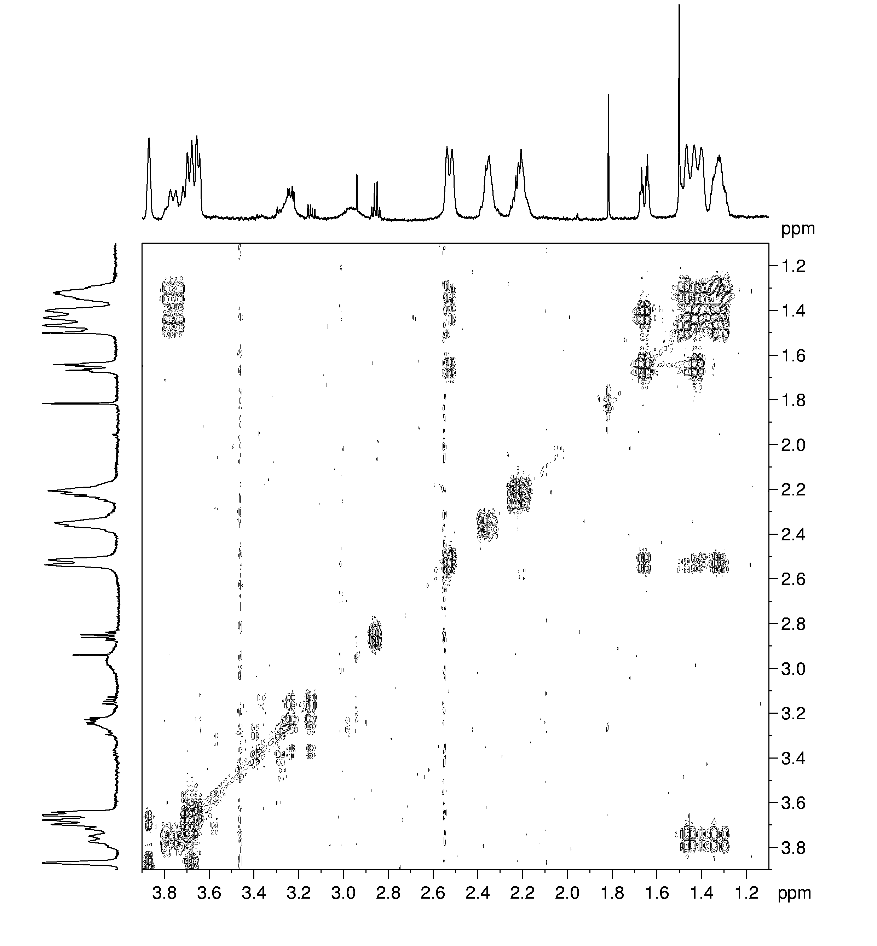  7 | 1.31 | equatorial
Tentative assignments of isomer 1

Figure S6: Ligand section of DQF-COSY experiment of
[Ptd(GpG)(cis-1,3-chxn)] in D₂O at 298 K – isomer 1.

Proton | Chemical Shift (ppm)
1'a | 5.82
1'b | 5.78
2'a | 2.36
2'b | 2.22
2"b | cannot distinguish
3'a | 4.25
3'b | 4.34
4'a | 3.65
4'b | 3.87
5'b | 3.67
H8 | 8.19
H8 | 7.85

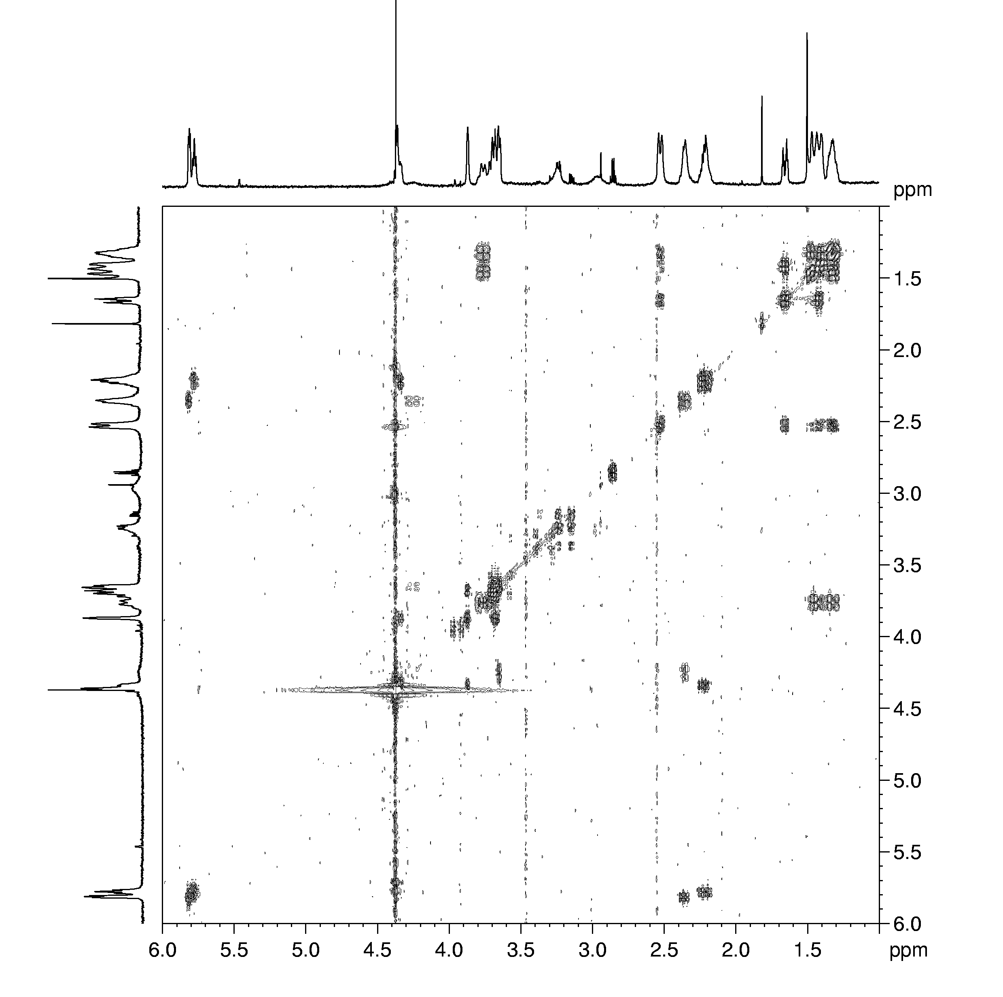
Figure S7: DQF-COSY spectrum of [Pt(dGpG)(cis-1,3-chxn)] isomer 1.

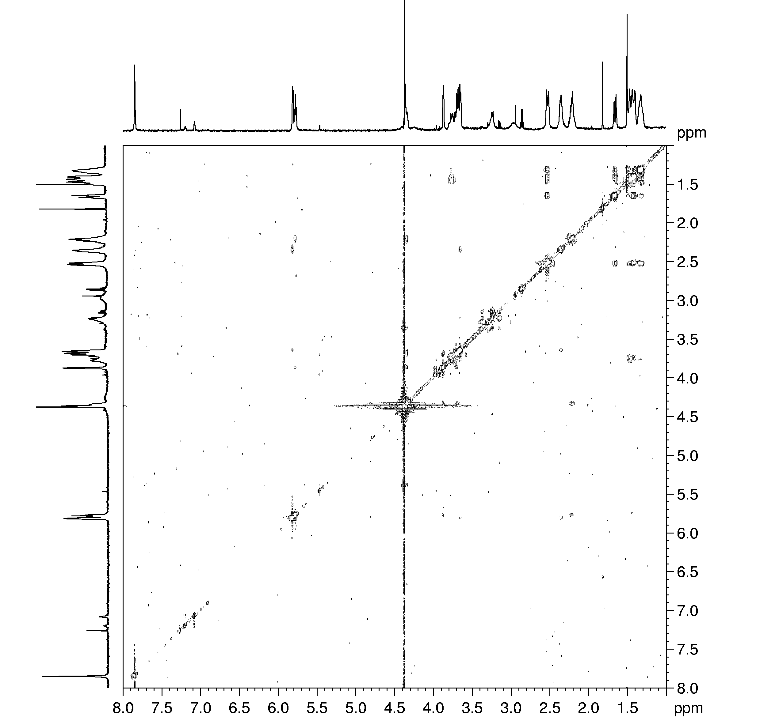

Figure S8: ROESY spectrum of isomer 1 in D₂O at 298 K, τ_{m} = 250 ms.

Figure S9: 1D ¹H spectra of isomer 1 at 298 and 305 K,
showing chemical exchange at both temperatures.

Figure S10: Variable temperature ¹H 1D NMR of isomer 1 in a 50:50 D₂O:CD₃OD mix.

Isomer 2

Assignments made from the COSY in D₂O at 298 K (Figure 6). Again, one ligand conformation is present, with effective symmetry of the ligand indicated. A chair conformation of the cyclohexane ring was again assumed.

Proton | Chemical Shift (ppm) | Orientation
1 | 3.78 | axial
2 | 2.56, 2.54 (d) | equatorial
3 | 1.66 | equatorial
4 | 1.50 | axial
5 | 1.47 | axial
6 | 1.39 | axial
7 | 1.30 | equatorial

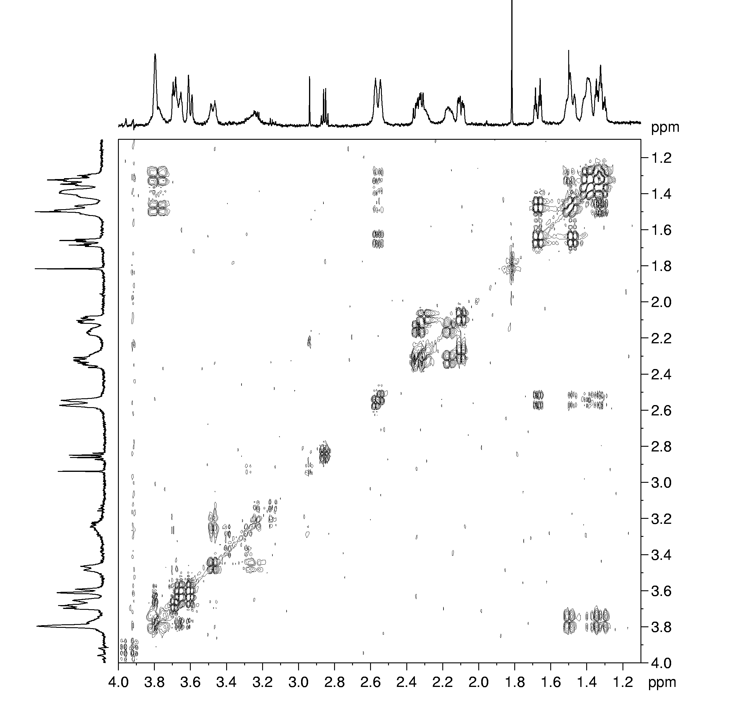

Figure S11: DQF-COSY spectrum of ligand section of isomer 2 in D₂O at 298 K.

DNA assignments:

Proton | Chemical Shift (ppm)
1' | 5.82
2' | 2.30
2" | 2.09
3' | 4.32
4' | 3.79
2'b | 2.33
2"b | 2.15
5' | 3.64
5" | 3.59
H8 | 8.14
H8 | 7.95

DNA assignments:

All assignments obtained from the COSY spectrum recorded in D₂O at 298 K (Figure 2).

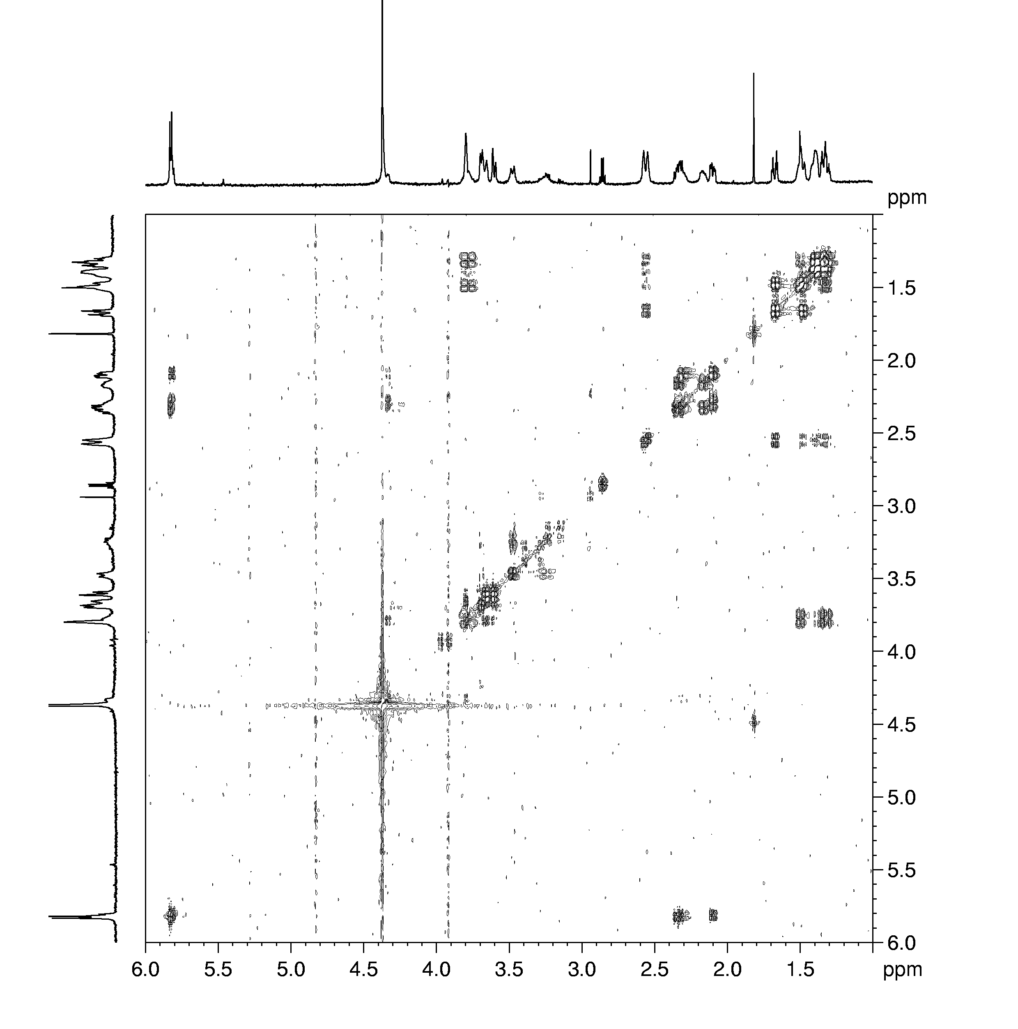
Figure S12: DQF-COSY spectrum of isomer 2 in D₂O at 298 K.
Only one discernible sub-unit of sugars is present, most likely due to complete overlapping of the peaks from exchange broadening, except in the case of the low-frequency protons (2'b, 2"b - labelling completely arbitrary).

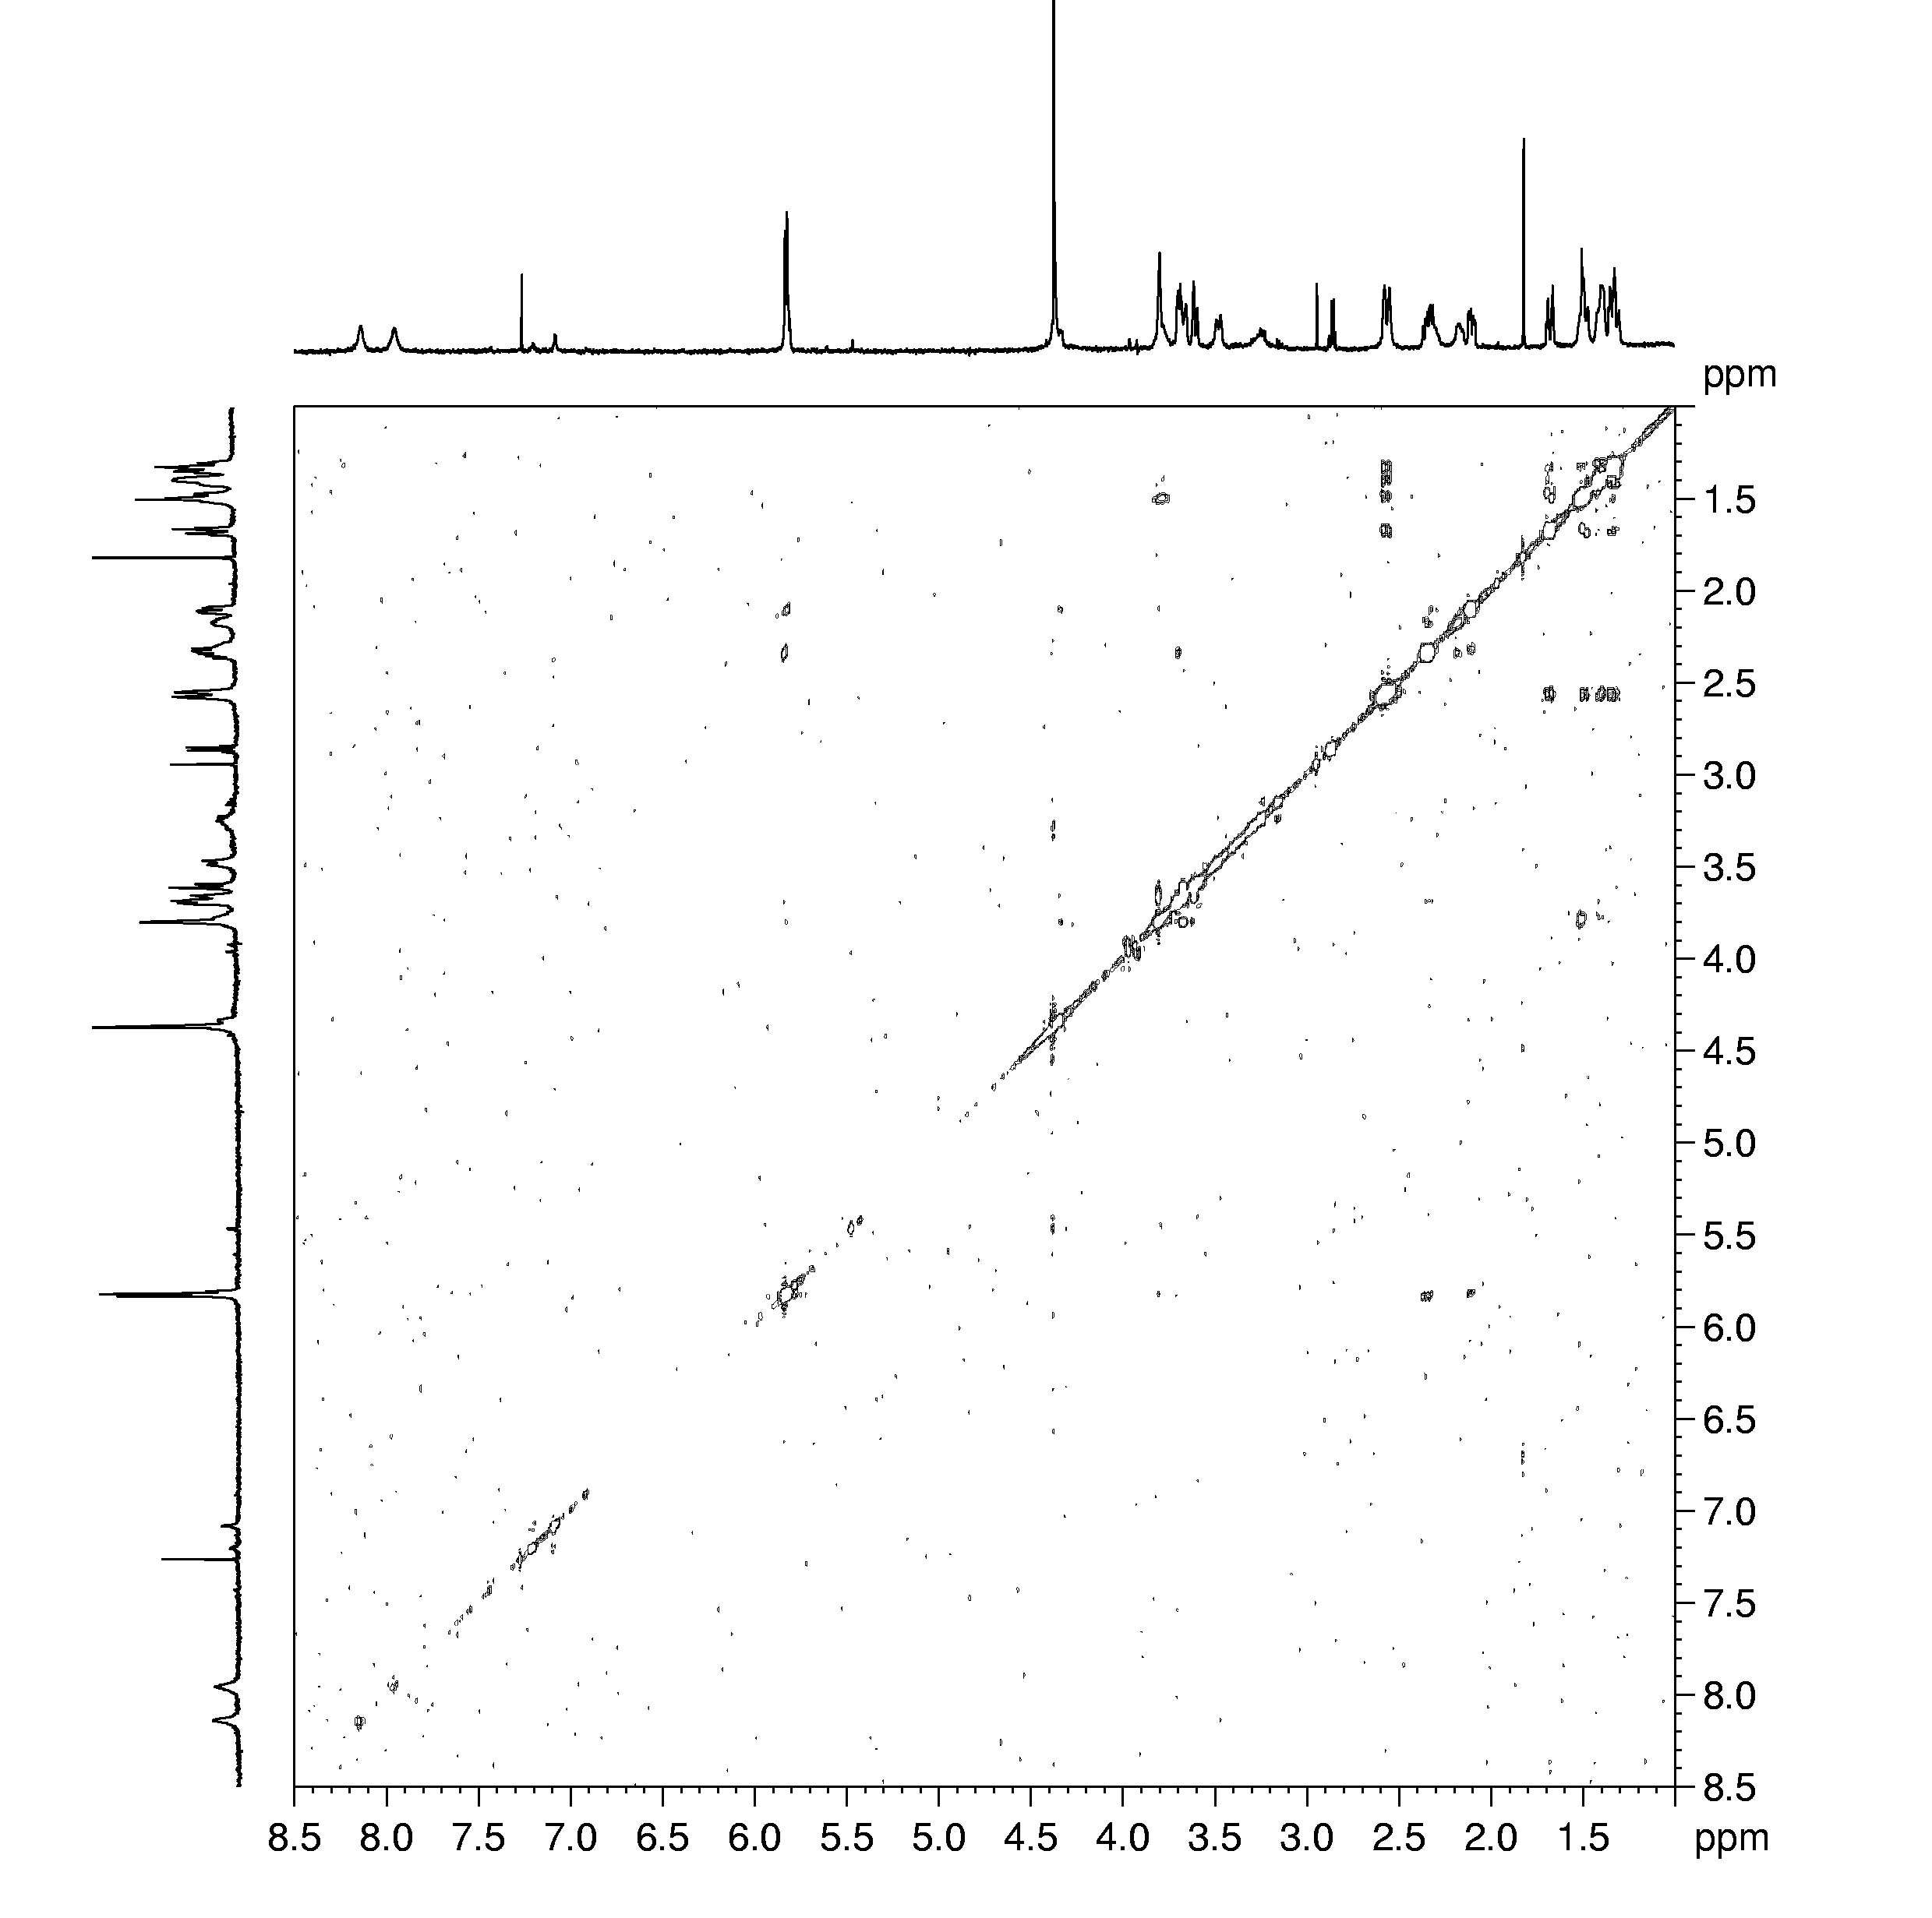

Figure S13: ROESY spectrum of isomer 2 at 298 K, τ_{m} = 250 ms.

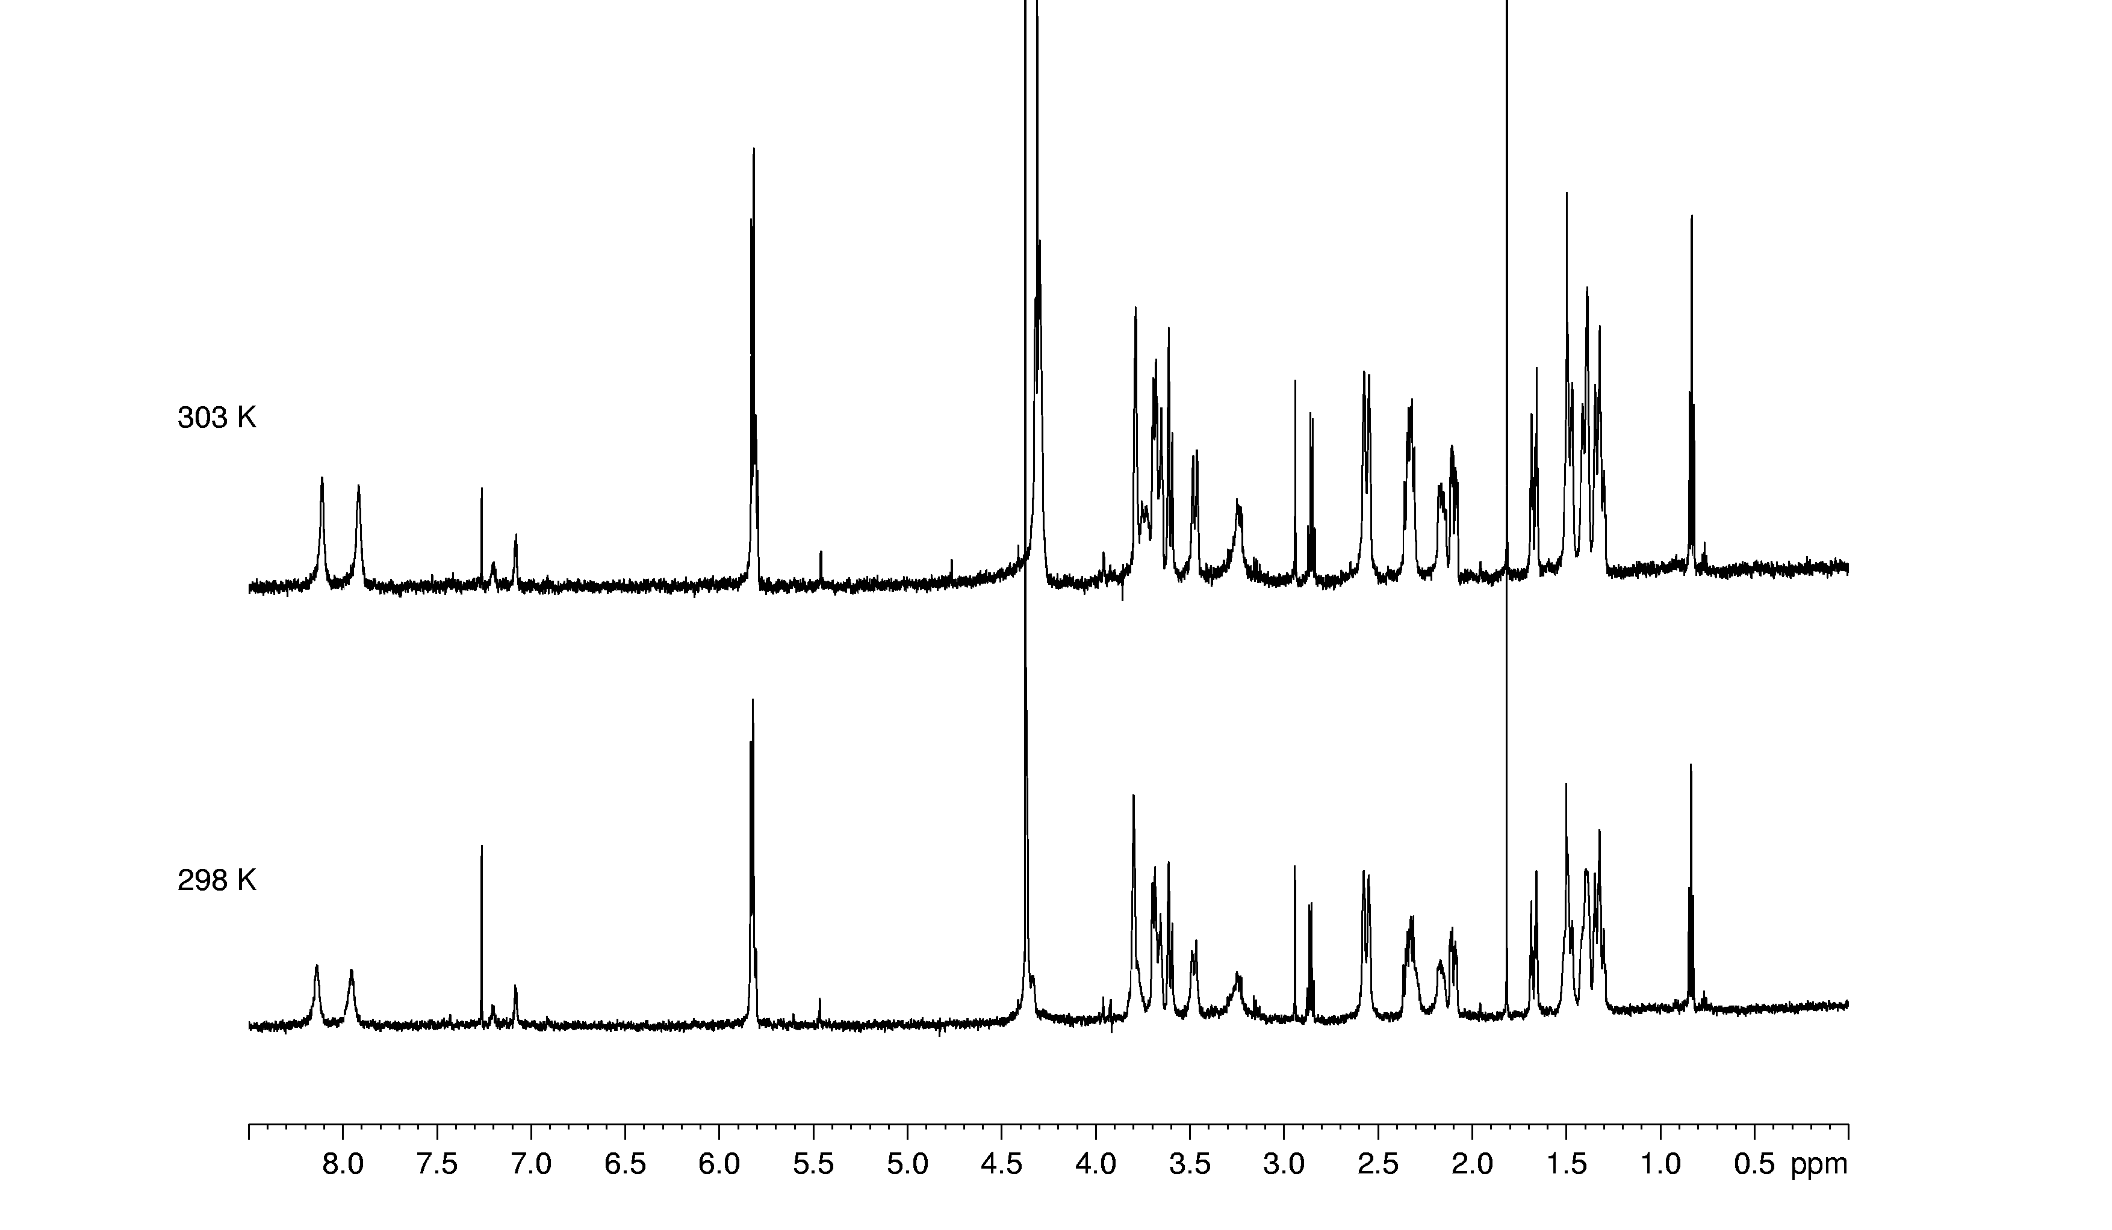

Figure S14: ¹H 1D spectra of isomer 2 recorded at 298 and 303 K.

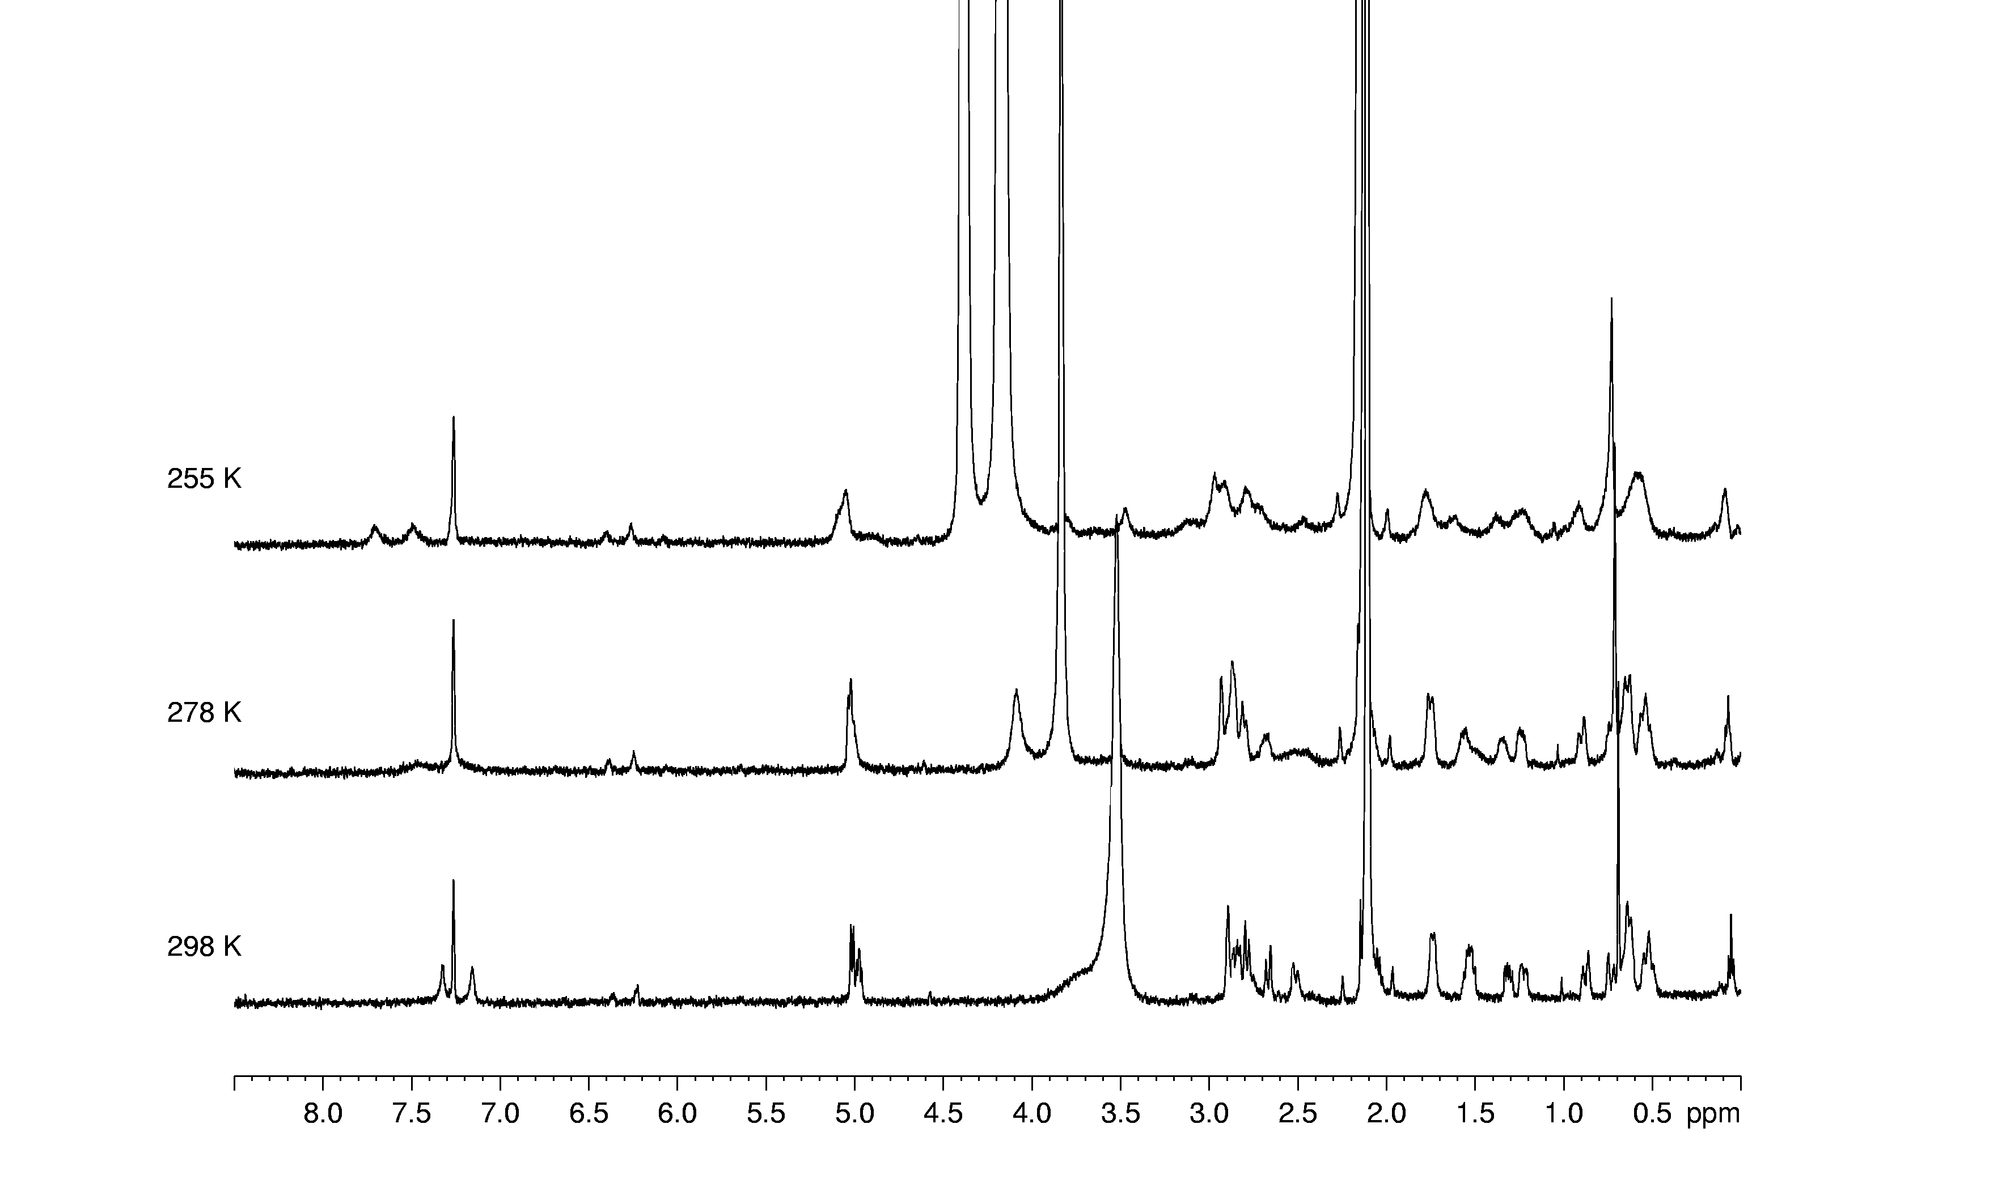
Figure S15: 1D spectra of isomer 2 from a 50:50 D₂O:CD₃OD mixture.

Table S1. Positional coordinates for non-hydrogen atoms for [PtCl₂(cis-1,3-chxn)]

x y z Beq

Pt(1) 0.09724(3) 0.44841(3) 0.12674(2) 2.227(6)
Cl(1) 0.3027(2) 0.6557(2) 0.0585(1) 3.44(4)
Cl(2) -0.1031(2) 0.6153(2) 0.2109(1) 3.35(3)
O(1) -0.3635(6) 0.2419(6) 0.3770(5) 5.5(1)
N(1) 0.2686(7) 0.3058(6) 0.0457(5) 2.9(1)
N(2) -0.0846(6) 0.2685(6) 0.1825(5) 2.8(1)
N(3) -0.6135(6) 0.3728(7) 0.4393(5) 3.6(1)
C(1) 0.2802(8) 0.1159(7) 0.0968(6) 3.2(1)
C(2) 0.0970(8) 0.0529(8) 0.1104(6) 3.4(2)
C(3) -0.0244(8) 0.0827(7) 0.2130(6) 3.0(1)
C(4) 0.0575(10) 0.0199(9) 0.3281(6) 4.0(2)
C(5) 0.2395(10) 0.0812(10) 0.3149(6) 4.2(2)
C(6) 0.3602(10) 0.0524(9) 0.2128(7) 4.2(2)
C(7) -0.4772(10) 0.3582(9) 0.3632(6) 4.6(2)
C(8) -0.746(1) 0.514(1) 0.4163(8) 6.7(3)
C(9) -0.644(1) 0.240(1) 0.5533(7) 6.2(2)
Table S2. Bond lengths (Å) for [PtCl₂(cis-1,3-chxn)]

Pt(1)-Cl(1) 2.323(1) Pt(1)-Cl(2) 2.315(1)
Pt(1)-N(1) 2.041(5) Pt(1)-N(2) 2.037(5)
O(1)-C(7) 1.218(8) N(1)-C(1) 1.492(7)
N(2)-C(3) 1.504(7) N(3)-C(7) 1.308(8)
N(3)-C(8) 1.446(8) N(3)-C(9) 1.452(9)
C(1)-C(2) 1.524(8) C(1)-C(6) 1.528(9)
C(2)-C(3) 1.510(9) C(3)-C(4) 1.527(9)
C(4)-C(5) 1.510(9) C(5)-C(6) 1.50(1)
Table S3. Bond angles (º) for [PtCl₂(cis-1,3-chxn)]

Cl(1)-Pt(1)-Cl(2) 92.65(5) Cl(1)-Pt(1)-N(1) 87.4(1)
Cl(1)-Pt(1)-N(2) 178.6(2) Cl(2)-Pt(1)-N(1) 177.4(2)
Cl(2)-Pt(1)-N(2) 87.6(1) N(1)-Pt(1)-N(2) 92.2(2)
Pt(1)-N(1)-C(1) 120.6(4) Pt(1)-N(2)-C(3) 119.7(4)
C(7)-N(3)-C(8) 124.0(6) C(7)-N(3)-C(9) 120.3(6)
C(8)-N(3)-C(9) 115.7(6) N(1)-C(1)-C(2) 108.4(5)
N(1)-C(1)-C(6) 112.1(5) C(2)-C(1)-C(6) 112.5(6)
C(1)-C(2)-C(3) 112.8(5) N(2)-C(3)-C(2) 110.0(5)
N(2)-C(3)-C(4) 110.9(5) C(2)-C(3)-C(4) 113.3(6)
C(3)-C(4)-C(5) 113.2(6) C(4)-C(5)-C(6) 113.1(6)
C(1)-C(6)-C(5) 113.8(6) O(1)-C(7)-N(3) 126.8(7)
Table S4. Thermal parameters of non-hydrogen atoms for [PtCl₂(cis-1,3-chxn)]

U11 U22 U33 U12 U13 U23

Pt(1) 0.0269(1) 0.0255(1) 0.0280(2) -0.00374(8)0.00038(9) -0.00450(10)
Cl(1) 0.0340(8) 0.0329(8) 0.060(1) -0.0106(6) 0.0047(7) -0.0127(7)
Cl(2) 0.0410(9) 0.0389(8) 0.0451(9) -0.0021(6) 0.0063(7) -0.0164(7)
O(1) 0.052(3) 0.066(3) 0.070(4) 0.002(3) 0.022(3) -0.010(3)
N(1) 0.031(3) 0.031(3) 0.044(4) -0.005(2) 0.001(3) -0.011(2)
N(2) 0.033(3) 0.033(3) 0.033(3) -0.005(2) 0.004(2) -0.006(2)
N(3) 0.036(3) 0.051(3) 0.043(3) 0.002(2) -0.001(3) -0.011(3)
C(1) 0.040(4) 0.030(3) 0.045(4) 0.000(3) 0.005(3) -0.012(3)
C(2) 0.045(4) 0.030(3) 0.053(4) -0.007(3) -0.002(3) -0.015(3)
C(3) 0.037(4) 0.026(3) 0.047(4) -0.010(3) -0.004(3) -0.005(3)
C(4) 0.057(5) 0.042(4) 0.041(4) -0.003(3) -0.005(3) 0.004(3)
C(5) 0.061(5) 0.048(4) 0.045(4) 0.004(4) -0.021(4) -0.002(4)
C(6) 0.043(4) 0.044(4) 0.064(5) 0.007(3) -0.018(4) -0.005(4)
C(7) 0.054(5) 0.064(5) 0.046(5) -0.014(4) 0.006(4) -0.006(4)
C(8) 0.084(6) 0.087(6) 0.085(7) 0.030(5) -0.026(5) -0.037(5)
C(9) 0.075(6) 0.076(6) 0.063(6) -0.010(4) 0.025(4) -0.009(4)

General temperature factor expression:

exp(-2π2(a*2U11h2 + b*2U22k2 + c*2U33l2 + 2a*b*U12hk + 2a*c*U13hl + 2b*c*U23kl)

Table S5. Positional coordinates and thermal parameters for the hydrogen atoms for [PtCl₂(cis-1,3-chxn)]
x y z Biso

H(1) 0.246(7) 0.341(6) -0.042(5) 2(1)
H(2) 0.350(7) 0.338(7) 0.050(5) 2(1)
H(3) -0.140(8) 0.276(7) 0.242(5) 3(1)
H(4) -0.165(8) 0.303(7) 0.107(6) 4(1)
H(5) 0.352(7) 0.078(6) 0.049(5) 2(1)
H(6) 0.032(8) 0.113(7) 0.021(6) 4(1)
H(7) 0.113(9) -0.053(8) 0.119(6) 5(1)
H(8) -0.128(7) 0.022(6) 0.225(5) 2(1)
H(9) -0.046(8) 0.044(7) 0.396(5) 4(1)
H(10) 0.076(8) -0.099(8) 0.339(5) 4(1)
H(11) 0.232(7) 0.202(7) 0.309(5) 3(1)
H(12) 0.303(8) 0.015(8) 0.388(6) 4(1)
H(13) 0.392(8) -0.068(8) 0.215(6) 5(1)
H(14) 0.464(9) 0.111(8) 0.205(6) 5(1)
H(15) -0.4656 0.4480 0.2896 5.4916
H(16) -0.6921 0.6168 0.3972 8.0957
H(17) -0.8035 0.5138 0.3523 8.0957
H(18) -0.8307 0.4981 0.4849 8.0957
H(19) -0.7461 0.2719 0.5978 7.3537
H(20) -0.6618 0.1364 0.5411 7.3537
H(21) -0.5450 0.2240 0.5939 7.3537
Table S6. Least-Squares Planes for [PtCl₂(cis-1,3-chxn)]

-------------- Plane number 1 ---------------

Atoms Defining Plane Distance
Pt(1) ( 1) 0.0300
Cl(1) ( 1) 0.0036
Cl(2) ( 1) -0.0177
N(1) ( 1) -0.0201
N(2) ( 1) 0.0042

Mean deviation from plane is 0.0151 angstroms
Chi-squared: 0.0

-------------- Plane number 2 ---------------

Atoms Defining Plane Distance
N(1) ( 1) -0.0058
N(2) ( 1) 0.0058
C(1) ( 1) 0.0068
C(3) ( 1) -0.0068

Mean deviation from plane is 0.0063 angstroms
Chi-squared: 0.0

Dihedral angles between least-squares planes
plane plane angle
2 1 27.20

-------------- Plane number 3 ---------------

Atoms Defining Plane Distance
C(1) ( 1) -0.0006
C(3) ( 1) 0.0006
C(4) ( 1) -0.0006
C(6) ( 1) 0.0006

Mean deviation from plane is 0.0006 angstroms
Chi-squared: 0.0

Dihedral angles between least-squares planes
plane plane angle
3 1 84.48
3 2 111.68

-------------- Plane number 4 ---------------

Atoms Defining Plane Distance
O(1) ( 1) -0.0035
N(3) ( 1) 0.0133
C(7) ( 1) -0.0003
C(8) ( 1) -0.0063
C(9) ( 1) -0.0033

Mean deviation from plane is 0.0053 angstroms
Chi-squared: 0.0

Dihedral angles between least-squares planes
plane plane angle
4 1 55.15
4 2 31.12
4 3 134.29

Table S7. Torsion angles for [PtCl₂(cis-1,3-chxn)]

(1) (2) (3) (4) angle (1) (2) (3) (4) angle

Pt(1)N(1) C(1) C(2) 56.1(7) N(1) C(1) C(2) C(3) -74.9(7)
Pt(1)N(1) C(1) C(6) -68.7(6) N(1) C(1) C(6) C(5) 72.7(8)
Pt(1)N(2) C(3) C(2) -54.6(6) N(2) Pt(1)N(1) C(1) -34.2(5)
Pt(1)N(2) C(3) C(4) 71.5(6) N(2) C(3) C(2) C(1) 74.8(7)
Cl(1)Pt(1)N(1) C(1) 147.1(5) N(2) C(3) C(4) C(5) -74.5(7)
Cl(1)Pt(1)N(2) C(3) 109(6) C(1) C(2) C(3) C(4) -49.9(7)
Cl(2)Pt(1)N(1) C(1) -121(3) C(1) C(6) C(5) C(4) 49.8(8)
Cl(2)Pt(1)N(2) C(3) -149.9(4) C(2) C(1) C(6) C(5) -49.9(8)
O(1) C(7) N(3) C(8) -178.9(7) C(2) C(3) C(4) C(5) 49.8(8)
O(1) C(7) N(3) C(9) -1(1) C(3) C(2) C(1) C(6) 49.7(7)
N(1) Pt(1)N(2) C(3) 32.7(5) C(3) C(4) C(5) C(6) -49.4(8)

The sign is positive if when looking from atom 2 to atom 3 a clock-
wise motion of atom 1 would superimpose it on atom 4.

