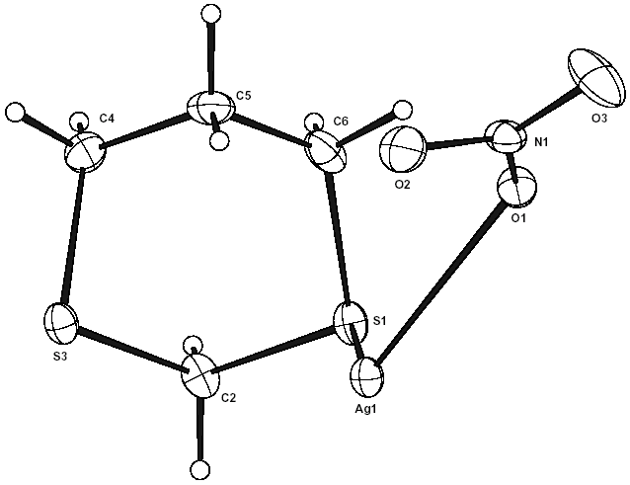

Fig. S1 Asymmetric unit of, and numbering scheme for {[{Ag₂(μ-1,3-dithiane)₂}(μ-NO₃)₂]}∞ 1 (150 K determination).

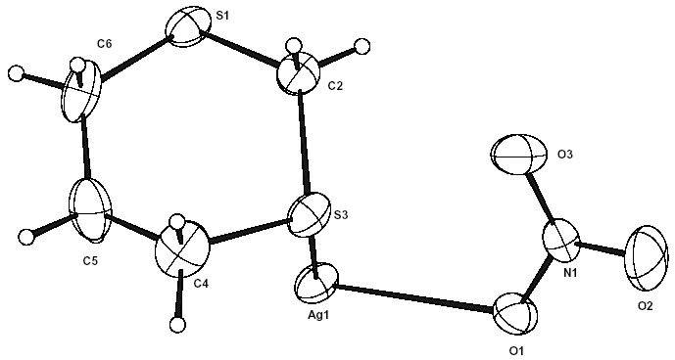

Fig. S2 Asymmetric unit of, and numbering scheme for {[{Ag₂(μ-1,3-dithiane)₂}(μ-NO₃)₂]}∞ 1 (296 K determination).

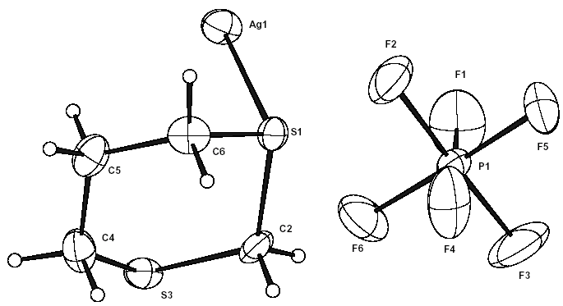

Fig. S3 Asymmetric unit of, and numbering scheme for {[{Ag₂(μ-1,3-dithiane)₂}(μ-PF₆)₂]}∞ 2.

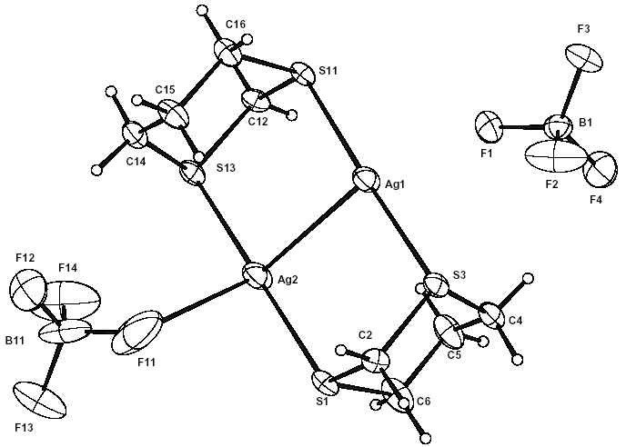

Fig. S4 Asymmetric unit of, and numbering scheme for {[{Ag(BF₄)}₂(μ-1,3-dithiane)₂]}∞ 3.

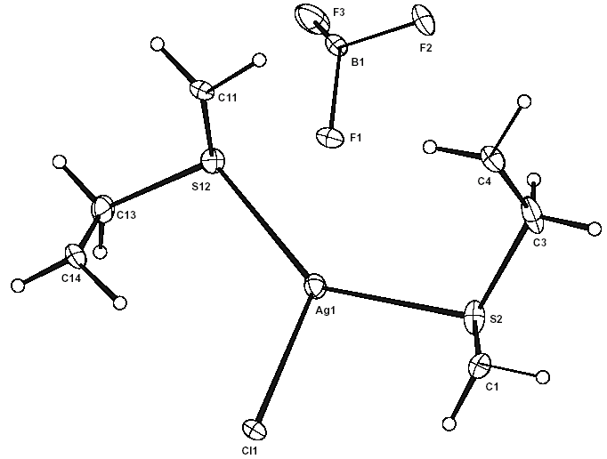

Fig. S5 Asymmetric unit of, and numbering scheme for {[Ag₂(μ-1,3-dithiane)₂(μ-Cl)][BF₄]}∞ 4.

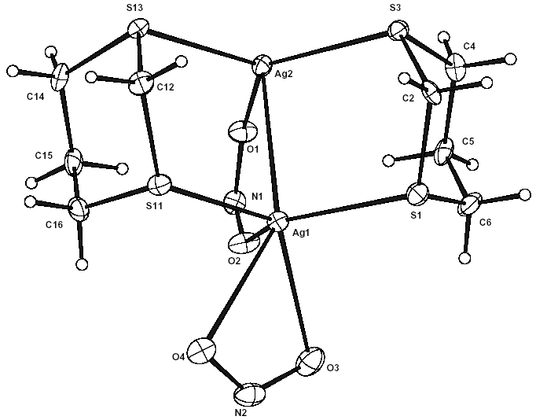

Fig. S6 Asymmetric unit of, and numbering scheme for {[Ag(μ-1,3-dithiane)₂{Ag(NO₂)}(μ-NO₂)]}∞ 5.

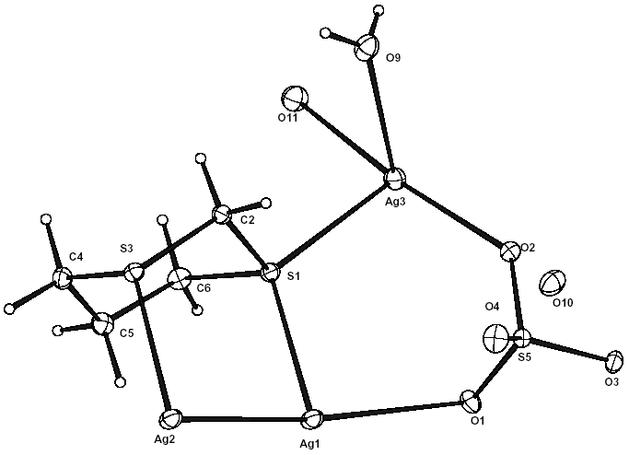

Fig. S7 Asymmetric unit of, and numbering scheme for {[{Ag₂(μ-1,3-dithiane)₂}(μ-SO₄)₂{Ag(H₂O)₂}₂]·2H₂O}∞ 6.

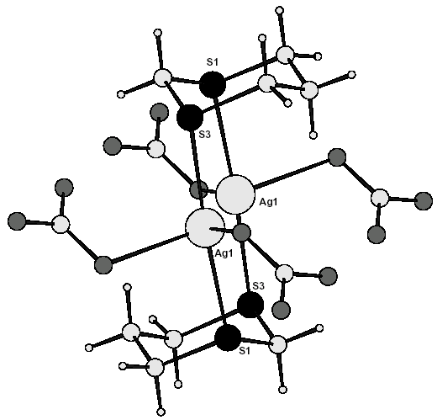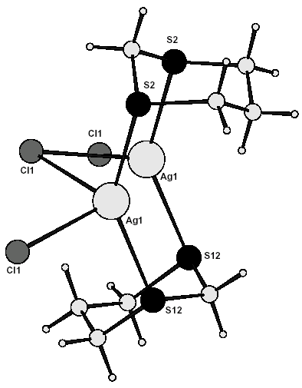

(a) (b)

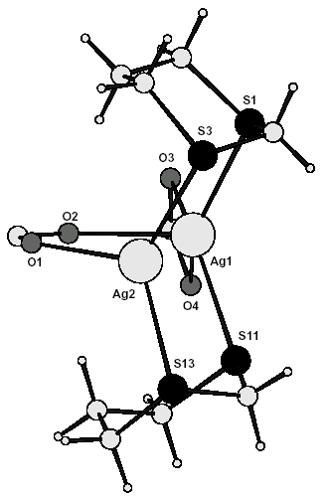

(c)

Fig. S8 A comparison of the molecular structures of (a) the [Ag₂(μ-1,3-dithiane)₂]²⁺ cation in 1, (b) the [Ag₂(μ-1,3-dithiane)₂(μ₂-Cl)]⁺ cation in 4, and (c) the [{Ag(NO₂)}(μ-1,3-dithiane)₂Ag(μ₃-NO₂)] moiety in 5 (Ag, large open circles; S, intermediate closed circles).

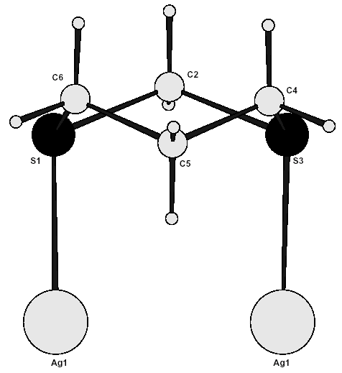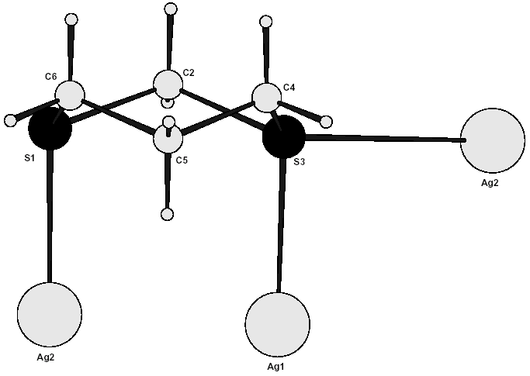

(a) (b)

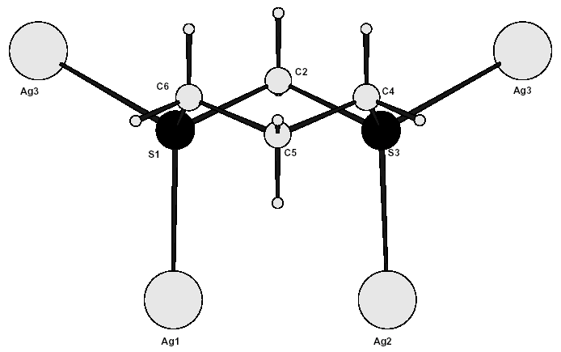

(c)

Fig. S9 Two-fold (a), three-fold (b) and four-fold connectivity of 1,3-dithiane in 1, 3 and 6 respectively (Ag, large open circles; S, intermediate closed circles; O, small shaded circles) (Ag, large open circles; S, intermediate closed circles).

