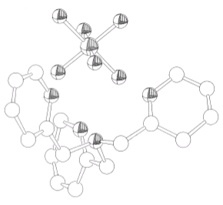

Fig. S1 ORTEP drawing of [H₃TPA(PF₆)]²⁺.

