Supplementary Material (B212443B)

Spectroscopy and photocleavage diagrams for experimental and theoretical study on DNA-Binding and Photocleavage Properties of Chiral Complexes Δ- and Λ-[Ru(bpy)₂L](L= o-hpip, m-hpip and p-hpip)

Wen J. Mei, Jie Liu, Kang C. Zheng, Li J. Lin, Hui Chao, An X. Li, Feng C. Yun and Liang N. Ji*

1. Submission details

Publication contact author name: Liang-Nian Ji
Publication contact author address:
School of Chemistry and Chemical Engineering,
Zhongshan University
Guangzhou
GD 510275
PRC
Publication contact author email: cesjln@zsu.edu.cn
Publication contact author fax: +86 20 8403 5497
Publication contact author phone: +86 20 8403 5453
Publication requested category:
Publication requested coeditor name:

2. Title and author list

Publication section title:
Experimental and Theoretical Study on DNA-Binding and Photocleavage Properties of Chiral Complexes Δ- and Λ-[Ru(bpy)₂L](L= o-hpip, m-hpip and p-hpip)

Publication author name and address

W. -J. Mei
School of Chemistry and Chemical Engineering,
Zhongshan University
Guangzhou,
GD, 510275
PRC

J. Liu
School of Chemistry and Chemical Engineering,
Zhongshan University
Guangzhou,
GD, 510275
PRC

K.-C. Zheng
School of Chemistry and Chemical Engineering,
Zhongshan University
Guangzhou,
GD, 510275
PRC

L.-J. Lin
School of Chemistry and Chemical Engineering,
Zhongshan University
Guangzhou,
GD, 510275
PRC

H. Chao
School of Chemistry and Chemical Engineering,
Zhongshan University
Guangzhou,
GD, 510275
PRC

A.-X. Li
School of Life Sciences,
Guangzhou,
GD, 510275
PRC

F.-C. Yun
School of Chemistry and Chemical Engineering,
Zhongshan University
Guangzhou,
GD, 510275
PRC

L.-N. Ji
School of Chemistry and Chemical Engineering,
Zhongshan University
Guangzhou,
GD, 510275
PRC

3. Captions for figures:

Figure 1. Electronic spectra of Δ- 2, Λ- 2, Δ- 3, and Λ- 3 in 5 mM Tris-HCl buffer (pH 7.2), 50 mM NaCl in the presence of increasing amounts of calf thymus DNA (the DNA absorption was subtracted, and the change at IL absorption was not shown). [DNA] = 0 ~3.0 × 10⁻⁴ mol•dm⁻³, [Ru] = 6.0 × 10⁻⁶ M. Arrows show the absorbance changes upon increasing amounts of CT-DNA concentration.
Figure 2. Emission spectra of Δ - 2, Λ - 2, Δ - 3 and Λ – 3 in 5 mM Tris-HCl buffer (pH 7.2), 50 mM NaCl in the presence of increasing amounts of CT-DNA. [DNA] = 0 ~2.4 × 10⁻⁵M; [Ru] = 1.0 × 10⁻⁵ M. Arrows show the emission intensity changes upon increasing amounts of CT-DNA concentration.
Figure 3. Photocleaveage of pBR322 DNA in 50 mM Tris-HCl buffer (pH 8.3), 18 mM NaCl in the absence (lane 0) and in the presence of Ru(II) complexes Δ-2 (lane 1 ~ 3), Λ-2 (lane 4 ~ 6), Δ-3 (lane1′~ 3′), and Λ-3 (lane 4′~ 6′).[Δ-2] = 25, 50, 100 × 10⁻⁶M (lane 1 ~ 3); [Λ-2] = 25, 50, 100 × 10⁻⁶M (lane 4 ~ 6); [Δ-3] = 25, 50, 100 × 10⁻⁶M (lane 1′~ 3′); [Λ-3] = 25, 50, 100 × 10⁻⁶M (lane 4′~ 6′). The control without complex and without light irradiation was shown in lane 0′.
Figure 4. Photocleaveage of pBR322 DNA in 50 mM Tris-HCl buffer (pH 8.3), 18 mM NaCl in the presence of Ru(II) complexes Δ-2 (lane 1 ~ 4), Λ-2 (lane 5 ~ 8), Δ-3 (lane1′~ 4′), and Λ-3 (lane 5′~ 8′). [Ru] = 50 × 10⁻⁶M ( t = 15, 30, 45 and 60 min, respectively).

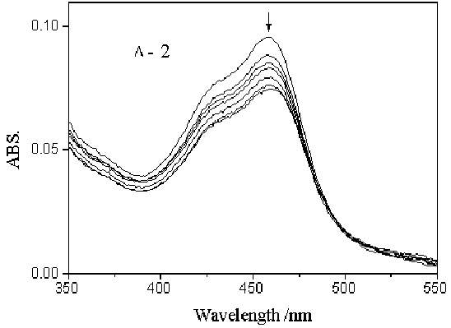

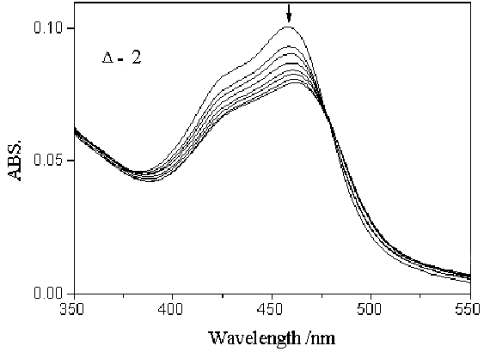

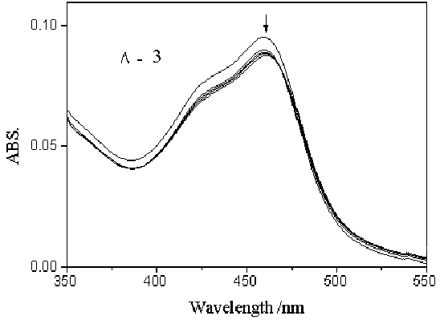
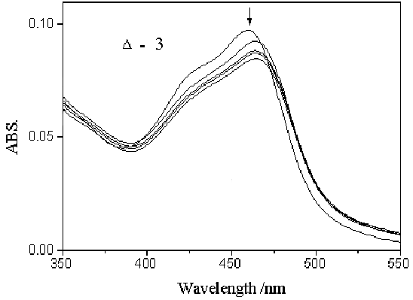

Fig. 1

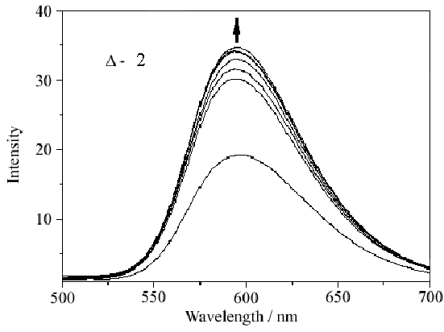
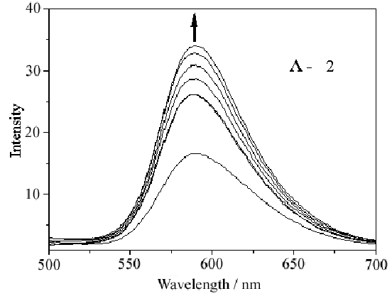

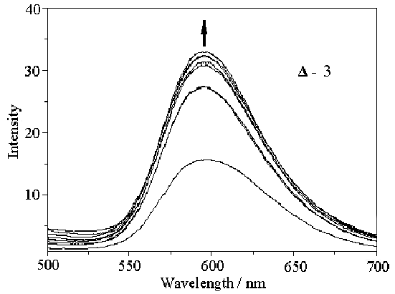
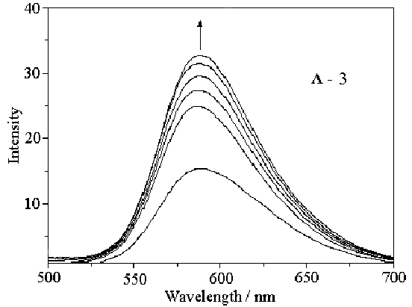

Fig. 2

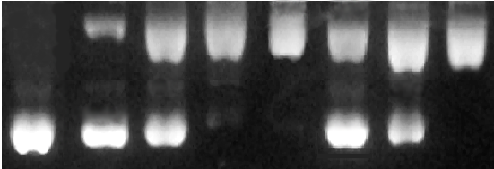
Form II
Form I
0′ 0 1 2 3 4 5 6

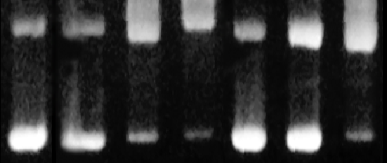
Form II
Form I
0 1′ 2′ 3′ 4′ 5′ 6′
Fig. 3

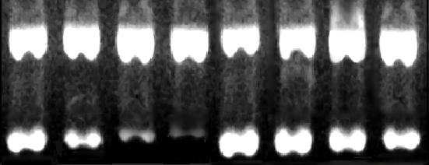
Form II

Form I
1 2 3 4 5 6 7 8

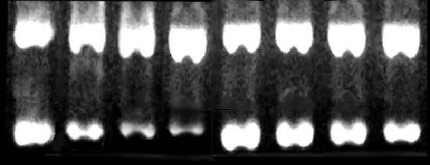
Form II

Form I
1′ 2′ 3′ 4′ 5′ 6′ 7′ 8′

Fig. 4

