The ESI spectra of the reaction mixtures:

- ^{t}BuOLi + ZnMe₂
- Me₃SiOK + ZnMe₂
- ^{t}BuOK + ZnMe₂

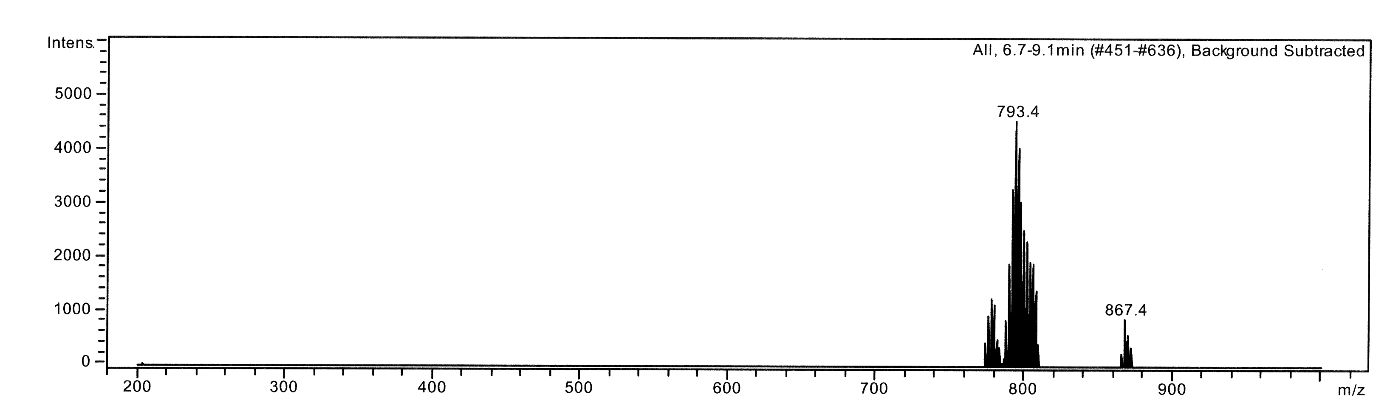
I
*

ESI 1. The ESI spectrum of ^{t}BuOLi + ZnMe₂
*: not identified

ESI 2. Measured (a) and calculated (b)
(a)
ESI spectrum of I.
I : C₃₆H₈₀Li₃O₈Zn₂
≡ C + Li⁺ + (^{t}BuOLi)₂ + 4 thf
(b)

*
*
*
*
*
III
*
II

ESI 3. The ESI spectrum of Me₃SiOK + ZnMe₂
*: not identified

ESI 4. Measured (a) and calculated (b)
ESI spectrum of II: K(Me₂ZnOSiMe₃)₂ ≡ C + K⁺

(a)

(b)

ESI 5. Measured (a) and (b) calculated ESI spectrum of III:
K[(OSiMe₃)₂(MeZn)]₂ ≡ D + K⁺
(a)

t
(b)

IV

*
*

*
*
*

ESI 6. The ESI spectrum of ^{t}BuOK + ZnMe₂
*: not identified

ESI 7. Measured (a) and calculated (b)
ESI spectrum of IV:
(O^{t}Bu)(MeZnO^{t}Bu)₃ ≡ F
(a)

(b)

