Palladium(II)-Based cis,trans-1,3,5-Triaminocyclohexane Complexes Demonstrating a Variety of Coordination Modes and Architectures

Georg Seeber,ª De-Liang Long,ª Benson M. Kariuki^{b} and Leroy Cronin^{*a}

ª Department of Chemistry, The University of Glasgow, University Avenue, Glasgow, G12 8QQ, UK. Fax +44 141 330 4888; Tel: +44 141 330 6650; E-mail: L.Cronin@chem.gla.ac.uk

^{b} School of Chemical Sciences, The University of Birmingham, Edgbaston, Birmingham, B15 2TT, UK

The flexibility of L is demonstrated by the variation of the interplanar angle Θ (Supplementary Fig., blue) between the Pd(II) coordination mean plane (Plane A) and the mean plane of the two axial nitrogens and their corresponding methine carbons (Plane B). The smaller the angle Θ becomes, the more regular the metallacyclic chair conformation is and the more the Pd(II) is orientated towards the cyclohexane centre, resulting in an overall compressed structure. Additional flexibility of trans-tach is given upon coordination of the ‘Tail’ amino group, which is expressed by the torsion around the C-N bond of the pendant amino group (Supplementary Fig., red; χ is the torsion angle between the centre of the cyclohexane ring, carbon C, nitrogen N_{eq} and Pd(II)).
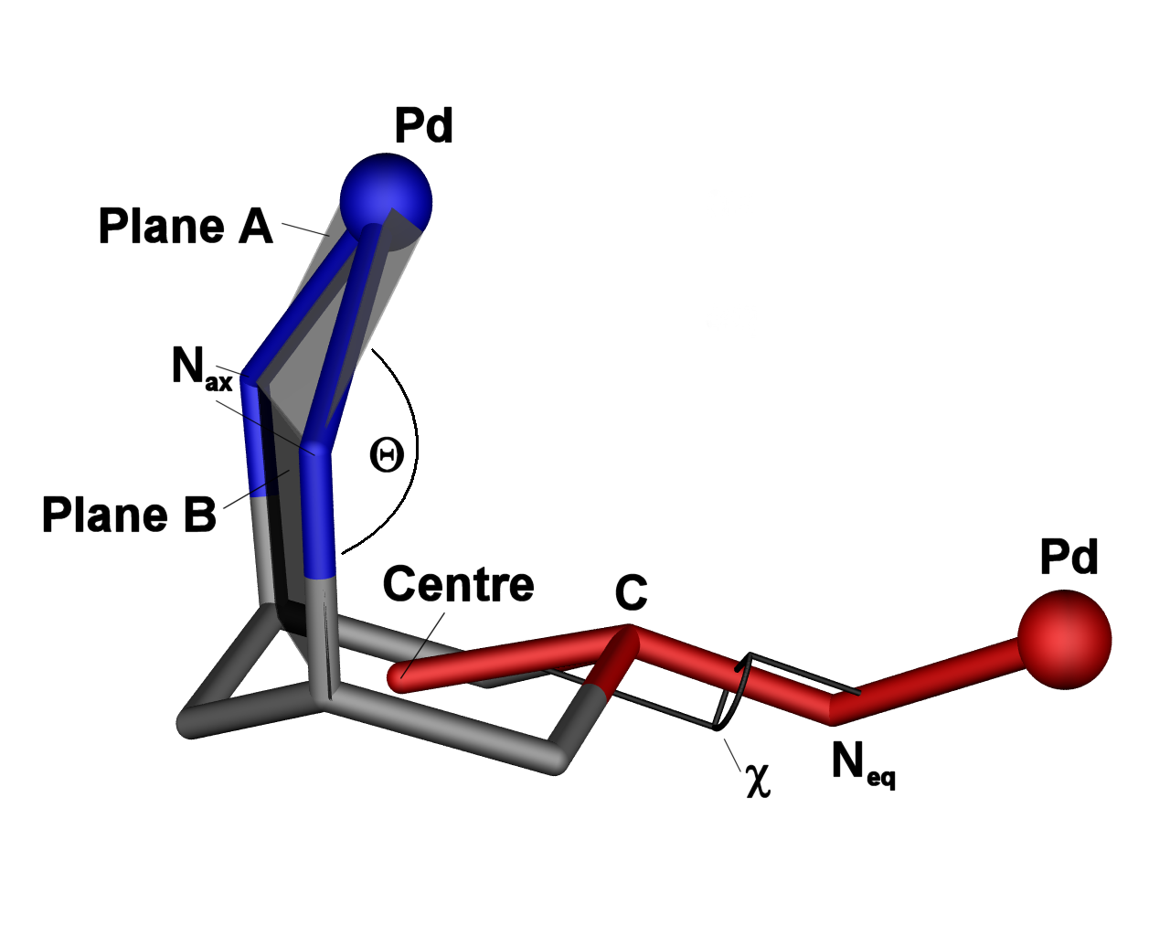
Fig. S1 Interplanar angle Θ (blue) between planes A and B. A is the mean plane of the chelated Pd(II) coordination sphere; plane B is the mean plane of the two nitrogen atoms N_{ax} and the corresponding methine carbon atoms. Torsion angle χ (red) lies between the centre of the cyclohexane ring, carbon C, nitrogen N_{eq} and Pd(II).

Table S1 Interplanar angle Θ and torsion angle χ for complexes 1-7.
[Pd(LH)Cl₂]Cl  1 | [Pd(LH)Br₂]₂[PdBr₄] 2 | [Pd(LH)₂](NO₃)₄  3 | [Pd(LH)₂](SO₄)₂  4 | [{Pd(L)Cl}₆]Cl₆  5 | [{Pd(L)Br}₆]Br₆  6 | [Pd{Pd(L)Cl₂}₂Cl₂]  7
Θ 146.0° | Θ 170.8° | Θ 142.8° | Θ 165.2° | _{i}  Θ₁ 159.7,  χ₁ 112.1  Θ₂ 148.5,  χ₂ 123.5  Θ₃ 147.2,  χ₃ 116.6 | _{i}  Θ₁ 148.0,  χ₁ 114.7  Θ₂ 148.9,    χ₂ 122.4  Θ₃ 149.6,  χ₃ 127.6 | Θ 150.3°,  χ 133.6°
^{i} Indices_{1,2,3} correspond to Ring units 1, 2, 3.

