SUPPORTING INFORMATION

Self-assembly sodalite-like framework
Pavlo V. Solntsev,ª Joachim Sieler,^{b} Alexander N. Chernega,^{c} Judith A.K. Howard,^{d} Thomas Gelbrich^{e} and Konstantin V. Domasevitch^{∗a}
ª Inorganic Chemistry Department, Kiev University, Volodimirska Street 64, Kiev 01033, Ukraine. E-mail: dk@anorgchemie.univ.kiev.ua
^{b} Institut für Anorganische Chemie, Universität Leipzig, Linnéstraße 3, D-04103 Leipzig, Deutschland
^{c} Institute of Organic Chemistry, Murmanskaya St.4, Kiev 253660, Ukraine
^{d} Dept. of Chemistry, University of Durham, Durham, DH1 3LE, UK
^{e} Dept. of Chemistry, University of Southampton, Southampton SO17 1BJ, UK

1. Synthesis
1,2,3,6,7,8-Hexahydro-cinnolino[5,4,3-cde]cinnoline (L)
and its 2,2,7,7-tetramethyl derivative (Me₄L)
were prepared in one stage reacting 1,3-cyclohexanedione (5,5-dimethyl-1,3-cyclohexanedione) and hydrazine.

J.K. Stille and R. Ertz, J. Am. Chem. Soc., 1964, 86, 661.

Coordination compounds were prepared by layering methanolic solutions of corresponding copper(II) salts over methanol-chloroform solutions of the ligands. Brown cubes (1-3) or light-brown platelets (4) of the complexes grew in a period of 15-20 d as the solutions interdiffused. The yields of well-crystalline compounds were 60-70%.
Complex Cu(Me₄L)₂(ClO₄)₂ 4 is air-stable, while compounds 1-3 easily lose incorporated solvent with disintegration of the structure (nitrate complex Cu(L)₂(NO₃)₂⋅3CHCl₃ 2 is relatively more stable). On this reason it was possible to obtain satisfactory analytical data only for compounds 2 and 4 (C, H, N – Carlo Erba Str., Cu – trilonometry):
Cu(L)₂(NO₃)₂⋅3CHCl₃ 2: Found: C 33.9, H 2.4, N 13.9, Cu 5.92%; Calcd: C 33.42, H 2.81, N 14.44, Cu 6.55%.
Cu(Me₄L)₂(ClO₄)₂ 4: Found: C 48.4, H 4.9, N 13.8, Cu 7.54%; Calcd: C 48.09, H 5.05, N 14.02, Cu 7.95%.
Immersion experiments for the complex 1 in CHCl₃/CHBr₃ mixtures suggested density of the crystals at 1.59 g cm⁻³, which agrees well with the value D_{calc} = 1.564 g cm⁻³ calculated from crystal data. Density of crystals 2 is the same as for chloroform (1.49 g cm⁻³), and immersion in CCl₄/CH₂Cl₂ mixtures also suggested 1.48 g cm⁻³, which is consistent with the calculated D_{calc} = 1.478 g cm⁻³ value for Cu(L)₂(NO₃)₂⋅3CHCl₃.

2. Crystallography

The intensity data for 2 were collected at room temperature on a Stoe Image Plate Diffraction System [1] using MoKα graphite monochromated radiation (λ = 0.71073 Å): φ oscillation scans 0 – 130°, step Δφ = 0.8°. Crystallographic measurements for 1, 3 and 4 were made at 223 K using a Siemens SMART CCD area-detector diffractometer (graphite monochromated Mo-Kα radiation, λ = 0.71073 Å, omega scans, Δω 0.2º, exposition time 30 (4) and 70 (1, 3) sec per frame, empirical absorption corrections using SADABS). The data frames were integrated using SAINT. The structures were solved by direct methods and refined in the anisotropic approximation using SHELXS-86 [2] and SHELXL-93 [3]. Details are given below.
Graphical representation of the crystal structures was made using program Diamond [4].

1. Stoe & Cie (2000). IPDS Software. Stoe & Cie GmbH, Darmstadt, Germany.
2. G.M. Sheldrick, Acta Crystallogr., 1990, A46, 467.
3. G.M. Sheldrick, SHELXL93, A system of computer programs for X-ray structure determination, University of Göttingen, Göttingen, Germany, 1993.
4. K. Brandenburg, Diamond 2.1c, Crystal Impact GbR, Bonn, 1999.

Refinement of structures

Structure Cu(Me₄L)₂(ClO₄)₂ 4

All non-hydrogen atoms were refined anisotropically, all CH₂ and CH₃ hydrogens were placed in calculated positions with isotropic U values set invariant at 0.08 Å². There are two unique perchlorate ions in the structure. One of them is enclathrated inside a cage formed by square mesh of the network and is ordered. Second unique perchlorate anion is disordered, with chlorine and one oxygen atom situated on a four-fold axis (Fig. 1). Thus a perfect disordering scheme consumes splitting of three oxygen atoms over 12 positions those are related by symmetry. It was not possible to refine such a model. This ClO₄⁻ ion was refined in a fashion show in Fig. 1, with site occupancy factor for O(3) atom 0.75. No constraints in geometry were applied, resulting bond distances were reasonable: Cl-O 1.46 and 3 × 1.39 Å, bond angle O(2)-Cl(2)-O(3) 4 × 107.6º.

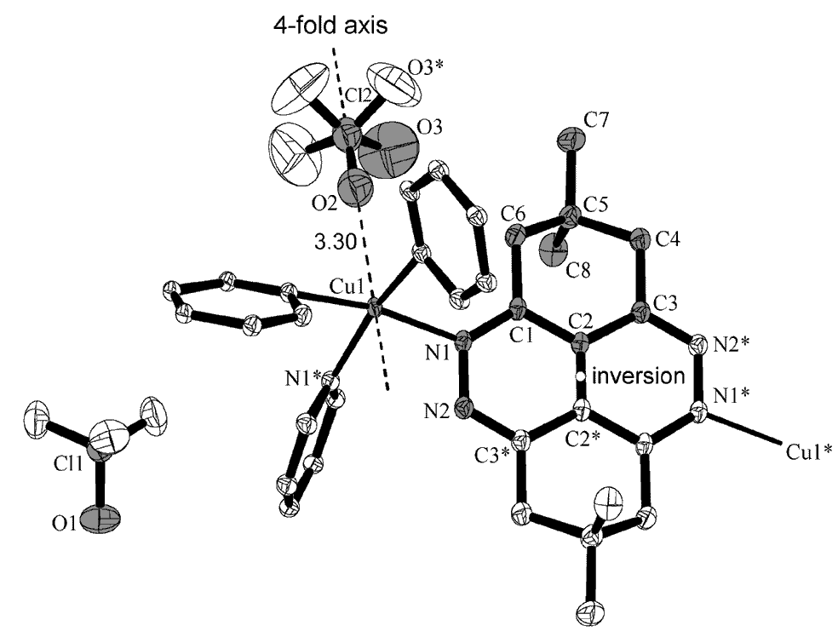
Fig. 1. Atom labelling scheme for structure Cu(Me₄L)₂(ClO₄)₂ 4 :
40% thermal ellipsoids, hydrogen atoms are not shown. Unique part of the structure is marked in grey. One of two unique perchlorate ions is disordered over four-fold axis.

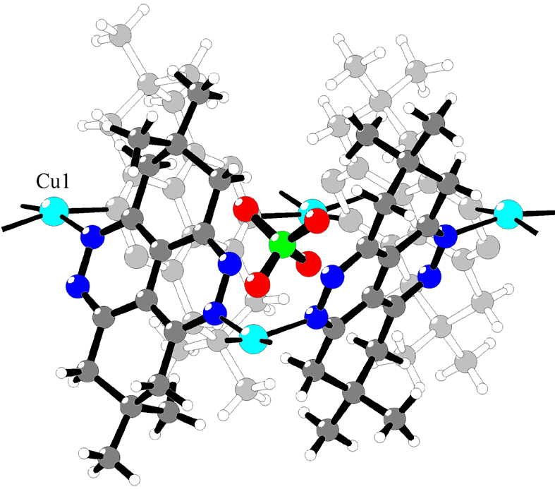

Fig. 2. Illustration of how square mesh of the coordination network Cu(Me₄L)₂(ClO₄)₂ 4 provides tetrahedral cavity for housing of perchlorate anion.

Structure Cu(L)₂(ClO₄)₂⋅3CHCl₃ 1

All non-hydrogen atoms of coordination framework were refined anisotropically and hydrogens were placed in calculated positions with isotropic U values set invariant at 0.08 Å². This very open structure includes a number of “guest” ClO₄⁻ and CHCl₃ moieties. Only one unique perchlorate ion (providing 0.5 counter anions per metal atom) is completely ordered and has values for thermal motions comparable with those for framework atoms. This anion is situated in a little cage that is formed within square face of the truncated octahedron (See Fig. 5). The rest of ClO₄⁻ and CHCl₃ moieties have large thermal U values, typical for guest components enclathrated inside large voids. Second unique perchlorate (Cl2, Fig. 3) is also ordered with higher parameters for thermal motion. These two ClO₄⁻ ions were refined anisotropically. Third unique perchlorate anion was left isotropic and refined with fixed tetrahedral geometry (Cl-O were fixed at 1.43(3) Å) and with equal isotropic U values for chlorine and oxygen atoms refined as a single variable. All this ions lie as well as copper atom in special positions and considering their multiplicities, the resulting Cu/ClO₄ ratio was 1:1.84. It was not possible to locate remaining ClO₄ anion inside the hole (required site letter 8c). There are two unique chloroform molecules (site letters for carbon atoms 24g, 12e), one of them is badly disordered. The disorder was resolved in accordance with a reasonable model shown in Fig. 4, with eight components for chlorine atoms. Their possible orientations in such a model were Cl6+Cl8a+Cl8c; Cl6a+Cl8+Cl8b; Cl7+Cl8a+Cl8b; Cl7a+Cl8+Cl8c thus indicating occupancy factors for the disorder components Cl6, Cl7, Cl8 at 0.25, 0.25 and 0.5. Atoms of this molecule were refined in anisotropic approximation for the sake of overall convergence.
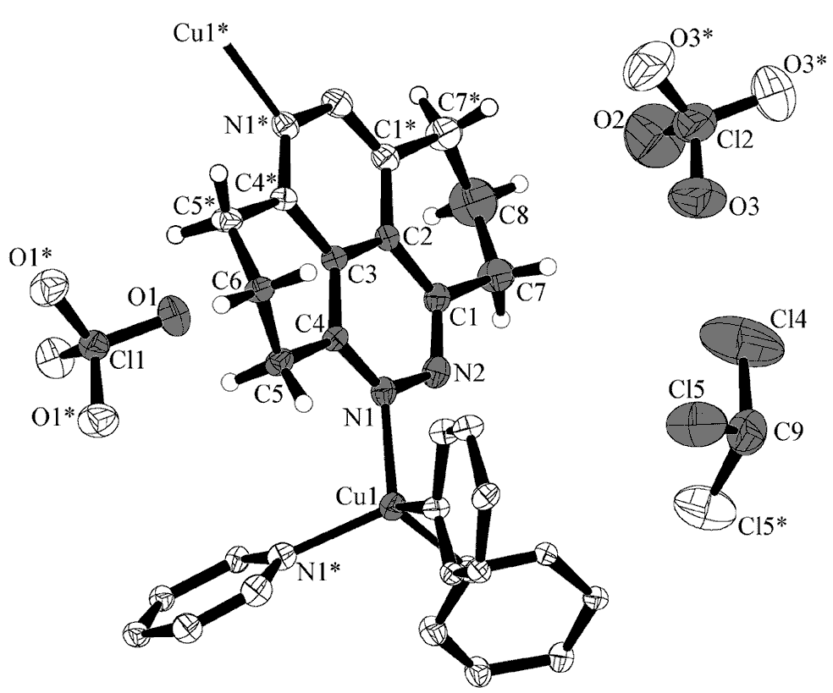
Fig. 3. Atom labelling scheme for structure Cu(L)₂(ClO₄)₂⋅3CHCl₃ 1 :
40% thermal ellipsoids. Unique part of the structure is marked in grey. One unique perchlorate (Cl3, O4, 5) and one chloroform molecule (C10) are not shown here.

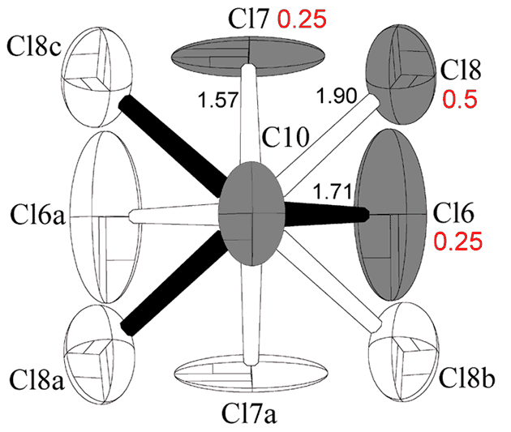
Fig. 4. Refined disordering scheme for chloroform molecule in structure Cu(L)₂(ClO₄)₂⋅3CHCl₃ 1 :
30% thermal ellipsoids. Unique part of the structure is marked in grey and used occupancy factors for disordered chlorine atoms are given in red. One of the possible orientations of the molecule is shown with black bonds.

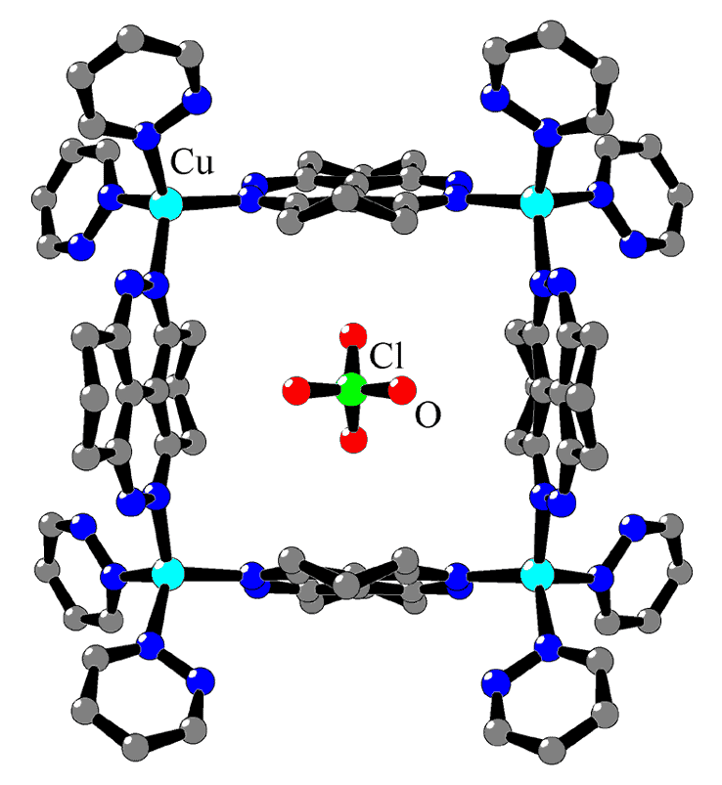 | 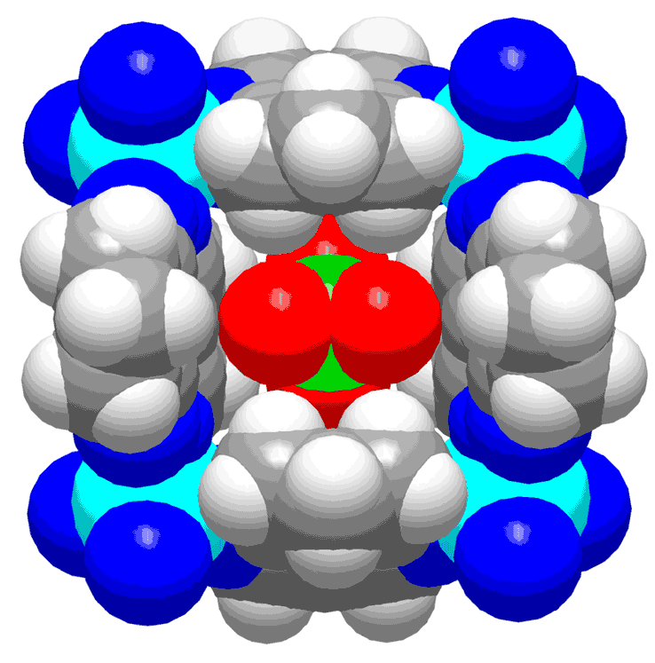

Fig. 5. Square face of truncated octahedron in structure Cu(L)₂(ClO₄)₂⋅3CHCl₃ 1 provides quite suitable position for situation of perchlorate anion, considering either size, shape and site symmetry. Right: space-filling representation showing a densest packing.

Structure Cu(L)₂(NO₃)₂⋅3CHCl₃ 2

All non-hydrogen atoms of coordination framework were refined anisotropically and hydrogens were placed in calculated positions with isotropic U values set invariant at 0.08 Å². It was possible to locate
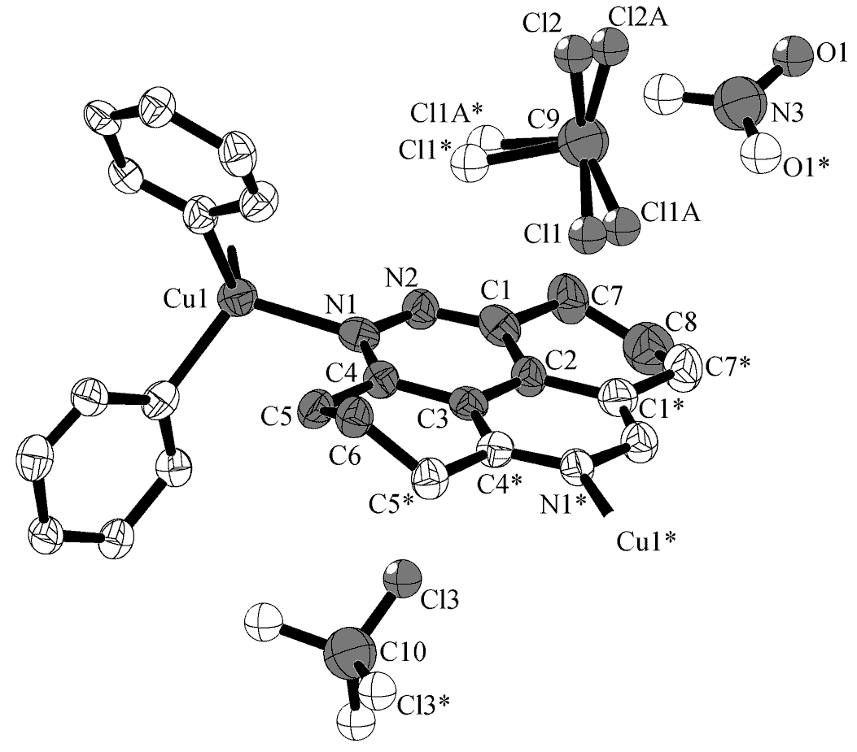
Fig. 6. Atom labelling scheme for structure Cu(L)₂(NO₃)₂⋅3CHCl₃ 2 (hydrogen atoms are not shown) and refined disordering schemes for two refined chloroform molecules. 40% thermal ellipsoids (Only atoms of coordination framework are anisotropic). Unique part of the structure is marked in grey.

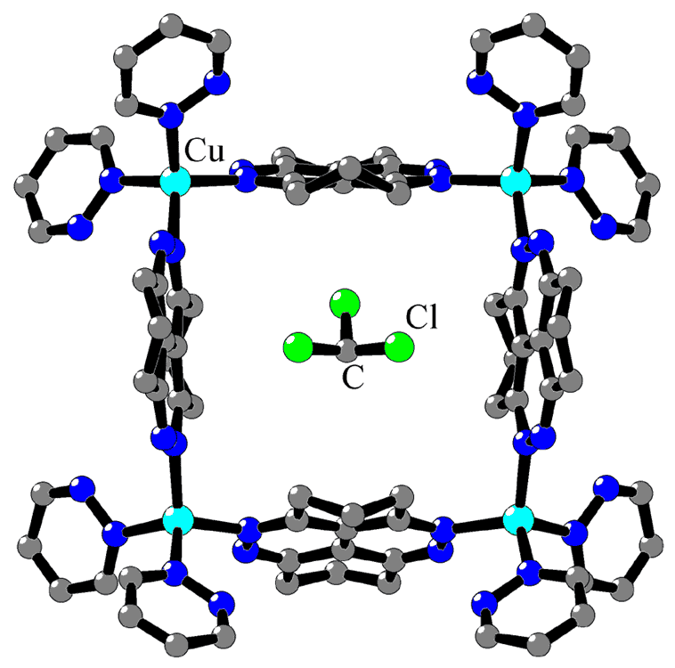

Fig. 7. Population of small cages in structure Cu(L)₂(NO₃)₂⋅3CHCl₃ 2 – chloroform molecule occupies exactly the same position like ClO₄⁻ ion in the structure 1 (compare with Fig. 5). Only one possible orientation of guest molecule is shown.

only one unique nitrate ion (0.66 per copper atom) and two unique chloroform molecules (2.5 per copper atom) and the refinement gave convergence at R1=0.150 level. Thus the remaining disordered electron density was successfully modeled using Squeeze (A. L. Spek, PLATON/PLUTON, Jan. 1999, Acta Crystallogr. Sect. A. 1990, 46, C-34) that decreased convergence factor to R1=0.060. Atoms of all guest moieties were left isotropic, hydrogens were not added, and for improving the refinement stability the nitrate ion was refined with fixed N-O 1.22(3) Å. Both unique chloroform molecules are disordered: one shows two orientations of chlorine atoms (See Fig. 6, C9) with equal contributions. Second chloroform molecule occupies exactly the same position in the structure like enclathrated ClO₄⁻ anion in complex 1. It is situated inside rectangular cage and is disordered by symmetry, in a “CCl₄ fashion” with only one unique chlorine atom, which was refined with occupancy factor 0.75.

Structure Cu(L)₂SiF₆⋅3CHCl₃ 3

The compound is isomorphous with complexes 1, 2. It was not possible to solve this structure. Using of atomic coordinates found from refinement of structure 2 against diffraction data for 3 led to a stable model for the framework, convergence factors were R1=0.22, wR2=0.49. However, it was not possible to locate guest moieties and to model the disordered electron density. Attempted redetermination of the structure using either CCD and Image Plate diffraction systems as well as rotating anode system did not gave improvement in diffraction data. Concerning this structure we only note isomorphism of copper hexafluorosilicate compound and complexes 1 and 2.

