Metal-assisted red light-induced DNA cleavage by ternary L-methionine copper(II) complexes of planar heterocyclic bases†
Ashis K Patra, Shanta Dhar, Munirathinam Nethaji and Akhil R. Chakravarty*
Department of Inorganic and Physical Chemistry, Indian Institute of Science, Bangalore 560012, India.
Fax: +91-80-2360683; E-mail: arc@ipc.iisc.ernet.in.

Supporting Information
Fig. S1 Effect of addition of [Cu(L-met)B(Solv)](ClO₄) (L = phen, 2, ; dpq, 3, ; and dppz, 4, ) to the emission intensity of the CT- DNA (303 μM) bound ethidium bromide (1.3 μM) at different complex concentrations in 5 mM Tris-HCl buffer (pH 7.2) at 4 ºC.
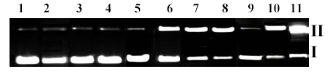

Fig. S3 Gel electrophoresis diagram displaying the UV light-induced DNA (SC pUC19, 0.5 μg) cleavage activity of the complexes 1- 4 (50 μM) at 365 nm (12 W) with an exposure time of 5 min: Lane 1, DNA control; Lane 2, DNA + 3 in dark; Lane 3, DNA + dpq (50 μM); Lane 4, DNA + L-methionine (50 μM); Lane 5, DNA + 1; Lane 6, DNA + 2; Lane 7, DNA + 4; Lane 8, DNA + 3; Lane 9, DNA + NaN₃ (90 μM) + 3; Lane 10, DNA + D₂O (14 μL) + 3; Lane 11, DNA + DMSO (4 μL) + 3.
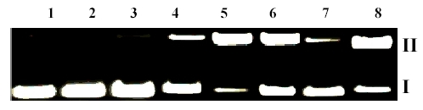
Fig. S4 Gel diagram showing the red light-induced SC DNA (0.5 μg) cleavage activity of the complexes 2 – 4 (100 μM) at 632.8 nm (CW He-Ne laser, 3 mW) for an exposure time of 1.0 h: Lane 1, DNA control; Lane 2, DNA + dpq (100 μM); Lane 3, DNA + 3 (in dark); Lane 4, DNA + 2; Lane 5, DNA + 3; Lane 6, DNA + 4; Lane 7, DNA + 3 + NaN₃ (90 μM); Lane 8, DNA + 3 + DMSO (4 μL).
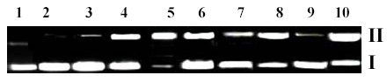
Fig. S2 Gel electrophoresis diagram showing the chemical nuclease activity of the complexes 1 - 4 (100 μM) using SC pUC19 DNA (0.5 μg) and MPA (5 mM): Lane 1, DNA control; Lane 2, DNA + 2; Lane 3, DNA + 1 + MPA; Lane 4, DNA + 2 + MPA; Lane 5, DNA + 3 + MPA; Lane 6, DNA + 4 + MPA; Lane 7, DNA + distamycin (75 μM) + 3 + MPA; Lane 8, DNA + distamycin (75 μM) + 4 + MPA; Lane 9, DNA + DMSO (4 μL) + 3 + MPA; Lane 10, DNA + NaN₃ (90 μM) + 3 + MPA.

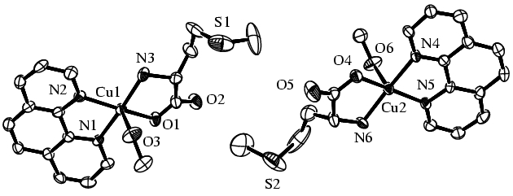
Fig. S5 ORTEP views of two independent molecules in the crystallographic asymmetric unit of complex [Cu(L-met)(phen)(MeOH)](ClO₄) (2) showing 30% probability thermal ellipsoids with labelling of the metal and hetero atoms.

