This journal © the Royal Society of Chemistry 2006

Near-field optical enhancement

According to the Heisenberg uncertainty relation, features significantly smaller than the operating wavelength can neither be resolved nor created by exploiting any kind of propagating waves. However, it appears to be possible by using the so called evanescent waves which decay exponentially with increasing the distance from their source.

The use of evanescent light radiation for the improvement of the resolution forms the basis of the scanning near-field optical microscopy (SNOM), in which a tapered metal-coated optical fiber with a tiny aperture at the very end is used as an optical probe. By using SNOM as a lithographic tool, one can form features with the lateral dimensions of down to 70 nm. ¹⁻³
An alternative to the aperture SNOM-bases nanoprocessing is the proximity focusing approach. ⁴ The idea consisted in the formation of radiation intensity singularities by means of very small conductive objects immersed into the radiation field. The resulting electric (linear or non-linear) polarization of such objects results in a considerable enhancement of the radiation intensity in the region comparable with the curvature radius of the object (near-field enhancement). Such an object can itself be treated as a very small but intensive source of secondary evanescent near-field radiation, which can be considerably stronger than the field of the primary beam. If this source is brought so close to the target surface that this secondary radiation cannot diverge to any great degree during the transit between the two, it can cause a local laser-induced surface effects limited only by the object size rather than by diffraction effects.

The theory of the light interaction with small metal particles was developed intensively in recent decades and in particular after the discovery of the surface enhanced Raman scattering (see e.g. Gersten and Nitzan ⁵ or Chang and Furtak ⁶).
The elementary consideration of the near field enhancement effect can be done using the electrostatic approximation. The wavelength optical radiation $λ$is a spatial scale of the electric field alteration. If a particle is small enough, the phase shifts, i.e. retardation effects of the electromagnetic field over the particle size are thus considered negligible. Without the retardation, the interaction of the matter with the field is reduced to a purely electrostatic one.⁷ It means that within distances much smaller than λ (near- field optics limit) one can use the corresponding solutions of electrostatics.

Consider a perfectly conducting prolate spheroid with the aspect ratio a/b immersed into the quasi-static electric field $E_{0}$ parallel to the major axis of the spheroid. This field induces charges on the surface of the spheroid, which in turn distort the electric field around. The resulting field E can be presented as a vector sum of the undisturbed field ${\vec{E}}_{0}$without the spheroid and an additional field ${\vec{E}}_{\text{pol}}$ due to the induced surface charges. This additional field outside of the spheroid is equal to the field that would be caused by a point dipole placed in the center of the spheroid with some effective dipole momentum$P=\frac{{\text{ab}}^{2}}{3L}E_{0}$, where a and b are the major and minor axes of the spheroid. ⁸ The resulting field at the "sharp" edge of the spheroid will be
$E=E_{0}+E_{\text{pol}}=E_{0}+\frac{2P}{a^{3}}{ºxE}_{0}$, (1)
where the depolarization (demagnetization) factor L is determined by the geometry of the spheroid ⁹. The factor of the electrical field enhancement ξ near the "sharp" edge of a prolate spheroid is plotted in Fig. S1. For a sphere (a = b), L = 1/3 and ξ = 3, whereas for a needle-like spheroid $L→0$ and$x→¥$. In the latter case, the field enhancement is similar to the well-known lightning rod effect. The characteristic spatial scale of field enhancement is b²/a.
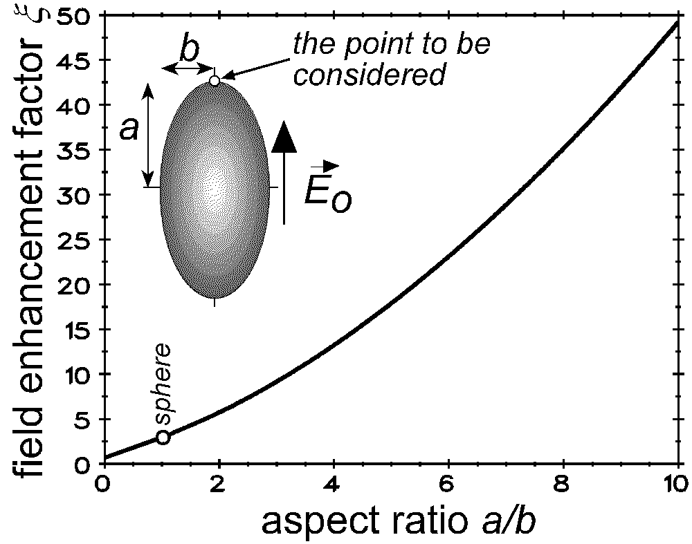

Fig. S1: Electrostatic field enhancement factor on the polar points (outside) of a perfectly
conducting prolate spheroid ξ as a function of its aspect ratio a/b. The primary field
E₀ is parallel to the major axis a.

The above electrostatic approximation is no more valid in the visible and UV spectral regions where the optical frequency is comparable with the electron plasma frequency in the metals and the optical properties of real metals can markedly differ from those of PC. As has been shown by Emelyanov and Koroteev ¹⁰, the resulting field at the "sharp" edge of the spheroid will be
$E\left(ω\right)=\frac{ε_{1}E_{0}}{1+\left(\tilde{ε}\left(ω\right)−1\right)L}≡{ξE}_{0}$ (2)
where $\tilde{e}=e_{1}+{ie}_{2}$ is the complex dielectric constant of the metal. The vanishing of the denominator in Eq. 2 leads to a resonant enhancement of the local field, which physically corresponds to the excitation of dipole-like charge oscillations or surface plasmons (SPs). The resonant field enhancement factor can be estimated as
$x\left(w_{r}\right)=\frac{e_{1}\left(e_{1}−1\right)}{−{ie}_{2}}$, (3)
where the resonant frequency $w_{r}$ of SPs is defined through the condition $1+\left(\tilde{ε}\left(ω_{r}\right)−1\right)L=\text{min}$. Silver has the smallest damping in the visible and near IR spectral region among all metals and has Re$x\left(w_{r}\right)$≥10⁴. Au and Cu have larger damping but still provide Re$x\left(w_{r}\right)$≥10³. Note that the far field radiation intensity is proportional to the square of the electric field amplitude of the electromagnetic wave.

1 E. Betzig, J.K. Trautman, R.Wolfe, E.M. Gyorgy, P.L. Finn, M.H. Kryder and C.-H. Chang, Appl. Phys. Lett. 1992, 61, 142.
2 G. Krausch and J. Mlynek, Microel. Eng. 1996, 32, 219.
3 M. Müllenborn, K. Birkelund and F. Grey, Appl.Phys.Lett. 1996, 69, 544.
4 M.I. Stockmann, Avtometriya 1989, 3, 30 in Russian.
5 J.I. Gersten and A.Nitzan, J.Chem.Phys. 1980, 73, 3023.
6 R.T. Chang and T.E.Furtak, eds., Surface Enhanced Raman Scattering, Plenum Press, New York, 1982.
7 W. Denk and D.W. Pohl, J. Vac. Sci. Technol. 1991, B9, 510.
8 L.D. Landau and E. M. Lifshiz, Electrodynamics of Continuous Media, Butterworth-Heinenann (1998).
9 E.C. Stoner, Phil. Mag. 1945, 36, 803.
10 V.I. Emelyanov and N.I. Koroteev, Usp. Fiz. Nauk 1981, 135, 345 in Russian.

