ESM Table 1 The cup configuration for the measurements is shown.
Element | H6 | H5 | H4 | H3 | H2 | H1 | Ax | L1 | L2 | IC0 | L3 | IC1 | L4 | IC2 | L5
Pb |  |  | 208 | 207 | 206 | 205 | 204 | 203 | 202 |  | 200 |  | 198
Cu/Zn | 70 | 69 | 68 |  | 67 |  | 66 |  | 65 |  | 64 |  | 63 |  | 62
Hf |  | 182 | 180 | 179 | 178 | 177 | 176 | 175 | 174 |  | 172

ESM Table 2 MC-ICPMC conditions for the liquid analysis.
Lead measurements |  |  | Brass measurements
RF power [W] | 1300 |  | RF power | 1300
Coolant gas flow [L/min] | 13.0 |  | Coolant gas flow[L/min] | 13.0
Auxiliary gas flow [L/min] | 0.75 |  | Auxiliary gas flow [L/min] | 0.75
Cones | Nickel |  | Cones | Nickel
Nebulizer | concentric |  | Nebulizer | concentric
Spray chamber | cyclonic |  | Spray chamber | Scott
Nebulizer gas pressure [psi] | 34.7 |  | Nebulizer gas pressure [psi] | 37.4
 |  |  | Membrane gas flow [L/min] | 3.84

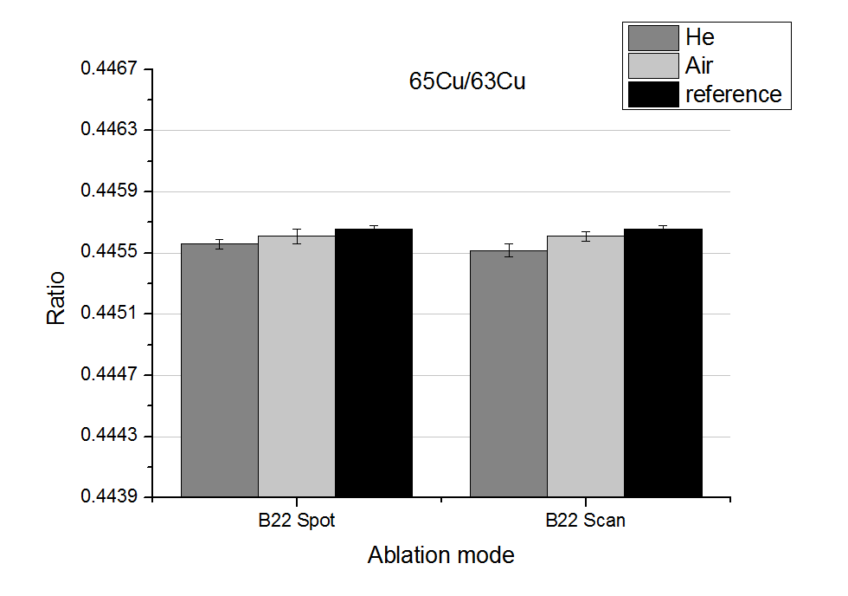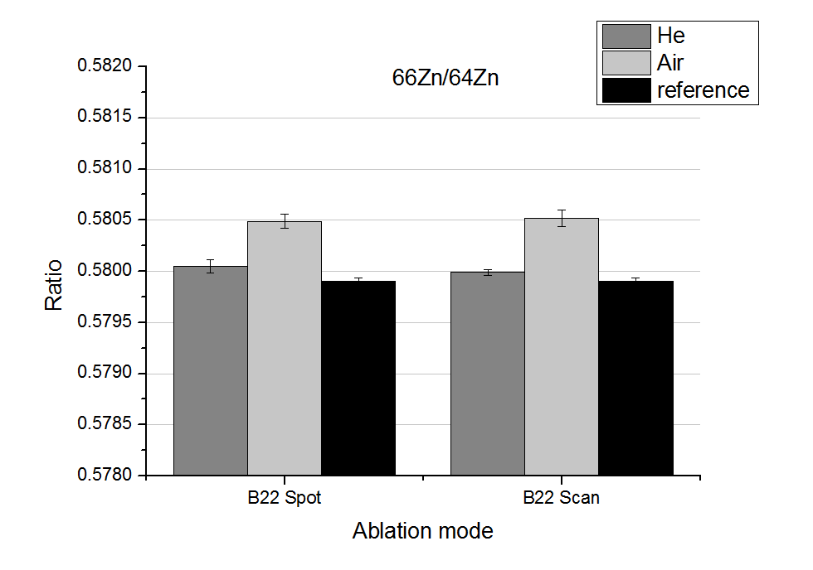
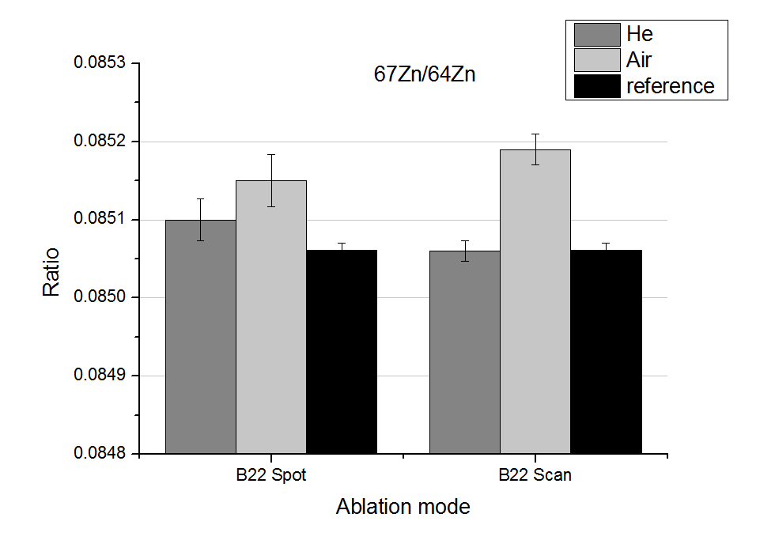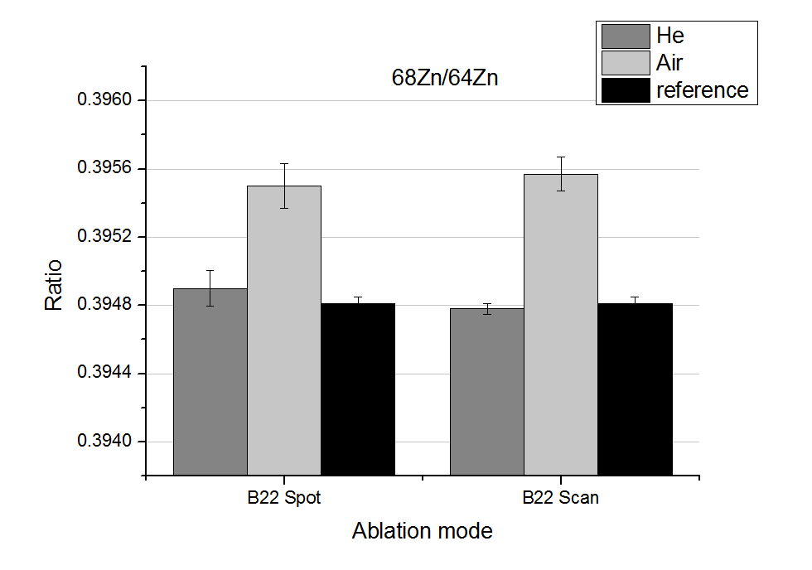
ESM Figure 1 Isotope ratios obtained for MBH B22 for single and line scan ablation modes. The error bars correspond to the standard deviation of 8 measurements of MBH CRM B22. The mass bias was corrected by standard-sample-bracketing.

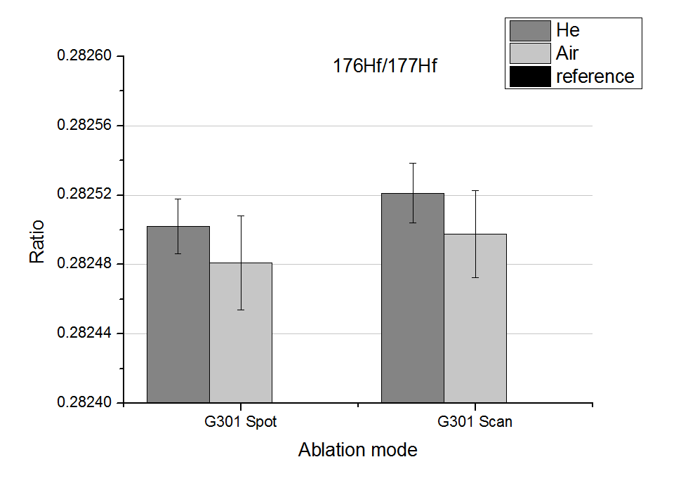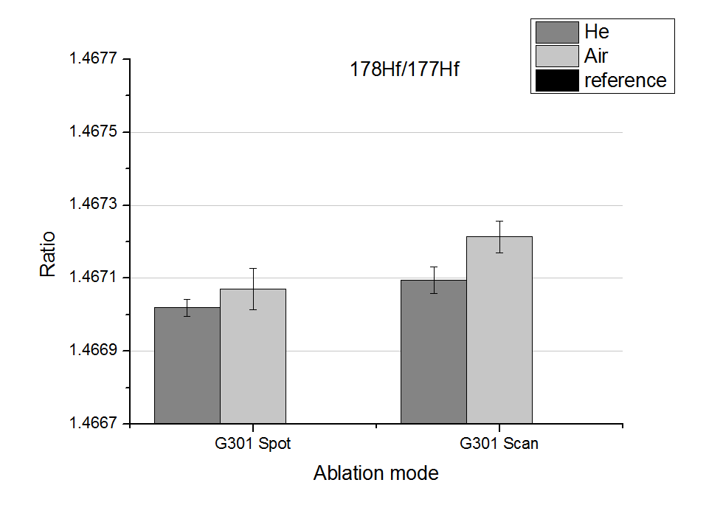
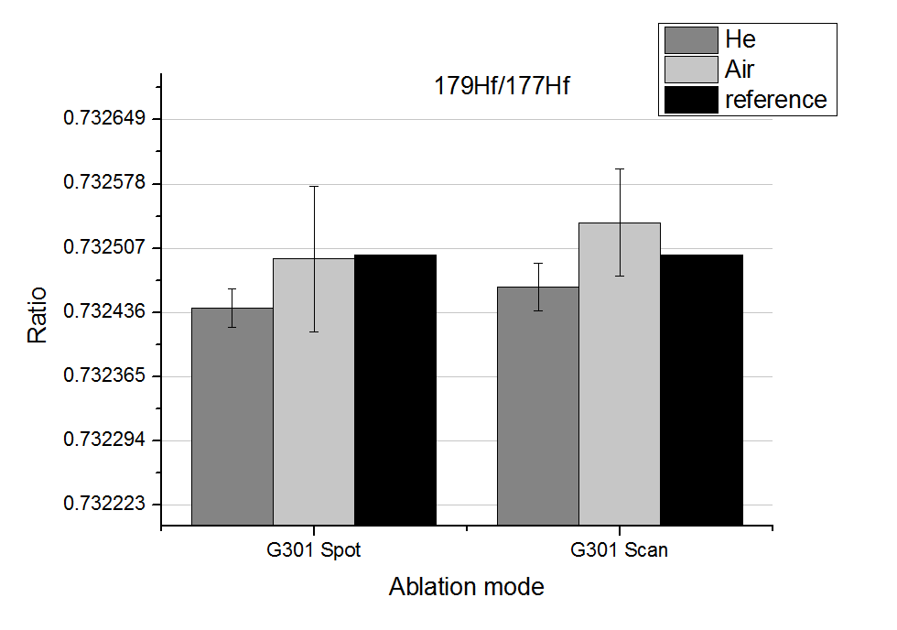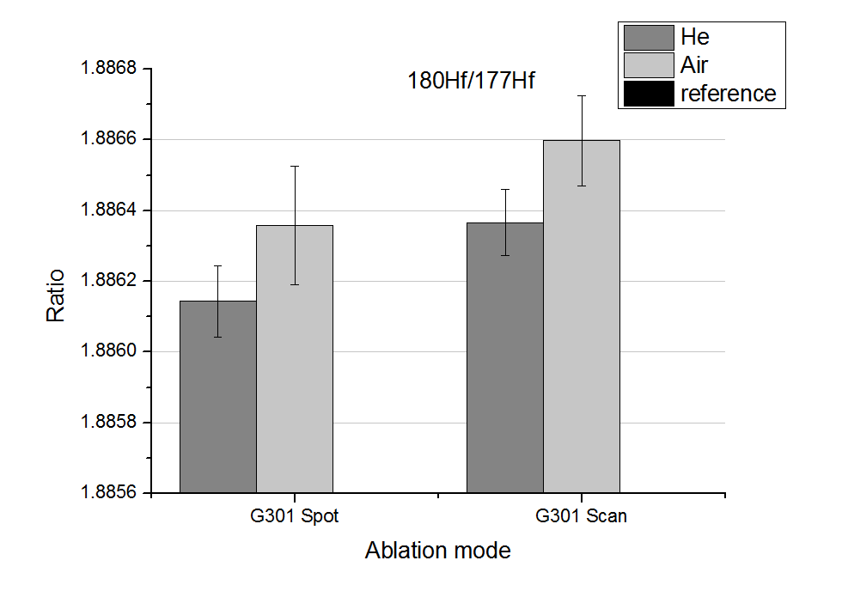
ESM Figure 2 Isotope ratios obtained for zircon G301 for single and line scan ablation modes. The error bars correspond to the standard deviation of 8 measurements of G301. The mass bias was corrected by standard-sample-bracketing.

Visualization of the sampling process. In ESM Figure 3, an evolution of the laser plume for scanning ablation on brass is shown. The pictures were taken between 80 µs and 5.08 ms after the laser shot. Most of the aerosol appears to be captured by the flow field formed in front of the tube. However, the topmost part of the expanding plume was observed to propagate out of range as observed in frame # 4 – 5. This aerosol may disperse over a large volume and float for seconds before it is aspirated with delay or removed from the flow by diffusion. The delay would lead to a mixing of the elemental information of the consecutive LA events, whereas the diffusion alone would lead to a loss of sensitivity. Kovacs et al.¹ observed a sample loss of 30% when compared to in-cell ablation. To minimize the loss of aerosol, the velocity gradient in front of the tube should be increased, as it defines the sphere of action. A higher gas flow or a smaller inner diameter of the tube can be changed to achieve higher velocities. The first option is not possible with the current system; a higher gas flow would lead to an incomplete exchange of the gases, which will lead to different ICP conditions, and in worst case extinguish the plasma. For the second option, the inner diameter should be smaller than 150 µm to achieve velocities of 250 m/s (specified for IDs of 0.5 – 2 mm) that allow capturing plumes produced by LA using energies lower than 170 µJ entirely and instantaneously.² It is, however, questionable whether the flow field produced by the nozzles of such a small size would accesses a sufficiently large solid angle to collect the LA aerosols as commonly produced for trace element analysis. Aerosol expansion radii are known to reach several centimetres under those conditions.³ Furthermore, the local Reynolds number inside the nozzle would exceed values of 2500 suggesting a transition to a turbulent flow that might enhance particle deposition, and thus, additional sample loss on the inner side of the orifice. Also different particle size distributions between LA in He and in air can lead to different ionization efficiencies (larger in air), therefore incomplete vaporization, and further reducing signal intensities.
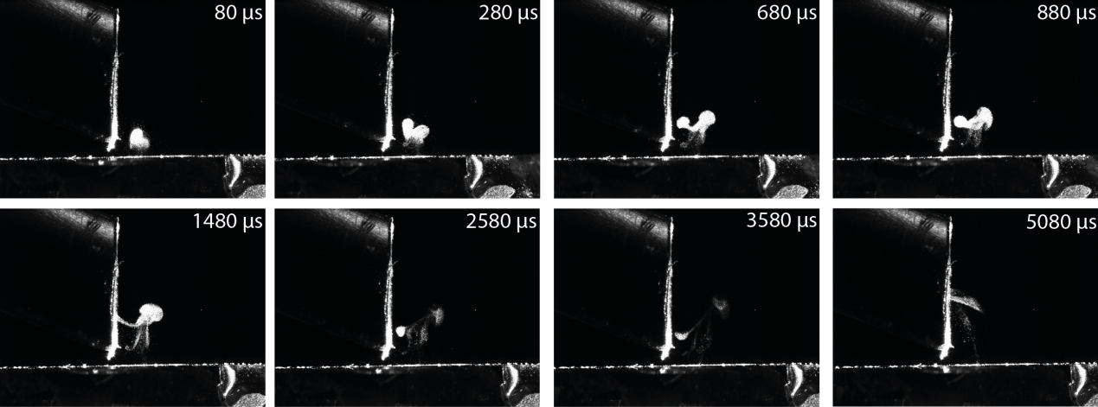
ESM Figure 3 The evolution of the laser plume for scanning ablation of brass and the extraction efficiency into the tube. The frames were taken 80 µs, 280 µs, 680 µs, 880 µs, 1480 µs, 2580 µs, 3580 µs, and 5080 µs after the laser shot. The energy was 150 µJ/pulse, the gas flow rate was 0.21 l/min, and the repetition rate was 6Hz.

References
1. R. Kovacs, K. Nishiguchi, K. Utani and D. Gunther, J. Anal. At. Spectrom., 2010, 25, 142-147. DOI: 10.1039/b924425e.
2. T. A. Schmitz, J. Koch, D. Guenther and R. Zenobi, Applied Physics B-Lasers and Optics, 2010, 100, 521-533. DOI: 10.1007/s00340-010-4112-9.
3. J. Koch, M. Waelle, S. Schlamp, T. Roesgen and D. Guenther, Spectrochim. Acta, Part B, 2008, 63, 37-41. DOI: 10.1016/j.sab.2007.11.013.

