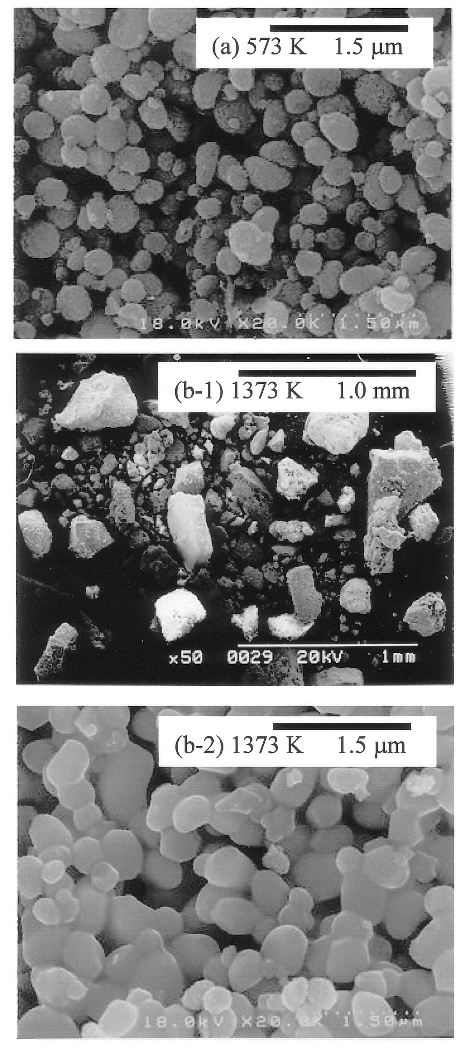

Fig. S2 Scanning electron micrographs for La phosphate particles prepared via the ELM system, following calcination for 2 h at temperatures of (a) 573 K and (b) 1373 K. $[\overline{\text{EHPNA}}]_{\text{feed}}$ = 0.5 mol l^{–1}, [Ln]_{feed} = 0.01 mol l^{–1}, [Span 83]_{feed} = 5 wt%, and [H₃PO₄]_{feed} = 0.3 mol l^{–1}.

