Supplementary Material for Article Ref: B107981F

Figure S1: Schematic comparison of the citric glycerol hybrid gel technique and the matrix trapping and decomposition route for the synthesis of Sr₃Fe_{2-x}Co_{x}O_{7-y}.

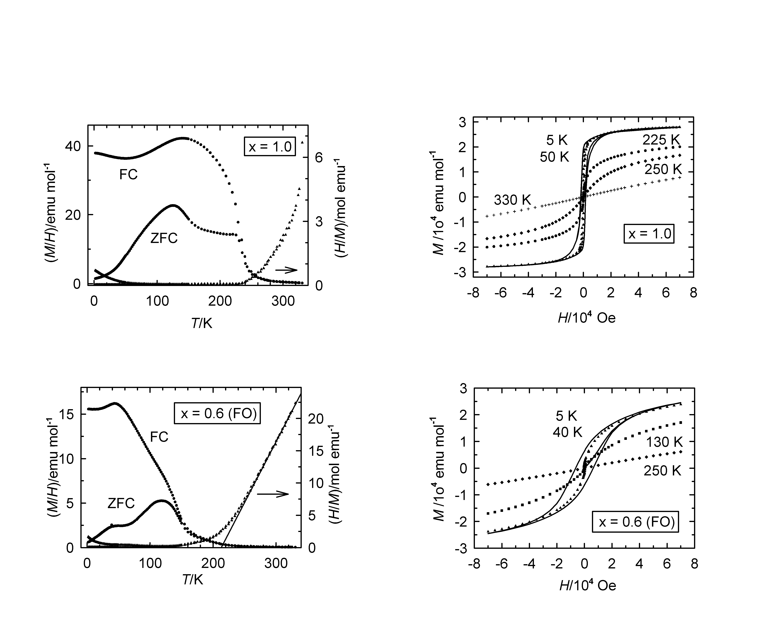

Figure S2: Temperature dependence of magnetic susceptibility M/H and its inverse H/M at 100 Oe (left) and isothermic magnetization measurements M(H) (right) for high oxygen pressure annealed Sr₃FeCoO_{7-y} and flowing oxygen annealed Sr₃Fe_{1.4}Co_{0.6}O_{7-y}.

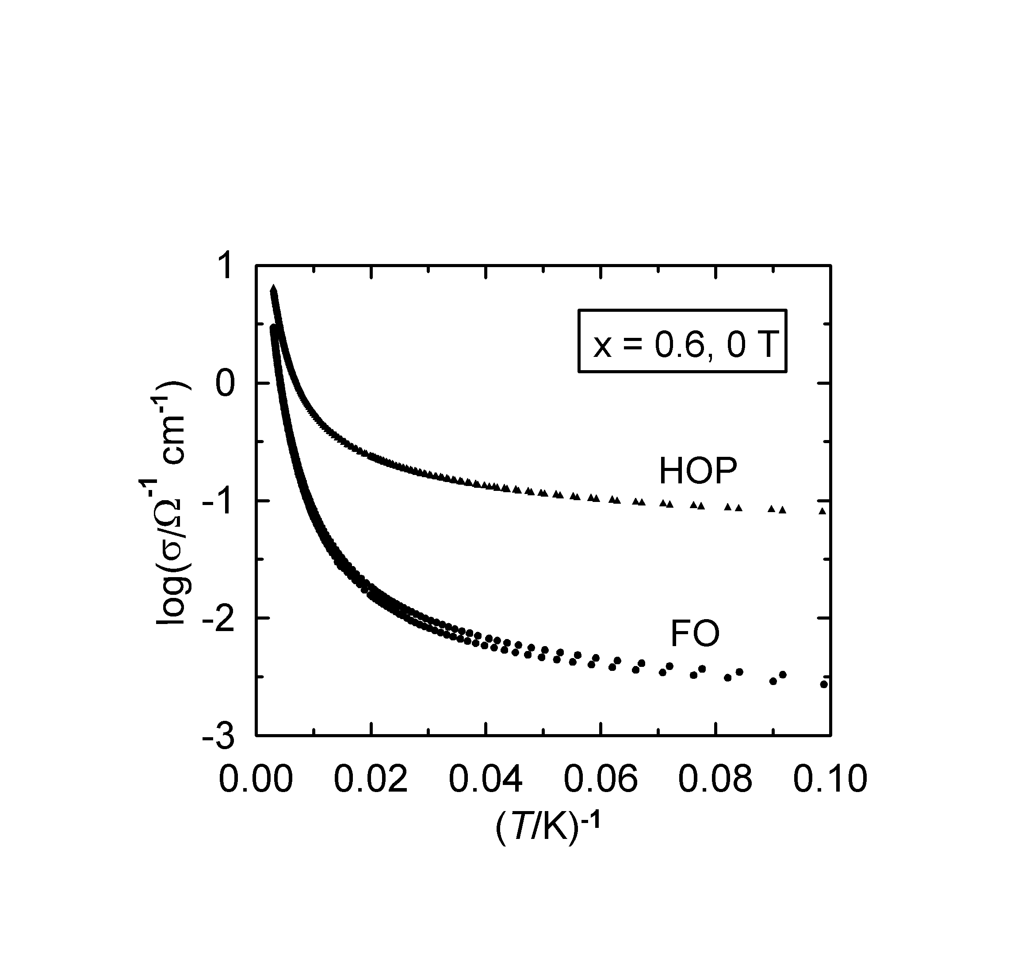
Figure S3: Comparison of conductivity data for high oxygen pressure (HOP) and flowing oxygen (FO) annealed Sr₃Fe_{1.4}Co_{0.6}O_{7-y}. The logarithm of the electrical conductivity σ is displayed as a function of inverse temperature T.

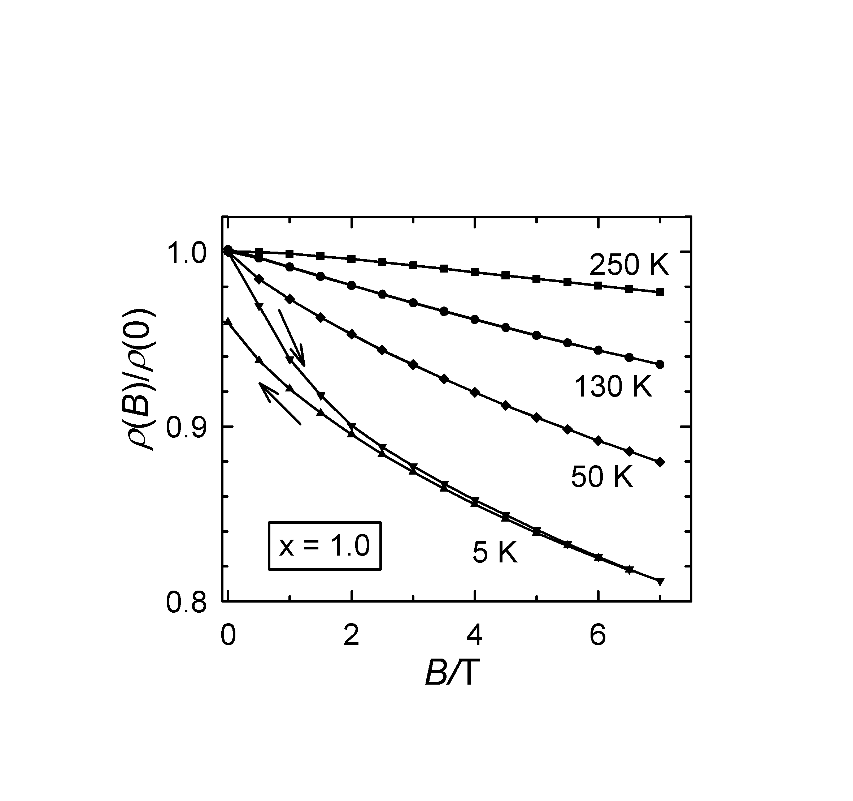
Figure S4: Isothermic magnetoresistance properties of Sr₃FeCoO_{7-y}

