Supporting Information

The Au(111) surface has been visualized with STM (see image below). It exhibits atomically flat terraces with a size of a few hundreds of nanometers across. These crystals are proper supports for the growth of ordered architectures of fullerene.

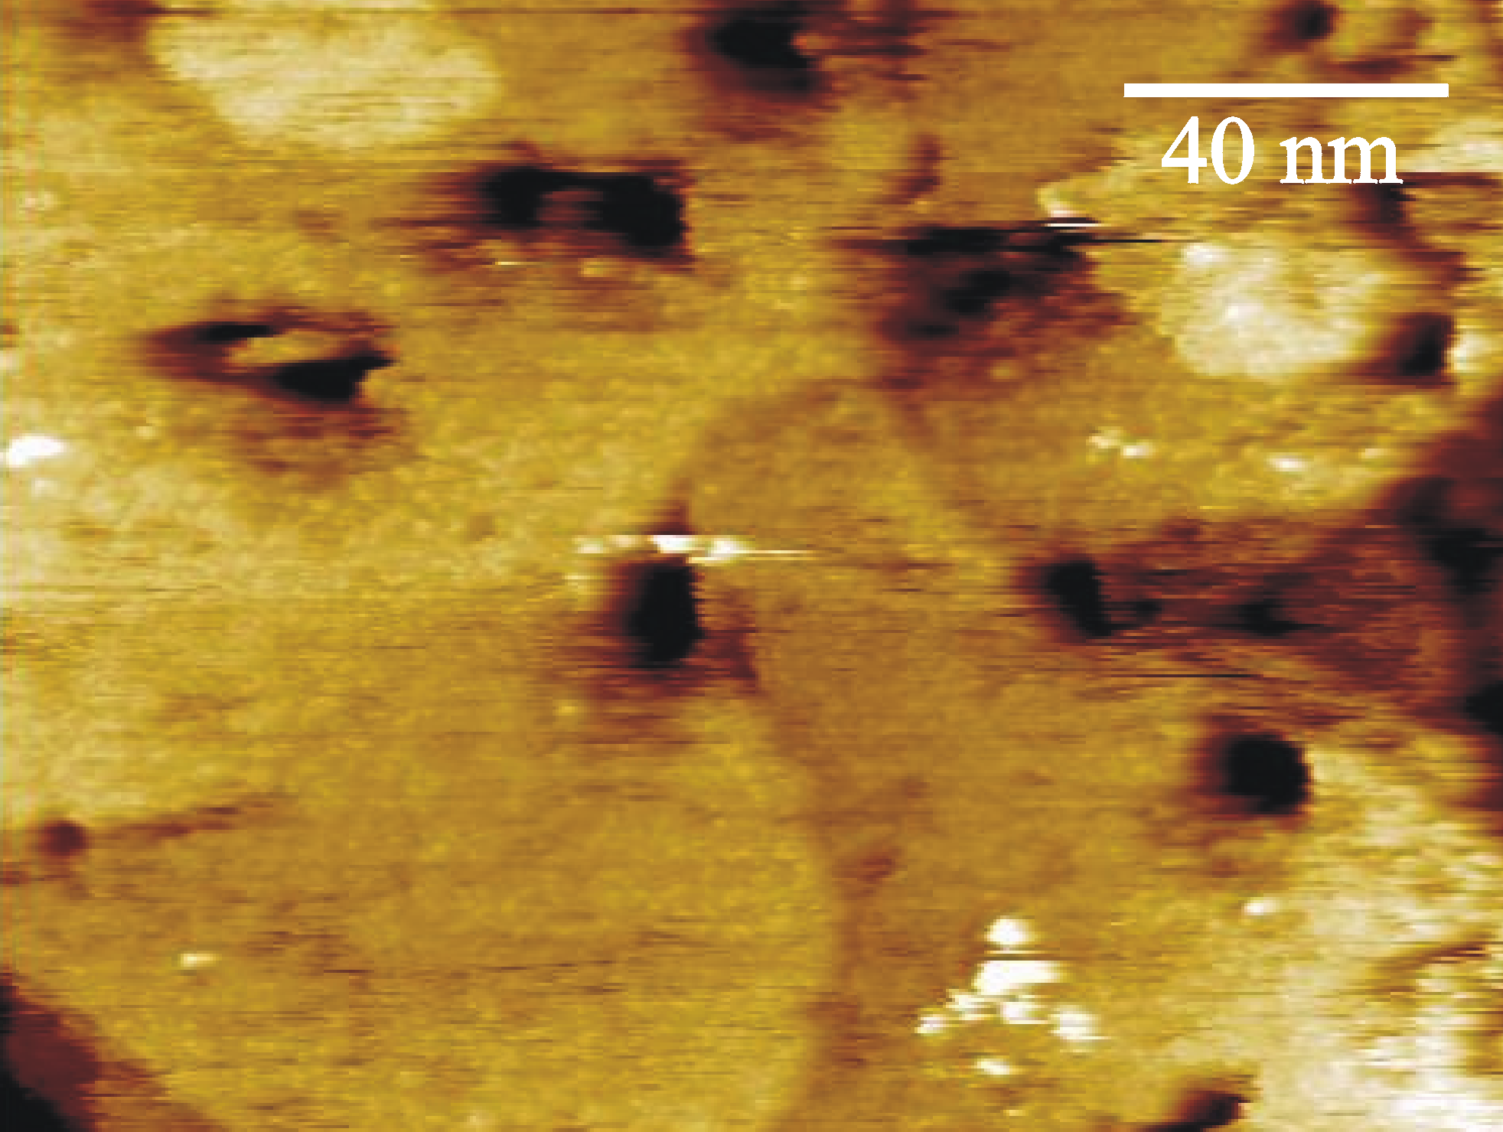

Constant current STM image of a Au(111) surface, onto which the C₆₀ is adsorbed. By using slightly invasive tunneling parameters (tip bias=500 mV ; average tunneling current=200 pA) the structure of the bare substrate is visible. The small visualized roughness can be ascribed to the layer of C₆₀ above. Height range: 8.5 nm.

