A Solution-Solid Growth of α-monoclinic Selenium Nanowires at Room Temperature
Authors: Xueyun Gao, Tao Gao, and Lide Zhang

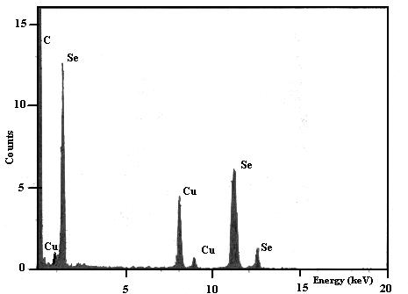

EDS spectrums of α-monoclinic selenium nanowires. The experiments were carried out on a JEOL 2010 High-Resolution Transmission Electron Microscope (HRTEM) equipped with an Oxford Link ISIS Energy Dispersive Spectrometry (EDS) System working with an accelerating voltage at 200keV.

