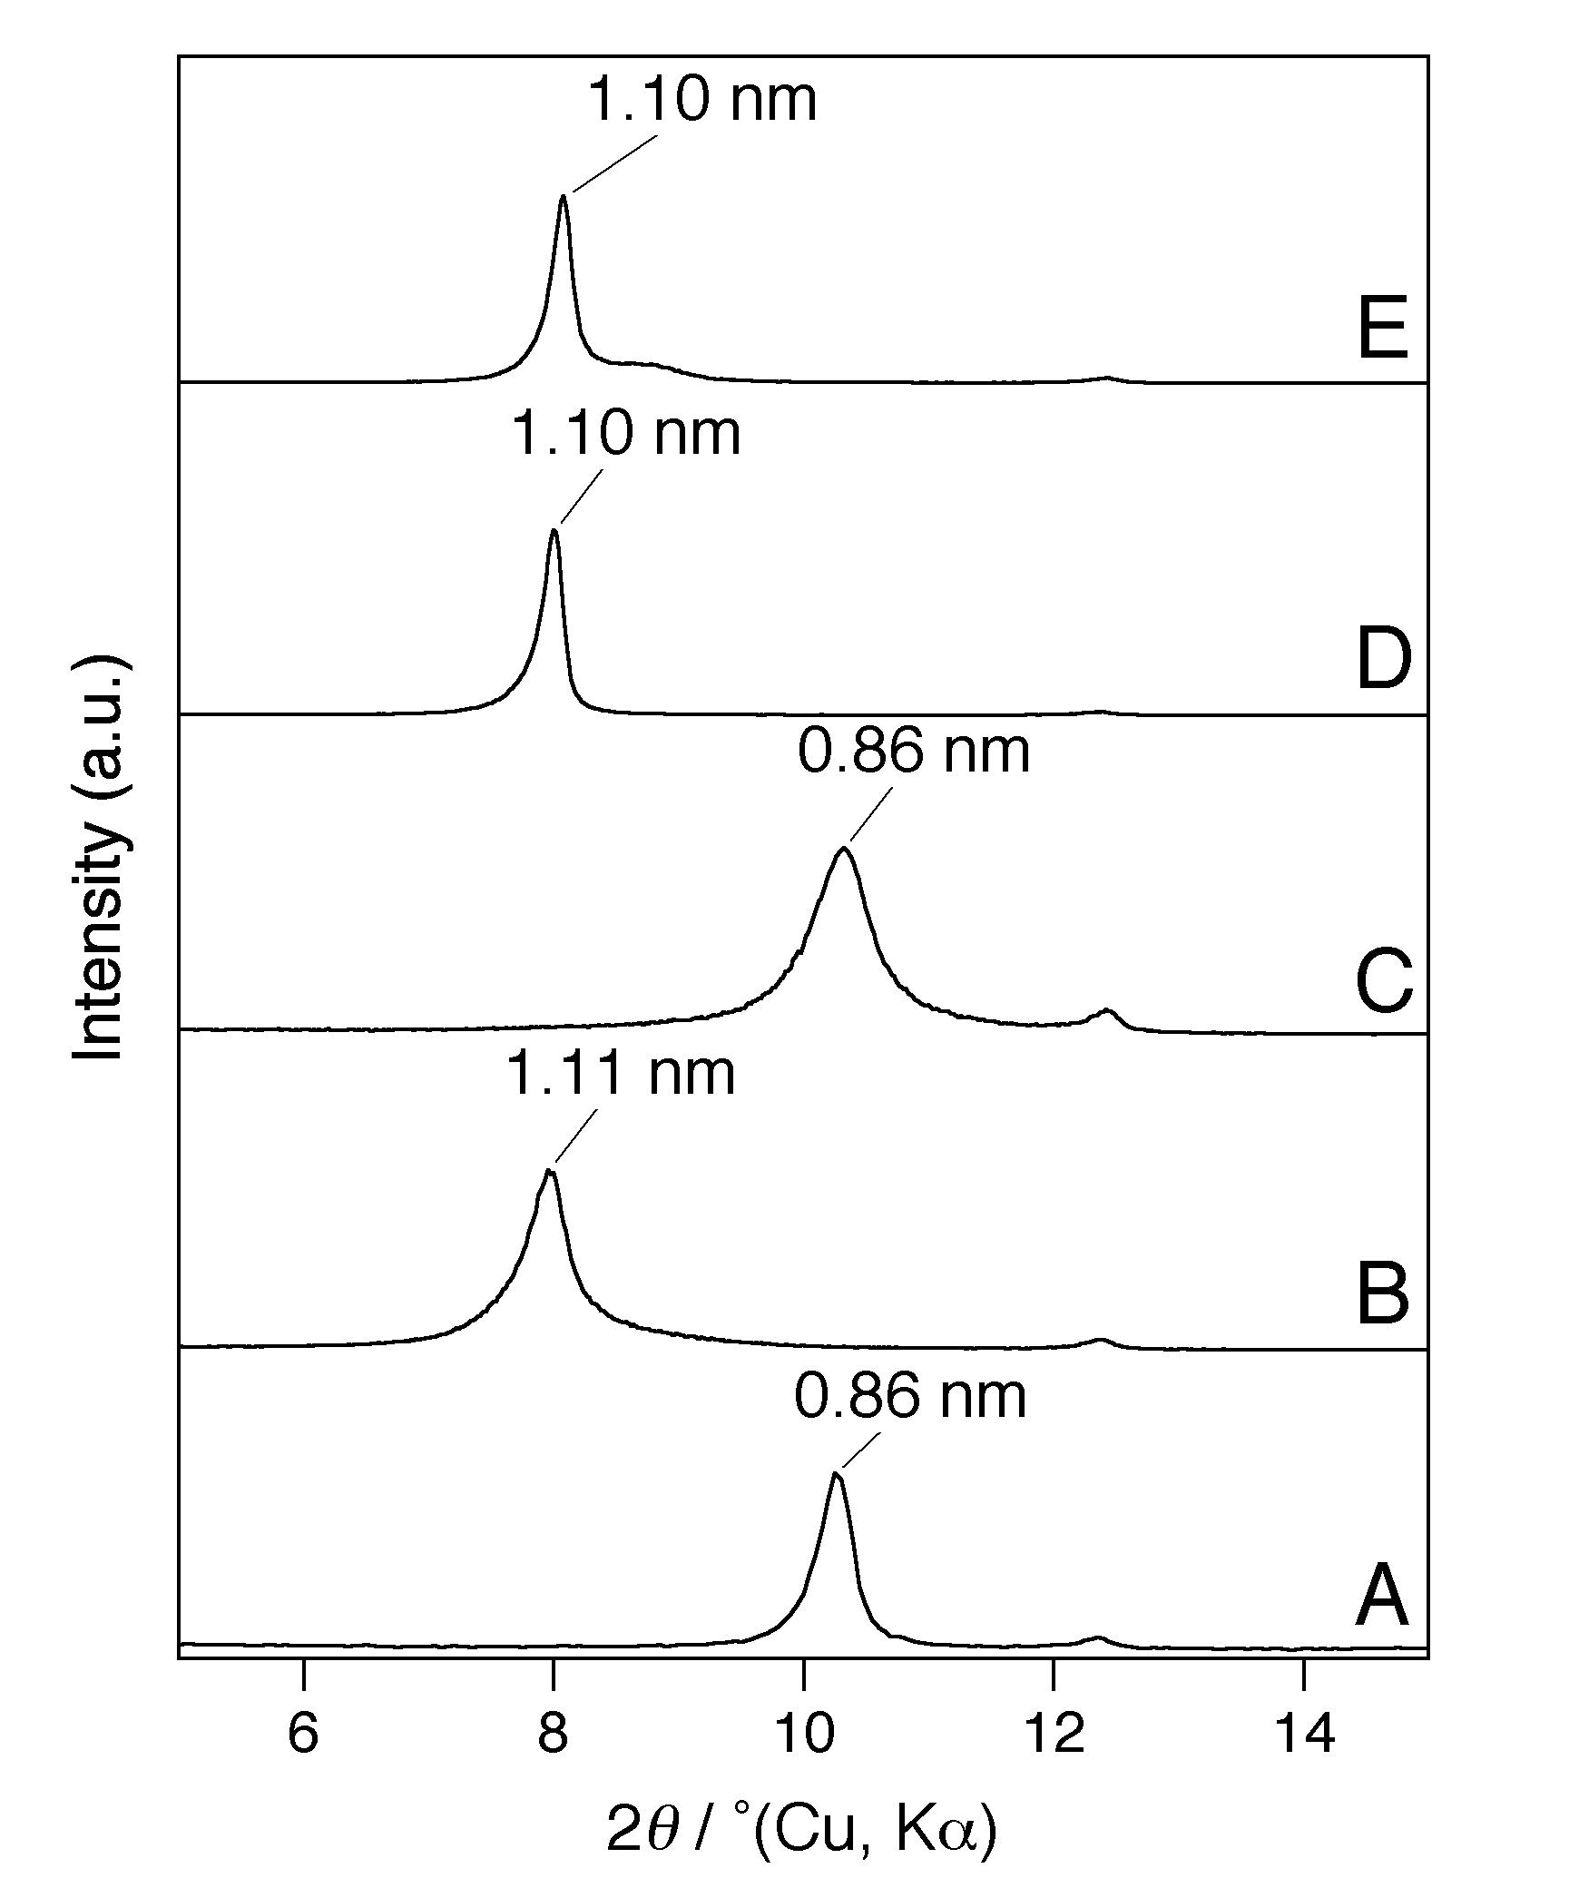Figure S1 XRD patterns of (A) methoxy-modified kaolinite, (B) Kao–1,3PDint, (C) Kao–1,3PDint washed by ethanol, (D) Kao–1,3PDgraft, and (E) Kao–1,3PDgraft washed by ethanol
Itagaki et al.

