Electronic Supplementary Information(ESI) for
Ultra-Low-κ Polyimide Hybrid Films via Copolymerization of Polyimide and Polyoxometalates
Honggang Chen, Long Xie, Hongbin Lu* and Yuliang Yang
Key Laboratory of Molecular Engineering of Polymersof Ministry of Enducation & Department of Macromolecular Science, Fudan University, Shanghai, 200433, China

Novel polyimide hybrid films in which nanoscale polyoxometalates (POM) clusters are covalently linked with the polymer chains exhibit not only remarkably reduced dielectric constants, as low as 1.22, but also efficiently improved thermal stability and mechanical properties without sacrificing the transparency of the polymer films.
Experimental Section

Materials and Characterizations.
4, 4’-Oxydianiline (ODA) and pyromellitic dianhydride (PMDA) were purchased from Sinopharm Co. Shanghai, and dried under vacuum prior to use. γ – Aminopropyltriethoxysilane was supplied by Ye Hao Chemical Co., Shanghai, and distilled under reduced pressure. All other chemicals used in this study were purchased from Sinopharm Co. Shanghai, and purified with standard methods.
¹H NMR spectra were recorded on a Bruker-500MHz NMR spectrometer. FT – IR spectra of the ultra thin films (<10μm), prepared afresh and prior to any moisture adsorption, were obtained from a Nicolet Nexus 470 FT – IR spectrophotometer. UV/vis spectra were measured on a Perkin – Elmer Lambda 35 UV/vis spectrometer in the wavelength range 300 ~ 900 nm. The morphologies of the fracture surfaces of the hybrid films were observed using a JSM-5600LV scanning electron microscopy (SEM). The samples were quenched in liquid nitrogen and then broken to observe fracture surfaces. Thermogravimetric analyses (TGA) were performed on a Perkin – Elmer Pyris 1 TGA with a heating rate of 10 °C /min and the temperature range 50 °C to 960 °C under N₂. Dynamic mechanical analyses (DMA) were conducted on a NETZCH DMA 242 with the heating rate 5 °C/min, and frequency 0.1 Hz. The sample size for DMA measurements is around 3×60 mm and the thickness is between 30 – 40μm. XPS experiments were carried out on a RBD upgraded PHI-5000C ESCA system (Perkin Elmer) with Mg Kα radiation (hν=1253.6 eV) or Al Kα radiation (hν=1486.6 eV). The ²⁹Si NMR spectra were obtained on a Bruker-DSX300 NMR spectrometer operating at 59.6 MHz.The dielectric constants measurements were conducted at room temperature, frequency range 10⁰ Hz to 10⁷ Hz and relative humidity 50%, using a broadband dielectric spectrometer Novocontro Concept 40. Prior to the measurement, all the films dried at 130 °C under vacuum for 2 days and discharged sprays of Au to the each surface of films with a diameter of 3 cm. The accuracy and reproducibility of the apparatus was ascertained with several polymers with known dielectric constants, e.g., PTFE etc. The hybrid films were evaluated with round plate electrodes with the diameter of 2 cm. These measurements were repeated at least three times for each sample. During the measurements, the isothermal frequency scan mode was used, the low impedance load short calibration and the low loss reference capacitor correction were in “On” state. The instrument parameters C₀ and C_{edge} /C₀ for these measurements are 6.95×10⁻¹¹ F and 1.4%, respectively.

Synthesis.
Preparation of diamine-POM. The potassium salt of the lacunary Keggin polyoxometalate, K₈[γ–SiW₁₀O₃₆]∙12H₂O, was synthesized by the procedure described by Tézé and Hervé,¹ The tetrahexylammonium salt of [γ–SiW₁₀O₃₆(RSi)₂O]⁴⁻ where R=CH₂CH₂CH₂NH₂ was synthesized using a similar procedure previously described as follows:² K₈[γ–SiW₁₀O₃₆]12H₂O (3 g, 1 mmol) was suspended with Bu₄NBr (0.97 g, 3 mmol) in a mixture of acetonitrile (30 mL) and water (8 mL). γ – Aminopropyltriethoxysilane (0.46 mL, 2 mmol) and HCl (12M, 0.5 mL) were successively added under vigorous stirring. The mixture was stirred overnight. The white compound (Bu₄N)₃H[γ–SiW₁₀O₃₆(RSi)₂O] obtained after evaporation of the organic solvent in a rotary evaporator was copiously washed with 200 mL of deionized water, 200 mL of 2-propanol, and 200 mL of diethyl ether. The crude compound was recrystallized in acetonitrile and dried in a vacuum. The resulting diamine-POM product was identified using Infrared spectra and nuclear magnetic resonace, see Figures S1 and S2 : IR (cm⁻¹): 555 (υ_{sym}WOW), 624 (υ_{sym}WOW), 774 (υ_{asym}WOW), 835(υ_{asym}WOW), 871 (υ_{asym}WOW), 904(υ_{asym}W=O), 967 (υ_{asym}W=O), 1030 (υ_{asym}Si–O–Si), 1382 (Si–C), 1483 (C–H), 1655 (C–N), 2940 (C–H), 3241 (N–H), 3449 (N–H). ¹H NMR (500 MHz CD₃CN): δ 0.86 (4H, SiCH₂), δ 0.97(48H, CH₃), δ 1.38 (32H, CH₂), δ 1.62 (32H, CH₂), δ 2.77 (4H, CH₂CH₂NH₂), δ 2.89 (4H, CH₂CH₂NH₂), δ 3.15(32H, CH₂), δ 3.99(4H, CH₂CH₂NH₂).

Preparation of POM/polyimide Thin Films. Poly(amic acid) (PAA) was synthesized by first putting 10mmol ODA into a three-necked flask containing 45ml of DMF under nitrogen purge at 25 °C. After ODA was completely dissolved in DMF, 10.02 mmol of PMDA was added to the flask batch-by-batch with a time interval of 3 h between batches, and stirring of the mixture was kept for 24 h. Subsequently, different proportions of diamine-POM were added to the mixture and reacted for 12 h under nitrogen purge at 40 °C. The solution was cast on a glass substrate and thermally treated at 80 °C for 5h, 110°C for 3h, 200 °C for 2h, and 300°C for 2h in nitrogen atmosphere. The thickness of the resulting films is between 30 and 40 μm.

Charaterizations.
FTIR can provide information about the POM covalently linked with
the polymer chains. The infrared spectrum below 1100 cm-1 of the 10 wt % POM polyimide hybrid exhibits the characteristic vibration absorptions of the oxometalate network, indicating that the POM backbone remains unchanged after the high temperature imidization. These characteristic absorptions include three peaks located at 725, 821 and 879 cm⁻¹ for W-O-W and W=O asymmetric stretching vibrations and two peaks located at 1089 and 1114 cm-1 for Si-O-Si asymmetric stretching vibrations.²
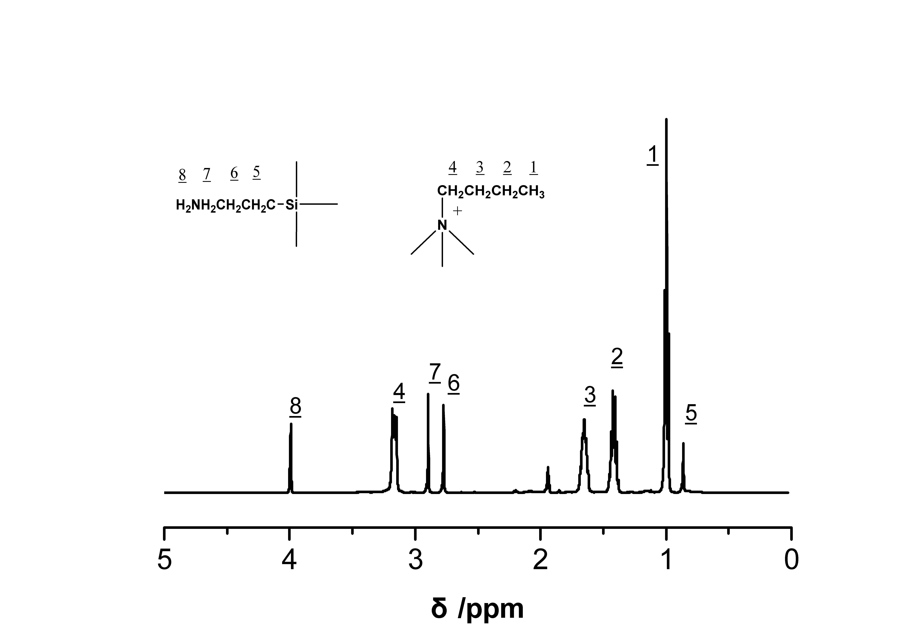
Figure S1 ¹H NMR spectra of (Bu₄N)₃H[γ-SiW₁₀O₃₆(RSi)₂O] (R=CH₂CH₂CH₂NH₂).
To further confirm the covalent linkage between polymer chains and polyoxometalate, the solid state ²⁹Si NMR spectrum of the POM-based polymer hybrid was performed. It presents two singlets at -47.5 and -82.6 ppm with relative intensities 2:1, as shown in Figure S3. The high-frequency signal presents the RSi group and the low-frequency one corresponds to the central SiO4 unit in POM clusters.³⁻⁵
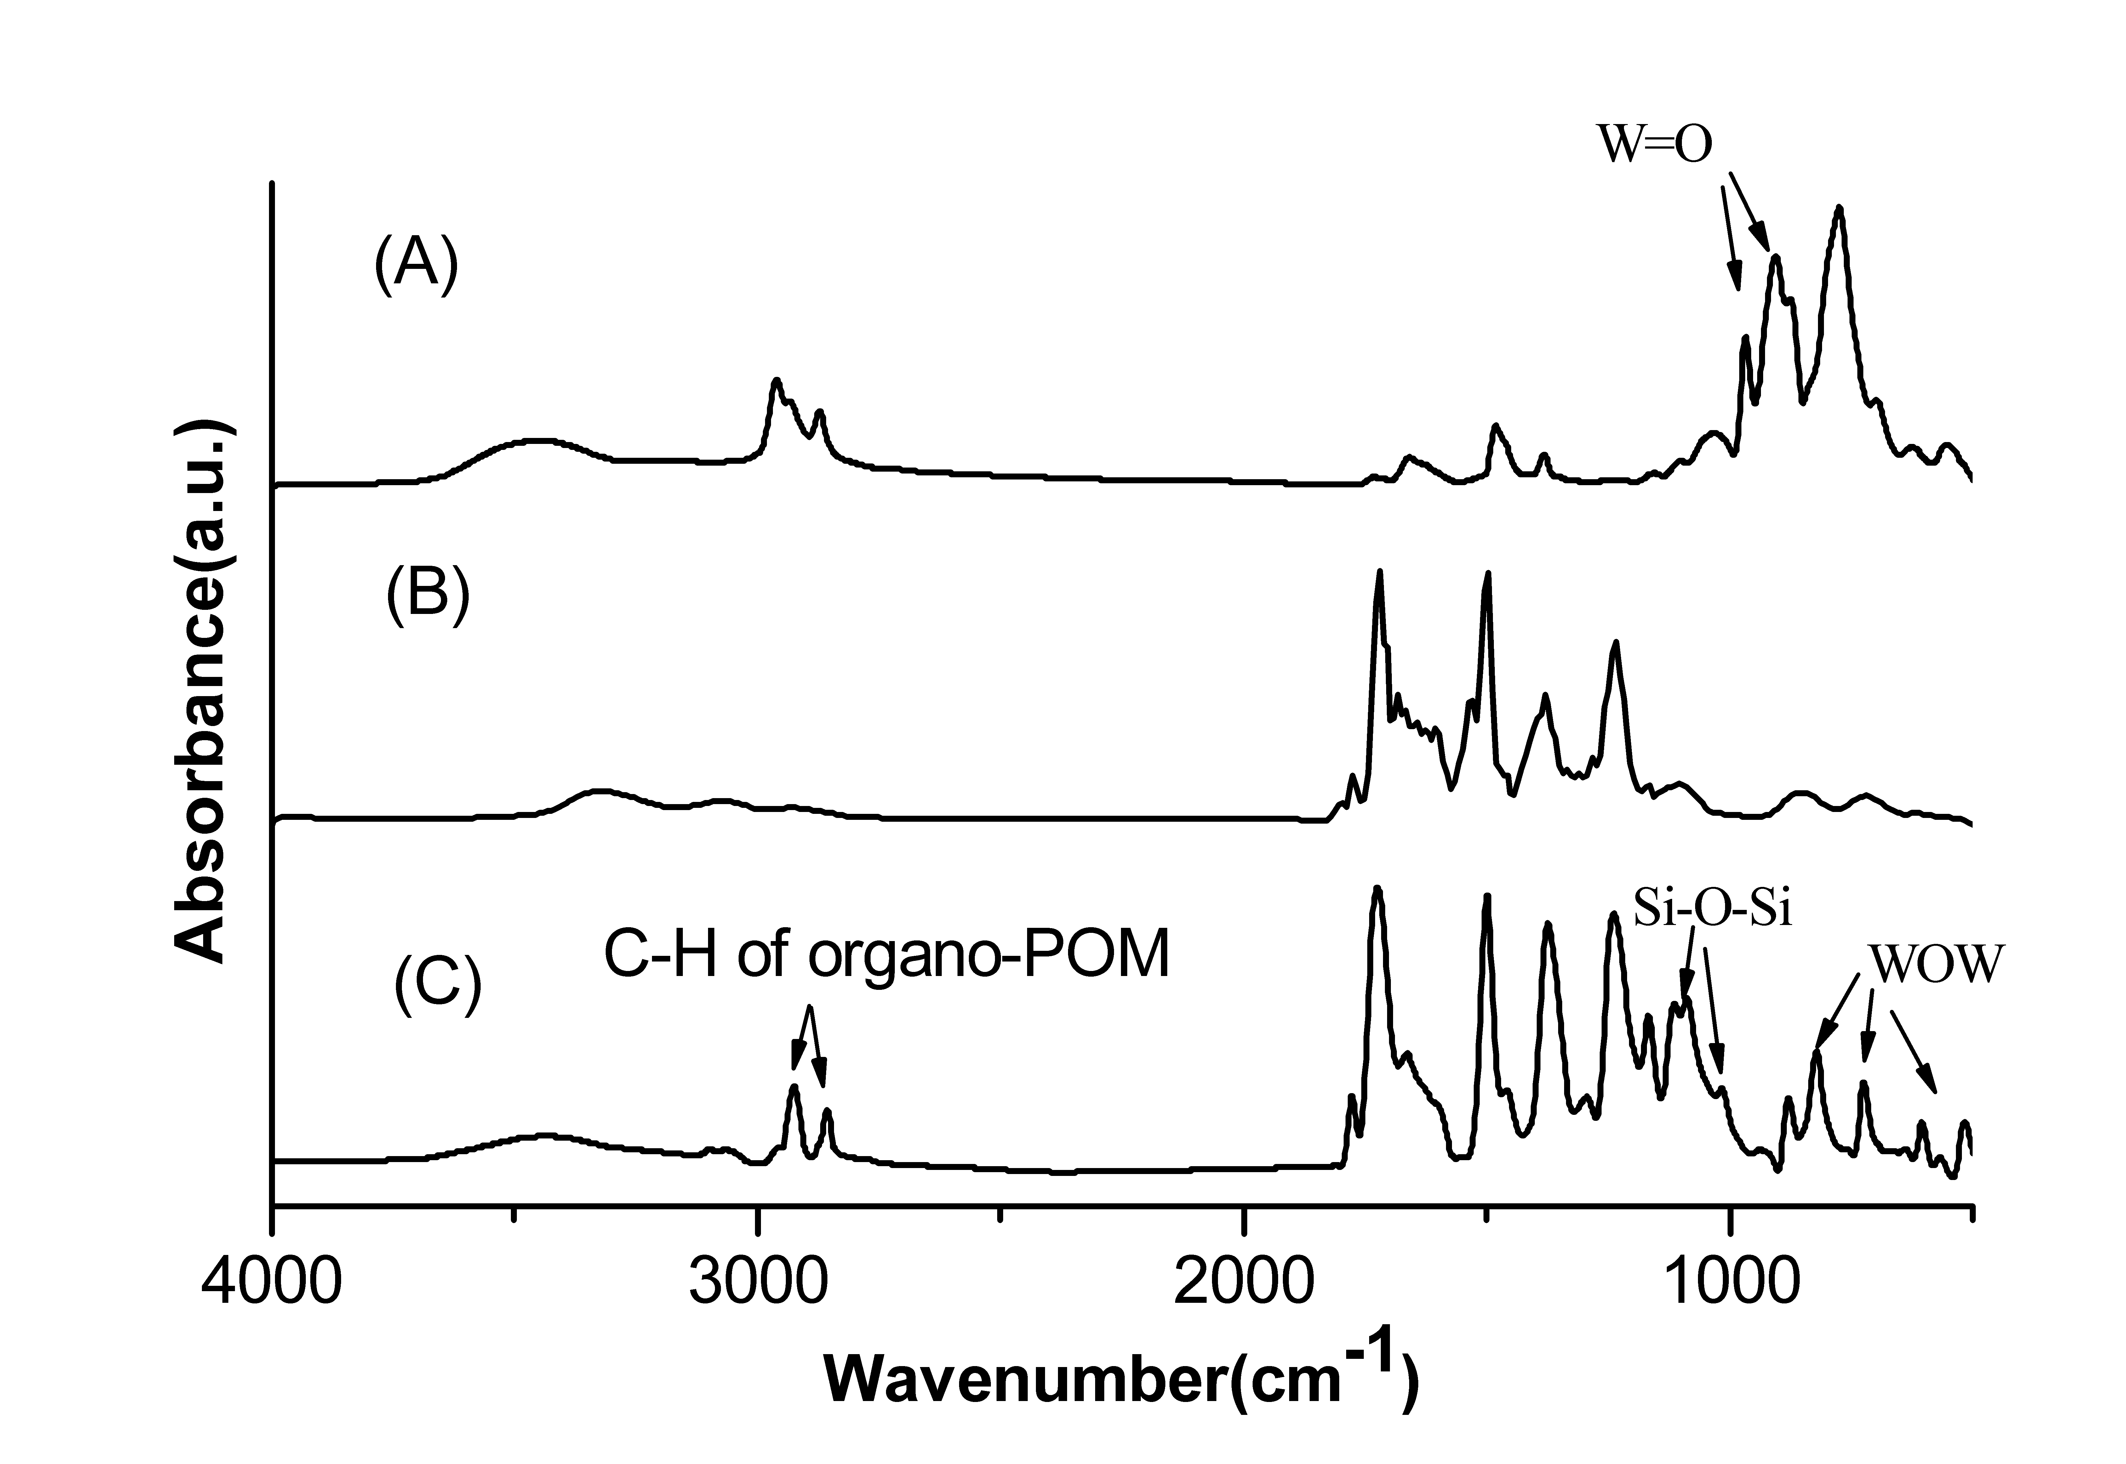
Figure S2. FTIR spectra of (A) organo-POM (B) PMDA-ODA and (C) 10 wt% POM/PMDA-ODA.
The X-ray photoelectron spectra (XPS) can show the real content of the polyoxometalate clusters in hybrid films. As Tabel S1 shows, the real contents are consistent with the results that we listed previously.
The UV/vis results reveal that the addition of POM clusters almost does not affect the transparency of these polyimide films, which indicates to some extent a good compatibility between these molecular clusters and the polyimide, as well as uniform dispersion of the clusters in the organic matrix.
Table S1 X-ray photoelectron spectra for the POM and hybrid films
Sampleª | Mol% of C | Mol% of W | wt of POM
POM | 54 | 10 | -
PI-1 | 71.7 | 0.05 | 0.011
PI-3 | 71.22 | 0.13 | 0.03
PI-5 | 68.26 | 0.21 | 0.049
PI-10 | 68.95 | 0.4 | 0.098
ª X in PI-X represents the POM content in hybrid films, i.e., PI-1 represents the hybrid film containing 1 wt% POM

For the neat polyimide and hybrid films the variations in dielectric lossε”, with log(f) are shown in Fig. S5. It can be seen that in all hybrid films the dielectric loss reduces with increasing POM contents, although it appears fluctuation in 3 wt%. The dielectric loss for the 10 wt% sample was reduced to 0.01, in contrast to 0.053 of the neat polyimide.
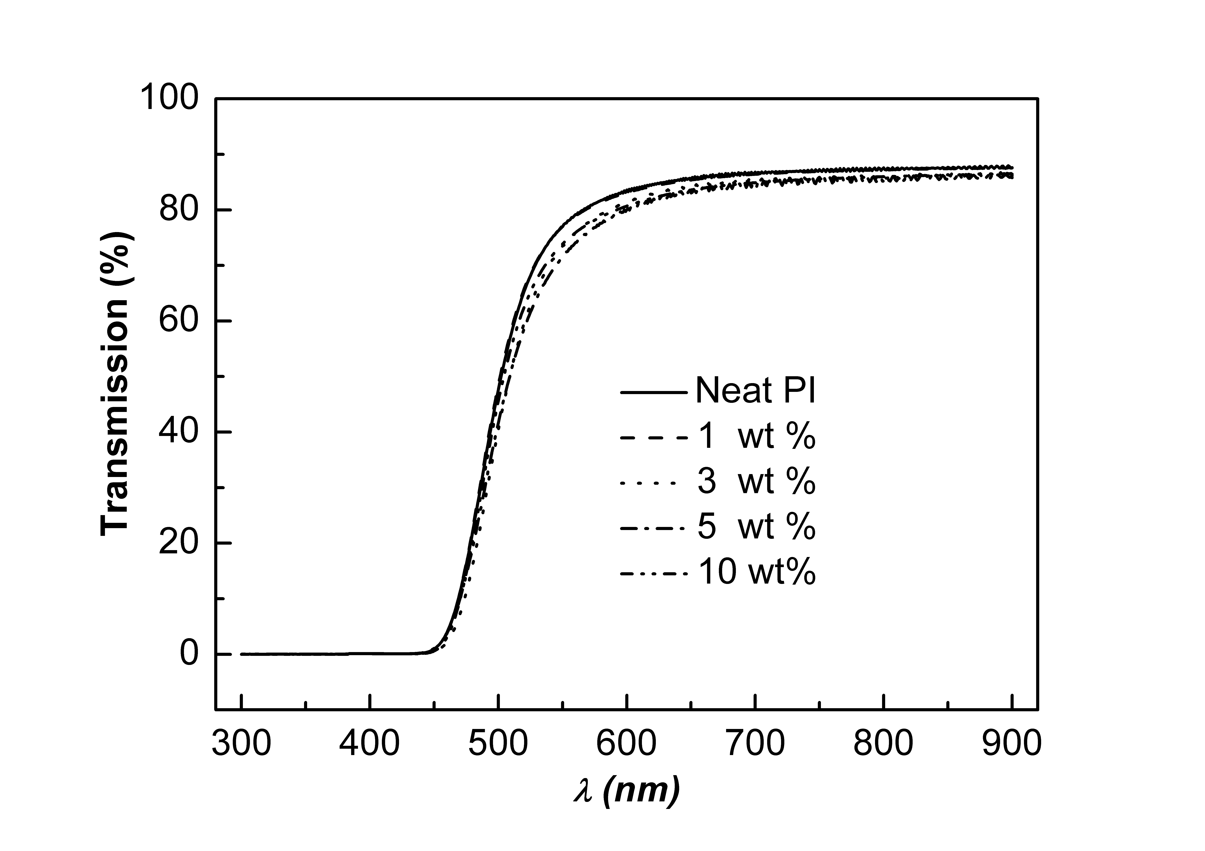
Figure S4 UV/vis spectra of the neat polyimide and hybrid film.
The thermogravimetric curves for the neat polyimide and hybrid films under N₂ atmosphere are presented in Figure S6. It is found that the initial decomposition temperature T_{d}, defined as 5% weight loss, significantly increases with increasing POM contents. Although the increase in T_{d} with
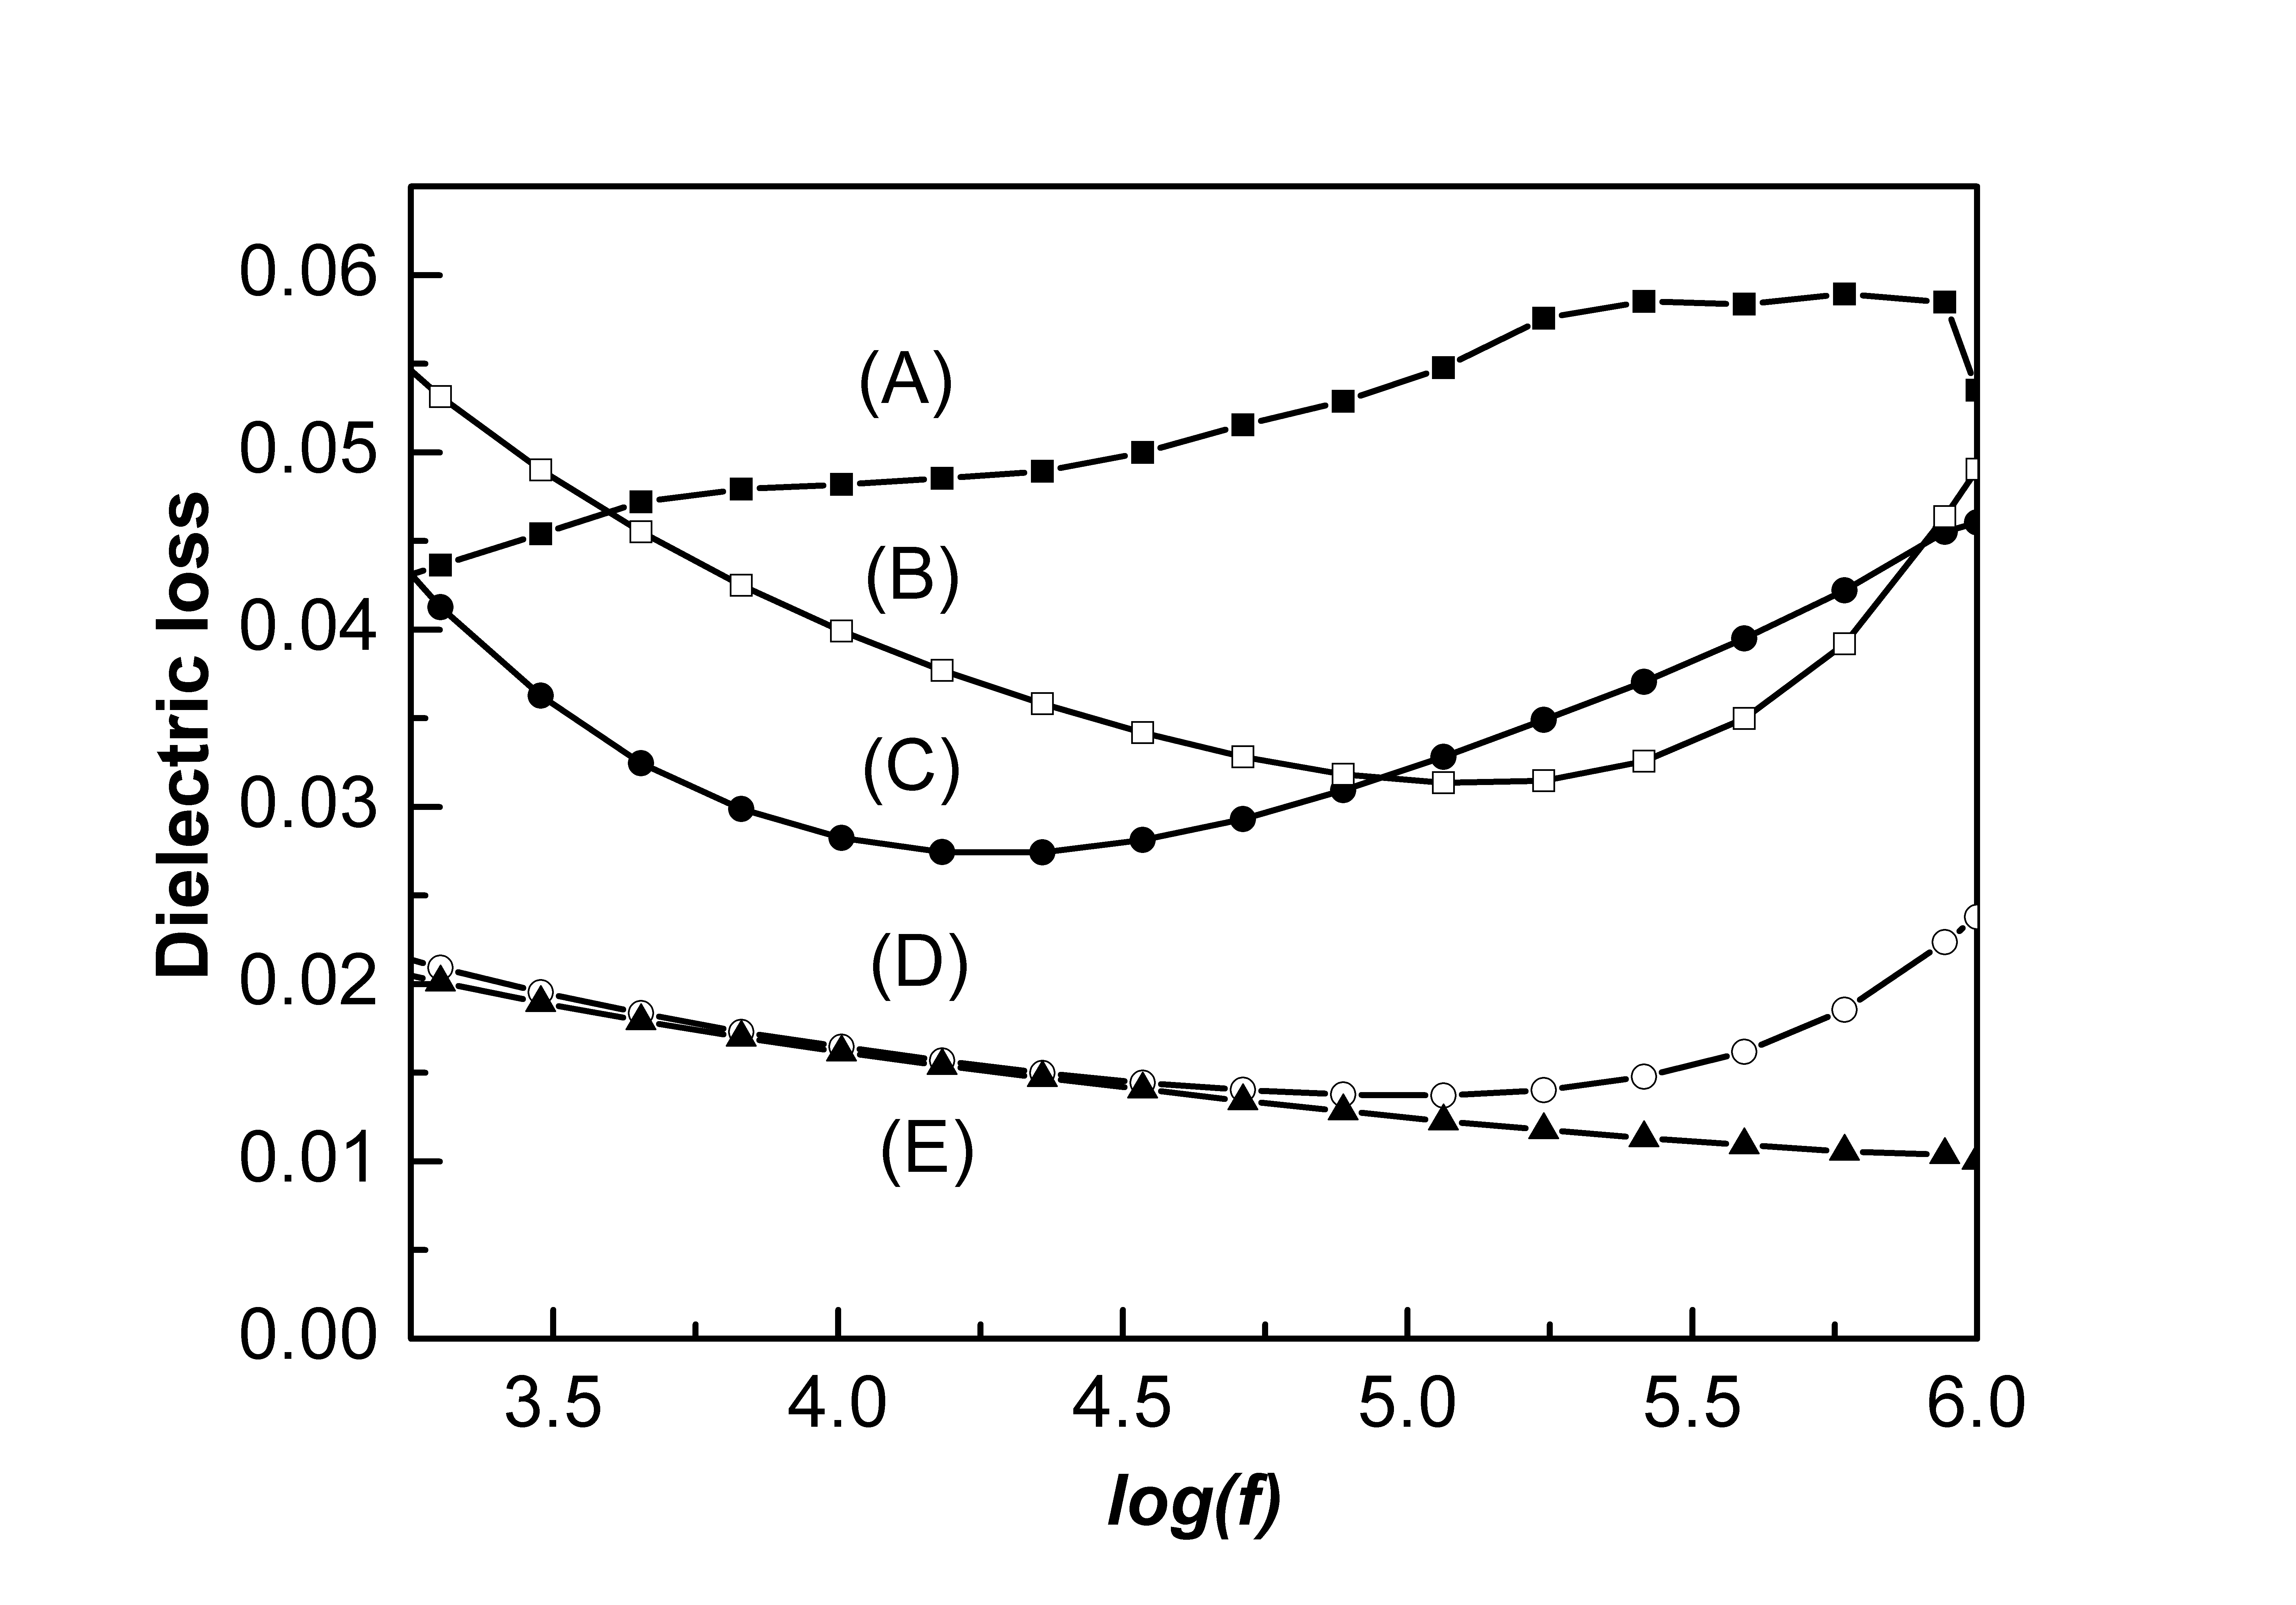
Figure S5 Variations in dielectric loss, ε’’, with log(f) for (A) neat polyimide; (B) 1 wt% POM; (C) 3 wt% POM; (D) 5 wt%POM; (E) 10 wt% POM.
POM contents is not linear and appears fluctuation above 3 wt %, 32 ~ 46 °C of T_{d} increases for all the hybrid samples can be normally observed. For PMDA-ODA polyimides, a few researches have shown that the addition of inorganic components, even with the addition of only 1 wt %, could remarkably improve their thermal stability.⁶ For the present hybrid films, the POM clusters were incorporated into the polyimide chains by the aminopropyl groups attached on the lacunas of POM. During the thermal decomposition the organic fragments attached to POM might loss, causing the recovery of lacunae on the POM surface. The formed lacunae can trap the radicals generated in the chain-breaking process and thus retard the decomposition of polymer chains. Besides the present tungstosilicate clusters, titania clusters like Ti₁₆O₁₆(OEt)₂₄(OC₂H₄Mc)₈ and Ti₆O₄(OEt)₈(OMc)₈ have been found by a few researchers to cause a 20 °C T_{d} increase relative to the neat polymers.⁷ It is conjectured that the improved thermal stability of these hybrids containing POM clusters might follow a similar radical- trapping mechanism.
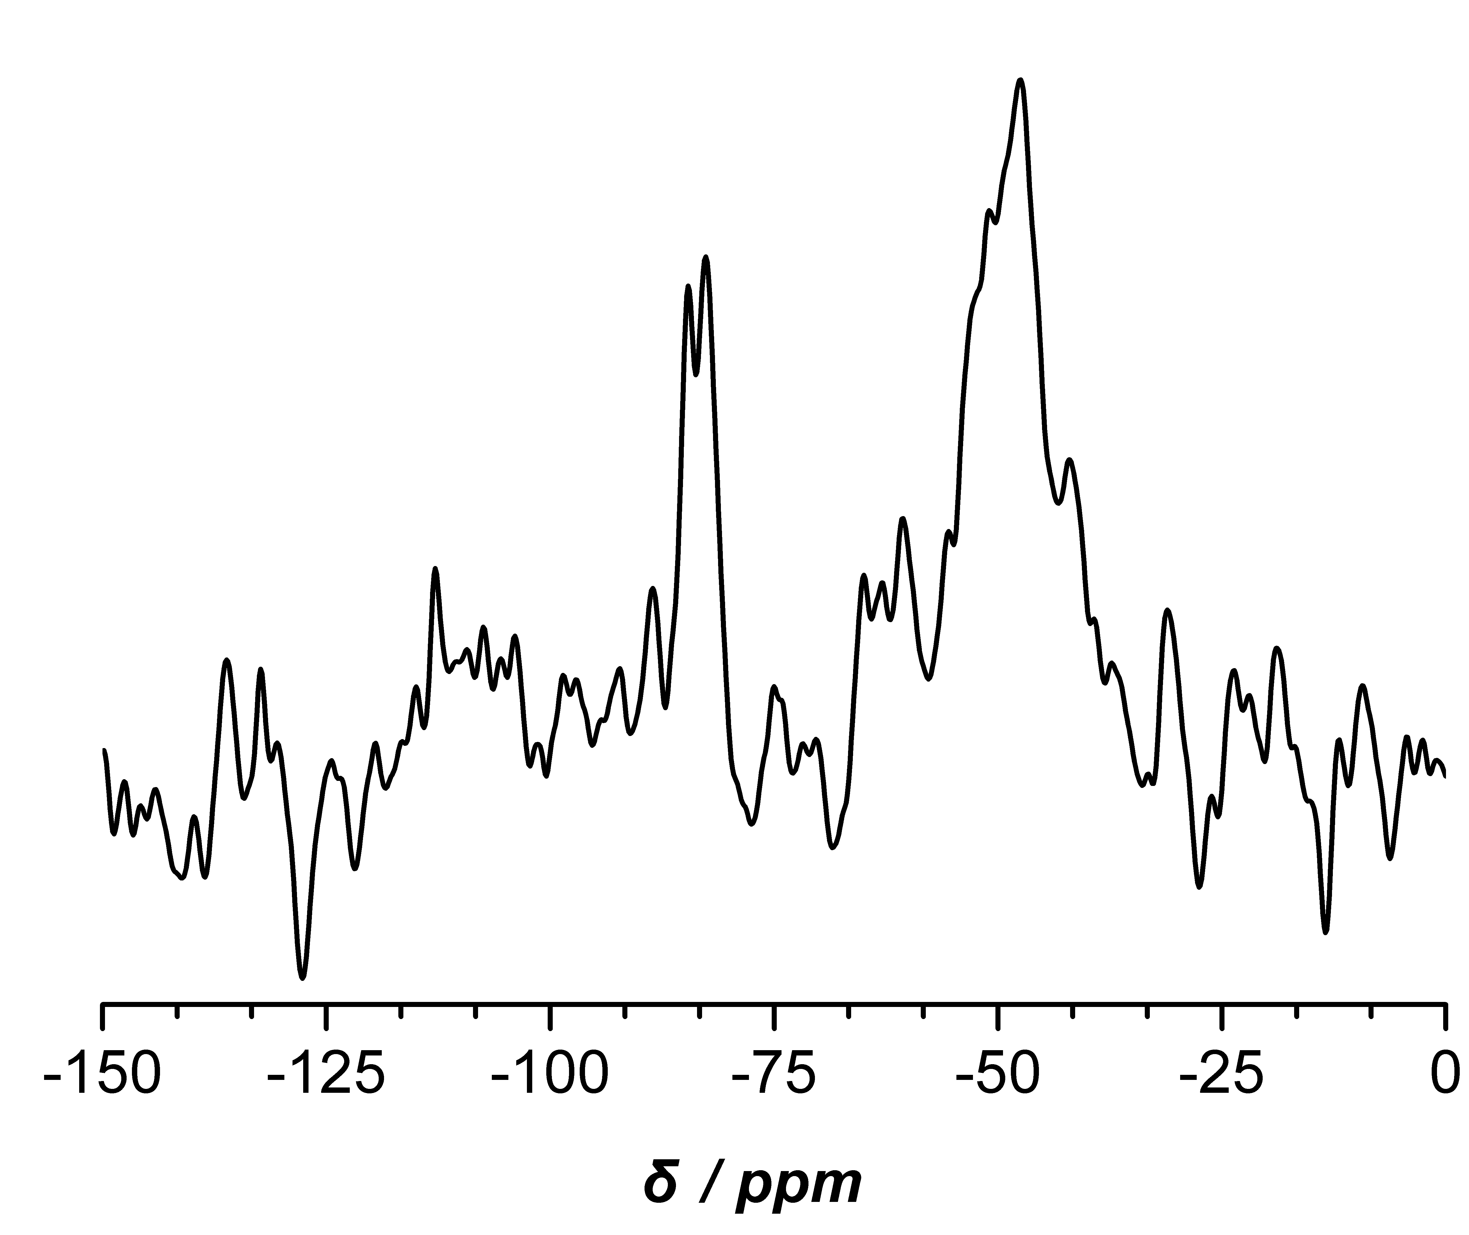
Figure S3 The solid state ²⁹Si NMR spectrum of 10 wt% POM/PI hybrid film.
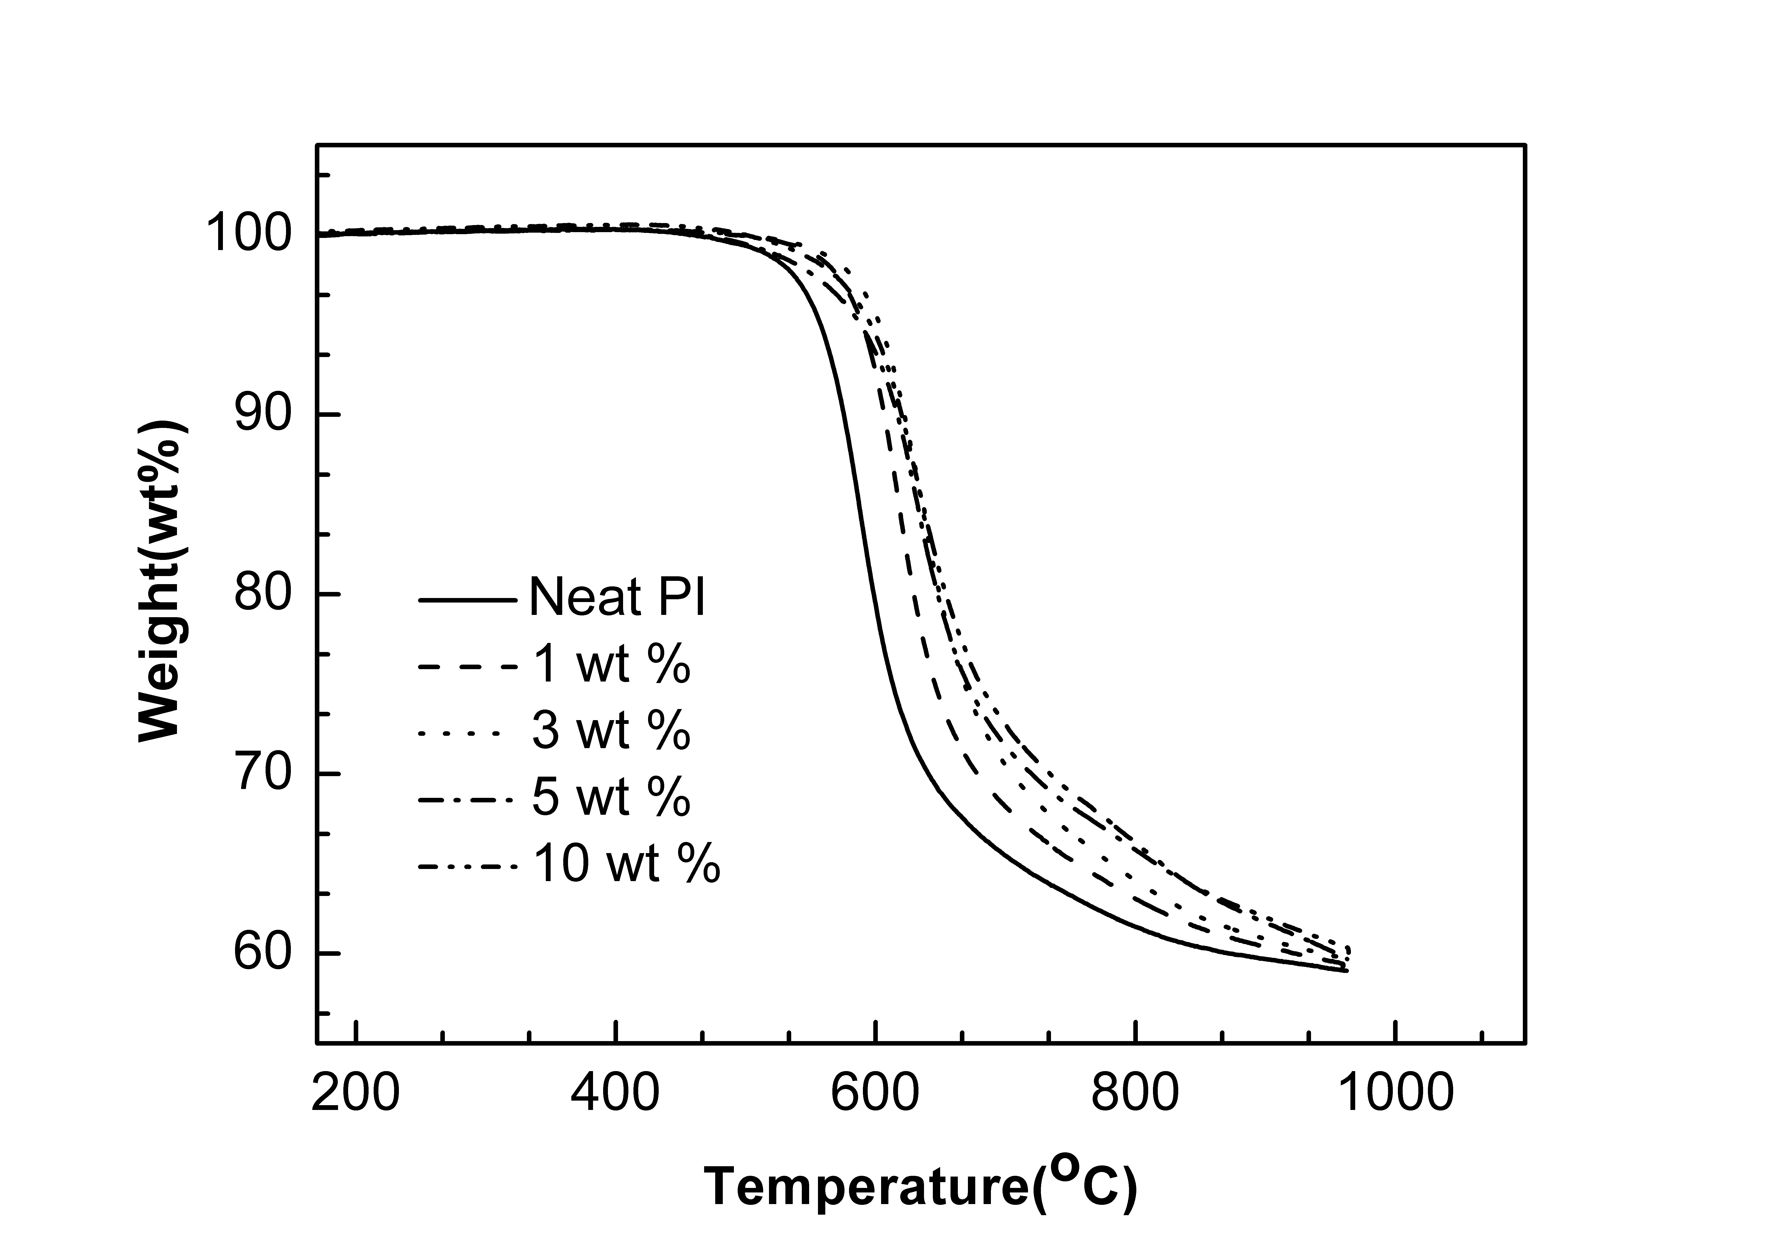
Figure S6 Thermal properties of the neat polyimide and POM hybrid films, at heating rate 10 °C/min, N₂ atmosphere.
References
- J. Canny, A. Tézé, R. Thouvenot, G. Hervé, Inorg. Chem.,.1986, 25, 2114.
- C. R. Mayer, I. Fournier, R. Thouvenot, Chem. Eur. J., 2000, 6, 105
- C. R. Mayer and R. Thouvenot, Chem. Mater., 2000, 12, 257.
- Y. Guo, Y. Wang, C. Hu, C. Guo, E. Wang, Y. Zou and S. Feng, J. Mater. Chem., 2002, 12, 3046.
- M. Bonchio, O. Bortolini, V. Conte and A. Sartorel, Eur. J. Inorg. Chem., 2003, 699.
- H. L. Tyan, Y. C. Liu, K. H. Wei, Chem. Mater., 1999, 11, 1942.
- (a) Y. Gao, N. R. Choudhury, J. Matisons, U. Schubert, B. Moraru, Chem. Mater., 2002, 14, 4522. (b) T. Liang, Y. Makita, S. Kimura, Polymer, 2001, 42, 4867

