Addition and correction

Small polarons in Nb- and Ta-doped rutile and anatase TiO₂

Benjamin J. Morgan, David O. Scanlon and Graeme W. Watson

J. Mater. Chem., 2009, 19, 5175–5178 (DOI: 10.1039/b905028k)

Figures 2 and 4 are interchanged. The correct figure and caption combinations are shown below:
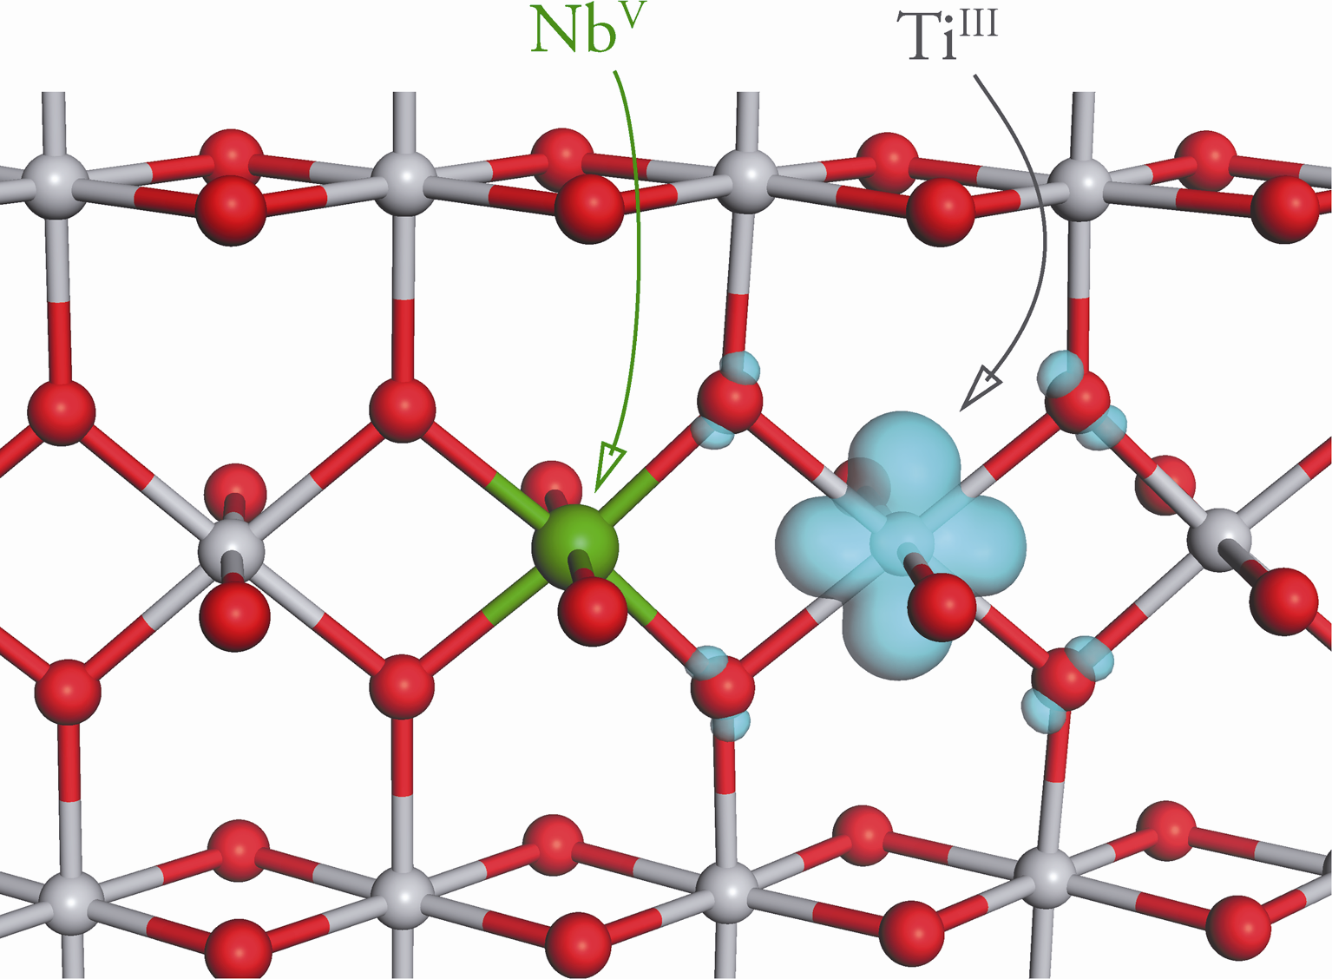

Fig. 2 A slice through a (110) plane of the Nb-doped rutile TiO₂ system, showing the charge density associated with the gap state in Fig. 1(b). The Nb dopant is shown in green. Ti atoms are grey, and oxygen atoms are red. The charge isosurface is shown at a density of 0.05 e ⁻³.

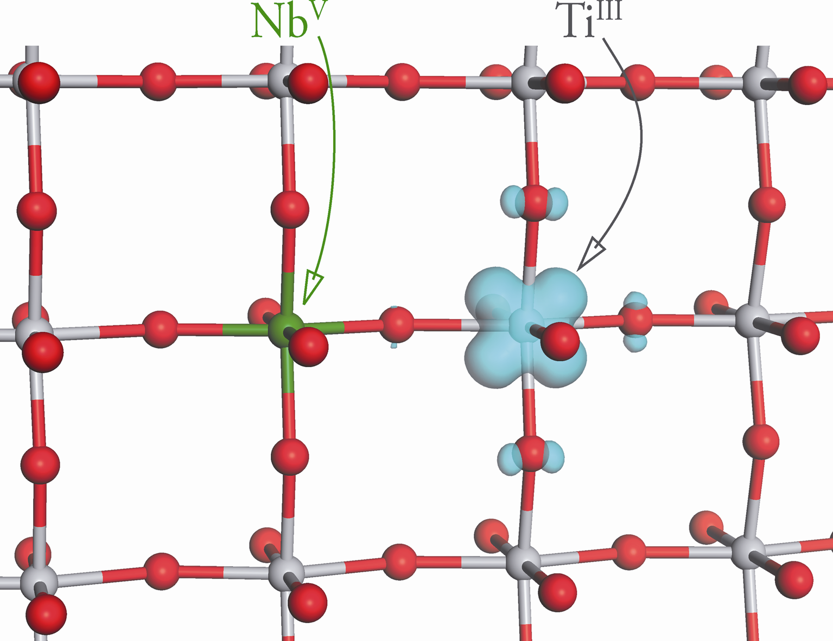

Fig. 4 A slice through a (001) plane of the Nb-doped anatase TiO₂ system, showing the charge density associated with the gap state in Fig. 3(b). The Nb dopant is shown in green. Ti atoms are grey and oxygen atoms are red. The charge isosurface is shown at a density of 0.05 e ⁻³.

The Royal Society of Chemistry apologises for these errors and any consequent inconvenience to authors and readers.

Additions and corrections can be viewed online by accessing the original article to which they apply.

