SUPPLEMENTARY MATERIAL (ESI) – FIGURES S1-S4

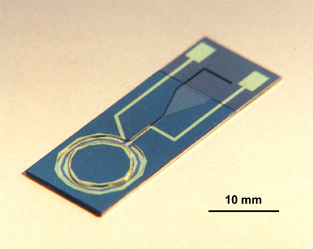

Supplementary Material, Fig. S1 MHD microreactor with an annular channel realised by KOH etching silicon, and with Cr/Au electrodes patterned on the channel walls.
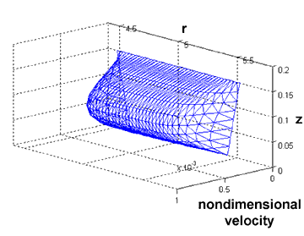

Supplementary Material, Fig. S2 Finite element solution for velocity profile in the silicon microreactor annulus at a region with a 54 ° etch. Depth is 150 μm and measured along the vertical z axis in mm. The channel width is 1045 μm at the top and 830 μm at the bottom of the channel, with channel radius measured in mm along the r axis.

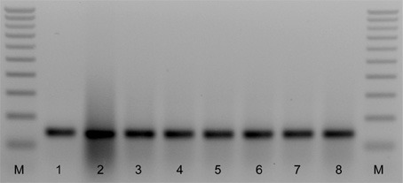

Supplementary Material, Fig. S3 The effect of MHD actuation conditions (0.6 V_{RMS} applied to the channel electrodes and a magnetic field of 10 mT) on the PCR product previously generated by conventional amplification methods. Silicon devices were derivatised with 5 mg mL⁻¹ BSA and 5 mg mL⁻¹ DNA. From left to right, 100 bp increment ladder (M), positive control, i.e. without exposure to actuation conditions, device materials or room temperatures (lane 1), exposure to actuation conditions for 0, 10, 30, 60, 120 and 180 min (lanes 2-7, respectively), and stored at room temperature for 180 min (lane 8). Lane 2 reveals that crude oligonucleotides used for derivatisation can contribute to the amplicon signal.

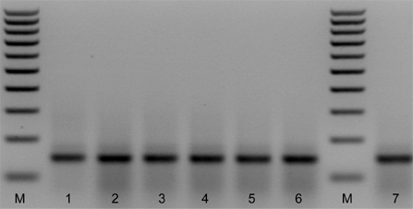

Supplementary Material, Fig. S4 The effect of MHD actuation conditions (0.6 V_{RMS} applied to the channel electrodes and a magnetic field of 10 mT) on the PCR reagents prior to thermocycling by conventional methods. Silicon devices were derivatised with 5 mg mL⁻¹ BSA and 5 mg mL⁻¹ DNA. From left to right, 100 bp increment ladder (M), positive control, i.e. without exposure to actuation conditions, device materials or room temperatures (lane 1), exposure to actuation conditions for 0, 30, 60, 120 and 180 min (lanes 2-6, respectively), and stored at room temperature for 180 min (lane 7).

