Supplementary Material (ESI) for Lab on a Chip
This journal is © The Royal Society of Chemistry 2007

Electronic Supplementary Information for

Multifunctional Microvalves Control by Optical Illumination on Nanoheaters and Its Application in Centrifugal Microfluidic Devices

Jong-Myeon Park†, Yoon-Kyoung Cho†, Beom-Seok Lee, Jeong-Gun Lee*& Christopher Ko*

†First two authors contributed equally. *To whom correspondence should be addressed.
E-mail: *biogun.lee@samsung.com & *chrisko@samsung.com

Electronic Supplementary Information includes 3 Movie files, 3 Figures and 1 Table.

- Movie file 1.
- A movie file showing the operation of NC-LIFM (Normally Closed Laser Irradiated Ferrowax Microvalves).
- Upon the laser irradiation started at 0.407 sec, the ferrowax is melted away and the channel was open at 0.419 sec. Therefore, the response time to open the channel was determined to be 0.012 sec.

- Movie file 2.
- A movie file showing the operation of NO-LIFM (Normally Open Laser Irradiated Ferrowax Microvalves).
- Upon the laser irradiation started at 1.222 sec, the molten ferrowax is burst into the main channel and close it at 1.666 sec. Therefore, the response time to seal the channel was determined to be 0.444 sec.

- Movie file 3.
- A movie file showing the total process of centrifugal microfluidics using LIFM.
- Detail description is shown in Fig. 4. and the corresponding text.

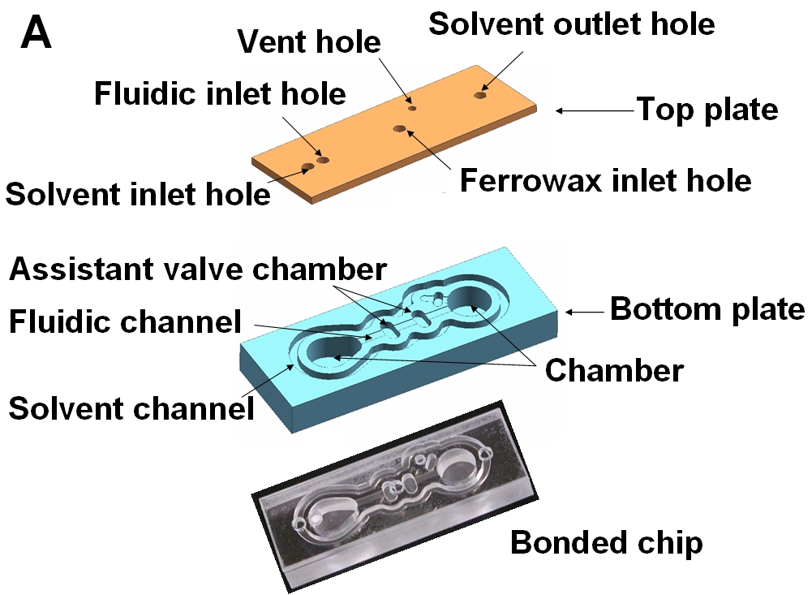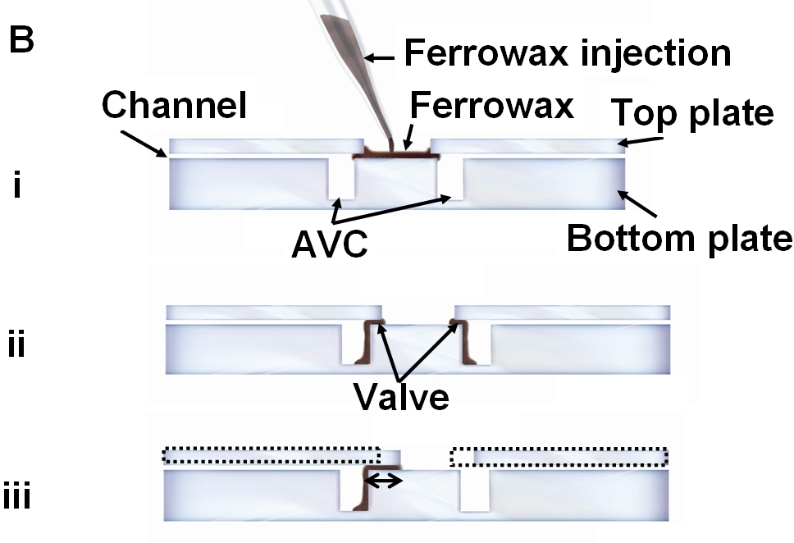

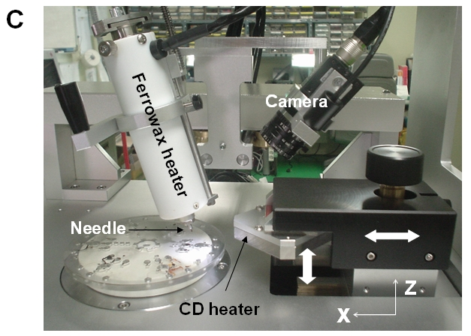

Fig. S1. (A) Schematic diagram of the test chip with NC-LIFM (B) the side view of the LIFM fabrication procedure. (i) As the molten ferrowax is injected into the ferrowax inlet hole, it flows into the microchannel by capillary action and blocks the main channel as it is solidified. (ii) The excess amount of the molten ferrowax flows into the AVC(Assistant Valve Chamber). (iii) The valve length could be controlled by adjusting the distance between the ferrowax injection hole and the AVC position. For example, if the top plate is positioned as the dotted line, the valve length is decreased and so does the LIFM volume. (C) The dispensing ferrowax was automatically controlled by a custom-designed instrument equipped with CD heater, CCD camera, X-Y stage and a syringe installed with a ferrowax heater.

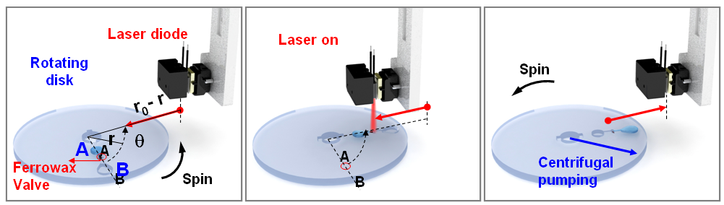

Fig. S2 Schematic diagram of the ferrowax valve operation on a CD. In order to transfer liquid from reservoir A to reservoir B, the CD is rotated with the angle θ to the laser home and the laser diode is moved to the valve position with the distance (r-r₀). Then, laser with power of 1.5 W was applied for 1 sec to melt the ferrowax and the disk is spin to pump liquid from reservoir A to reservoir B.

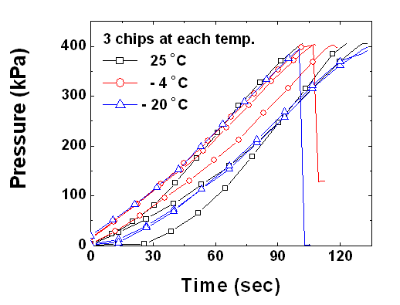

Fig. S3 Test chips with preloaded ferrowax kept at -4 ℃, -20 ℃, and 25 ℃ for two months were used for leakage tests. In all of the cases, the maximum hold-up pressure was larger than 400 kPa. For clear visualization, only 10 data points were shown in symbols among more than 3000 data.

Table S1. A spin program for the microfluidics on a CD

Spin No. | Spin speed (Hz) | Time (sec) | Operation
- | - | - | Input 0.1 N NaOH solution (blue) 50 μL to chamber 1 (Fig. 4B).
- | - | - | Input 0.1 N HCl (yellow) 50 μL to chamber 2 (Fig. 4B).
- | - | - | Input 0.1N NaOH (blue) 50 μL to chamber 3 (Fig. 4B).
1 | 30 | 5 | LIFM 1 opened, blue solution transfer to chamber 4 from chamber 1 (Fig. 4C).
2 | 30 | 5 | LIFM 2 opened, yellow solution transfer to chamber 4 from chamber 2 (Fig. 4D).
3 | + 9 ~ - 9 | 12 | Mixing, Color changes from blue to yellow by neutralization (Fig. 4E).
4 | 30 | 5 | LIFM 3 opened, defined-volume of 50 μL in chamber 4 is transferred into chamber 7 (Fig. 4F).
5 | - | - | LIFM 4 closed (Fig. 4G).
6 | 30 | 5 | LIFM 5 opened, blue solution in chamber 3 is transferred into chamber 4 (Fig. 4H).
7 | + 9 ~ - 9 | 12 | Mixing, Color changes from yellow to blue (Fig. 4H).
8 | 30 | 5 | LIFM 6 opened, defined-volume 50 μL in chamber 4 is transferred into chamber 5 (Fig. 4I).
9 | 30 | 5 | LIFM 7 opened, defined-volume 50 μL in chamber 4 is transferred into chamber 6 (Fig. 4J).

