Supplementary data

Differential Substituent Effects of β-Halogens in Water-Soluble Porphyrins

Justin C. Biffinger, Haoran Sun, Andrew P. Nelson, and Stephen G. DiMagno*

Electrochemical Procedures: Cyclic voltammograms (CV), square wave voltammograms (SWV) and differential pulse volatammograms (DPV) were obtained with a computer controlled (M270 software) EG&G PARC M273A potentiostat/galvanostat. A three-electrode system (glassy carbon working electrode (Cypress), Pt wire counter electrode, and a homemade Ag/AgCl (sat’d KCl) reference electrode) was used for the electrochemical experiments. All reported potentials are referenced to Ag/AgCl. The working electrode was polished using EG&G polishing kits and cleaned ultrasonically in water (Fluka, inorganic trace analysis grade). All solutions were degassed and all electrochemical experiments were conducted under N₂.

Procedure for pK_{a} determinations. Absorption spectra of the free base porphyrins in aqueous solution (< 10⁻⁶ M) were obtained as a function of pH at constant ionic strength (generally 0.1 M, with NaNO₃ making up the electrolyte balance). The pK_{a} values were determined by spectrophotometric titrations at 23 ºC; the pH was adjusted with NaOH or HNO₃. In all cases the Soret bands were monitored. Clean isosbestic behavior was observed for 1 for all measurable pK_{a}s; for 2 more than two species were observed in the 0 > pH > -1 range. Representative traces are shown in Figures S1-S5. The pK_{a} values reported are accurate to ±0.1. Low pH solutions (pH < 0) were obtained by adding measured quantities of conc. HNO₃ (15.9 M) to dilute porphyrin solutions. (At extremely low pH, constant ionic strength was not maintained.)
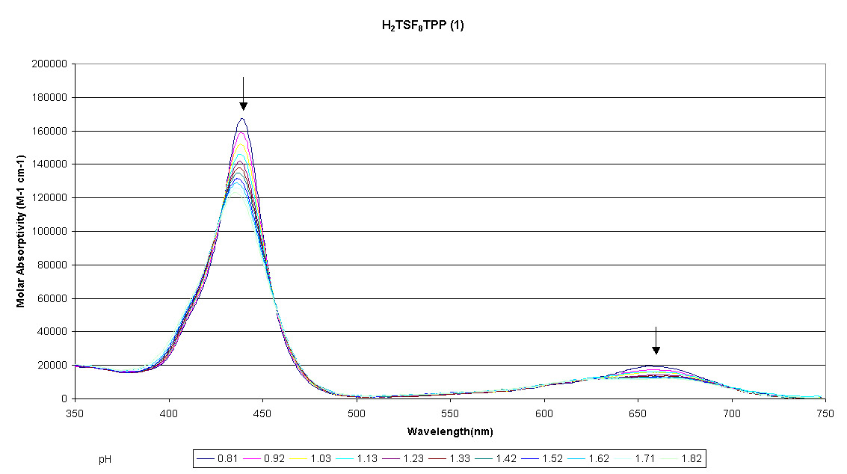
Figure S1. Change in absorption spectrum of 1 over the pH range 0.81-1.82.
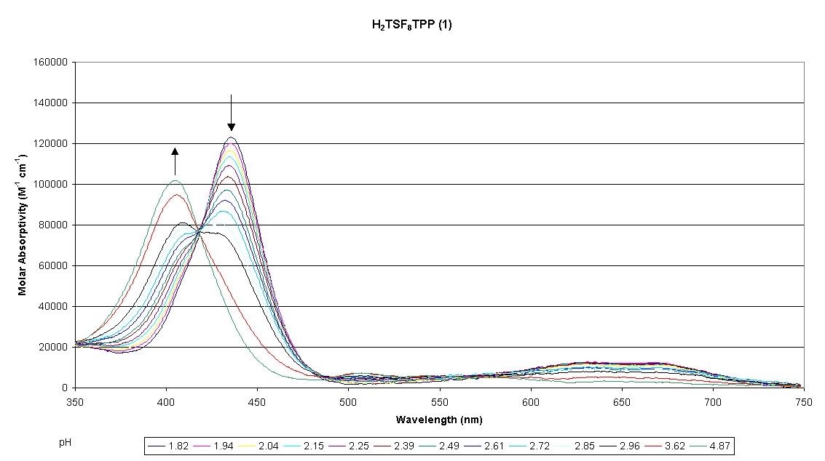
Figure S2. Change in absorption spectrum of 1 over the pH range1.82 - 4.87.
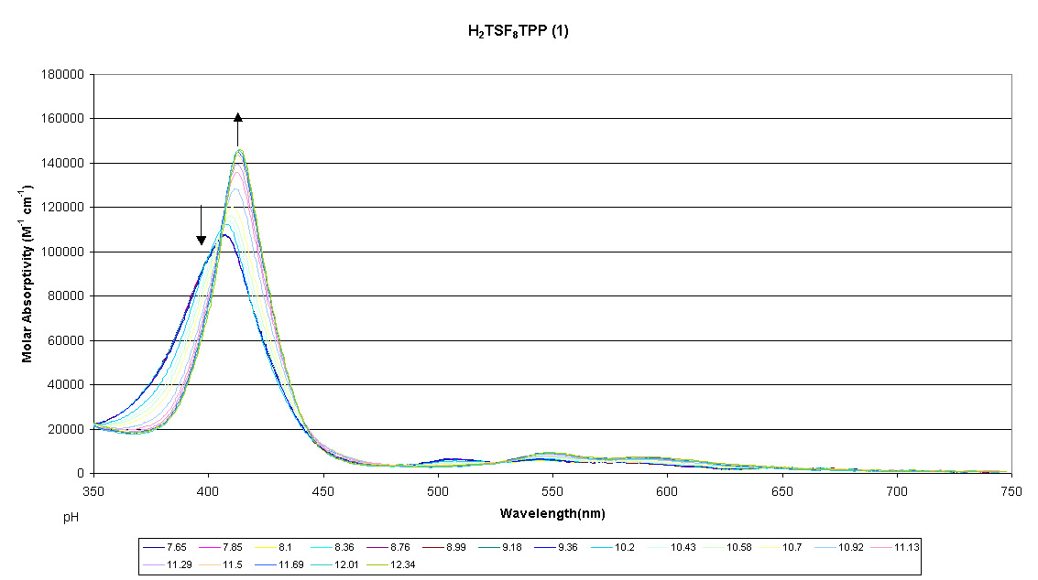
Figure S3. Change in absorption spectrum of 1 over the pH range 7.67 -12.34.
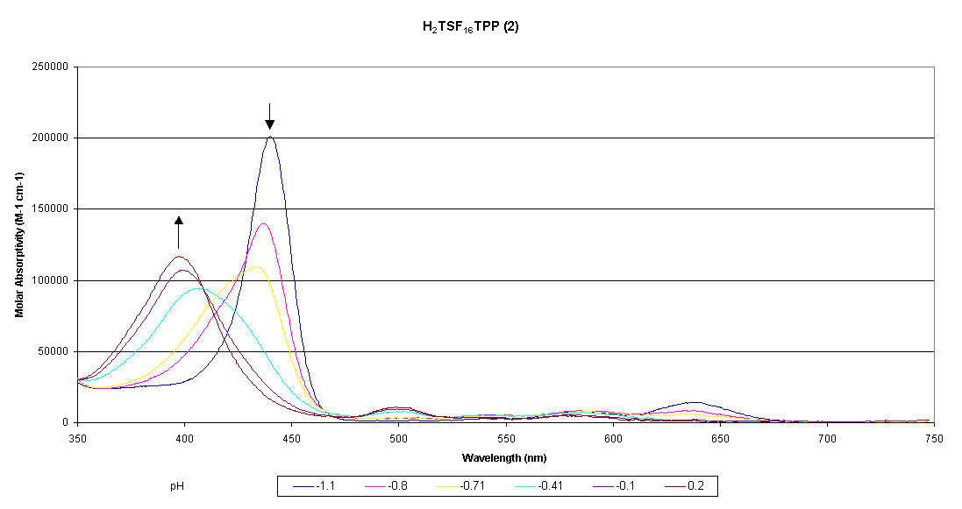
Figure S4. Change in absorption spectrum of 2 over the pH range –1.1 - 0.2.
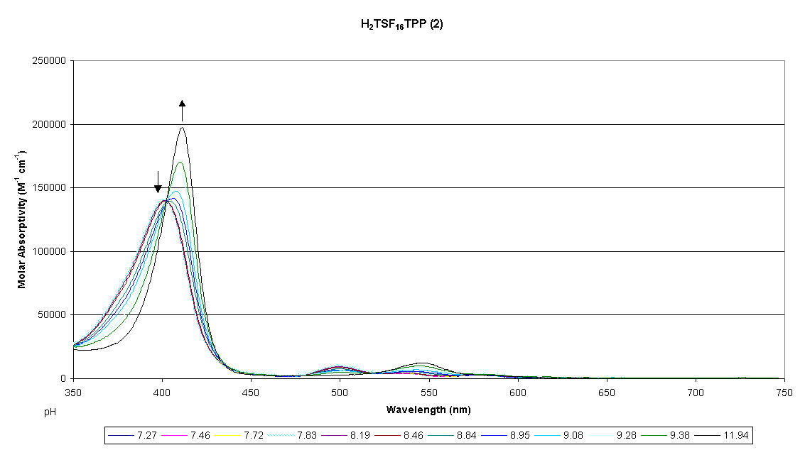
Figure S5. Change in absorption spectrum of 2 over the pH range 11.94 – 7.27.

Beer’s Law Deviations. Aggregation of fluorinated anionic porphyrins was studied in aqueous solution (I = 0.1 NaNO₃) at neutral pH. Aggregation was detected by deviation from Beer’s law in the porphyrin concentration range of 10⁻⁵ – 10⁻⁷ M.^{1,2} Representative plots are shown in Figures S6-S9.
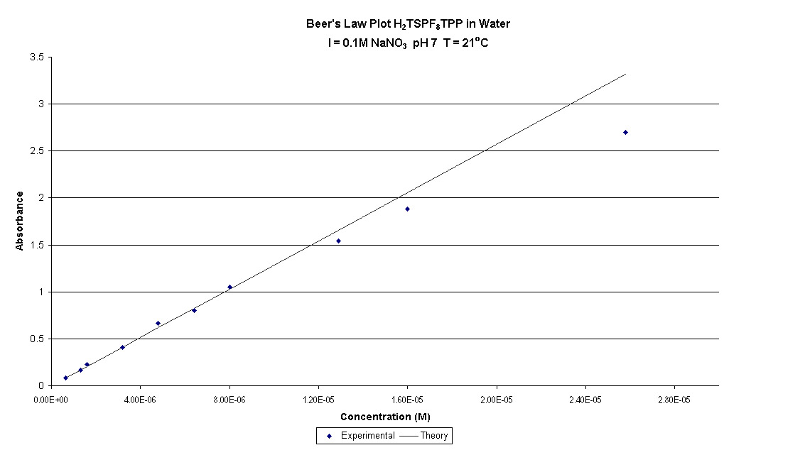
Figure S6. Concentration dependent absorption of 1 at λ = 406 nm. There is evidence for aggregation (deviation from Beer’s Law behavior) at [1] > 8x10⁻⁶ M.

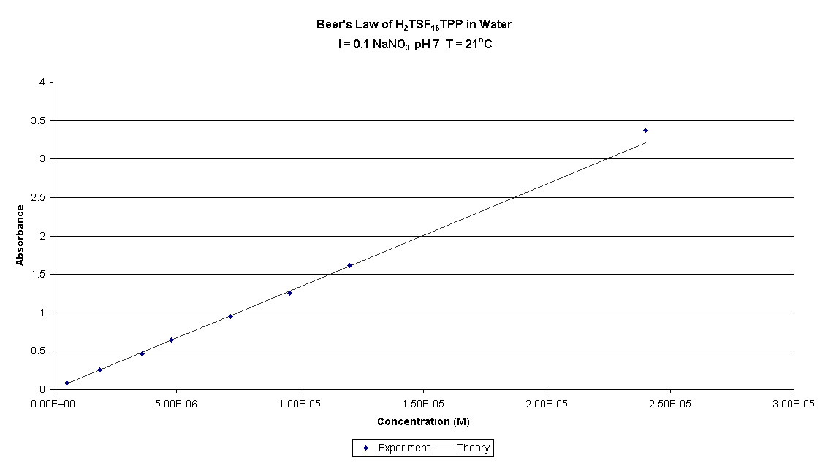
Figure S7. Concentration dependent absorption of 2 at λ = 399 nm. There is no evidence for aggregation at [2] < 2.5x10⁻⁵ M.

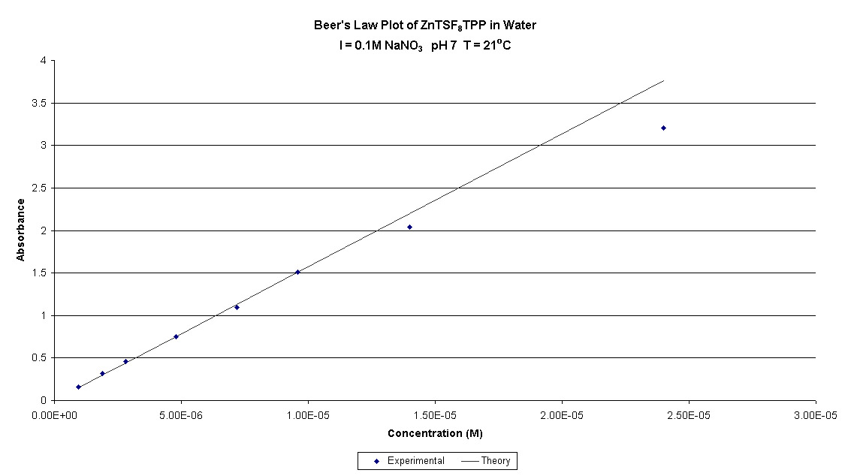
Figure S8. Concentration dependent absorption of 3 at λ = 410 nm. There is evidence for aggregation (deviation from Beer’s Law behavior) at [3] > 10⁻⁵ M.
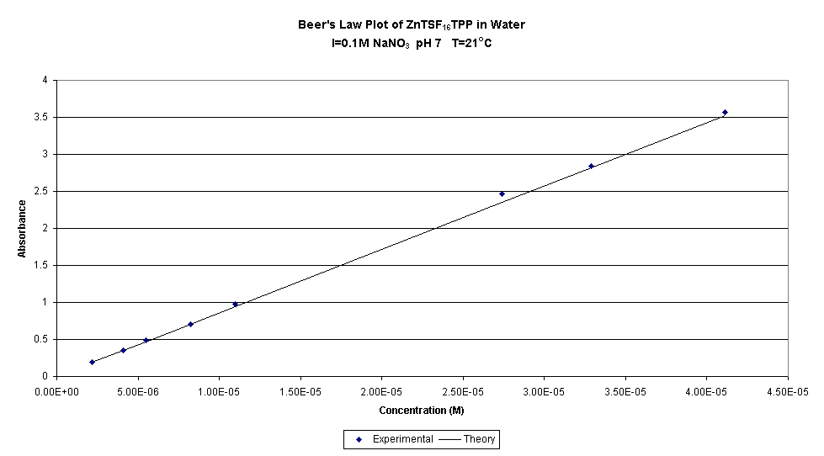
Figure S9. Concentration dependent absorption of 4 at λ = 410 nm. There is no evidence for aggregation at [4] < 4x10⁻⁵ M.

Calculations: All calculations were performed using the PC Spartan Pro program.³ For the constrained [Con] porphyrins a total of 8 dihedral constraints (N-C_{a}-C_{meso}-C_{a’} = ±20º) were imposed to induce saddling. The calculated (AM1) heats of formation are summarized in Table S1. All energies are in kcal/mol. Gas phase acidities were calculated using the AM1-derived ΔH_{f} (proton) = 365.6 kcal/mol.

Table S1. Results of Semiempirical (AM1) Calculations.
ªCompd | ^{b}β-H₈ | Acidity | ^{b}β-F₈ | Acidity | ^{b}β-Br₈ | Acidity
 | ΔH_{f} |  | ΔH_{f} |  | ΔH_{f}
PH2+ | 580.889 | 158.115 | 271.164 | 139.394 | 639.944 | 149.684
PH+ | 373.404 | 234.831 | 44.958 | 212.436 | 424.028 | 220.134
P | 242.635 | 338.822 | -108.206 | 311.63 | 278.562 | 314.938
P- | 215.857 | 433.227 | -162.176 | 406.16 | 227.9 | 405.676
P2- | 283.484 |  | -121.616 |  | 267.976
conPH2+ | 585.923 | 160.117 | 276.643 | 141.437 | 644.111 | 151.552
conPH+ | 380.44 | 237.677 | 52.48 | 214.981 | 430.063 | 222.944
conP | 252.517 | 337.201 | -98.139 | 310.231 | 287.407 | 313.586
conP- | 224.118 | 431.417 | -153.508 | 405.034 | 235.393 | 404.596
conP2- | 289.935 |  | -114.074 |  | 274.389
tetraphenyl analogues
PH2+ | 675.143 | 176.455 | 375.097 | 164.534 | 750.232 | 171.009
PH+ | 485.998 | 240.865 | 174.031 | 219.285 | 555.641 | 226.218
P | 361.263 | 335.736 | 27.716 | 321.12 | 416.259 | 322.773
P- | 331.399 | 414.527 | -16.764 | 393.986 | 373.432 | 394.428
P2- | 380.326 |  | 11.622 |  | 402.26
tetrakis(2,6-difluorophenyl) analogues
PH2+ | 341.053 | 173.262 | 38.49 | 161.556 | 414.301 | 169.31
PH+ | 148.715 | 231.895 | -165.554 | 217.403 | 218.011 | 225.656
P | 15.01 | 343.914 | -313.751 | 321.822 | 78.067 | 324.234
P- | -6.676 | 415.06 | -357.529 | 393.46 | 36.701 | 392.571
P2- | 42.784 |  | -329.669 |  | 63.672

ªPH₂ = free base, PH+ = monoprotonated cation , PH2+ = diprotonated dication, PH-=monodeprotonated anion, P2- = fully deprotonated dianion, con indicates a constrained, saddled structure. ^{b} Indicates the 8 substituents at the 2,3,7,8,12,13,17,18 positions. ^{c}Calculated heat of formation in kcal/mol. ^{d}Calculated gas phase acidity in kcal/mol. Acidity = ΔH_{f} (base) + ΔH_{f} (proton) - ΔH_{f} (acid).

References for Supplementary data:

(1) Pasternack, R. F.; Francesconi, L.; Raff, D.; Spiro, E. Inorg. Chem. 1973, 12, 2606-11.
(2) D'Souza, F.; Deviprasad, G. R.; Zandler, M. E. J. Chem. Soc., Dalton Trans. 1997, 3699-3703.
(3) Deppmeier, B. J.; Wavefunction Inc: Irvine CA, 1996-2000.

