Diazacoronand linked β-cyclodextrin† dimer complexes of Brilliant Yellow tetraanion and their sodium(1) analogues‡
Lee C. West,ª Oska Wyness,ª Bruce L. May,ª Philip Clements,ª Stephen F. Lincoln^{a*} and Christopher J. Easton^{b}
ª Department of Chemistry, The University of Adelaide, Adelaide SA 5005, Australia
^{b} Research School of Chemistry, The Australian National University, Canberra, ACT 0002, Australia

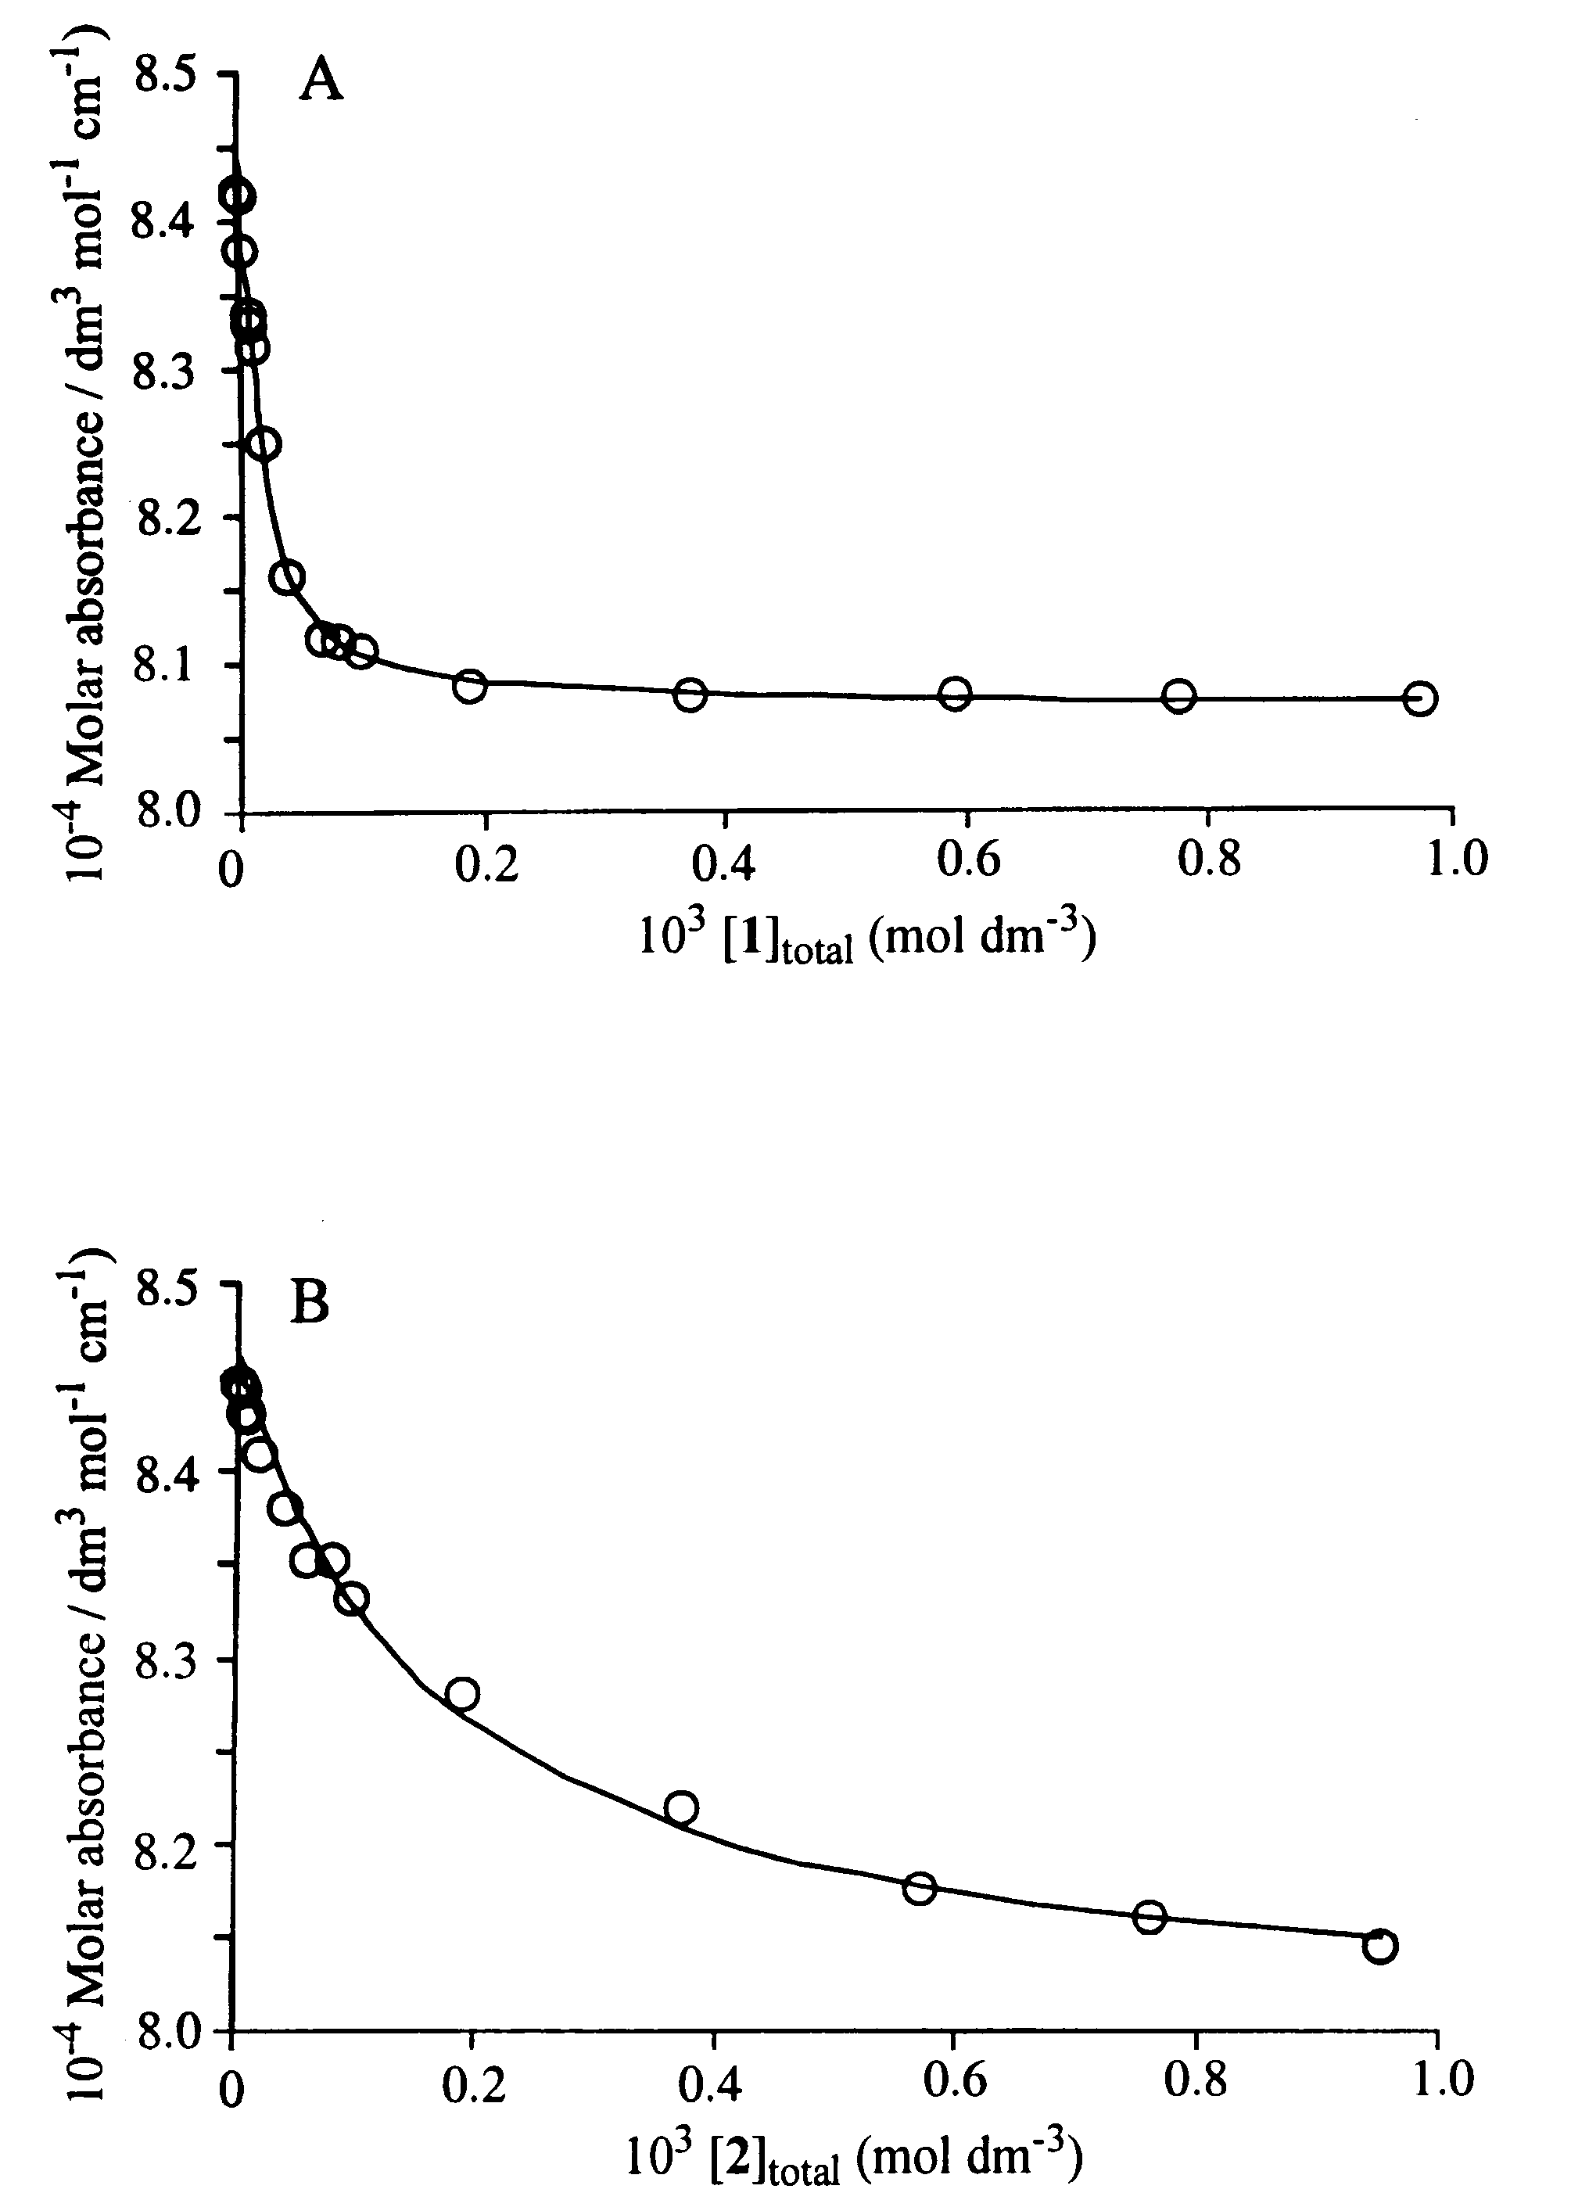
Fig. S1. Variations of the molar absorbance of 1.00 × 10⁻⁵ dm³ mol⁻¹ 3⁴⁻ at 298.2 K in 0.05 mol dm⁻³ aqueous B(OH)₃/NEt₄OH buffer at pH 10.0 and I = 0.10 mol dm⁻³ (NEt₄ClO₄) at 498 nm in the presence of 1, A, and at 475 nm in the presence of 2, B, where in each case the concentration was varied in the range 1.00 × 10⁻⁶ to 1.00 × 10⁻³ mol dm⁻³. A. The curves represent the best fit of the algorithm for the formation of 1·3⁴⁻ and 2·3⁴⁻, respectively, to molar absorbance data at 1 nm intervals over the ranges 470-520 nm and 480-550 nm, respectively.

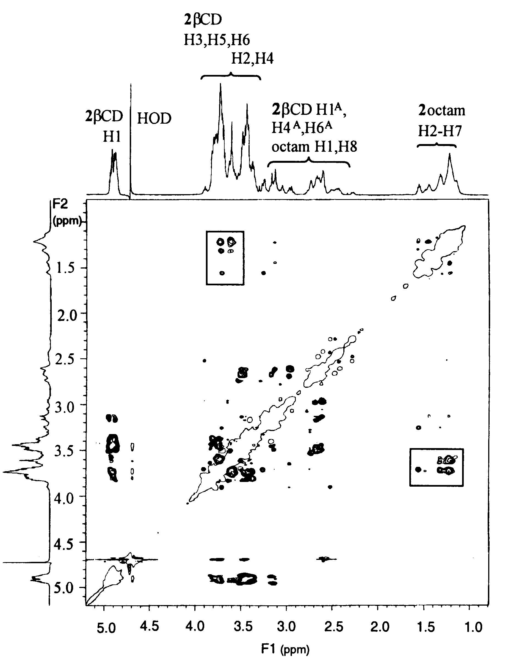
Fig. S2. The 2D ¹H ROESY NMR (600 MHz) spectrum of a D₂O solution 0.014 mol dm⁻³ in 2 in 10⁻³ mol dm⁻³ NaOD and 0.1 mol dm⁻³ in NaClO₄ (pD ≈ 11) at 298.2 K. The rectangles enclose cross-peaks arising from ROE interactions between the H2-H7 protons of the octyl linker units and the βCD H3, H5 and H6 protons.

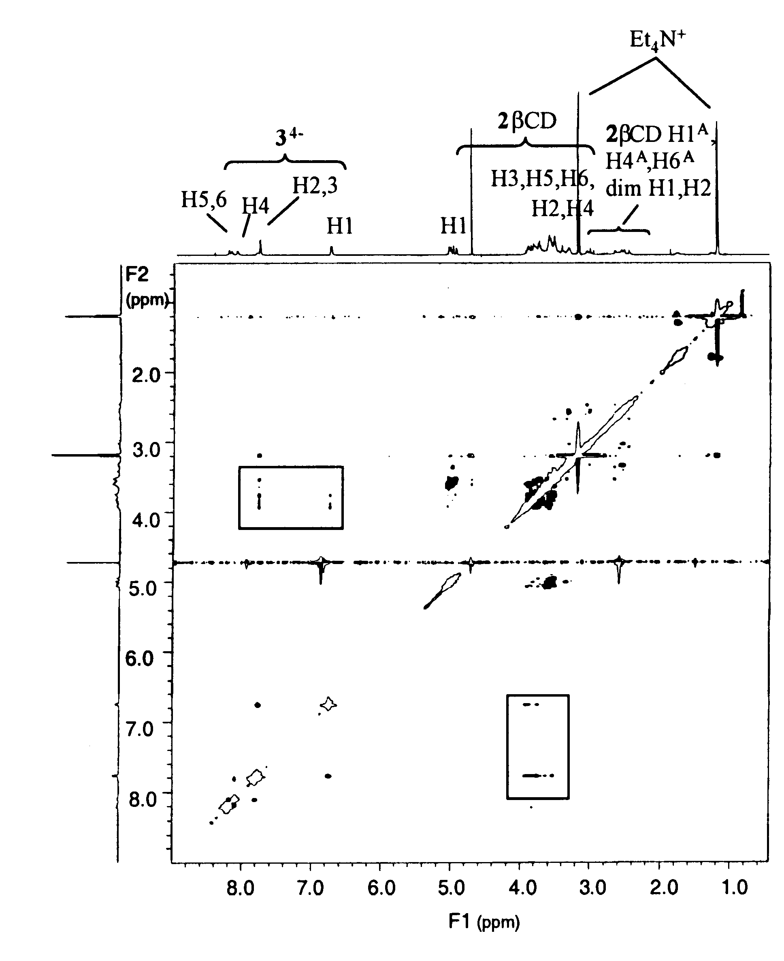
Fig. S3. The 2D ¹H ROESY NMR (600 MHz) spectrum of a D₂O solution 0.014 mol dm⁻³ in 1 and 3⁴⁻ buffered at pD 10.0 by 0.1 mol dm⁻³ ND₃/ND₄Cl buffer at 298.2 K. The rectangles enclose cross-peaks arising from ROE interactions between the protons of 3⁴⁻ and the βCD H3, H5 and H6 protons.

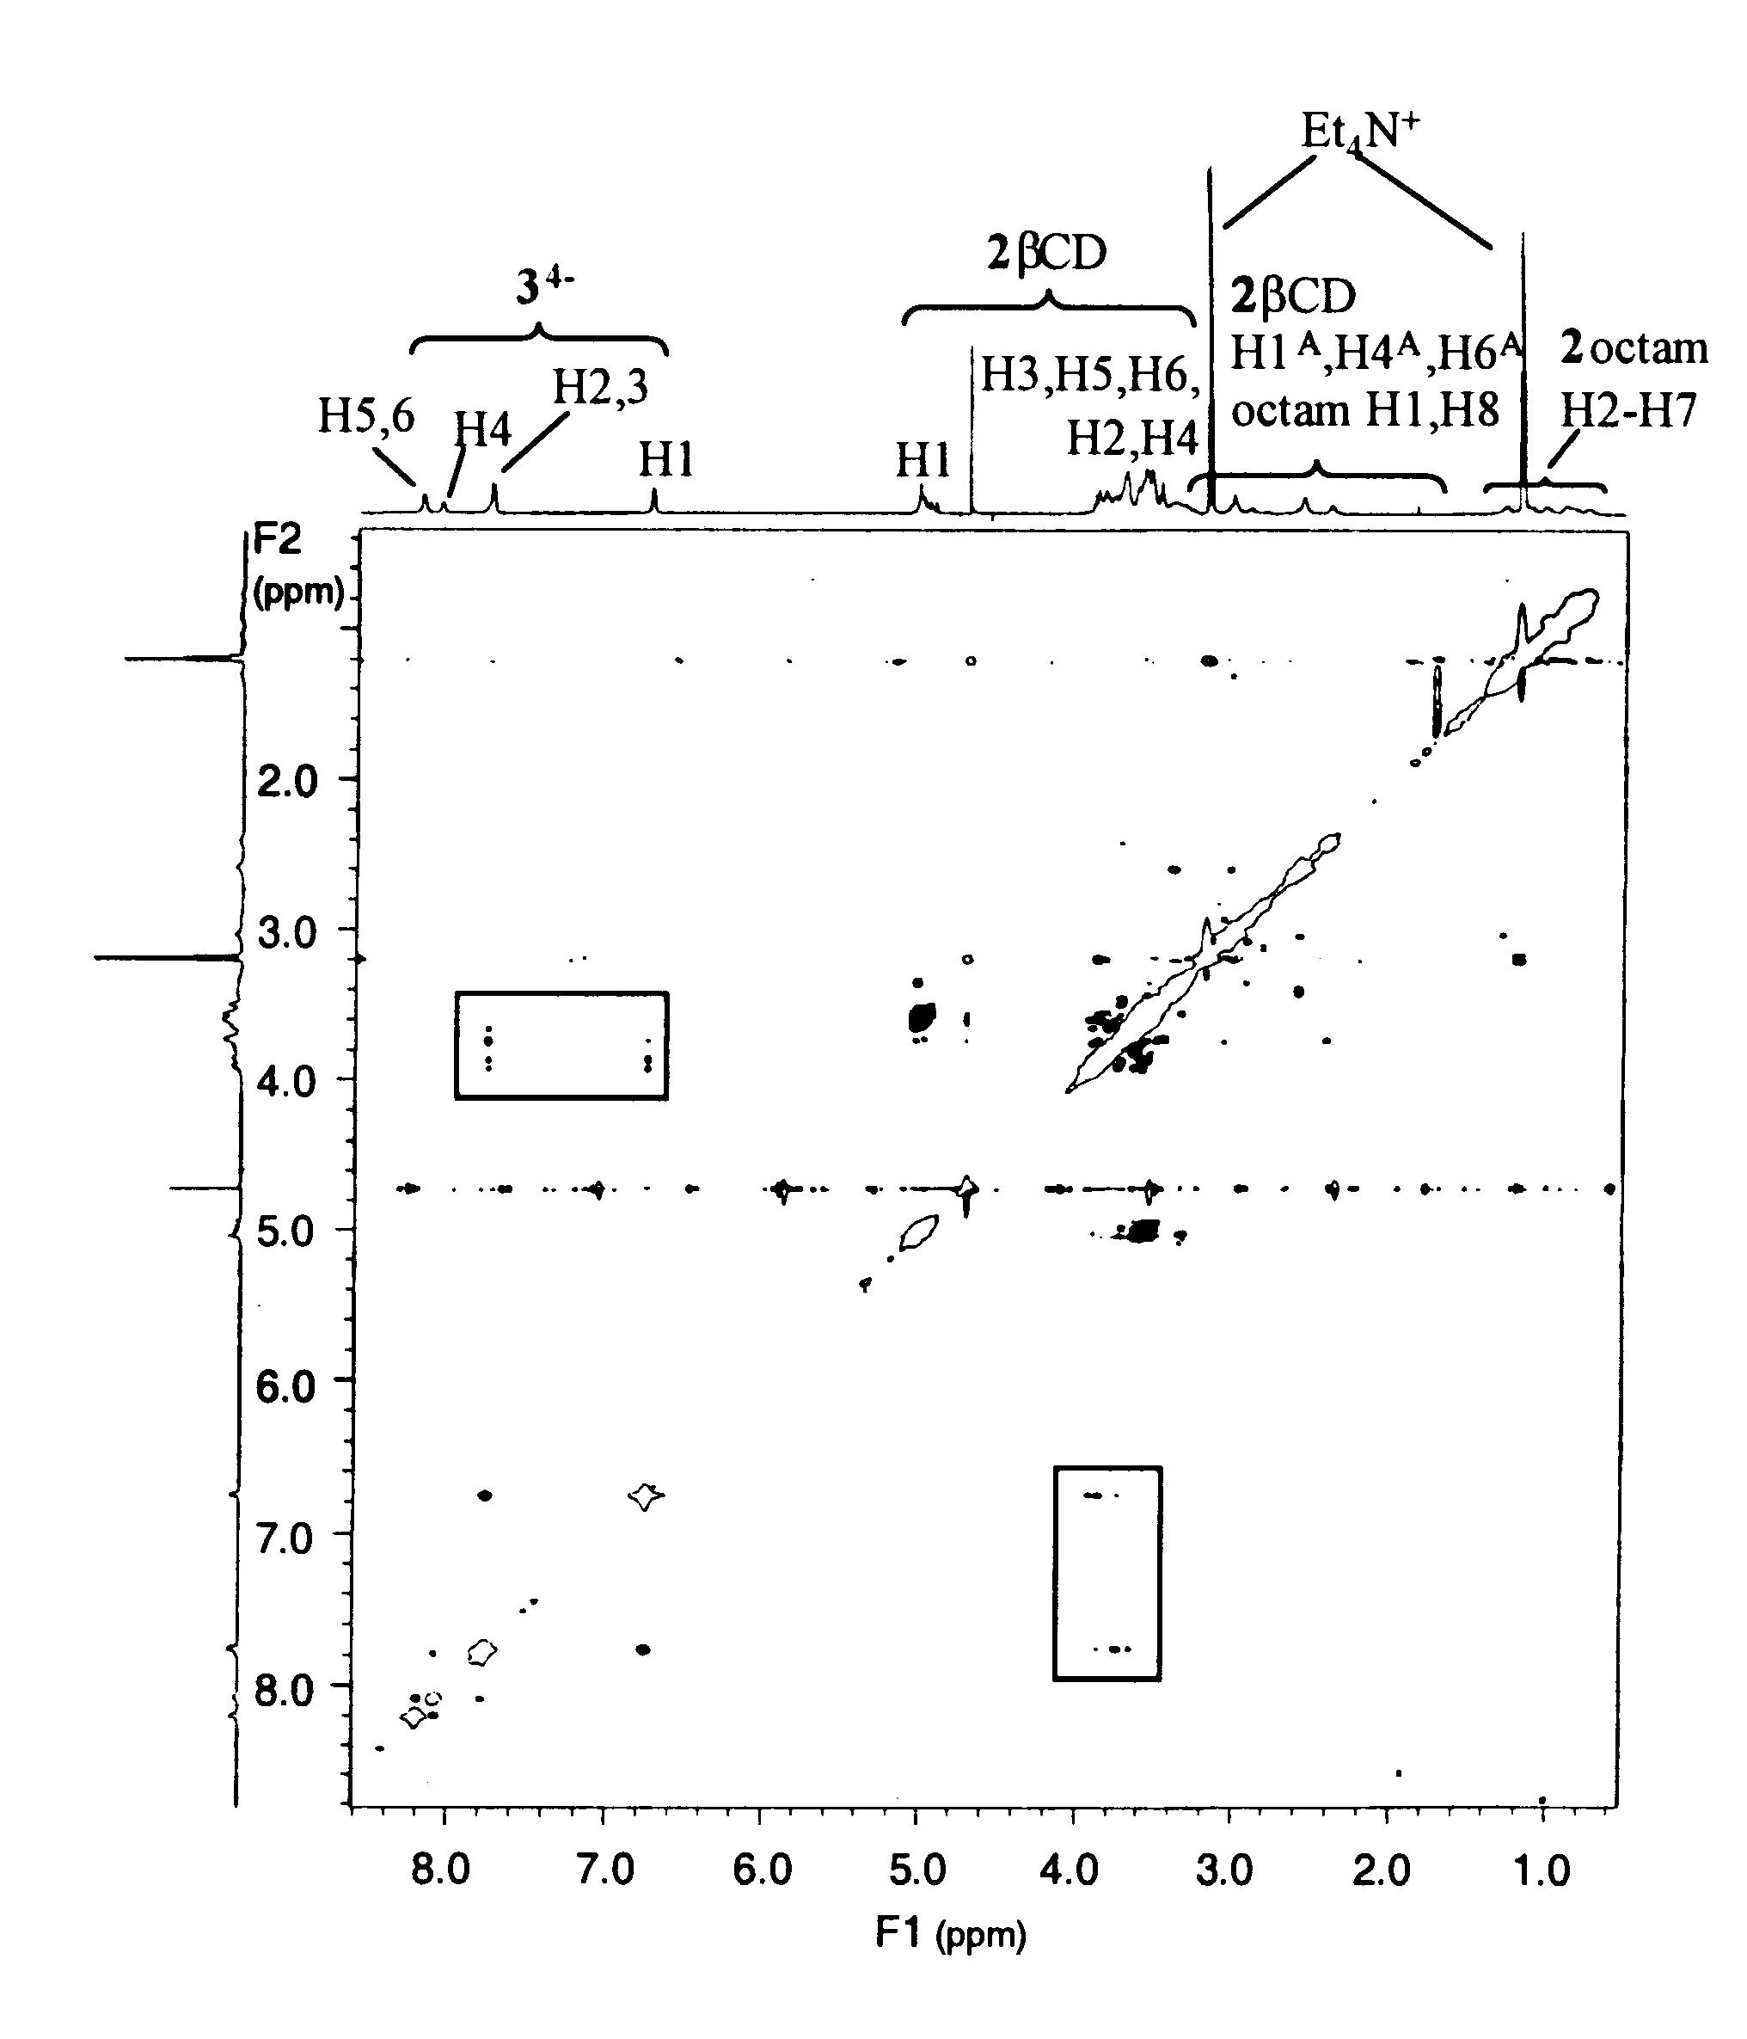
Fig. S4. The 2D ¹H ROESY NMR (600 MHz) spectrum of a D₂O solution 0.014 mol dm⁻³ in 2 and 3⁴⁻ buffered at pD 10.0 by 0.1 mol dm⁻³ ND₃/ND₄Cl buffer at 298.2 K. The rectangles enclose cross-peaks arising from ROE interactions between the protons of 3⁴⁻ and the βCD H3, H5 and H6 protons.

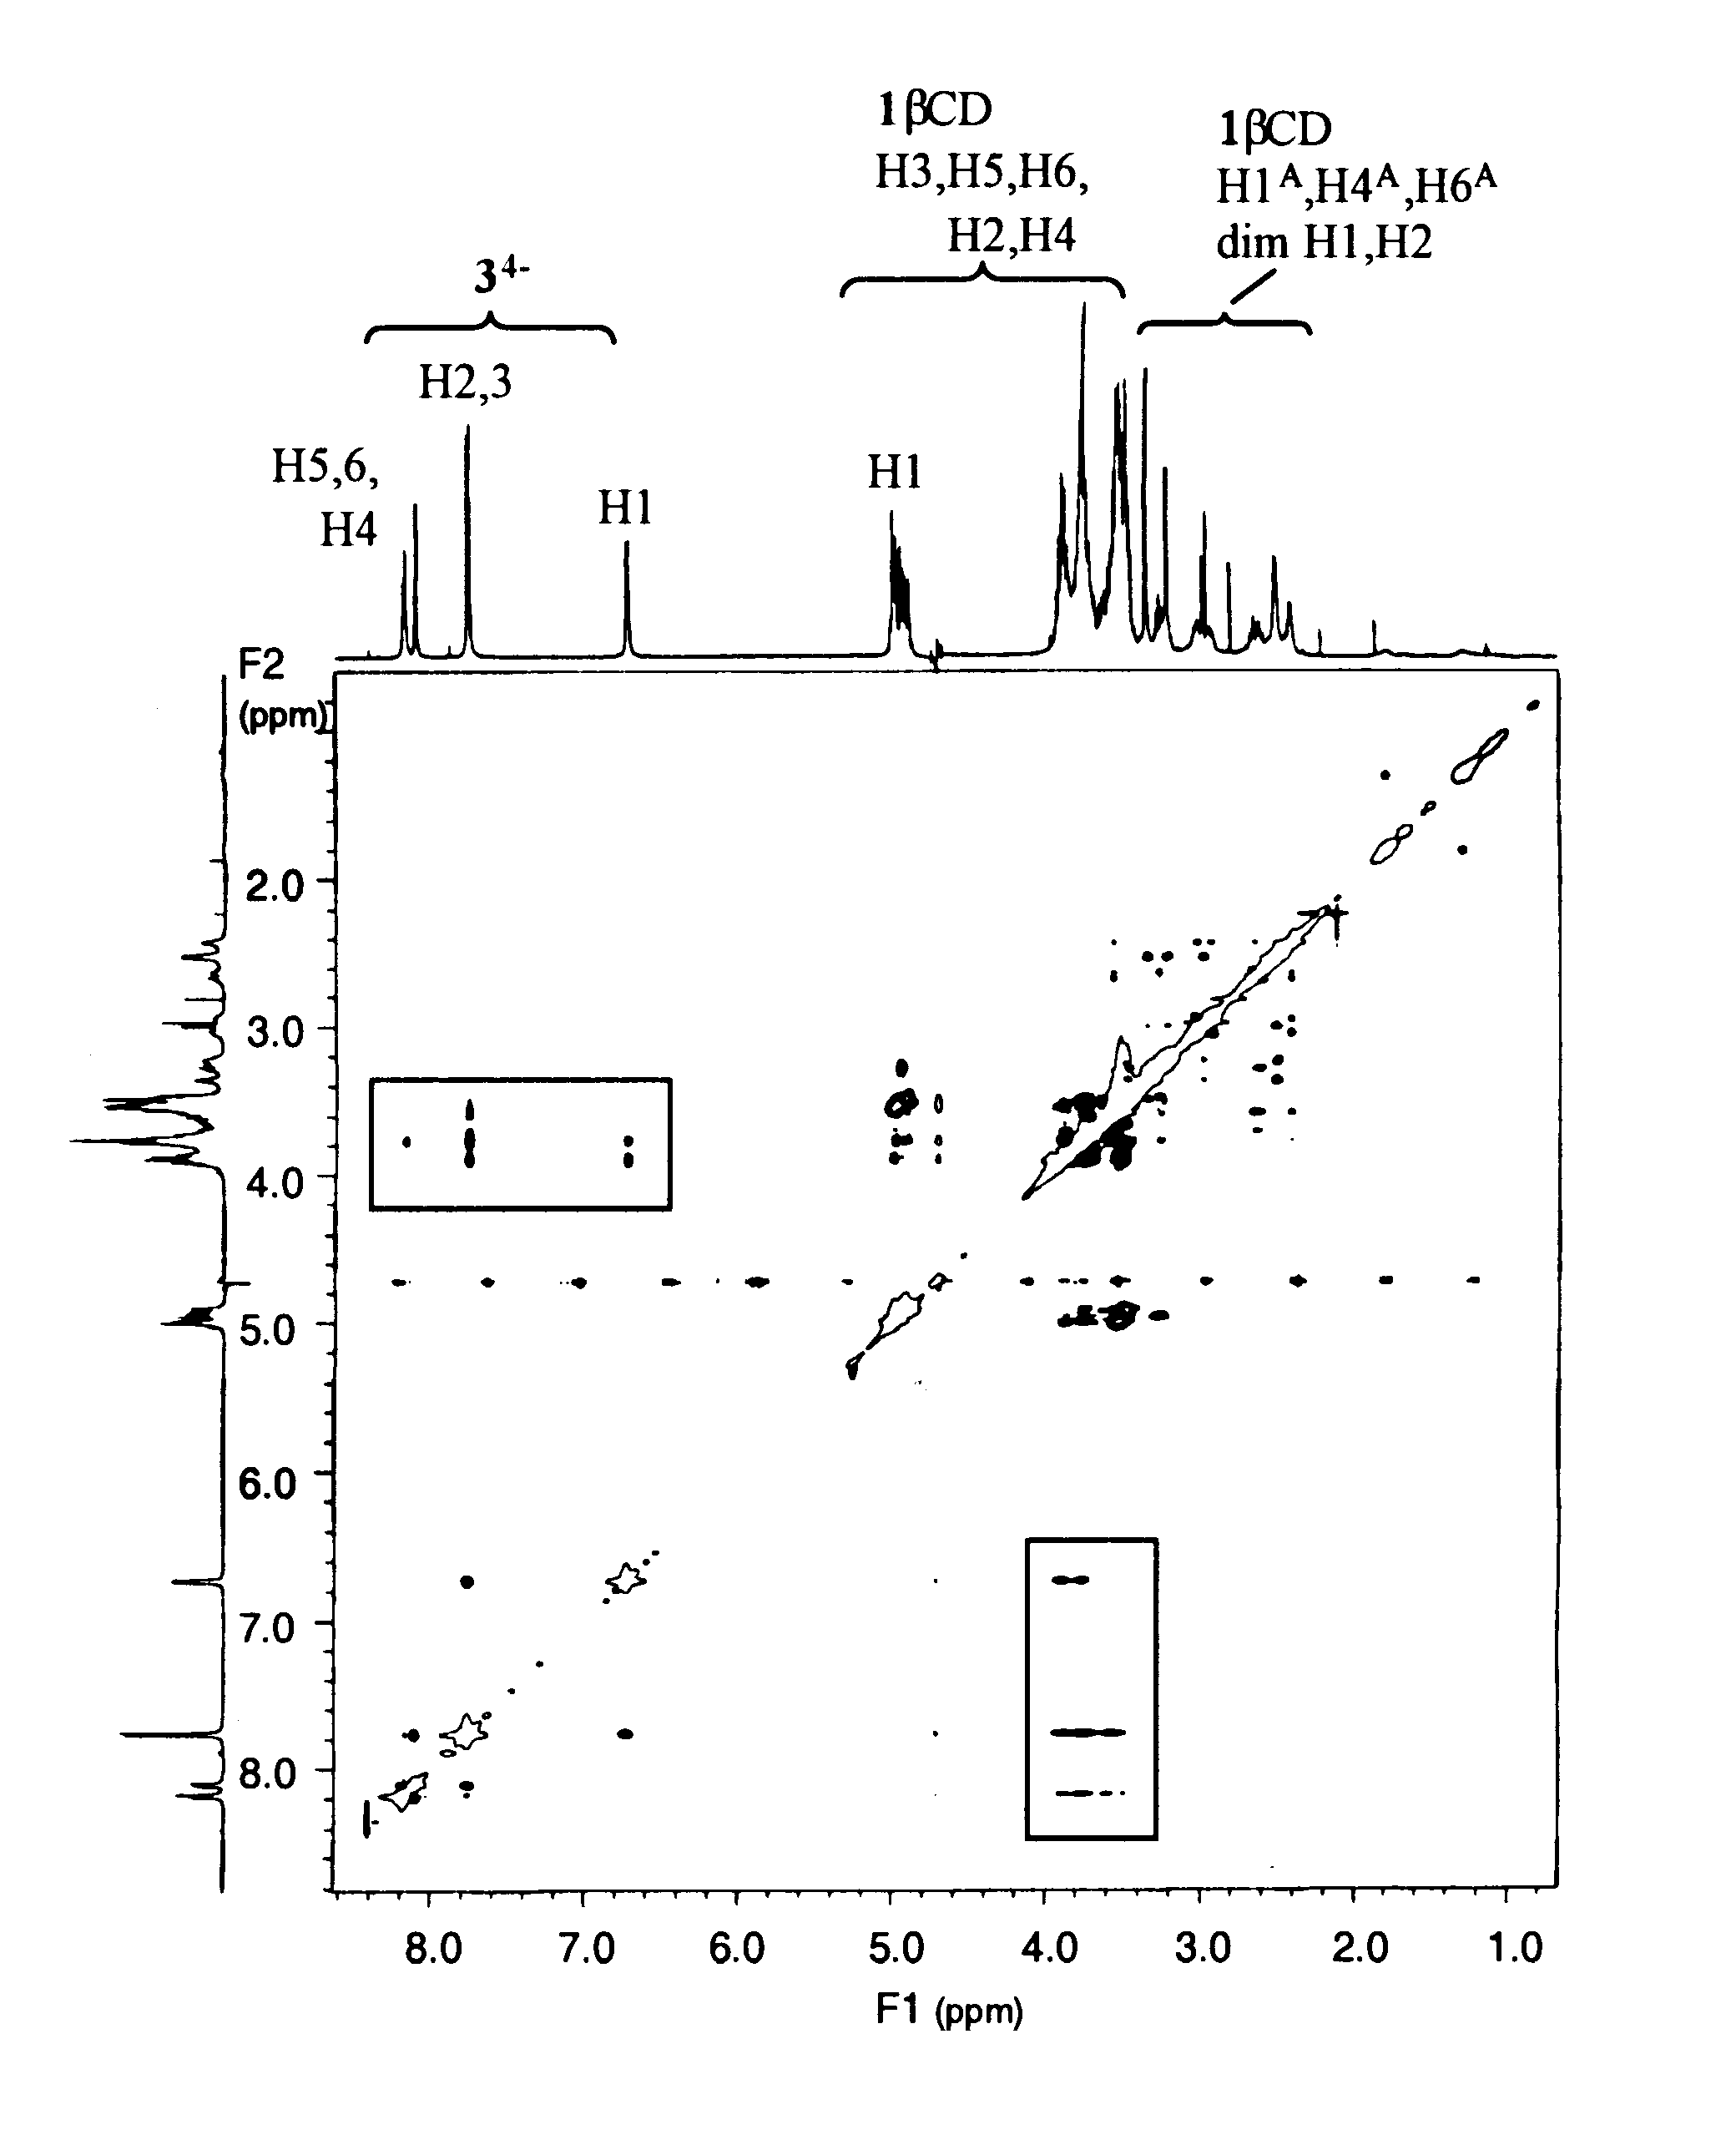
Fig. S5. The 2D ¹H ROESY NMR (600 MHz) spectrum of a D₂O solution 0.014 mol dm⁻³ in 1 and 3⁴⁻ in 10⁻³ mol dm⁻³ NaOD and 0.1 mol dm⁻³ in NaClO₄ (pD ≈ 11) at 298.2 K. The rectangles enclose the cross-peaks arising from ROE interactions between the protons of 3⁴⁻ and the βCD H3, H5 and H6 protons.

