Electronic Supporting Information

Aromaticity and Antiaromaticity in Fulvenes, Ketocyclopolyenes,
Fulvenones, and Diazocyclopolyenes

Katayoun Najafian#, Paul von Ragué Schleyer*⊥, and Thomas T. Tidwell*#
Department of Chemistry, University of Toronto, Toronto, Ontario, M5S 3H6 Canada#
Department of Chemistry, University of Georgia, Athens, Georgia 30602⊥

Fig 1 ESI. Optimized structures
Fig 2 ESI. Bond lengths
Fig 3 ESI. Natural charges
Tables 1-18 ESI. Complete computational results
Figure 1 (ESI). Computed structures of 1-4

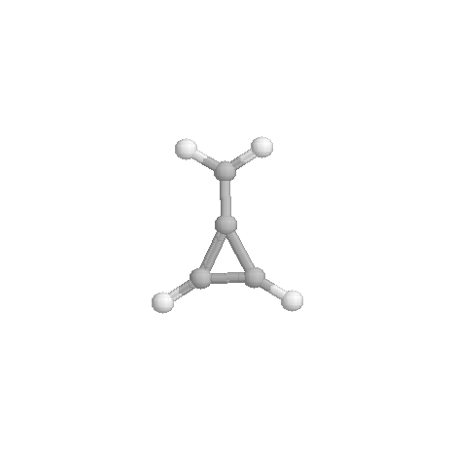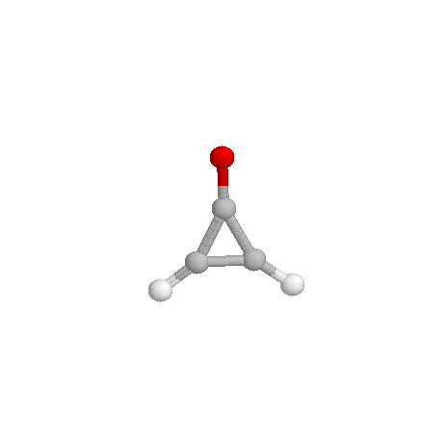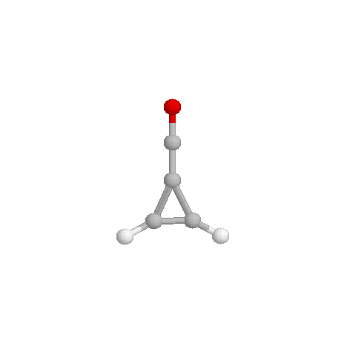

1a 1b 1c

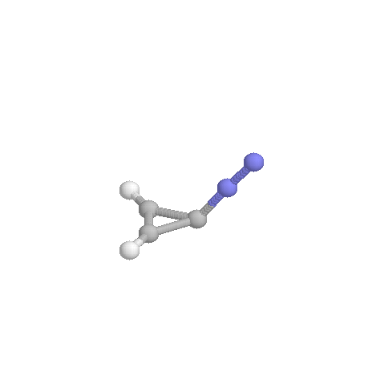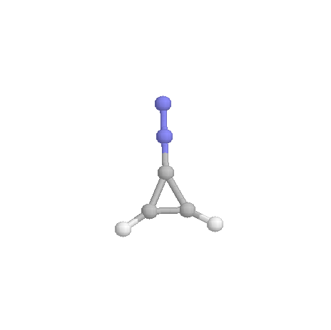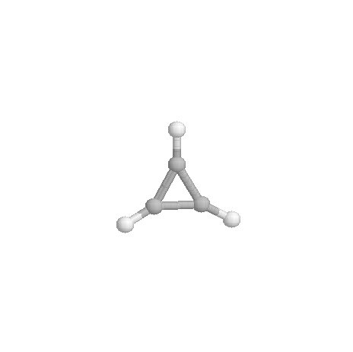
1d (C_{S}) 1d (C_{2v}) 1e

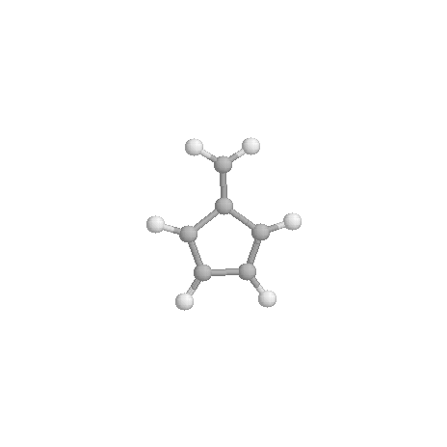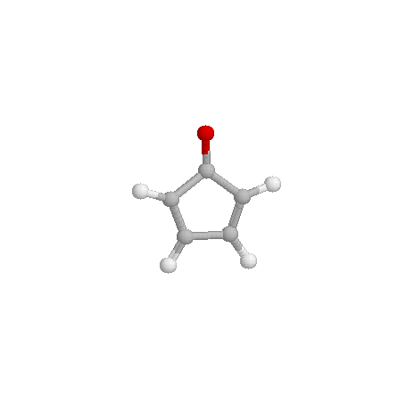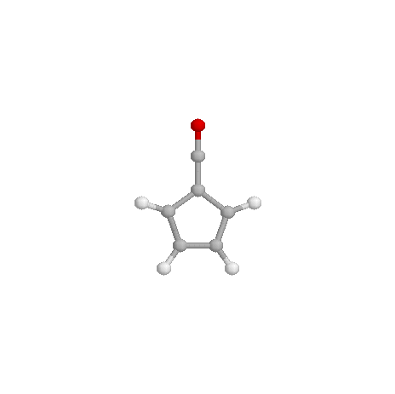
2a 2b 2c
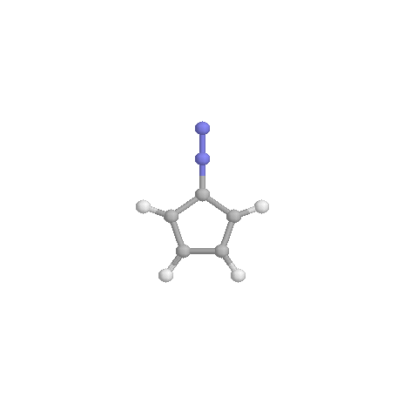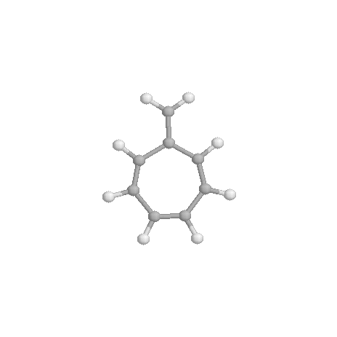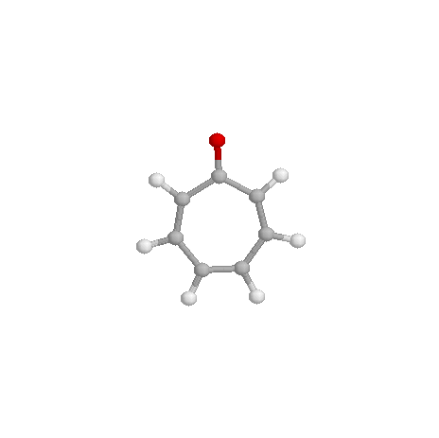
2d 3a 3b

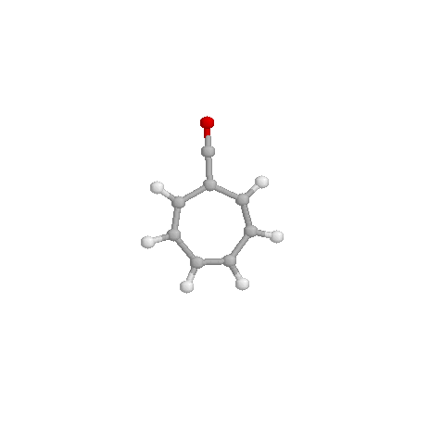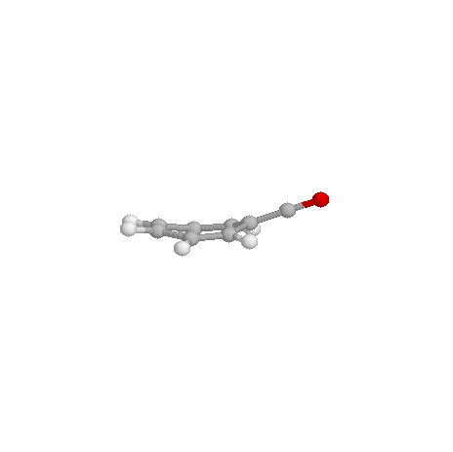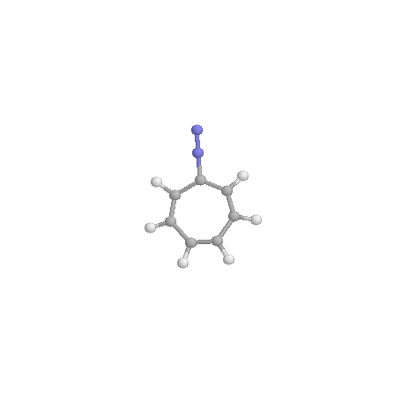
3c 3c (C_{S}) 3d (C_{2v})
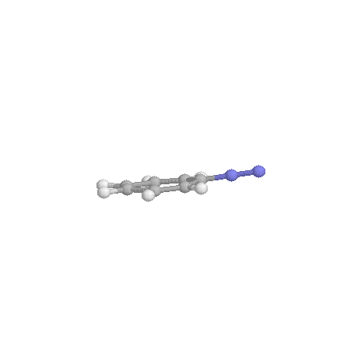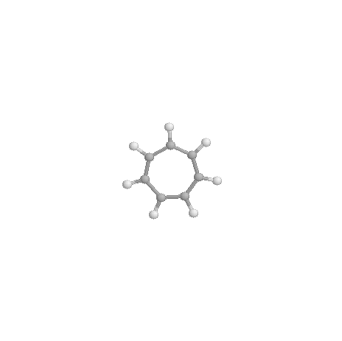
3d (C_{S}) 3e
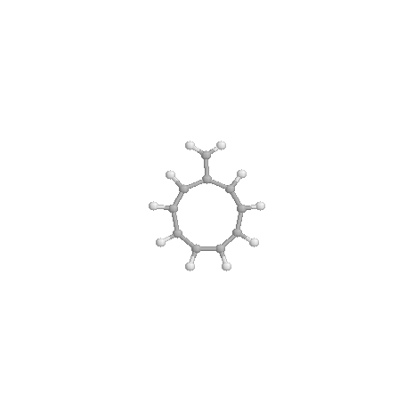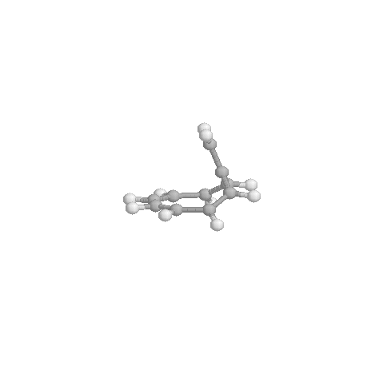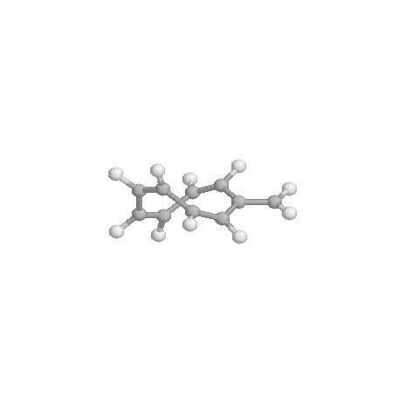
4a (C_{2v}) 4a (C_{S}) 4a (C₂)

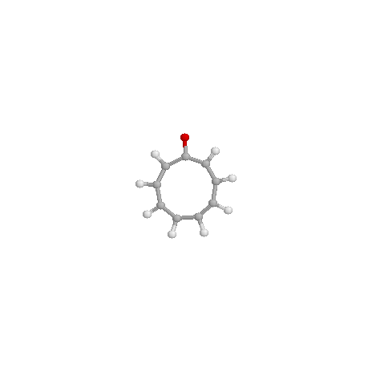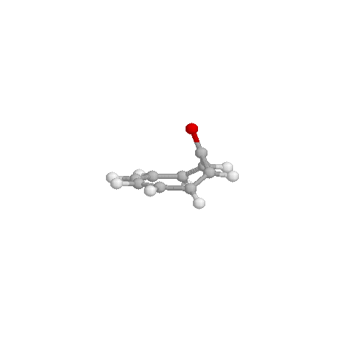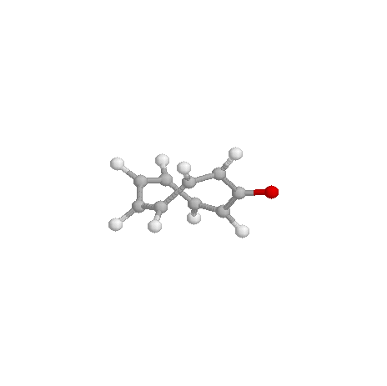
4b (C_{2v}) 4b (C_{S}) 4b (C₂)
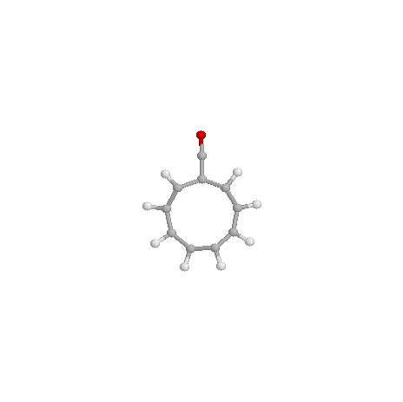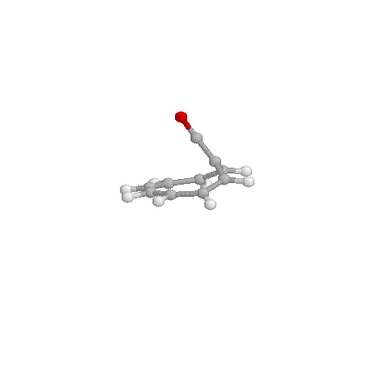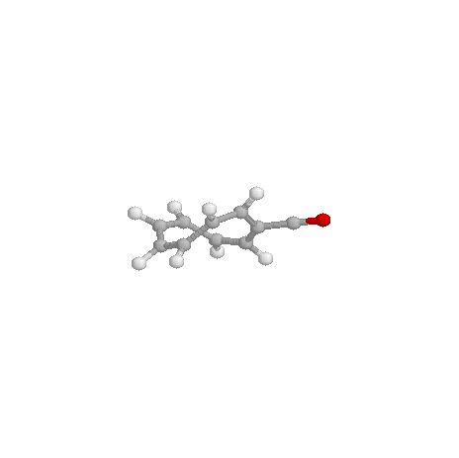
4c (C_{2v}) 4c (C_{S}) 4c (C₂)
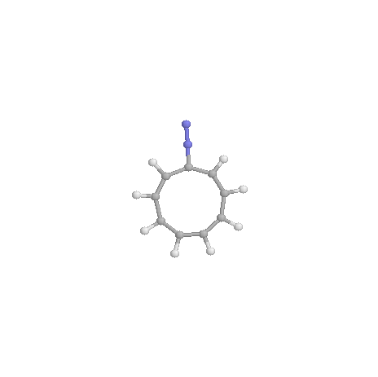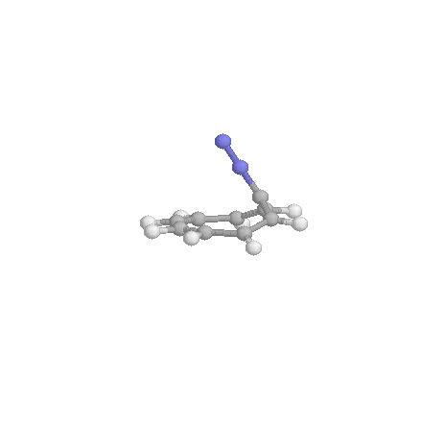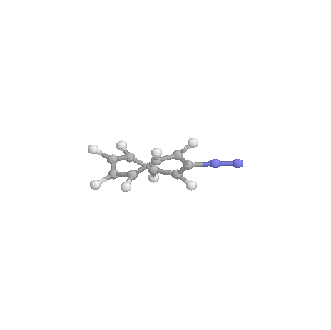
4d (C_{2v}) 4d (C_{S}) 4b (C_{2v})
Table 1 Total Electronic Energies (au) for (CH)₂C=X
X | Symmetry | ZPE (NImag)ª | E_{total}^{b}
(CH₂) 1a | C_{2v} | 37.88(0) | -154.74667
(O) 1b | C_{2v} | 23.59(0) | -190.70030
(C=O) 1c | C_{2v} | 25.92(0) | -228.75521
(N₂) 1d | C_{s} | 23.56(0) | -224.89083
(N₂) 1d | C_{2v} | 25.70(1) | -224.88003
(H⁺)1e | D_{3h} | 28.26(0) | -115.76107
ªZero-point energy (kcal/mol), calculated at B3LYP/6-311+G**; in parentheses: number of imaginary frequencies (NImag). ^{b}At B3LYP/6-311+G**

Table 2 The energy difference between the C_{2v} and C_{s} forms for triafulvenone, 1c
Level of theory | C_{2v} Symmetry | C_{s} Symmetry | Favored structure (kcal/mol)
HF/6-311+G(2DF,2P) | -227.4055695 | -227.3977351 | C_{2v} (4.91)
Mp2/6-311+G(2DF,2P) | -228.2341787 | -228.2340599 | C_{2v} (0.07)
Mp3/6-311+G(2DF,2P) | -228.237512 | -228.2348155 | C_{2v} (1.69)
MP4SDTQ/6-311+G(2DF,2P) | -228.2976742 | 228.298547 | C_{s} (0.55)
CCSD/6-311+G(2DF,2P) | -228.2429272 | -228.240513 | C_{2v} (1.51)
CCSD(T)/ 6-311+G(2DF,2P) | -228.2885141 | -228.2881864 | C_{2v} (0.21)

Table 3 Calculated ISEª (kcal/mol); Exaltations of Magnetic Susceptibility Λ;^{c} Bond length Alternation (ΔR, A°)^{d} for (CH)₂C=X
X | ISEª | RelISE^{b} | Λ^{c} | RelΛ^{b} | ΔR^{d}
(C=O)1c | 18.92 | 14.96 | 4.56 | 4.59 | 0.189
(N₂)1d | 16.16 | 12.2 | 3.74 | 3.77 | 0.203
(CH₂)1a | 3.96 | 0.00 | -0.03 | 0.00 | 0.123
(O)1b | -10.76 | -14.72 | -3.94 | -3.91 | 0.087
(H⁽⁺⁾)1e | -39.75 | -43.78 | -6.02 | -5.99 | 0.000
ªAll energies refer to minima optimized in their most stable geometries at B3LYP/6-311+G** levels, including zero point vibrational energies using eq 1 ^{b}X=CH₂ was chosen as the reference species. ^{c}Calculated using eq 1, CSGT-B3LYP/6-311+G**//B3LYP/6-311+G**. ^{d}Difference (A°) between the C=C vs C-C distance in the three-membered ring at B3LYP/6-311+G**.

Table 4 Calculated NICS 1A above the ring centers (denoted as NICS(1)) (ppm) for (CH)₂C=X
X | Sym | NICS_{total}(0)/  NICS_{total}(1) | RelNICS_{total}(0)/  RelNICS_{total}(1)ª | NICS_{2π}(0)/  NICS_{2π}(1)^{b} | RelNICS_{2π}(0)/  RelNICS_{2π}(1)ª | NICS_{4π}(0)/  NICS_{4π}(1)^{c} | RelNICS_{4π}(0)/  RelNICS_{4π}(1)ª
(C=O)1c | C_{2v} | -25.6/-2.8 | -3.9/4.9 | -6.8/-0.1 | 13.6/2.5 | -10.9/+5.3 | 7.7/3.5
(N₂)1d | C_{2v} | -19.9/-0.9 | 1.8/6.8 | -8.6/-0.8 | 11.8/1.8 | -10.7/+4.0 | 7.9/2.2
(N₂)1d | C_{s} | -27.3/-3.5 | -5.6/4.2 | -13.3/-0.8 | 7.1/1.8 | -18.3/-1.6 | 0.3/-3.4
(CH₂)1a | C_{2v} | -21.7/-7.7 | 0.0/0.0 | -20.4/-2.6 | 0.0/0.0 | -18.6/+1.8 | 0.0/0.0
(O)1b | C_{2v} | -16.6/-9.9 | 5.1/-2.2 | -24.4/-4.4 | -4.0/-1.8 | -22.8/-3.7 | -4.2/-5.5
(H⁽⁺⁾)1e | C_{2v} | -23.4/-15.0 | -1.7/-7.3 | -20.0/-4.6 | 0.4/-2.0
ªX=CH₂ was chosen as the reference species. ^{b}Refer to the C=C in the ring. ^{c}The exocyclic C=X contributions are included.

Table 5. Correlation Coefficients for the correlation between Aromaticity Indices include Nucleus Independent Chemical Shift (NICS), Isomerization Energies (ISE), Aromatic Stabilization Energyies (ASE), Exaltation of Magnetic Sucseptibility (Λ) for Triafulvenes (1a-e), Pentafulvenes (2a-d), Heptafulvenes (3a-e), Nonafulvenes (4a-d) Derivatives
Rings | ISE | Λ_{ISE} | ASE | Λ_{ASE} | ISE_{non-planar} | Λ_{ISE non-planar} | ASE_{twist} | Λ_{twist}
3MR
NICS_{total}(1) | 0.96 | 0.95
ISE |  | 0.95
5MR
NICS_{total}(1) | 0.99 | 0.99 | 0.99 | 0.99
ISE |  | 0.99
ASE |  |  |  | 0.99
7MR
NICS_{total}(1) |  |  |  |  | 0.94 | 0.99
ISE_{planar} |  | 0.98
ISE_{non-planar} |  |  |  |  |  | 0.93
9MR
NICS_{total}(1) |  |  | 0.97 | 1.0 |  |  | 1.0 | 1.0
ASE_{planar} |  |  |  | 0.97
ASE_{non-planar} |  |  |  |  |  |  |  | 0.99

Table 6 Total Electronic Energies (au) for (CH)₄C=X
X | Symmetry | ZPE (NImag)ª | E_{total}^{b}
(CH₂)2a | C_{2v} | 61.18(0) | -232.25518
(O)2b | C_{2v} | 46.30(0) | -268.1809
(C=O)2c | C_{2v} | 49.86(0) | -306.29587
(N₂)2d | C_{2v} | 49.77(0) | -302.43780
ªZero-point energy (kcal/mol), calculated at B3LYP/6-311+G**; in parentheses: number of imaginary frequencies (NImag). ^{b}At B3LYP/6-311+G**

Table 7 Calculated ISE (kcal/mol),ª Exaltations of Magnetic Susceptibility Exaltation (Λ)^{c} Bond length Alternation (ΔR, A°)^{d} for (CH)₄C=X
X | ISEª | RelISE^{b} | Λ_{ISE}^{c} | RelΛ_{ISE}^{b} | ΔR^{d}
(N₂)2d | -10.59 | -9.42 | -7.68 | -4.76 | 0.078
(C=O)2c | -9.61 | -8.44 | -7.46 | -4.54 | 0.096
(CH₂)2a | -1.17 | 0.00 | -2.92 | 0.00 | 0.122
(O)2b | +7.66 | +8.83 | +2.82 | +5.64 | 0.172
ªAll energies refer to minima optimized in their most stable geometries at B3LYP/6-311+G** levels, including zero point vibrational energies using eq 2. ^{b}X=CH₂ was chosen as the reference species. ^{c}Calculated using eq 2, CSGT-B3LYP/6-311+G**//B3LYP/6-311+G**. ^{d}Difference (A°) between the C=C vs C-C distance in the five-membered ring at B3LYP/6-311+G**.

Table 8 Calculated ASE (kcal/mol),ª Exaltations of Magnetic Susceptibility Exaltation (Λ)^{c} for (CH)₄C=X
X | ASEª | RelASE^{b} | Λ_{ASE}^{c} | RelΛ_{ASE}^{b}
(N₂)2d | 6.48 | 12.14 | 5.05 | 6.88
(C=O)2c | 6.11 | 11.77 | 4.32 | 6.15
(CH₂)2a | -5.66 | 0.00 | -1.83 | 0.00
(O)2b | -16.82 | -11.16 | -9.53 | -7.70
ªAll energies refer to minima optimized in their most stable geometries at B3LYP/6-311+G** levels, including zero point vibrational energies using eq 3 ^{b}X=CH₂ was chosen as the reference species. ^{c}Calculated using eq 3, CSGT-B3LYP/6-311+G**//B3LYP/6-311+G**.

Table 9 Calculated total NICS(0) and NICS(1) (1Aº above the ring centers) (ppm) as well as their π dissected contributions for (CH)₄C=X
X | NICS_{total}(0)/  NICS_{total}(1) | RelNICS_{total}(0)/  RelNICS_{total}(1)ª | NICS_{4π}(0)/  NICS_{4π}(1)^{b} | RelNICS_{4π}(0)/  RelNICS_{4π}(1)ª | NICS_{6π}(0)/  NICS_{6π}(1)^{c} | RelNICS_{6π}(0)/  RelNICS_{6π}(1)ª
(N₂)2d | -10.1/-7.2 | -10.3/-4.2 | -13.2/-2.4 | -3.4/-3.1 | -18.8/-4.0 | -6.3/-4.0
(C=O)2c | -9.6/-7.7 | -9.8/-4.7 | -13.4/-2.8 | -3.6/-3.5 | -18.5/-4.1 | -6.0/-4.1
(CH₂)2a | +0.2/-3.0 | 0.0/0.0 | -9.8/+0.7 | 0.0/0.0 | -12.5/0.0 | 0.0/0.0
(O)2b | +9.6/+3.2 | +9.4/+6.2 | -5.0/+5.2 | +4.8/+4.5 | -3.6/+5.9 | +8.9/+5.9
ªX=CH₂ was chosen as the reference species. ^{b}Refer to the C=C in the ring. ^{c}The exocyclic C=X contributions are included.

Table 10 Total Electronic Energies (au) for (CH)₆C=X
X | Symmetry | ZPE (NImag)ª | E_{total}^{b}
(CH₂)3a | C_{2v} | 82.29(0) | -309.68691
(O)3b | C_{2v} | 68.77(0) | -345.63362
(C=O)3c | C_{s} | 71.42(0) | -383.70751
(C=O)3c | C_{2v} | 71.47(1) | -383.70737
(N₂)3d | C_{s} | 71.34(0) | -379.85197
(N₂)3d | C_{2v} | 71.32(1) | -379.85197
(H⁺)3e | D_{7h} | 74.3(0) | -270.74028
ªZero-point energy (kcal/mol), calculated at B3LYP/6-311+G**; in parentheses: number of imaginary frequencies (NImag). ^{b}At B3LYP/6-311+G**

Table 11 Calculated isomerization energies ISEª (kcal/mol); Exaltations of Magnetic Susceptibility Λ;^{c} for (CH)₆C=X
X | ISE_{non-planar}ª | RelISE_{non-planar}^{b} | Λ_{non-planar}^{c} | RelΛ_{non-planar}^{b} | ΔR^{d}
(N₂)3d | -2.60 | 5.57 | 28.72 | 17.99 | 0.114
(C=O)3c | -2.62 | 5.55 | 25.50 | 14.77 | 0.114
(CH₂)3a | -8.17 | 0.00 | 10.73 | 0.00 | 0.095
(O)3b | -13.90 | -5.73 | -3.95 | -14.68 | 0.074
(H⁺)3e | -29.82 | -21.65 | -13.34 | -24.07 | 0.000
ªAll energies refer to energy minima optimized to their most stable geometries at B3LYP/6-311+G** levels, including zero point vibrational energies using eq 4 ^{b}X=CH₂ was chosen as the reference species. ^{c}Calculated using eq 4, CSGT-B3LYP/6-311+G**//B3LYP/6-311+G**. ^{d}Difference (A°) between the maximum C=C vs C-C distance in the seven-membered ring moieties (i.e., the ring C-C bonds to the C=X unit are not considered) at B3LYP/6-311+G**.

Table 12 Calculated isomerization energies ISEª (kcal/mol); Exaltations of Magnetic Susceptibility Λ;^{c} Bond length Alternation (ΔR, A°)^{d} for (CH)₆C=X
X | ISE_{planar}ª | RelISE_{planar}^{b} | Λ_{planar}^{c} | RelΛ_{planar}^{b}
N₂(3d) | -4.42 | 5.73 | 28.80 | 19.03
C=O(3c) | -4.52 | 5.73 | 25.87 | 16.10
CH₂(3a) | -10.52 | 0.00 | 9.77 | 0.00
O(3b) | -16.36 | -6.21 | -7.40 | -17.17
(H⁺)3e | -34.02 | -23.50 | -31.93 | -41.70
ªAll energies refer to optimized structures in their planar geometries at B3LYP/6-311+G** levels, including zero point vibrational energies using eq 4 ^{b}X=CH₂ was chosen as the reference species. ^{c}Calculated using eq 4, CSGT-B3LYP/6-311+G**//B3LYP/6-311+G**.

Table 13 Calculated NICS 1A above the ring centers (denoted as NICS(1)) (ppm) for (CH)₆C=X
X | Sym | NICS_{total}(0)/  NICS_{total}(1) | RelNICS_{total}(0)^{b}/  RelNICS_{total}(1)ª | NICS_{6π}(0)/  NICS_{6π}(1)^{b} | RelNICS_{6π}(0)/  RelNICS_{6π}(1)ª | NICS_{8π}(0)/  NICS_{8π}(1)^{c} | RelNICS_{8π}(0)/  RelNICS_{8π}(1)ª
(N₂)3d | C_{s} | +20.3/+15.3 | +10.7/+9.5 | +3.5/+6.1 | +5.8/+4.0 | +9.0/+11.4 | +10.4/+8.3
 | C_{2v} | +20.8/+15.5 | +11.2/+9.7 | +2.8/+6.3 | +5.1/+4.2 | +9.4/+11.7 | +10.8/+8.6
(C=O)3c | C_{s} | +13.3/+9.05 | +3.7/+3.25 | -1.0/+3.05 | +1.3/+0.95 | +2.5/+6.65 | +3.9/+3.55
 | C_{2v} | +18.6/+13.7 | +9.0/+7.9 | +3.1/+6.0 | +5.4/+3.9 | +8.5/+11.2 | +9.9/+8.1
(CH₂)3a | C_{2v} | +9.6/+5.8 | 0.0/0.0 | -2.3/+2.1 | 0.0/0.0 | -1.4/+3.1 | 0.0/0.0
(O)3b | C_{2v} | +0.9/-2.6 | -8.7/-8.4 | -12.7/-6.3 | -10.4/-8.4 | -10.3/-4.2 | -8.9/-7.3
(H⁽⁺⁾)3e | D_{7h} | -6.9/-8.5 | -16.5/-14.3 | -17.1/-15.6 | -14.8/-17.7
ªX=CH₂ was chosen as the reference species. ^{b}Refer to the C=C in the ring. ^{c}The exocyclic C=X contributions are included.

Table 14 Total Electronic Energies (au) for (CH)₈C=X
X | Symmetry | ZPE (NImag)ª | E_{total}^{b} | ^{c}E_{rel.}
(CH₂)4a
 | C₂ | 103.65(0) | -387.07855 | 0.00
 | C_{s} | 103.78(1) | -387.06435 | 9.03
 | C_{2v} | 105.16(1) | -387.06023 | 13.00
(O)4b
 | C₂ | 88.86(0) | -423.01788 | 0.00
 | C_{s} | 88.79(1) | -422.99726 | 12.86
 | C_{2v} | 90.01(2) | -422.98763 | 20.12
(C=O)4c
 | C₂ | 92.25(0) | -461.10986 | 0.00
 | C_{s} | 93.38(0) | -461.09584 | 9.09
 | C_{2v} | 93.38(1) | -461.10413 | 4.71
(N₂)4d
 | C₂ | 92.38(0) | -457.25530 | 0.00
 | C_{s} | 92.65(0) | -457.23847 | 10.82
 | C_{2v} | 93.35(1) | -457.25194 | 3.06
ªZero-point energy (kcal/mol), calculated at B3LYP/6-311+G**; in parentheses: number of imaginary frequencies (NImag). ^{b}At B3LYP/6-311+G** ^{c}Relative Energy at B3LYP/6-311+G** including zero point energy.

Table 15 Calculated Aromatic Stabilization energies ASEª (kcal/mol); Exaltations of Magnetic Susceptibility Λ;^{c} for (CH)₈C=X
X | ASE_{planar}ª | RelASE_{planar}^{b} | Λ_{planar}^{c} | RelΛ_{planar}^{b}
(N₂)4d | -17.67 | -18.25 | -19.28 | -24.14
(C=O)4c | -13.67 | -14.25 | -18.59 | -23.45
(CH₂)4a | +0.58 | 0.00 | +4.86 | 0.00
(O)4b | +10.48 | +9.90 | +36.52 | +31.66
ªAromatic stabilization energies were computed as the sum of the energies of the homodesmotic reactions (5) and (6). ^{b}nonafulvene is chosen as a reference. ^{c}Magnetic susceptibility exaltation were computed as the sum of the energies of the homodesmotic reactions (5) and (6).

Table 16 Calculated Aromatic Stabilization energies ASEª (kcal/mol); Exaltations of Magnetic Susceptibility Λ;^{c} for (CH)₈C=X
X | ASE_{twist}ª | RelASE_{twist}^{b} | Λ_{twist}^{c} | RelΛ_{twist}^{b}
(N₂)4d | -8.26 | -8.22 | -16.1 | -12.88
(C=O)4c | -5.92 | -5.88 | -10.97 | -7.75
(CH₂)4a | -0.04 | 0.00 | -3.22 | 0.00
(O)4b | +2.82 | +2.86 | +0.67 | +3.89
ªAromatic stabilization energies were computed as the sum of the energies of the homodesmotic reactions (5) and (6). ^{b}nonafulvene is chosen as a reference. ^{c}Magnetic susceptibility exaltation were computed as the sum of the energies of the homodesmotic reactions (5) and (6).

Table 17 Calculated isomerization energies ISEª (kcal/mol); Exaltations of Magnetic Susceptibility Λ;^{c} for (CH)₈C=X
X | ISEª | RelISE^{b} | Λ^{c} | RelΛ^{b}
(N₂)4d | -2.17 | -0.62 | -10.64 | -4.22
(C=O)4c | -1.95 | -0.4 | -9.02 | -2.60
(CH₂)4a | -1.55 | 0.0 | -6.42 | 0.00
(O)4b | -1.85 | 0.3 | -5.1 | +1.32
ªAll energies refer to energy minima optimized to their most stable geometries at B3LYP/6-311+G** levels, including zero point vibrational energies using eq 5. ^{b}X=CH₂ was chosen as the reference species. ^{c}Calculated using eq 5 and 6, CSGT-B3LYP/6-311+G**//B3LYP/6-311+G**.

Table 18 Calculated NICS 1A° above the ring centers (denoted as NICS(1)) (ppm) Bond length Alternation (ΔR, A°)^{d} for (CH)₈C=X
X | Sym. | NICS_{total}(0)/NICS_{total}(1)ª | RelNICS_{total}(0)/RelNICS_{total}(1)^{b} | NICS_{10π}(0)/  NICS_{10π}(1)^{c} | RelNICS_{10π}(0)/  RelNICS_{10π}(1)^{c} | ΔR^{d} | ΔR^{e}
(N₂)4d | C₂ | -4.2/-4.7 | -3.8/-2.3 | -10.0/-5.6 | -3.2/-2.3 | 0.096 | 0.101
 | C_{2v} | -8.5/-7.8 | -7.4/-5.2 | -14.0/-9.6 | -6.8/-5.8 | 0.053 | 0.068
(C=O)4c | C₂ | -2.9/-3.8 | -2.5/-1.2 | -8.7/-4.5 | -1.9/-1.4 | 0.109 | 0.122
 | C_{2v} | -8.7/-8.1 | -7.6/-5.4 | -14.2/-9.8 | -7.0/-6.1 | 0.059 | 0.083
(CH₂)4a | C₂ | -0.4/-2.4 | 0.0/0.0 | -6.8/-3.3 | 0.0/0.0 | 0.123 | 0.132
 | C_{2v} | -1.1/-2.0 | 0.0/0.0 | -7.2/-4.4 | 0.0/0.0 | 0.084 | 0.106
(O)4b | C₂ | +0.6/-2.0 | +1.0/-0.5 | -6.6^{c}/-3.8^{c} | +0.2^{c}/+0.4^{c} | 0.128 | 0.146
 | C_{2v} | +9.3/+6.6 | +10.4/+9.1 | +9.3^{c}/+4.7^{c} | +11.2^{c} /+8.6^{c} | 0.103 | 0.137
ªX=CH₂ was chosen as the reference species. ^{c}The exocyclic C=X contribution are included, but are negligible.^{d}Difference (A°) between the maximum C=C vs C-C distance in the nine-membered ring moieties (i.e., the ring C-C bonds to the C=X unit are not considered) at B3LYP/6-311+G**. ^{e}Difference (A°) between the maximum C=C vs C-C distance in the nine-membered ring moieties at B3LYP/6-311+G**.

