Supplementary data

Fig. S1. Cyclic voltammogram of 1– (2.0 × 10^{–3} M) in MeCN containing 0.1 M Bu₄NClO₄ at 298 K at scan rate of 2.0 V s^{–1} with Pt working electrode.

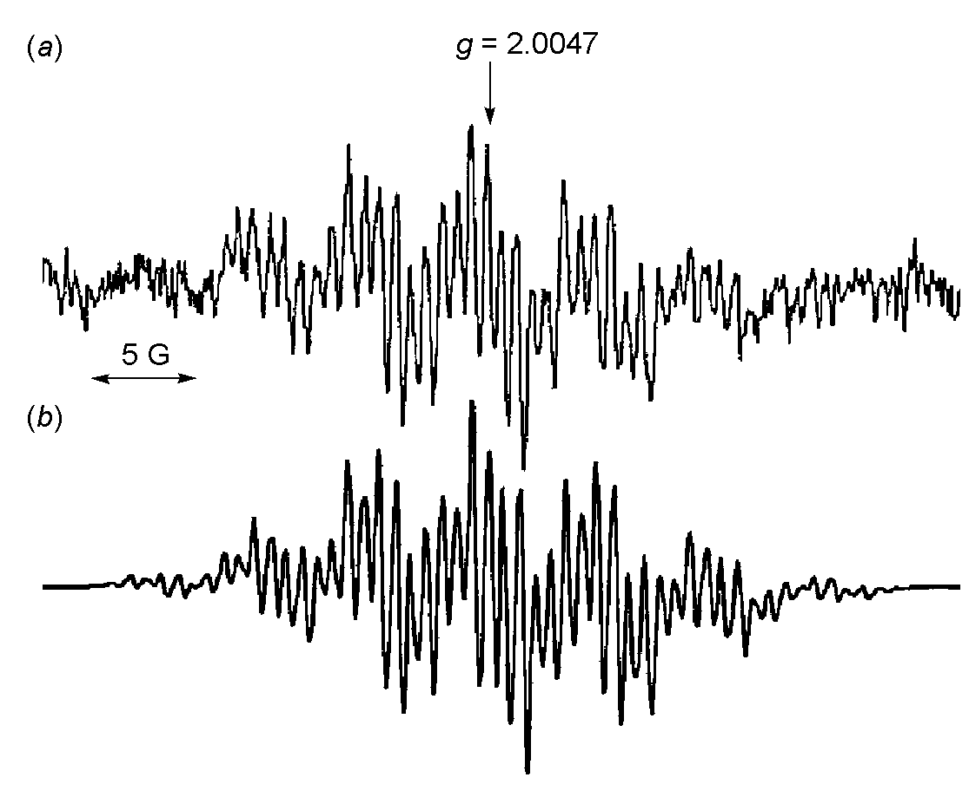
Fig. S2. (a) ESR spectrum of 1• generated by electron-transfer oxidation of 1– (5.0× 10^{–4} M) by DOPPH• (5.0 × 10^{–5} M) in deaerated MeCN at 298 K; (b) the computer simulation spectrum using the hfc values shown in Scheme 1.

