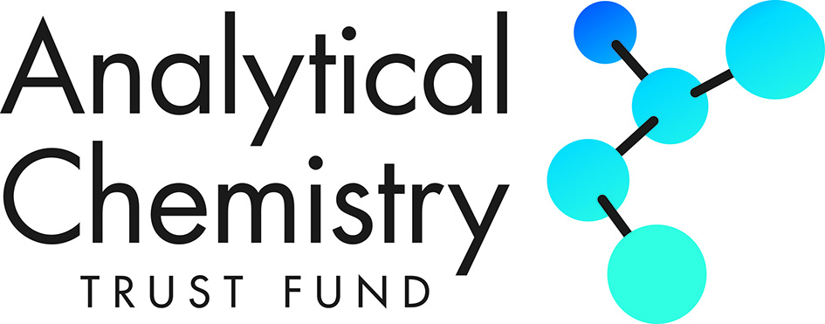

OVERSEAS CONFERENCE TRAVEL GRANT

Regulations

The Object of the Analytical Chemistry Trust Fund is to promote, assist and extend the science and study of Analytical Chemistry and of all questions relating to the analysis, nature and composition of natural and manufactured materials for the benefit of the public.

Definitions

Applicant Means a registered post-graduate PhD student at a UK or Irish Higher Education
Institution.

Conference Means any scientific conference which in the opinion of the Trustees is consistent with
the Object of the Analytical Chemistry Trust Fund.

Normally Resident Means the Applicant’s normal place of work and normal domestic residence during the
period of their post-graduate studentship.

Other Sources Means any other source of funds which is not the Analytical Chemistry Trust Fund.

Overseas Means any country, excluding the UK and Ireland.

Registration Costs Means the cost of registering for the conference.

Subsistence Costs Means the cost of meals and accommodation at the conference location for the duration
of the conference only.

Travel Costs Means the cost of travelling from the applicant’s normal place of work in the UK or
Ireland to the conference location by economy class fares and local travel directly
related to attendance at the conference.

Trustees Means the Trustees of the Analytical Chemistry Trust Fund.

Honorary Treasurer Means the Honorary Treasurer of the Analytical Chemistry Trust Fund.

Trust Administrator Means the Administrator of the Analytical Chemistry Trust Fund.

Purpose

These grants are designed to assist post-graduate PhD students at UK or Irish Higher Education Institutions who are engaged in research projects related to analytical chemistry to attend and to participate actively in overseas scientific conferences. A grant will not normally exceed £750. It is also expected that normally the grant will not constitute more than 50% of the Registration, Travel and Subsistence Costs of attending the Conference. Students who have already received a grant under this scheme are not eligible to apply again.

1. Applicants must be members of the Analytical Science Community of the Royal Society of Chemistry. The application form can be found at http://www.rsc.org/Membership/join/admission/index.asp.

2. Applicants must be registered for a post-graduate PhD degree by research at a UK or Irish Higher Education Institution.

3. There is no restriction on an Applicant’s nationality.

4. There is no restriction on an Applicant’s age.

5. An Overseas Conference Travel Grant will not normally exceed £750. Applicants must demonstrate that at least 50% of the Registration, Travel and Subsistence Costs will be met from Other Sources; for example, university, college or departmental funds, research council grant, personal funds etc.

6. Applicants must be Normally Resident in the UK or Ireland during the period of their studentship.

7. The Conference must be focused upon a field of science in which analytical chemistry plays a significant part in the judgement of the Honorary Treasurer. The Conference programme must accompany an application or a reference given to its web site.

8. Preference will be given to Applicants who will be presenting an oral paper or a poster or otherwise actively participating in the Conference to which the application relates. The title and a short extract (250 words maximum) of the oral paper or poster must be included in the application form.

If a grant is awarded it will paid by BACS upon receipt of the Higher Education Institution’s invoice by the Trust Administrator at the address below. The payment will be made by the Royal Society of Chemistry on behalf of the Analytical Chemistry Trust Fund.

Within thirty days of the end of the conference the Applicant must send a short report on the conference of not more than one A4 page to the Trust Administrator at the address below. Failure to supply a report will be reported to the Applicant's supervisor for action and applicants from that supervisor in the following year may not be funded.

The decision of the Trustees is final.

- If, for any reason, the Applicant fails to attend the conference, the grant must be returned to the Trust Administrator.

Applicants must acknowledge the support of the ‘Analytical Chemistry Trust Fund’ in their oral or poster presentation.

Successful applicants will not be eligible to apply for any additional OCTG until 4 years later.

ACTF Trust Administrator: Dr Ruth Hearn
ruth@rhearn.net

November 2021

